Home Farm Primary School

Permanent Cover Supervisor

Start date: ASAP



**Contents**

1. Welcome letter from the Headteacher
2. Our School – Pupil views
3. Key Facts, Statistics and Location
4. Copy of the advert
5. Statement of the school’s values and ethos
6. Job Description and Personnel Specification
7. Equal Opportunities
8. Key Dates summary

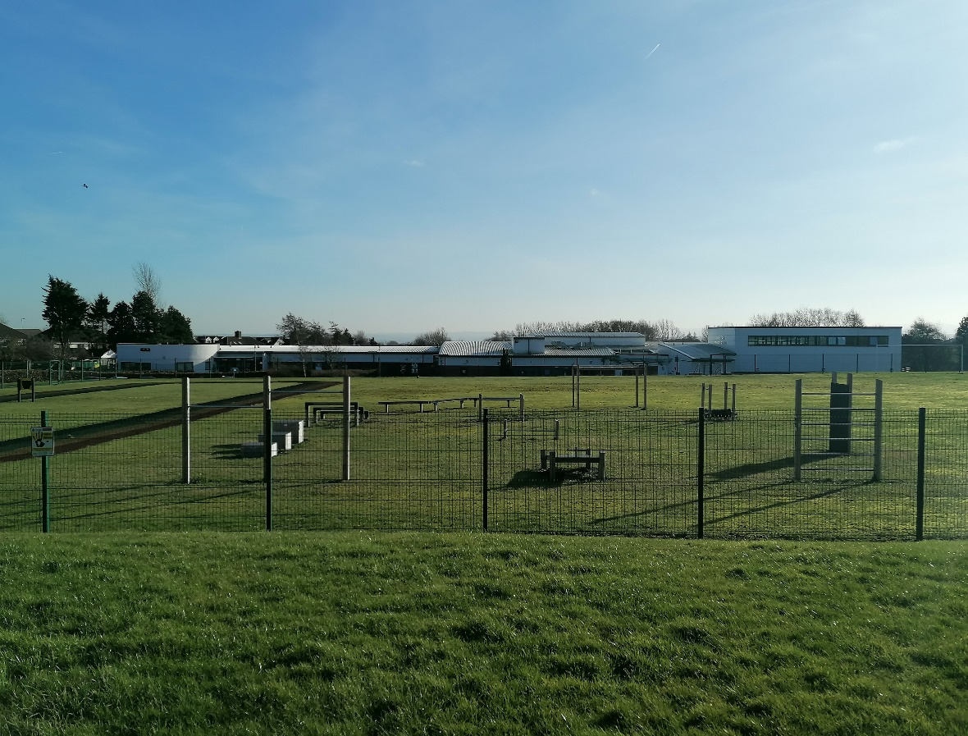

**Letter from the Headteacher**

Dear Applicant,

Thank you for your interest in the vacancy for the Cover Supervisor position at Home Farm. I hope you find this information pack useful and that it encourages you to apply for this exciting position within our school community.

We are a two form entry school with 458 pupils on roll. Our children come from a range of backgrounds and our school is rightly proud of the work we do and the support we provide to, the community that is in our catchment area. We use our Home Farm values to underpin the work we do for all who are part of our school.

Home Farm is a welcoming, happy school on the outskirts of Bradford, with wonderful children and a hardworking, committed staff who have helped shape the culture of the school into a nurturing and vibrant educational establishment. We collaborate well with other schools in the local area and additionally, have developed strong links with the high schools.

Therefore, we are looking for a positive, creative and hard-working individual who cares passionately about children’s education and wellbeing. The ideal applicant will share the schools vision and enthusiasm for learning to ensure the best outcomes for our children. Please have a look at our website ([https://www.homefarm.bradford.sch.uk/](https://www.homefarm.bradford.sch.uk/bradford/primary/homefarm)) where you can find more information and our latest reports.

We look forward to your application and seeing what you can bring to our school.

Yours sincerely,

Joanne Poole

Headteacher

*“Coming to school makes me happy. I am proud of the Home Farm Way.” KS1 Pupil*

*“I have lots of kind friends. My teachers help me learn and they are very kind.” KS1 Pupil*

**H**onesty

**O**pportunities

**M**utual Respect

**E**njoyment

**F**riendship

**A**chievement

**R**esilience

**M**aturity

*“Everyone is kind and helpful, and say how nice the teachers are. The teachers help every pupil. Not all schools have Home Farm Values, that’s what makes us special.” KS2 Pupil*

*“I love everything about Home Farm.” KS2 Pupil*

**Key Facts and Statistics**

|  |  |
| --- | --- |
| Type of School | Community |
| Age Range | Nursery, 5-11 |
| Number of Children | 458 |
| % of children with SEN support | 16.8% |
| % EHCP | 4.6% |
| % of children with EAL | 17.2% |
| % eligible for free school meals | 30.8% |
| Pupil Premium (2023/24 budget) | 32.5% |

**School Location**

Home Farm Primary School  
Home Farm Close  
Bradford  
West Yorkshire  
BD6 3NR

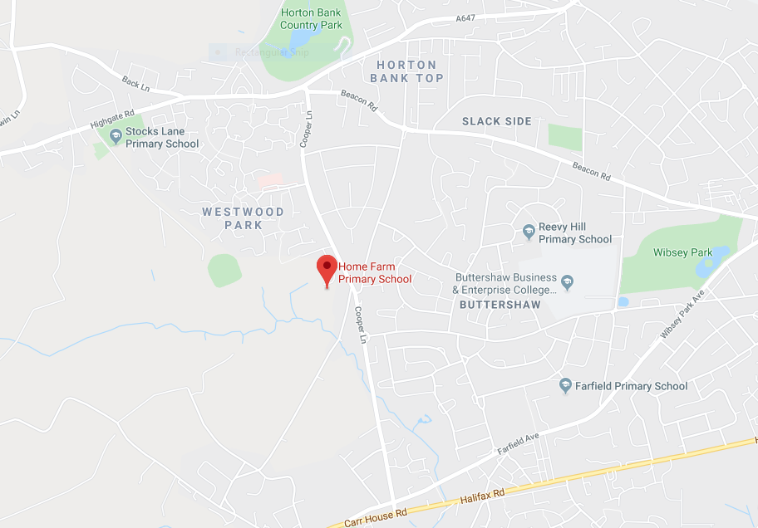

**Cover Supervisor**

**Permanent**

**27.5 hours per week, Term Time Only**

**Salary (Band 6, SCP 8-11) £15,385 - £16,180**

**Required ASAP**

**Job Information**

Home Farm Primary School wishes to appoint an inspirational and outstanding Cover Supervisor who has the ability to support children of all years to achieve high standards of learning.

Home Farm Primary School is a 2 form entry school with 458 pupils on roll.

We are looking for an outstanding individual who can support our school in an innovative, nurturing and creative manner. Our school is looking to appoint someone who can utilise our many strengths and also see what’s needed to move our school to the next level. The ideal applicant should be able to use our embedded ethos to work with parents.

**The successful candidate will:**

* Be passionate about working with children
* Be patient, caring and a good communicator
* Be inspirational and believes all children deserve the very best
* Have great teamwork skills, a good sense of humour and a willingness to ‘go the extra mile’ every day
* Are committed to and display the ‘Home Farm Way’ in everything they do

**Duties will include:**

* To provide planned and emergency classroom cover for pupils from Nursery to Year 6 in the absence of a teaching member of staff.
* To provide PPA cover lessons
* To create an orderly, purposeful classroom environment.
* To liaise with appropriate teacher on work to set for classes.
* To liaise with the member of staff on the return from absence where necessary
* To assist in classroom support if not needed for cover.
* To liaise with the School Business Manager for cover needed.
* To assist in assessment and SATs administration when required.
* To follow the school’s behaviour systems and promote the ‘Home Farm Way’.

**We can offer:**

* A friendly school with strong links with the community
* A supportive governing body and leadership team
* A genuine, welcoming, caring and professional school with pupils who are keen to learn in a very happy and engaging atmosphere
* Hardworking, supportive and enthusiastic colleagues
* A commitment to your continued professional development

**Closing date: 3rd November 2024  
Interviews: TBC**

We are committed to safeguarding and promoting the welfare of children  
All posts are subject to an enhanced DBS check

Proof of eligibility to work in the UK will be required   
**Please note: CVs are not accepted for this post**

**Statement of school’s values and ethos**

Our School Values

**H**onesty

**O**pportunities

**M**utual Respect

**E**njoyment

**F**riendship

**A**chievement

**R**esilience

**M**aturity

British Values

At Home Farm Primary School we provide opportunities for pupils to explore their own culture and have a clear understanding and appreciation of a wide range of the cultural influences that have shaped modern Britain.

We are a school for *all.* We recognise the multi-cultural, multi-faith nature of our community and of Britain. We understand the crucial role our school plays in promoting British Values.

**JOB DESCRIPTION: Cover Supervisor**

The following information is furnished to help staff and those people considering joining the City of Bradford Metropolitan District Council to understand and appreciate the work content of their post and the role they are to play in the organisation. However, the following points should be noted:

1. Whilst every endeavour has been made to outline all the duties and responsibilities of the post, a document such as this does not permit every item to be specified in detail. Broad headings, therefore, may have been used below, in which case all the usual associated routines are naturally included in the job description.
2. Officers should not refuse to undertake work, which is not specified on this form, but they should record any additional duties they are required to perform and these will be taken into account when the post is reviewed.
3. Bradford is an Equal Opportunities Employer and requires its employees to comply with all current equality policies both in terms of equal opportunity for employment and access to the Council Services.
4. The Council is committed to making any necessary reasonable adjustments to the job role and the working environment that would enable access to employment opportunities for disabled job applicants or continued employment for any employee who develops a disabling condition.

**Salary**

There is no statutory pay point. Salary should be in accordance with any agreement for staff at the school.

**Line of Responsibility**

The Cover Supervisor is directly responsible to the Headteacher.

**Operational Responsibilities**

* To provide planned and emergency classroom cover for pupils from Nursery to Year 6 in the absence of a teaching member of staff.
* To provide PPA cover lessons
* To create an orderly, purposeful classroom environment.
* To liaise with appropriate teacher on work to set for classes.
* To liaise with the member of staff on the return from absence where necessary
* To assist in classroom support if not needed for cover.
* To liaise with the School Business Manager for cover needed.
* To assist in assessment and SATs administration when required.
* To follow the school’s behaviour systems and promote the ‘Home Farm Way’.

**Conditions of Employment**

The above responsibilities are subject to the general duties and responsibilities contained in the written statement of conditions of employment (the Contract of Employment).

The postholder is required to support and encourage the school’s ethos and its objectives, policies and procedures as agreed by the governing body. S/he shall be subject to all relevant statutory and institutional requirements.

To uphold the school's policy in respect of child protection matters.

* 1. The postholder may be required to to undertake additional duties as reasonably requested by senior staff

This job description allocates duties and responsibilities but does not direct the particular amount of time to be spent on carrying them out and no part of it may be so constructed.

This job description is not necessarily a comprehensive definition of the post. It may be subject to modification at any time.

All staff participate in the school’s performance management scheme.

**Cover Supervisor**

**Person Specification**

**Essential Knowledge**

* A good standard of literacy and numeracy skills
* Able to use IT and relevant software effectively to support learning
* Good planning and organisation skills
* Excellent behaviour management skills

**Desirable Knowledge**

* A basic knowledge of the National Curriculum requirements for the sector
* A basic knowledge of Health & Safety requirements in a school environment
* Basic knowledge of Information Technology e.g. use of mouse and keyboard, or a willingness to learn.
* Level 3 in Childcare & Education or equivalent

**Essential Experience**

* Experience of establishing positive relationships with children
* Experience of working with children with a range of abilities and needs
* Recent and successful experience in a relevant setting
* Experience of working in a school
* Experience of preparing learning materials for children

**Essential Skills & Abilities**

* Ability to use language and other communication skills that children can understand and relate to
* Ability to demonstrate active listening skills
* Ability to empathise with the needs of children
* Ability to undertake observations of individual pupils and complete lesson records under the direction of the teacher
* Ability to work within and apply all school policies e.g. behaviour management, health & safety, equal opportunities
* Ability to work effectively with colleagues
* Initiative to develop own practice and advance pupil learning

**Desirable Skills and Abilities**

* Ability to speak and write a language spoken by our ethnic minority children

**Essential Personal Qualities**

* High commitment to safeguarding and promoting the welfare of children
* Be resilient, flexible and willing to undertake a range of duties
* Able to remain calm in stressful situations
* Willingness to participate in training and developmental opportunities offered by the school
* Willingness to deal with children’s personal hygiene where required
* Willingness to maintain confidentiality on all school matters

**Equal Rights and Key Dates**

**Equal Rights**

Our School is an equal rights employer. We require our governors and employees to follow our equality policies and to follow all statutory requirements concerning age, race, religious, sex, sexual orientation and disability discrimination. We respect and protect the rights of people with disabilities both in terms of equal opportunity for employment and access to the school's services.

**Disabled Applicants**

Disabled applicants are guaranteed an interview if they meet the essential requirements of the Personnel Specification. As an equal rights employer our school is committed to make any necessary reasonable adjustments to the selection process, the job role and the working environment that would enable access to employment opportunities for disabled people. Where a disabled applicant is being assessed the selection panel's decisions will be based on an assessment of that person's expected capabilities once reasonable adjustments have been made.

**Job Sharing**

Job share applicants are welcome to apply for all full-time posts unless otherwise stated in the advertisement.

**Key Dates**

|  |  |
| --- | --- |
| Closing Date | 3rd November 2024 |
| Shortlisting Date | 4th November 2024 |
| Interview Date | TBC |
| Start Date | ASAP |