Executive Head Teacher: Mr M. Thorp Head of School: Ms L. Clapham

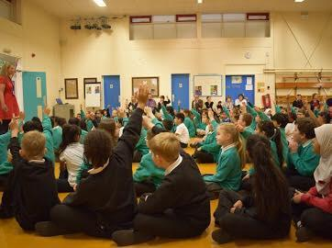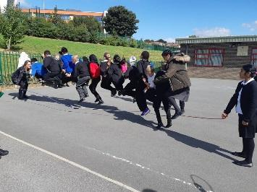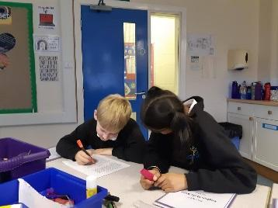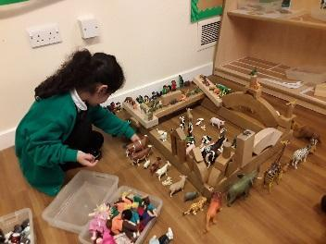

***Teaching Assistant Wanted***

***SCP 4 £11,206.00***

***27 hours 5 minutes Hours TTO***

**Start as soon as possible**

*Are you committed to improving pupil outcomes? Hardworking with a sensor of humour?*

*We are looking for a Teaching Assistant to join our driven and passionate team as soon as possible.*

*If you are ready for the challenge of a 2 form entry, forward thinking primary school then come and join us, as we continue our journey to Good.*

*You will need to be passionate, resilient and with the highest of expectations of our pupils as well as the ability to work as part of a flexible, happy team.*

***What Ofsted say (March 2018)***

✔ Governors and new leaders have created a positive and welcoming atmosphere across the school.

✔ Pupils play together harmoniously and the school is very inclusive, with staff and pupils keen to make everyone feel involved and valued.

✔ Senior leaders’ new behaviour policy is already having a good influence on pupils’ behaviour.

***As one of our staff we can offer you:***

* *Children who are motivated to learn*
* *Weekly Staff Development Meetings*
* *The support of working alongside other experienced teachers*

***Ready for the challenge?***

If you are interested, please download an application pack from Prospects online

*Or contact:* [*janet.pulford@grovehouseprimary.co.uk*](mailto:julie.taylor@grovehouseprimary.co.uk)

*Website:* [*www.grovehouseprimary.co.uk*](http://www.grovehouseprimary.co.uk) *Telephone: 01274 636921*

*Myers Lane, Bradford BD2 4ED*

***Closing date: Noon on Thursday 26th September***

***Shortlisting: Friday 27th September***

***Interview: Tuesday 1st October***

G*rove House is committed to safeguarding and promoting the welfare of children and young people and expects all staff and volunteers to share this commitment*