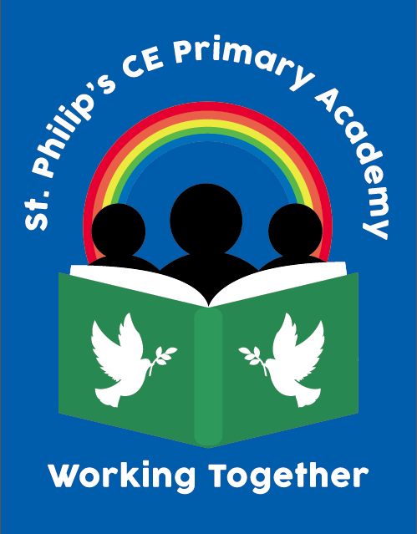
St Philip’s CE Primary Academy
Whitby Terrace, Girlington, Bradford BD8 9JL
Headteacher: Mrs M Hargreaves
email:office@stphilips.bdat-academies.org
Tel: (01274) 546496

St Philip’s Church of England Primary Academy, a member of the Bradford Diocesan Academy Trust, is a one form entry school in the central-Bradford location of Girlington. We have a strong leadership and teaching team to support any new members of staff coupled with the additional support and network opportunities that we access through our membership of BDAT.
The Governors would like to invite applications from ambitious and talented teachers for the following post to commence September 2024 or as soon as practically possible for the right candidate
1 x Year 4 Full time Class Teacher - Permanent
ECT to M1 salary range
(£30,000 - £31,737 before Sept 24 pay award is applied)

We are seeking people who:
- have high expectations of children’s achievement and a dedication to inspiring learners
- are practitioners striving towards excellence in all they do
- have evidence of good or outstanding teaching that is creative and innovative leading to the provision of exciting learning experiences
- are dedicated to school improvement and raising standards for all stakeholders
- have effective communication skills with children, parents, colleagues and the wider community.

We can offer you:
  - an induction programme for all new staff
  - a friendly and warm community with dedicated staff and governors
  - well behaved, enthusiastic learners
  - a commitment to raising standards for all our children
  - a highly motivated and supportive leadership team
  - a commitment to enhancing your professional development.

We take great care to ensure that our pupils are safeguarded against harm, therefore these posts are subject to an enhanced DBS check.
Visits to school are warmly welcomed and can be arranged by contacting the school office team on 01274 546496. Applicants are requested to apply online via My New Term.
Closing Date: Midday on Friday 14th June 2024
Short listing: Tuesday 18th June 2024
Observations conducted: 19th – 24th June
Interviews: Tuesday 25th June 2024

