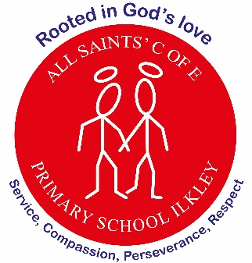

Higher Level Teaching Assistant
18.75 hours per week.
(Monday -Wednesday: 8:45 – 15:30)

Permanent
Band 8, SCP Points 17 -22
Term Time Only (£16.08 per hour)
Commencing: Monday 13th April 2026
We are seeking an enthusiastic, skilled and dedicated Higher Level Teaching Assistant (HLTA) to join our friendly and supportive team. The successful candidate will play a key role in supporting high-quality teaching and learning across the school, delivering targeted interventions, leading whole classes when required, and working closely with teachers to ensure every child thrives. This is an exciting opportunity for an experienced and motivated HLTA who is passionate about making a difference to children’s lives and who can contribute positively to our school’s values and ethos. The successful candidate will support teaching and learning and the personal development of pupils in EYFS, KS1 and KS2, including undertaking supervision at lunchtime.
We are looking for a candidate who:
- Holds an HLTA qualification (or equivalent)
- Has experience working within a primary school setting
- Can confidently deliver learning to whole classes in the teacher’s absence
- Demonstrates strong behaviour management and classroom organisation skills
- Builds positive relationships with pupils, staff and families
- Is adaptable, proactive and able to show initiative
- Works well as part of a team and contributes to whole-school life
- Is committed to promoting the wellbeing and progress of all children
We can offer you:
- A warm, caring and supportive school community
- Friendly, dedicated staff and leadership who value your contribution
- Opportunities for continued professional development
- A positive working environment rooted in our school values
- Children who are enthusiastic, kind and eager to learn

Interested candidates should apply online: to download job details and apply please visit www.prospectsonline.co.uk

Closing date: 9am on Monday 16 March 2026

Interviews: W/C 21^{h} March 2026

We are committed to safeguarding children and promoting the welfare of children. All posts are subject to an enhanced DBS check, satisfactory references, proof of eligibility to work in the UK and prohibition checks, as set out in Keeping Children Safe in Education.

