Growing together with love, courage and joy


Special Education Needs Support Assistant (SENSA)
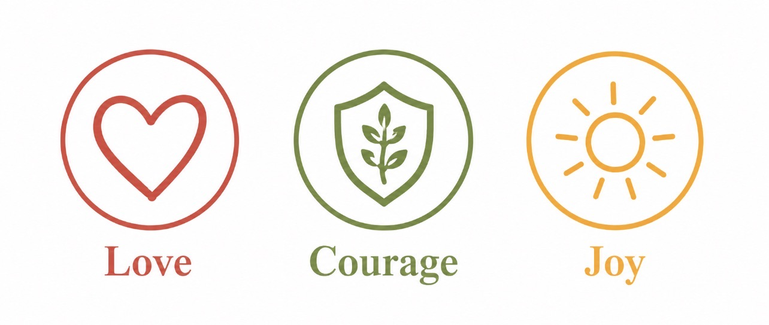

Special Educational Needs Support Assistant (SENSA)
Year 1
Band 5 (4-6)
Fixed Term until Friday 23rd July (maternity cover)
Start Date: 7th December 2026
This isn't just another support role...
At Idle CE Primary School, we believe every child deserves to feel known, valued and supported to flourish. We are seeking to appoint a caring, dedicated and enthusiastic Special Educational Needs Support Assistant (SENSA) to join our team and provide targeted support for a pupil in Year 1.
The successful candidate will play an important role in helping a child with additional needs access learning, develop independence and experience success within the classroom and wider school community.
Why Idle?
Guided by our vision of Growing Together with Love, Courage and Joy, we are committed to ensuring every child flourishes academically, socially, emotionally and spiritually.
We believe that inclusion sits at the heart of everything we do, and we are proud of the nurturing environment we provide for our children and families.
We Are Looking for Someone Who:
- Has experience of supporting children with Special Educational Needs and Disabilities (SEND).
- Has experience of working with children in Key Stage 1.
- Demonstrates patience, kindness and a nurturing approach.
- Understands the importance of developing children's confidence, independence and resilience.
- Can build positive relationships with pupils, families and colleagues.
- Is committed to inclusive practice and ensuring all children can succeed.
- Works effectively as part of a team whilst also using initiative when required.
- Has excellent communication and interpersonal skills.
- Shares our commitment to the school's Christian vision and values.
The Successful Candidate Will:
- Provide high-quality support for a pupil with SEND within a Year 1 classroom.
- Support learning through individualised strategies and interventions.
- Foster independence and encourage positive learning behaviours.
- Work in partnership with the class teacher, SENDCo and wider staff team.
- Support the pupil's emotional wellbeing and social development.
- Contribute to a safe, inclusive and engaging learning environment.
- Engage positively with parents and external professionals where appropriate.
Why Us?
- Friendly, enthusiastic and motivated children.
- A welcoming and supportive staff team.
- A strong commitment to inclusion and pupil wellbeing.
- High-quality professional development opportunities.
- Supportive leadership and a culture of continual improvement.
- The opportunity to make a genuine difference to a child's life every day.
Visits to School
Visits to school are warmly welcomed and encouraged.
To arrange a visit, please email enquires@idle.bradford.sch.uk
Safeguarding
Idle CE Primary School is committed to safeguarding and promoting the welfare of children and young people and expects all staff and volunteers to share this commitment.
The successful candidate will be subject to:
- Enhanced DBS clearance.
- Online searches.
- Satisfactory references.
- Verification of qualifications and right to work in the UK.
Closing Date: Friday 6th November 2026
Interviews: Week commencing 9th November 2026
Start Date: 7th December 2026
Please note: CVs are not accepted for this post.

Special Educational Needs Support Assistant (SENSA) - Year 1
Person Specification
Criteria | Essential | Desirable
Qualifications & Training | GCSE English and Mathematics (Grade C/4 or above) or equivalent. | Relevant TA qualification (Level 2 or Level 3).  Training relating to SEND support.
Experience | Experience of working with primary-aged children.  Experience of supporting children with additional needs.  Experience of working effectively as part of a team. | Experience of supporting pupils in Key Stage 1.  Experience of delivering interventions.  Experience of supporting pupils with communication, interaction, social, emotional or sensory needs.
Knowledge & Understanding | Understanding of the needs of children with SEND.  Understanding of safeguarding and child protection responsibilities.  Awareness of strategies which promote positive behaviour and engagement in learning. | Knowledge of the SEND Code of Practice.  Understanding of adaptive teaching and inclusive classroom practice.
Skills & Abilities | Ability to build positive relationships with children, parents and colleagues.  Ability to support learning under the direction of the class teacher and SENDCo.  Excellent communication skills.  Ability to encourage independence and resilience.  Ability to maintain confidentiality and professionalism at all times. | Ability to contribute to the planning and delivery of targeted interventions.  Ability to use a range of strategies to support children's emotional regulation and wellbeing.
Personal Qualities | Caring, patient and nurturing.  Positive and enthusiastic approach.  Committed to inclusion and high expectations for all pupils.  Flexible and adaptable.  Reliable, organised and able to use initiative.  Committed to the ethos and values of the school. | Willingness to engage in further professional development and training.

Key Responsibilities
The successful candidate will:
- Provide dedicated support for a small group of Year 1 pupil with SEND, enabling them to access learning and make progress.
- Support the implementation of individual support plans and provision outlined by the SENDCo and class teacher.
- Work with individuals and small groups to reinforce learning and develop key skills.
- Foster independence, confidence and positive learning behaviours.
- Support pupils' social, emotional and wellbeing needs.
- Contribute to maintaining a safe, stimulating and inclusive learning environment.
- Develop positive relationships with parents, carers and external professionals where appropriate.
- Record observations and contribute to monitoring pupil progress.
- Attend relevant training and meetings as required.
- Uphold the school's safeguarding responsibilities and policies at all times.
Idle CE Primary School Values:
The successful candidate will demonstrate a commitment to our vision of Growing Together with Love, Courage and Joy and will actively contribute to creating a nurturing and inclusive environment where every child can flourish.

