March 2021

Dear Applicant

**KS2 Teacher - Permanent**

Thank you for your interest in the above post. Please find enclosed information about our school, the personnel specification and job description.

The deadline for applications is Friday, 9th April 2021 at 12.00pm.

We look forward to receiving your application.

Yours sincerely

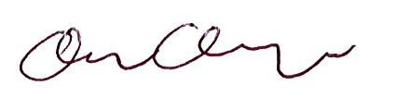

Clare Cosgrove

Head of School