

CONTENTS Page:

Application letter 3

Mission Statement 4

Job Description 5 - 9

Copy of advert 10

How to find us 11

How to apply 12





Congratulations
You have taken the first step on an exciting adventure to be part of our team, to inspire and enrich the education of all our children at Farfield Primary and Nursery School.
‘Farfield children can’
This is the belief of all staff and at the heart of everything we do. As Headteacher I want only the best teachers for our children, who are shining examples and strive every day to be ready, respectful, and safe. I expect them to attend school every day and I have the highest of expectations for their education. I want our children to,

“Walk with the dreamers, the believers, the courageous, the cheerful, the planners, the doers, the successful people with their heads in the clouds and their feet on the ground.” Wilfred Peterson
If you are enthusiastic, dynamic, up for a challenge, determined and want to have a positive impact on the education of our children - then fill out an application and tell me what you can bring to our community, what makes you unique and why you are the teacher I would entrust to educate Farfield children. Our priorities are to raise standards in phonics returning them to above 60% and increase combined in KS2 to 65%. All staff no matter what their role in school, know how important it is to ensure this goal is achieved and what they personally contribute to make it happen.
All our children have the potential to reach their goals, and this is a unique opportunity for you to join a supportive, hardworking, caring team and be part of their journey. You ‘MUST’ meet our amazing pupils and speak to our staff about what ‘Farfield’ means to them. Immerse yourself in our daily life and you will know immediately if you have what it takes to be part of our team. Every day is different, but every day is rewarding – we notice the positives and celebrate the differences. We inspire children to be scientists, deep sea divers, entrepreneurs, you name it! But most importantly we want our children to be unique, well-rounded citizens who will make a difference in our future communities.
We are a good school on a journey to outstanding. We will offer support whether you are at the start of your career or an experienced teacher within a community that will inspire and motivate you to be the best teacher you can be.
I look forward to meeting you, showing you around our school and introducing you to our Farfield Family.
Sarah Nichols
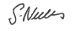
Head teacher
Farfield Primary and Nursery School

Our mission statement

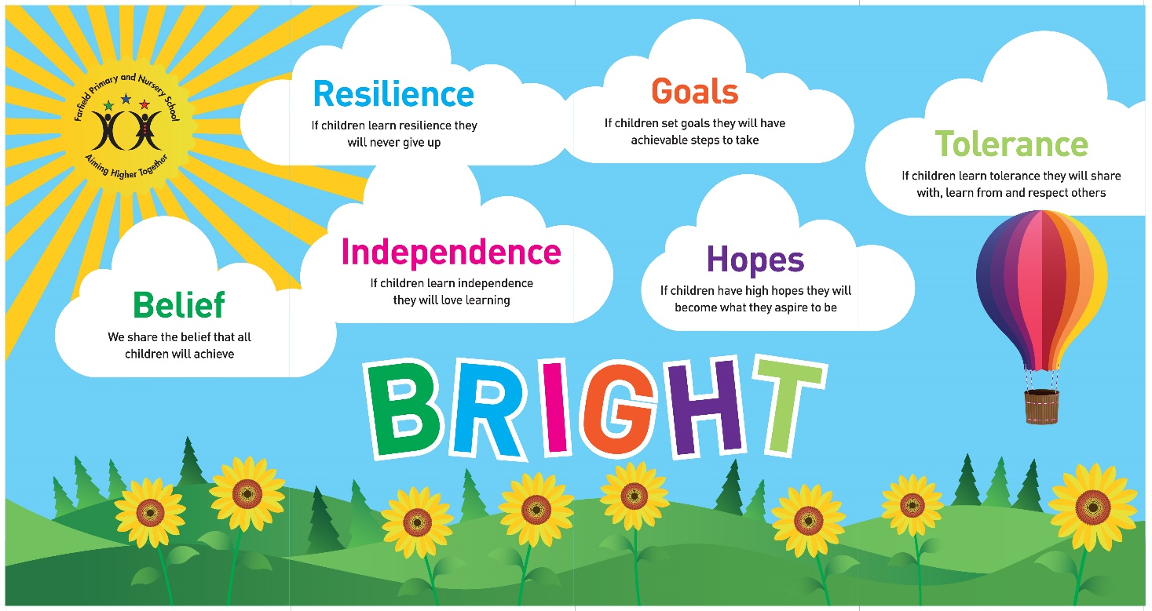

We share the Belief that all children will achieve,
If they learn Resilience they never give up,
If they learn Independence they will love learning,
If they set Goals they will have achievable steps to take,
If they have high Hopes they will become what they aspire to be,
If they learn Tolerance they will share with, learn from and respect others.



Outline Job Description

Post Title: | SITE MANAGER
Post Ref: | Septembr 2025
Grade: | Band 7, SCP 11- 17

Generic Introduction:

The following information is furnished to assist staff joining the School to understand and appreciate the work content of their post and the role they are to play in the organisation. The following points should be noted:

- Whilst every endeavour has been made to outline the main duties and responsibilities of the post, a document such as this does not permit every item to be specified in detail. Broad headings, therefore, may have been used below, in which case all the usual associated routines are naturally included in the job profile.

- Employees should not refuse to undertake work, which is not specified on this form, but they should record any additional duties they are required to perform and these will be taken into account when the post is reviewed.

- Bradford Council/Farfield Primary & Nursery School is an Equal Opportunities Employer and requires its employees to comply with all current equality policies in terms of equal opportunity for employment and access to the Council Services.

- Bradford Council/Farfield Primary & Nursery School is committed, where possible, to making any necessary reasonable adjustments to the job role and the working environment that would enable access to employment opportunities for disabled job applicants or continued employment for any employee who develops a disabling condition.

Prime Objectives of the Post:

Under the guidance of appropriate senior staff: be responsible for maintenance, security and facilities management services on school sites and premises and provide specialist support in a specific resource area be responsible for the maintenance of a clean and hygienic school interior.

May from time to time be required to undertake other duties commensurate with the grade and level of responsibility defined in this job description.

Knowledge and Skills:

(See Personnel Specification)

Effort Demands:

- Will work under own initiative with minimum supervision, managing conflicting priorities and referring only extremely complex issues to a member of the senior leadership team.

- Will contribute to the planning, development and organisation of systems/procedures/policies.

- Will be responsible for the development and operation of a preventative planned maintenance programme and for routine inspections of the buildings, fixtures, fittings, furniture, premises and grounds to assess for work or repairs required to be carried out to maintain safe and satisfactory conditions (including fire safety and electrical equipment) and to maintain appropriate, accurate records.

- Will undertake the procurement and ordering of associated stocks and supplies ensuring that there are adequate levels at all times to meet the needs of the school within budgetary parameters. Taking delivery and arranging for the storage of materials, stores and other goods.

Responsibilities:

- Will have an in-depth knowledge of and ensure compliance with policies and procedures relating to child protection, health, safety and security and confidentiality at all times, reporting all concerns to an appropriate person.

- Will promote and ensure the health and safety of pupils, staff & visitors (in accordance with appropriate health & safety legislation) at all times. (This responsibility is shared during normal school hours with the Head-teacher, but is the postholder’s sole responsibility whilst on site outside of these hours in the absence of the Head-teacher or other senior member of the school staff).

- Will have responsibility for the maintenance and security of the premises, advising the Head-teacher of any problems with appropriate suggestions for solutions/improvements.

- Will be responsible for the line management and performance appraisal of designated employees, maintaining good working relationships employing effective leadership techniques. Ensure timely completion of all related paperwork associated with the management of employees. Identify and implement necessary work-related training.

- Will control expenditure and set allocated budgets for staffing, annual site maintenance and capital budgets, to ensure that budgets are not overspent and best value is achieved.

- Will identify and create business opportunities and to assist in the external marketing of Facilities Services for the school, in particular, this will involve creating revenue through school facilities and developing pricing strategies.

- Will attend and participate in relevant meetings, producing analysis and reports as required.

- Will participate in training and other learning activities and performance development as required.

- Will establish constructive relationships and communication with contractors and other agencies/professionals, ensuring that contracts on site do not cause a health and safety hazard or damage school property. Report matters of concern or noncompliance with contract specification to the relevant contractor.

- Will contribute to the overall ethos/work/aims of the school and appreciate and support the role of other professionals.

- Will ensure the highest standards of professional conduct and confidentiality at all times.

- Will present a positive personal image, contributing to a welcoming school environment which supports equal opportunities for all, treating all users of the school with courtesy and consideration.

environmental demands/Working Conditions:

- Required to be a key-holder for emergency call-outs. Evening/weekend duties for lettings may be a feature of the job (further information is available from the Head-teacher).

- Regular outdoor work and exposure to the elements/weather.

- Will have contact with members of the public/other professionals e.g. teaching staff, governors, parents/carers, community groups, local education authority, external providers etc.

- The post holder may occasionally be subjected to antisocial behaviour from members of the public/parents/site users.

- This post may include a degree of manual lifting and handling. You are expected to be aware of health and safety policies and procedures and frequently assess your ability to carry out the lifting tasks required of you.

Fluency Duty

In line with the Immigration Act 2016; the Government has created a duty to ensure that all Public Authority staff working in customer facing roles can speak fluent English to an appropriate standard.

For this role the post holder is required to meet the Intermediate Threshold Level

Intermediate Threshold Level

The post holder should demonstrate:

- They can express themselves fluently and spontaneously with minimal effort and,
- Only the requirement to explain difficult concepts may hinder a natural smooth flow of language.

Special Conditions of Service:

- No contra-indications in personal background or criminal record indicating unsuitability to work with children/young people/vulnerable clients/finance (An enhanced DBS check is required).

Other considerations

- To be aware of and comply with policies and procedures relating to child protection; being vigilant for signs that children may be being abused and to report any such suspicions to the school’s nominated Child Protection Co-ordinator or the Headteacher.

- To act in accordance with the Data Protection Act and maintain confidentiality at all times e.g. access to staff/student/parent and carers files.

- Accept and commit to the principles underlying the Schools Equal Rights policies and practices.

- Be able to perform all duties and tasks with reasonable adjustment, where appropriate, in accordance with the Equality Act.

- Must be legally entitled to work in the UK.

PERSONNEL SPECIFICATION:

 | ESSENTIAL (E) / DESIRABLE (D)
Experience: | - Will possess handyperson, caretaking, cleaning/site-keeping experience in a school or similar environment.  - Provide evidence of having previously spoken fluently to customers at an Intermediate Threshold Level (E)
Qualifications/  Training: | - Will possess good literacy, ICT and numeracy skills (GCSE (or equiv) Maths and English).(E)
Knowledge/Skills: | - Detailed knowledge of plumbing, electrical and decorating repair procedures. (E)  - Will possess detailed knowledge of all policies, procedures and regulations relevant to the role. (E)  - Will possess knowledge of cleaning procedures required to meet specified cleaning standards. (E)  - Will possess knowledge of the use of ICT and other specialist equipment/resources with willingness to participate in development and training opportunities. (E)  - Will possess team-leading skills. (D)  - Will possess the ability to self-evaluate learning needs and actively seek learning opportunities. (E)  - Will possess the ability to relate well to children and adults. (E)  - In line with the Immigration Act 2016; you should be able to demonstrate fluency of the English Language at an Intermediate Threshold Level (E)

Job Advert
Site Manager
Salary: £27,269 - £30,06037 hours per week, all year round.
Required to start ASAP
Farfield Primary & Nursery School is looking for a Site Manager to ensure the smooth running and maintenance of our school environment, who must have good interpersonal skills to work with staff, children, parents and other stakeholders. We would like a Site Manager who cares about making an environment that is clean and tidy, who shows a real pride in their work. If you are a highly motivated person, then we are keen to hear from you.
At Farfield Primary and Nursery School we will trust, support and challenge you to empower our future generations, helping them to achieve their full potential and become unique well-rounded citizens.
Our priorities are to raise standards in phonics returning them to above 60% and increase combined in KS2 to 65%. All staff - no matter what their role in school - have this as their focus
Are you ready to help equip children with the knowledge and power to make a difference, to be different and embrace difference?
The candidate should have good knowledge of general maintenance and be able to work a split shift, as opening and closing the school at the beginning and end of a day is an essential requirement of the position. You must be able to prioritise tasks and work on your own initiative.
The hours of work are 6:30am to 10am then 2.30pm to 6:30pm and this is an all year round contract (52 weeks) with 23 days holiday per year, to be taken in the school holidays. You would need to be flexible because there are occasional late openings during the year for various meetings.
Are you ready to help equip children with the knowledge and power to make a difference, to be different and embrace difference?
.
To request a visit please email toniwilson@farfield.bradford.sch.uk or call 01274 678545
We are committed to safeguarding and promoting the welfare of our pupils and expect all staff and volunteers to share this commitment. All staff are subject to an enhanced DBS check and safer recruitment processes are followed for all vacancies, including relevant checks for shortlisted candidates.

Closing Date: Friday 26th September 2025, 3pm
Shortlisting: Monday 29th September 2025
Interview date: Wednesday 6th October 2025
HOW TO FIND US
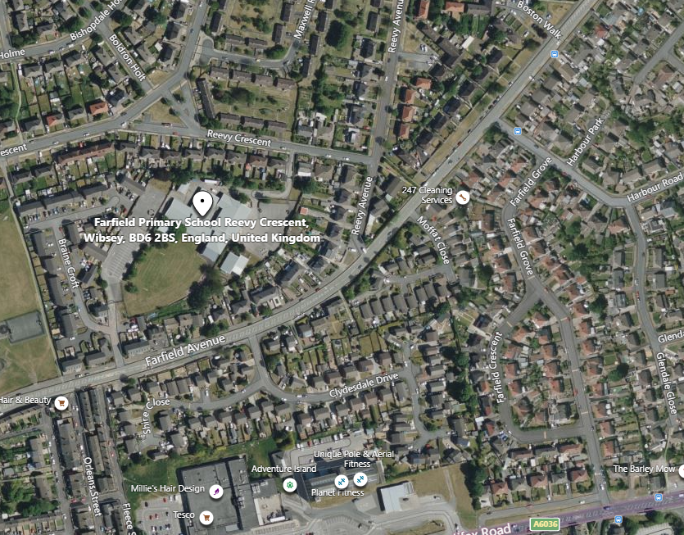

Farfield Primary School and Nursery
Reevy Crescent
Buttershaw
Bradford
BD6 2BS
(For carpark please use satnav postcode BD6 2JF)
Tel : 01274 678545
Fax: 01274 694022
E-mail: office@farfield.bradford.sch.uk

HOW TO APPLY

If you wish to apply for the post of full-time Site Manager at Farfield Primary and Nursery School, please log onto the Prospects Online website at www.prospectsonline.co.uk.

If you wish to arrange a visit to look around Farfield Primary & Nursery School please contact Toni Wilson via email of telephone, toni.wilson@farfield.bradford.sch.uk, tel 01274 678545

Upload your completed application form onto the website outlining how you meet the criteria on the job description and attributes required. A continuation sheet may be used if necessary.

We would request that you provide details of daytime and evening contact numbers and email addresses for use should you be called for interview.

The closing date for applications is 3pm on Friday 29th September 2025, with short listing on Monday 29th September 2025.

Interviews will take place on Wednesday 6th October 2025.

Please be available for task/observation/interview on this day if shortlisted.

Thank you for your interest in our post. We look forward to receiving your completed application.

