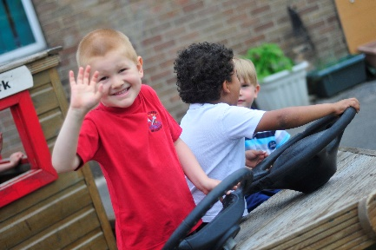

*Pupils spoke with real delight about how much they enjoyed school and how well the staff care for them.*

*Pupils develop high levels of empathy and understanding of each other because of the detailed and imaginative way the school promotes pupils’ spiritual, moral, social and cultural education.*

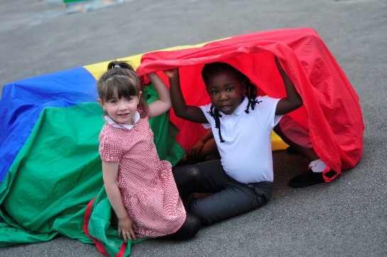

*Outcomes have improved significantly. They continue to improve across the school because of effective leadership, staff’s expertise and staff’s increasingly high expectations.*

*Pupils are very well behaved. They have positive attitudes to learning. Relationships among pupils and between adults and pupils are respectful, open and kindly. Pupils enjoy learning and coming to school.*

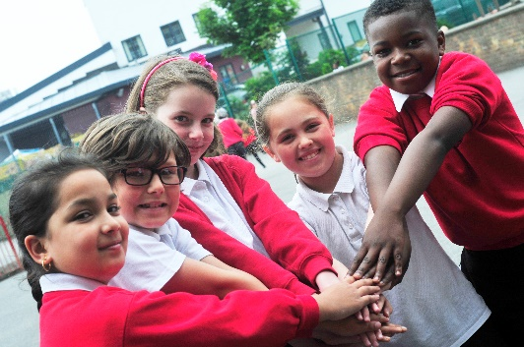

*Senior leaders lead the school with vision and a clear moral purpose. They have established an enthusiastic and increasingly able staff.*