

CONTENTS Page:

Application letter 2

About our school 3

Mission Statement 4

Job Description and Person Specification 5 - 8

Copy of advert 9

How to find us 10

How to apply 11
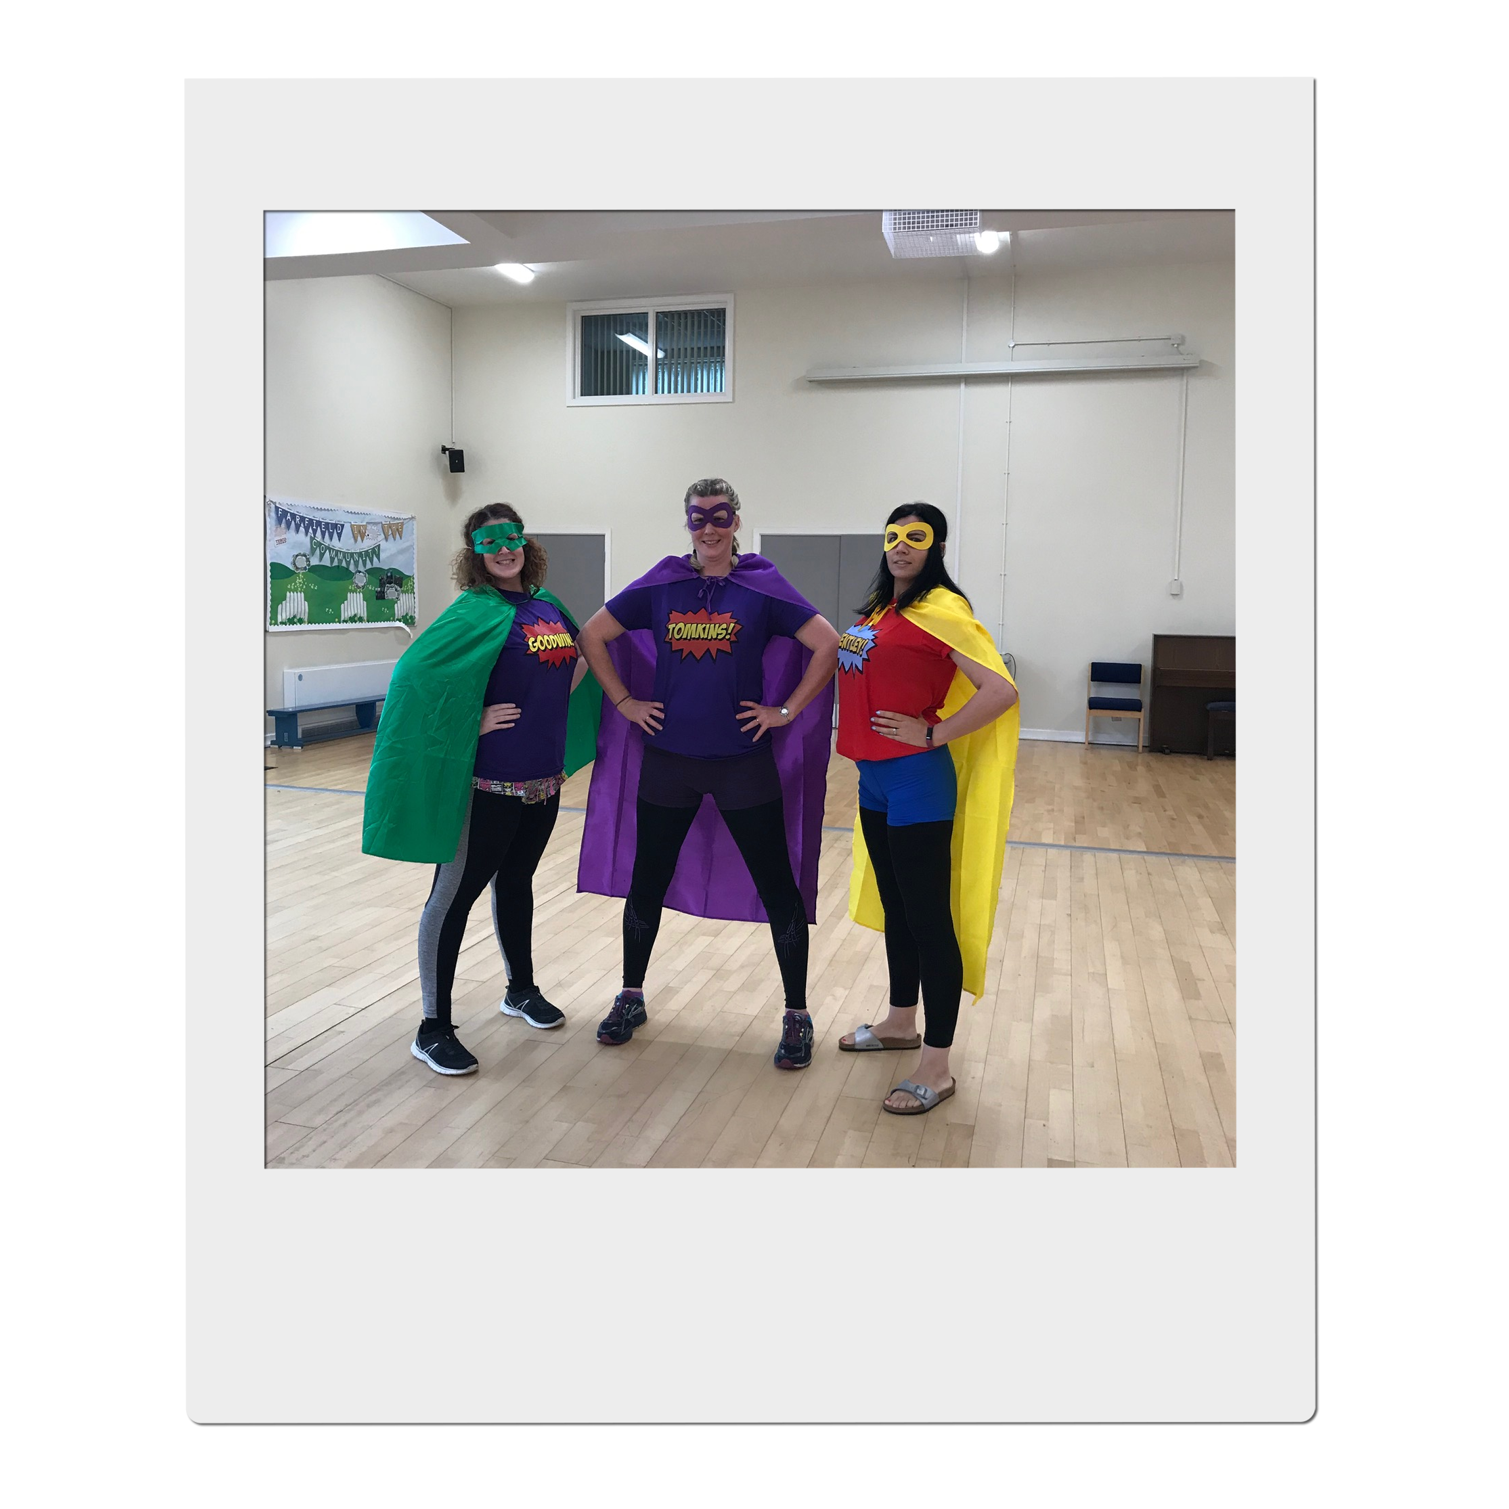
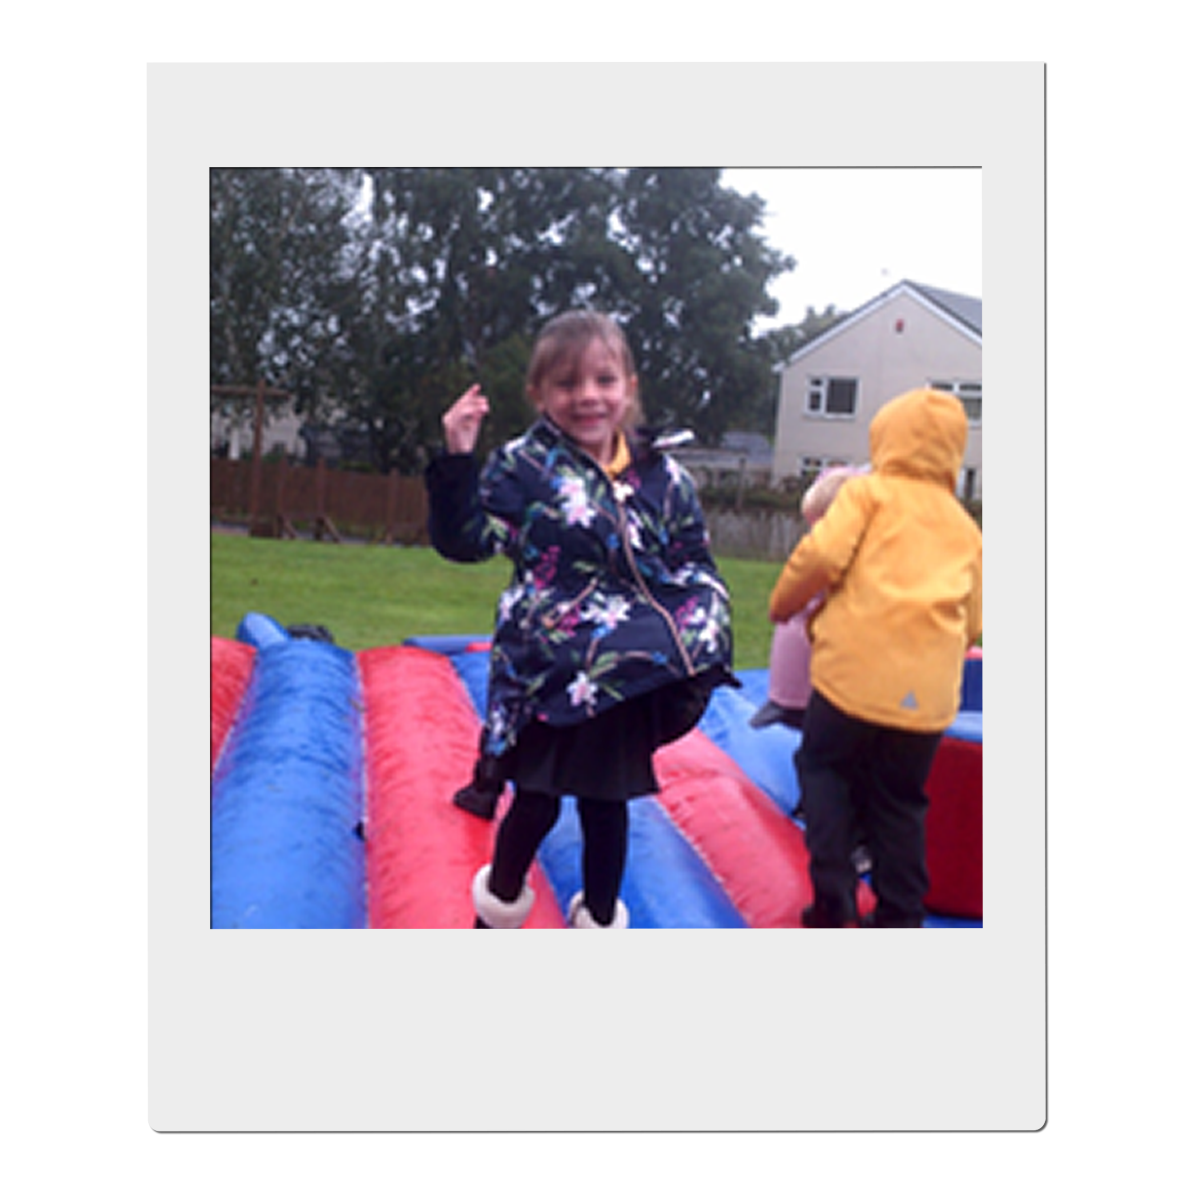

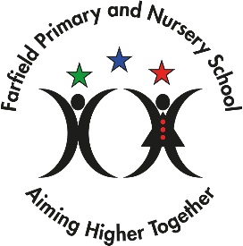

Congratulations
You have taken the first step on an exciting adventure to be part of our team, to inspire and enrich the education of all our children at Farfield Primary and Nursery School.
‘Farfield children can’
This is the belief of all staff and at the heart of everything we do. As Headteacher I want only the best teachers for our children, who are shining examples and strive every day to be ready, respectful, and safe. I expect them to attend school every day and I have the highest of expectations for their education. I want our children to,

“Walk with the dreamers, the believers, the courageous, the cheerful, the planners, the doers, the successful people with their heads in the clouds and their feet on the ground.” Wilfred Peterson
If you are enthusiastic, dynamic, up for a challenge, determined and want to have a positive impact on the education of our children - then fill out an application and tell me what you can bring to our community, what makes you unique and why you are the teacher I would entrust to educate Farfield children. Our priorities are to raise standards in phonics returning them to above 60% and increase combined in KS2 to 65%. All staff no matter what their role in school, know how important it is to ensure this goal is achieved and what they personally contribute to make it happen.
All our children have the potential to reach their goals, and this is a unique opportunity for you to join a supportive, hardworking, caring team and be part of their journey. You ‘MUST’ meet our amazing pupils and speak to our staff about what ‘Farfield’ means to them. Immerse yourself in our daily life and you will know immediately if you have what it takes to be part of our team. Every day is different, but every day is rewarding – we notice the positives and celebrate the differences. We inspire children to be scientists, deep sea divers, entrepreneurs, you name it! But most importantly we want our children to be unique, well-rounded citizens who will make a difference in our future communities.
We are a good school on a journey to outstanding. We will offer support whether you are at the start of your career or an experienced teacher within a community that will inspire and motivate you to be the best teacher you can be.
I look forward to meeting you, showing you around our school and introducing you to our Farfield Family.
Sarah Nichols
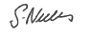
Head teacher
Farfield Primary and Nursery School
Job advert
Teaching Assistant
Salary: £23,114 – 23,893 full time equivalent (this will be pro-rated 31.15 hours, term time only)
Farfield Primary & Nursery School is looking for a skilled and caring adult who can support children in their learning. A key part of this role is to take responsibility for supporting learning in the classroom.
Are you ready to equip children with the knowledge and power to make a difference, to be different and embrace difference?
At Farfield Primary and Nursery School we will trust, support and challenge you to empower our future generations helping them to achieve their full potential and become unique well-rounded citizens.
Our priorities are to raise standards in phonics returning them to above 60% and increase combined attainment in KS2 to 65%. All staff, no matter what their role in school, have this as their focus.
Please click the link to find out more, and then read on : : https://drive.google.com/file/d/1knTFm9UuABiElbYuC2IfZPRq3K5tGeA2/view?usp=drive_link
We are looking for a highly motivated, inspirational practitioner who has the drive, vision and inter-personal skills to work with both staff, children, parents and other stakeholders.
We would like someone who cares about the children and is able to support children in lessons, allowing children to make good progress throughout their school career. This is a real opportunity to make a difference. If you are passionate about education and improving life chances, then we are keen to hear from you.
Grade C or above in GCSE English and Maths or equivalent is an essential requirement for this post. Please state all of your qualifications on your application.
We need a Teaching Assistant who is an:
- Outstanding classroom practitioner
- Committed to raising achievement through an exciting and stimulating curriculum
- Enthusiastic and forward thinking
- Well organised and creative
- Able to demonstrate excellent interpersonal skills and the ability to work with a range of staff to improve learning
- Able to work in partnership with parents/carers and the wider community
The successful candidate will be able to demonstrate:
- A good sense of humour, enthusiasm and a positive, proactive attitude to their role
- The ability to work well both independently and as part of a team
- Excellent interpersonal and communication skills
- Commitment to your own development
Farfield is a friendly, vibrant and lively school where our children are enthusiastic learners, well-motivated and encouraged to think for themselves. Visitors to our school always comment about the friendly, warm welcome from the staff and pupils.
Closing Date: 12 Noon, Monday 8th January 2024
Farfield is a friendly, vibrant and lively school where our children are enthusiastic learners, well-motivated and encouraged to think for themselves. Visitors to our school always comment about the friendly, warm welcome from the staff and pupils.
Closing Date: Monday 8th January 2024, 12pm
Shortlisting: Monday 8th January 2024
Interview date: Thursday 18th January 2024

Our mission statement

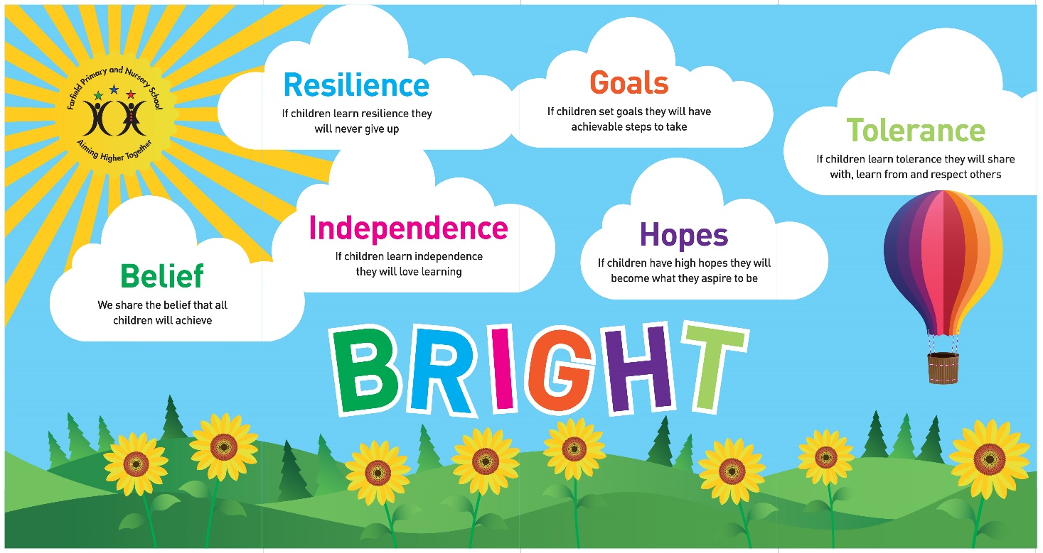

We share the Belief that all children will achieve,
If they learn Resilience they never give up,
If they learn Independence they will love learning,
If they set Goals they will have achievable steps to take,
If they have high Hopes they will become what they aspire to be,
If they learn Tolerance they will share with, learn from and respect others.

HOW TO FIND US
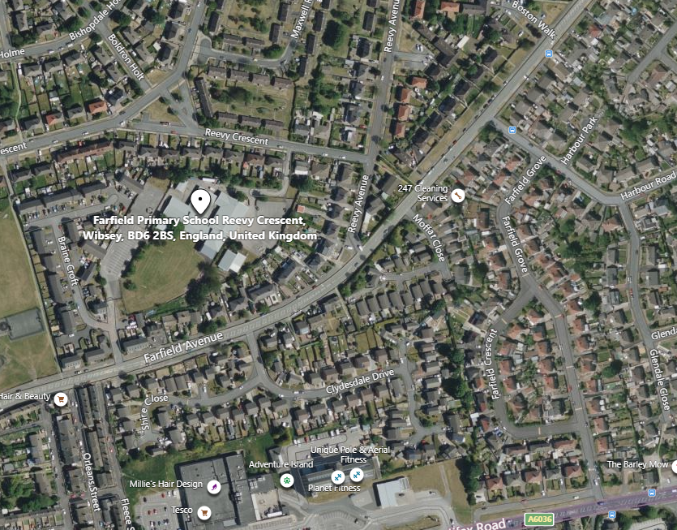

Farfield Primary School and Nursery
Reevy Crescent
Buttershaw
Bradford
BD6 2BS
(For carpark please use satnav postcode BD6 2JF)
Tel : 01274 678545
Fax: 01274 694022
E-mail: office@farfield.bradford.sch.uk

HOW TO APPLY

If you wish to apply for the post of full-time of Teaching Assistant at Farfield Primary and Nursery School, please log onto the prospects online website at www.prospectsonline.co.uk.

If you wish to arrange a visit to look around Farfield Primary & Nursery School please contact Toni Wilson via email of telephone, farfieldadmin@farfield.bradford.sch.uk, Tel 01274 678545

Upload your completed application form onto the website outlining how you meet the criteria on the job description and attributes required. A continuation sheet may be used if necessary.

We would request that you provide details of daytime and evening contact numbers and email addresses for use should you be called for interview.

The closing date for applications is 12pm on Monday 8th January 2024, with short listing the same day.

You will be informed by email before 6pm on Tuesday 9th January 2024 if your application has been successful.

Interviews will take place on Thursday 18th January 2024.

Please be available for observation/interview on this day if shortlisted.

Thank you for your interest in our post. We look forward to receiving your completed application.

