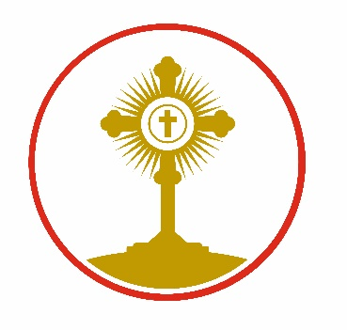

**St Clare’s Catholic Primary School, A Voluntary Academy**

**‘I have come that they may have life and have it to the full.’**

Fagley Road, Fagley, Bradford BD2 3JD

01274 637841

office@stclares.bradford.sch.uk

Headteacher: Mrs C A Utting

Dear Applicant

Thank you for your interest in applying for a post at our school.

St. Clare’s is a strong and successful school with a very well-established and highly effective staff team and very happy, friendly children.

We will be delighted to welcome you to our school, to show you round and to answer any questions you may have prior to your application.

We look forward to meeting you and wish you success with your application.

Yours faithfully

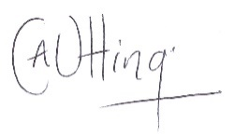

Mrs. C. A. Utting

Headteacher