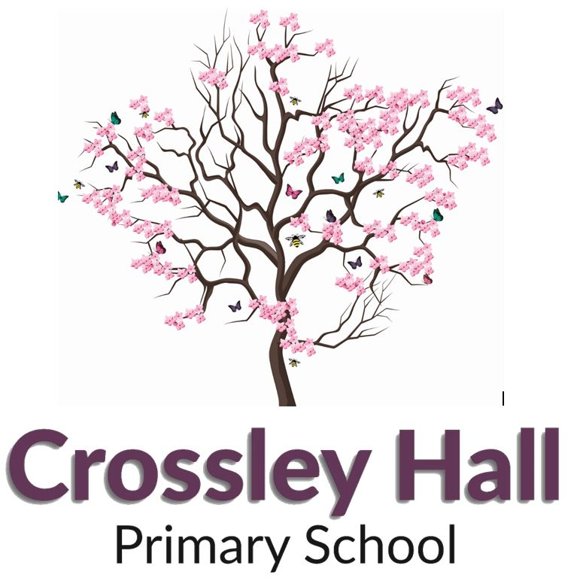

**Recruitment Pack**

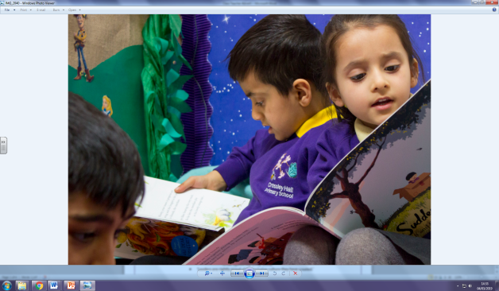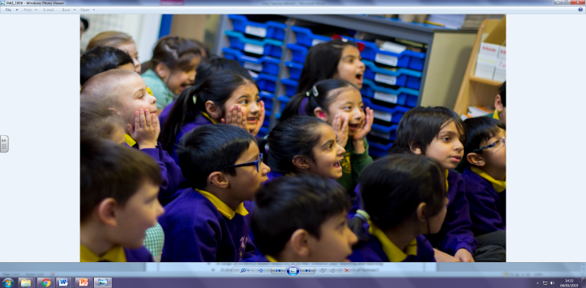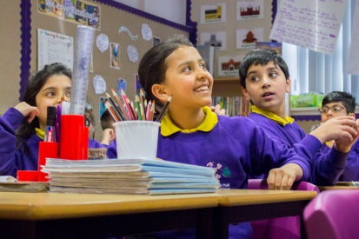**Class Teacher**



**Crossley Hall Primary School is a member of Pennine Academies Yorkshire**

Registered address: Farnham Primary School, Stratford Road, Bradford, West Yorkshire, BD7 3HU

A charitable company limited by guarantee registered in England and Wales (Company number: 10975521)

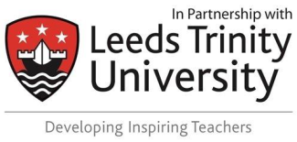 **Contact Us!**

**Contents**

1. A letter from the Chair of Governors
2. An introduction to the school, by the Executive Headteacher and Head of School
3. Pennine Academies Yorkshire – Our Vision & Values
4. Class Teacher Job Description
5. Personnel Specification

Dear Applicant,

Thank you for expressing an interest in our Class Teacher vacancy.

We are seeking to appoint outstanding, inspirational practitioners to become part of our dedicated teaching team. You may be an experienced teacher looking for a new challenge, or a newly qualified teacher looking to make that first step in your career. If you are keen and motivated and want to be part of a creative and energetic team, then we want you!

As a teacher in our 3 form entry school, you will work as a team alongside 2 other teachers to plan and deliver outstanding lessons and develop outstanding provision for our pupils. You will teach well-behaved, eager and highly motivated pupils who have a thirst for learning and a curiosity for the world around them. With access to our own mini buses you will be able to create a wide range of rich learning experiences, therefore raising standards and improving outcomes for our pupils.

At Crossley Hall, you are guaranteed a tailored programme of professional development. Our CPD has a proven track record of success with past senior leaders taking promotions as heads or deputies in Bradford schools. Over half of our current teachers joined us as Newly Qualified Teachers, some of which have now progressed to hold TLR posts. We also have strong links with Leeds Beckett and Leeds Trinity Universities, and we train teachers through the Exceed SCITT Programme.

Applications for this post can be submitted via post, email or online, using the approved application form. We would recommend that your supporting statement is presented on no more than 2 sides of A4 paper, stating your experience, strengths and evidence of the impact that your practice has had so far. Please take the time to look at our school website as it holds a wealth of information about our amazing school. We would also strongly encourage any candidate to visit us and discover what a great career move working with us would be. To arrange a visit, please contact Danielle Clifford on 01274 448703 or 07805 449496 or email her at [danielle.clifford@crossleyhallprimary.co.uk](mailto:danielle.clifford@crossleyhallprimary.co.uk).

We wish you every success in your application and look forward to meeting you.

Yours sincerely,

Chair of Governors

**Why Choose Crossley Hall Primary?**

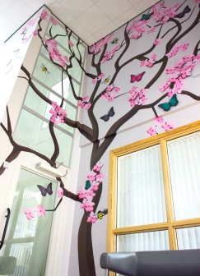Let us tell you more about our amazing school! We are a **thriving, energetic and vibrant** three-form entry primary school, situated in the Fairweather Green area of Bradford. Our school stretches across two buildings, a mixture of traditional and modern, both with extensive facilities. We are fortunate to work in an executive leadership agreement with Grove House Primary across the city, sharing expertise and best practice to ensure that all our pupils receive the best education. Michael Thorp, our Executive Head, leads both schools, with our Head of School (Chris Young) leading Crossley Hall on a day to day basis. Both have worked here for a number of years, and are incredibly **passionate** about our pupils and our wider **community**.

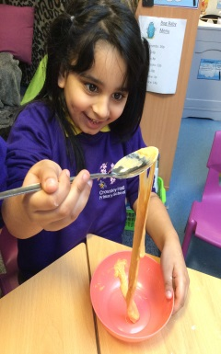Here at Crossley Hall, our team of dedicated teachers work tirelessly to bring our curriculum to life. Reading, writing and maths are taught using evidence-based principles such as ‘Talk for Writing’, ‘Inspire Maths’ (based on the Singapore approach) and a five-day cycle of whole-class reading lessons. Recently, we have introduced the International Primary Curriculum to Crossley Hall- this is a thematic and **creative** approach to teaching and learning, and it provides teachers with high-quality resources and ideas as a basis for delivering exciting learning. We believe that this will prepare our pupils for life as **international citizens** in modern society, as well as promoting independence.

We complement our classroom-based learning with lots of additional experiences to promote both academic achievement and **wellbeing**. Years 4, 5 and 6 all participate in an annual residential ‘adventure,’ and we visit places such as the National Media Museum, Eureka and the York Chocolate Story to bring our curriculum to life. Our very own school allotment gets our pupils outdoors, looking after our pets and growing plants and vegetables. We have an active Junior Leadership team, a large pupil workforce and an ‘Anti-Bullying Patrol’ to promote kindness and **empathy**. Furthermore, school doesn’t just end at 3 o’ clock, as we offer a range of after-school clubs including football, reading, dance and drama! Our school snake, Cornelia, is well looked after by our team of resident ‘Snake Charmers’.

The behaviour of our pupils is very good because we build **positive relationships** based on mutual respect- everyone is expected to be kind, polite and hard-working. As a school, we actively promote diversity, tolerance and respect for people of all faiths and backgrounds, and there is a real sense of harmony and dedication from staff and pupils alike. Some of our Year 5 pupils are trained ‘Mental Health Ambassadors,’ providing support to their peers.

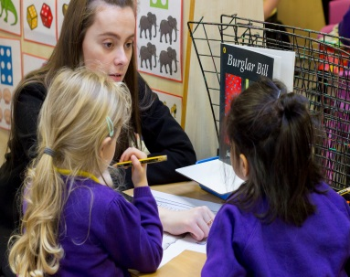Our pupils love coming to school! We reward their attendance by holding half-termly attendance celebrations to thank families for their commitment. For children who achieve 100% attendance each half term, a special afternoon of **fun** is organised, and in July the Top 200 attenders will take part in a private cinema screening at Cineworld, Bradford (complete with popcorn, of course)!

Not only do we have **enthusiastic**, well behaved pupils, we also have a talented team of motivated and dedicated professionals, who, along with the leadership team, are united in the strong sense of ambition for the school. Our team of Support Staff are confident and highly skilled. Our **inclusive ethos** resonates throughout the school, and we are proud to cater fully for our children with additional needs. Our Dedicated Specialist Provision for Autism works closely and collaboratively with the rest of the school.

Finally, please rest assured that we take the Professional Development of our teachers seriously. We recognise talent when we see it, and we pride ourselves on nurturing future leaders. Our Head of School started here as a Year 2 teacher, and in fact, it would not be unusual to arrive at Crossley Hall as an NQT and progress to Assistant Head level within five years.

Please do come and visit us to find out more!

Michael Thorp Chris Young

**Executive Head**  **Head of School**