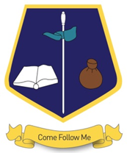
St Matthew’s Catholic Primary School,
Saffron Drive,
Allerton,
Bradford,
BD15 7NE
01274 541737
stmatthewscatholic.co.uk
Paul.whitehead@stm.bcwcat.co.uk

‘Behaviour in lessons and conduct … are exemplary’
‘Outcomes for pupils overall have remained strong ’
‘… a very warm, inclusive and caring environment where staff and pupils feel valued and supported’
OFSTED 2018

KS2 Full-time Teacher
Required for September 2025

Are you a great teacher with enthusiasm and a desire to make a positive difference to children’s learning?
If so, we’d like to hear from you. Come and find out what we can offer. Applications from Early Career Teachers welcome (ECT’S)

Visits to school are welcomed. Please phone school to make an appointment.
Application packs are available by emailing the office – office@stm.bcwcat.co.uk

Closing date: Friday 27th June 2025 9am

We are committed to safeguarding and all appointments are subject to an enhanced DBS check

