CITY OF BRADFORD METROPOLITAN DISTRICT COUNCIL
JOB PROFILE

DEPARTMENT: Corporate Services | SERVICE GROUP: Business Support,  Coroner’s Office
POST TITLE: Administrative Officer | REPORTS TO: Coroner’s Services  Manager
GRADE: Band 6 | SAP POSITION NUMBER :

The following information is furnished to help Council staff and those people considering joining the City of Bradford Metropolitan District Council to understand and appreciate the general work content of their post and the role they are to play in the organisation. The duties and responsibilities highlighted in this Job Profile are indicative and may vary over time. Post holders are expected to undertake other duties and responsibilities relevant to the nature, level and scope of the post and the grade has been established on this basis.
For posts where employees speak directly to members of the Public the post holder is required to demonstrate their ability to speak fluently in English.

As a candidate you will be expected to demonstrate your ability to meet the special knowledge, experience and qualifications required for the role by providing evidence in the application form for the purpose of shortlisting. Applicants with disabilities are only required to meet the essential special knowledge requirements shown by a cross in the end column of this section.

The employee competencies are the minimum standard of behaviour expected by the Council of all its employees and the management competencies outlined are those relevant for a post operating at this level within our organisation.

Both sets of competencies will be used at interview stage and will not be used for short listing purposes.

Key Purpose of Post:
To support the Coroner’s Services Manager on behalf of HM Senior Coroner in the delivery of a high quality Coronial Service to the people of the West Yorkshire Western area (the Coronial area covered by Bradford, Kirklees and Calderdale Councils) in accordance with related legislation, including the Coroners and Justice Act 2009.

To assist with the provision of a confidential, efficient and professional administrative service to the Senior Coroner and Assistant Coroners for inquests, particularly jury inquests and other complex cases, ensuring compliance with Statutory Regulations.

Act as the first point of contact providing advice and guidance for the Coroner’s service, dealing with enquiries in person, in writing and on the telephone to bereaved families, Coroner’s Officers, Pathologists, Funeral Directors, Registrars, members of the Medical Profession, the Police and other interested parties.

Main Responsibilities of Post:
- To support HM Senior Coroner in the organisation of business and day-to-day operations, maintaining the Coroner’s Database of Deaths, as required by the Coroner’s (Investigations) Regulations 2013, working with information of an extremely sensitive and highly confidential nature.
- To co-ordinate the diary of HM Senior Coroner; organising and arranging appointments in liaison with the Coroner, other officers and organisations as required.
- Deal with complex and confidential incoming and outgoing correspondence , including emails and telephone calls, prioritising and advising HM Coroner as appropriate.
- To ensure that complaints are routed correctly and dealt with appropriately in accordance with the Coroners’ Charter.
- Process financial tasks within the team including e-procurement, receipting of goods and payment of invoices.
- Accurately prepare, collate and process payments to be made to doctors/pathologists and others in accordance with Local Authority Financial Procedures and statutory fees.
- Verify for payment the large number and variety of invoices relating to the Coroner’s Service and process them in accordance with Local Authority procedures and nationally or locally agreed fees. The types of invoices will include those from hospital trusts, toxicological, microbiological and virology services, doctors’ surgeries, funeral directors, translators, universities and others.
- Respond to queries into historic deaths – retrieving files from archives.
- Develop knowledge and understanding of all relevant policies, practices, legislation and codes of practice in relation to the Coronial Service, including the need to comply with relevant legislation such as GDPR and Freedom of Information.
- Provide administrative support to colleagues with minimum supervision, assisting with the word processing of correspondence and reports, including evidence from openings and closing of inquest hearings, commencement of Investigations; undertaking any necessary copying/printing/scanning.
- Assist with the jury summons process and associated documentation.
- Manage and maintain stationery levels for the team including raising purchase orders.
- Assist with the maintenance of the Coroner’s records systems and archiving of Coroner’s records for the West Yorkshire Western Area.
- Be able to identify errors in paperwork provided by Coroner’s Officers in the cases of reported deaths. Undertake appropriate enquiries to establish the correct information and prepare the necessary paperwork.
- Deal with reports of deaths to the Coroner, record information and convey details to the Coroner for his instructions regarding action to be taken. Liaise with Coroner’s Officers in carrying out the Coroner’s directions.
- Following referral of cases to the Coroner, issue relevant paperwork to the Registrar of Deaths, Orders for burial or cremation or authorisation to remove a body Out of England.
- Deal with requests for information relating to causes of death, requests for copies of post mortem examination reports and statements from external organisations, ensuring where necessary that accounts for payment are calculated and issued.
- To ensure inquests are recorded electronically using required equipment, deal with requests for transcripts and copy disks in line with Chief Coroner Guidance Notes.
- Prepare notes of evidence for interested parties, calculating costs and preparing accounts for payment.
- To take responsibility for continuous personal development, gaining new skills and undertaking training to enable pursuit of personal and team goals/ objectives whilst supporting and actively working with others, to achieve common goals and objectives of the Coroner’s Service.supporting and actively work with others to achieve common goals and objectives of the Coroner’s Service.
- Carry out any other duties which fall within the broad scope and purpose of the post.

Structure:

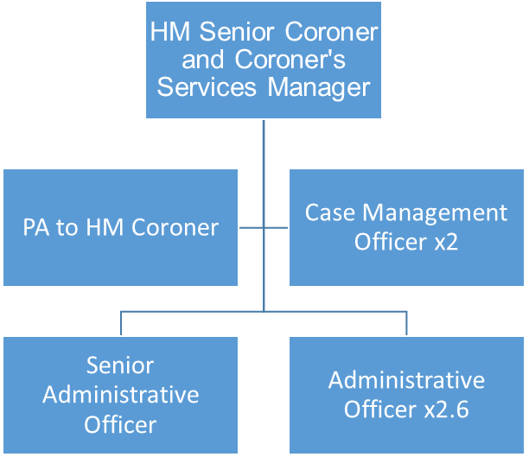

Special Knowledge Requirement. Will be used for shortlisting.
 |  |  | Essential
Applicants with disabilities are only required to meet the essential special knowledge requirements shown by a cross in the end column. |  |  | X
Due to the Governments Fluency in English Duty for posts where employees speak directly to members of the public the post holder is required to meet either the Lower threshold level – where the person is able to demonstrate that they can during the interview:  a) Can express themselves fluently and spontaneously, almost effortlessly  b) Only the requirement to explain difficult concepts simply hinders a natural smooth flow of language |  |  | X
Uses knowledge of Health, Safety and Environmental policies, procedures and regulations including risks in own area of  work |  |  | X
Uses a range of complex IT packages relating to area of work |  |  | X
Ability to adopt a process of continual improvement and suggest ways of  working more efficient and effectively to improve service delivery. |  |  | X
Knows and understands how to use, interpret, handle and communicate  information |  |  | X
Able to deal with highly sensitive, confidential and often distressing issues and evidence |  |  | X
Able to deal confidently and sympathetically with distressing and/or challenging situations, such as bereaved families |  |  | X
Enthusiastic and capable of working well under pressure |  |  | X
Able to work on own initiative, as well as being an active team player |  |  | X
Able to deal with internal and external customers both face to face and over the telephone. |  |  | X
Able to work flexibly to accommodate the needs of the service. |  |  | X
Relevant experience requirement: Will be used for shortlisting

The applicant is required to provide evidence of having previously spoken fluently to members of the public in order to meet either the Lower threshold or Advanced threshold level outlined under Special Knowledge above.
A minimum of 2 years office/administrative work including reception/telephone experience, preferably in a Coroner’s Service and provision of financial or management information via electronic systems.
Ability to demonstrate an awareness and commitment to the provision of a quality service and excellent customer care.
Significant experience of working in an administrative role, include regular use of Microsoft packages.
Relevant professional qualifications requirement: Will be used for shortlisting

GCSE in English grade A-C or equivalent e.g. CSE English Grade 1 or Adult Literacy Level 1, GCSE Maths grade A-C or equivalent e.g. CSE Maths Grade 1 or RSA Application of Number or Numeracy Stage ll or lll AND minimum RSA Stage 2 Typing or Word processing OR NVQ Level 2 in Business & Admin.
Previous experience
Previous experience of working in a Coronial or medical environment
Knowledge of the Coroners and Justice Act 2009 .
Core Employee competencies to be used at the interview stage.
Carries Out Performance Management
Covers the employee’s capacity to manage their workload and carry out a number of specific tasks accurately and to a high standard.
Communicates Effectively
Covers a range of spoken and written communication skills required as a regular feature of the job. It includes exchanging information/building relationships; giving advice and guidance; counselling, negotiating and persuading and handling private, confidential and sensitive information.
Carries Out Effective Decision Making
Covers a range of thinking skills required for taking initiative and independent actions within the scope of the job. It includes planning and organising, self effectiveness and any requirements to quality check work.
Undertakes Structured Problem Solving Activity
Covers a range of analytical skills required for gathering, collating and analysing the facts needed to solve problems. It includes creative and critical thinking; developing practical solutions; applying problem solving strategies and managing interpersonal relationships.
Operates with Dignity and Respect

Covers promoting equality, treating all people fairly and with dignity and respect, maintains impartiality/fairness with all people, is aware of the barriers people face.

Working Conditions:

Must be able to perform all duties and tasks with reasonable adjustment, where appropriate, in accordance with the Equality Act 2010 in relation to Disability Provisions.
Special Conditions:
You will be informed if there is a requirement for the post to have recruitment checks
such as DBS, Warner Process.
Compiled by:  Date: MM & MC | Grade Assessment Date: 13/05/2019 | Post Grade:  Band 6

