

Recruitment Pack

Learning Support Assistant

Contents
- Letter from the Headteacher
- Our School
- Job Advertisement
- Job Description
- Person Specification

Introduction from the Headteacher
Dear Candidate,
Thank you for your interest in the position of Learning Support Assistant at St. Stephen’s CE Primary School.
I am delighted that you have taken the opportunity to consider joining our hardworking and dedicated staff team.
St Stephen’s is a popular and thriving voluntary aided church school in the West Bowling area of Bradford where parents, staff and governors work closely together as a school family to make sure that all pupils have a positive experience and achieve their full potential.
Our ethos builds on the Church of England foundation of the school, promoting the belief that every individual has the right to be nurtured so that they can grow and flourish in their lives.
The dedicated staff team at St Stephen's provide a wide range of lessons and activities in order to enhance learning. We work hard to make sure that all our pupils, regardless of gender, class, additional support need, religion or ethnic heritage have equal access to a broad, balanced and differentiated curriculum and are provided with opportunities to develop their sense of self-worth, increase their self-esteem and grow in confidence.
Keeping our pupils safe is one of the most important aspects of our work and we take Safeguarding very seriously.
Please take the opportunity to enjoy exploring our website to find out more about our school community https://www.ststephens.bradford.sch.uk/
Visits to the school are strongly recommended and we invite all prospective candidates to make an appointment to visit our school. Please contact Louise Hurley louise.hurley@ststephens.bradford.sch.uk to arrange a visit.

Please do not hesitate to get in touch if you have any questions about our school.

Mr Paul Urry
Headteacher

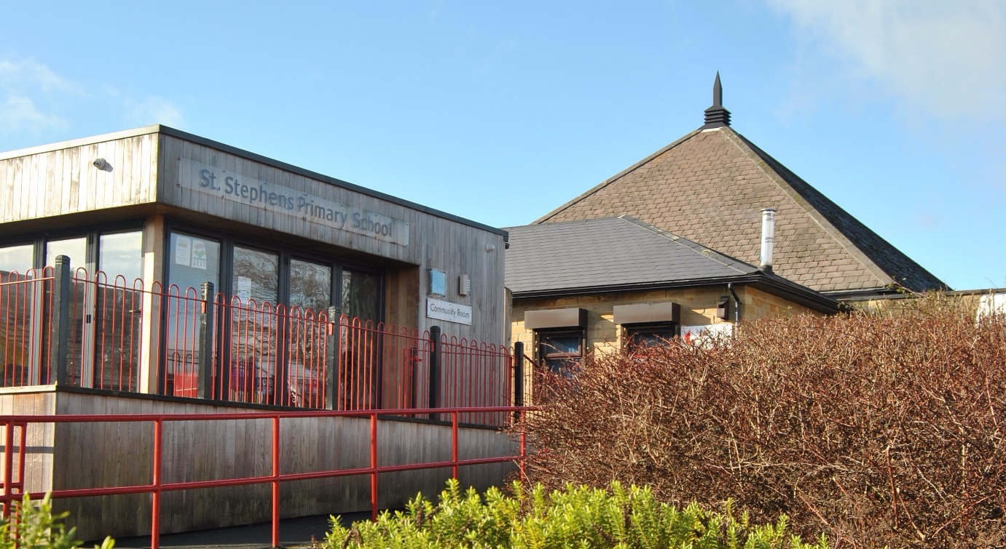

Our school
St. Stephen’s is a two-form entry primary school with a 60 place nursery based on a split site. We serve the community of West Bowling, which sits just outside the centre of Bradford.
We operate from five buildings – Nursery, Willow (Reception & KS1), Sycamore (KS2), The Orchard (community space) and our very own standalone Digital Den.
We currently have 455 pupils on role and our pupils come from a wide variety of backgrounds with 45% of our pupils being eligible for Free School Meals.
St. Stephen’s is at the heart of the local community and partnership is our watchword.
Our school is well-resourced with many staff, supporting learning and welfare.
To find out more about our school, please visit our school website, Tik Tok and Facebook pages.




Job Advertisement – Learning Support Assistant
(Full Time Temporary - maternity cover)
Pay: Band 4 - 5 TTO
8:30 – 15:30pm Monday to Friday
St. Stephen's is a Church of England school which serves a diverse community in West Bowling. Our pupils come from a wide range of backgrounds and abilities, they are enthusiastic learners who deserve and respond to the best.
We are a vibrant, creative and aspirational school with a team of hard working and highly skilled staff and governors. We are looking to appoint experienced Learning Support Assistants to support in class and possibly specific children with Education Health and Care Plans and complex special educational needs, within the class.
You will provide educational and/or medical support to ensure the pupils successful engagement with and access to quality learning.
The role will involve one-to-one and class-based support.

We are looking for candidates who are:
· Hardworking
· Playful at heart
· Kind, supportive and patient when supporting children with behavioural difficulties
· Have some relevant skills and experience working with children with additional needs
· Keen to further their skills by accessing training and CPD
· Can work effectively as part of a team
We can offer:
· Positive working relationships with a motivated and hard-working staff team
· A commitment to your on-going professional development
· Children keen to learn with supportive families
· A hard-working and professional school environment

Visits to the school are strongly encouraged and individual times can be arranged by contacting Louise Hurley, School Business Manager on 01274 731698 or louise.hurley@ststephens.bradford.sch.uk
Closing Date: Friday 5th December 2025 12 noon
Interviews will be held in person and all shortlisted candidates with be notified by email.
St. Stephen's CE Primary School is committed to safeguarding and promoting the welfare of our pupils and we expect all prospective candidates to share this commitment. All candidates are subject to an Enhanced DBS Check and recruitment checks satisfactory to the school.
Please note that in line with Keeping Children Safe in Education 2025, an online search will be undertaken on all shortlisted candidates.
Please also note that CVs are not accepted for this post.

OUTLINE JOB DESCRIPTION
GENERIC INTRODUCTION:

The following information is furnished to assist staff joining the School to understand and appreciate the work content of their post and the role they are to play in the organisation. The following points should be noted:

- Whilst every endeavour has been made to outline the main duties and responsibilities of the post, a document such as this does not permit every item to be specified in detail. Broad headings, therefore, may have been used below, in which case all the usual associated routines are naturally included in the job profile.

- Employees should not refuse to undertake work, which is not specified on this form, but they should record any additional duties they are required to perform and these will be taken into account when the post is reviewed.

- St. Stephen’s C.E Primary School is an Equal Opportunities Employer and requires its employees to comply with all current equality policies in terms of equal opportunity for employment.

- St. Stephen’s C.E Primary School is committed, where possible, to making any necessary reasonable adjustments to the job role and the working environment that would enable access to employment opportunities for disabled job applicants or continued employment for any employee who develops a disabling condition.

PRIME OBJECTIVES OF THE POST:
To complement, appreciate and support the role of teachers and other professionals by undertaking work/care/support programmes which enables access to learning in the community as part of a teacher planned approach.

To support the class teacher in the management of pupils in the classroom, and other senior staff on a range of teaching and learning experiences which deliver an appropriately differentiated and suitably challenging creative curriculum for all pupils whilst meeting statutory requirements.

Work within school policies and procedures under the direction and guidance of senior staff and within an agreed system of supervision.
May from time to time be required to undertake other duties commensurate with the grade and level of responsibility defined in this job description.

KNOWLEDGE AND SKILLS:
(See Personnel Specification)

EFFORT DEMANDS:
- Will assist in maintaining the good discipline of pupils throughout school and be expected to use good common sense, as well as use initiative in all matters relating to the conduct and behaviour of individual pupils, groups of pupils and whole classes, the safety, mobility (if required), hygiene and wellbeing of the pupils; making decisions within established working practices and procedures.

- Will recognise and challenge any incidents of racism, bullying, harassment, victimisation and any form of abuse of equal opportunities, ensuring compliance with the relevant school policy and procedures.

- Will deal with any issues, immediate problems or emergencies that arise in line with school policies and procedures liaising with colleagues where necessary e.g. dealing with a sick, injured or distressed child.

- Acting as a role model, will establish productive and constructive working relationships with pupils, setting high expectations, motivating and interacting with them, being aware of their individual needs, supporting difference and ensuring all pupils have equal access to opportunities to learn and develop whilst responding appropriately.

- Will have the ability to cope with the requirements of the post, which may include working with pupils who have emotional/behavioural/physical/medical difficulties.

- Will contribute to the overall ethos/work/aims of the school.

- Will appreciate and support the role of other professionals.

- Be vigilant and sensitive to any child protection/safeguarding concerns that arise, reporting any concerns to the Designated Safeguarding Lead in line with school policy and procedure.

RESPONSIBILITIES:
- Assist in the management of pupils in the learning environment.

- Assist in the planning of learning activities.

- Undertake structured and agreed learning activities/teaching programmes appropriate to the pupil’s needs to ensure physical, social, emotional and intellectual development, taking into account diversity e.g. language, culture, ability, race and religion.

- Will supervise and support pupils consistently at all times; recognising, responding and meeting the individual and physical needs of each child whilst ensuring their safety and education in the learning environment.

- Assist with the development and implementation of Education Health and Care Plans (EHCP), Individual Education Plans, and Personal Care Programmes; attending to the pupils’ personal needs and maintaining related personal programmes with the correct use of care materials including the safety and wellbeing of the pupils, therapy and medical intervention needs of the pupil and first aid, paying attention to social, health, physical and welfare matters as well as high standards of cleanliness and hygiene e.g. washing, dressing, toileting (including intimate care if appropriate), and, if applicable, mobility.

- For posts working with pupils who are physically less able, it may be necessary to be able to physically assist the pupil in line with school polices and good practice.

- Will occasionally be required to supervise the class for brief periods during a morning or afternoon session where the classroom teacher is not available.

- Promote and reinforce the inclusion, acceptance and integration of all pupils, including those from different cultures and/or with a different first language as appropriate.

- Set challenging and demanding expectations whilst promoting self-esteem and encouraging pupils to act independently as appropriate as well as interact and work co-operatively with others and engage in activities led by the teacher.

- Will prepare, create and maintain a purposeful, orderly and supportive learning environment to meet the lesson plans. Take responsibility for the care, preparation, maintenance and use of relevant equipment, assisting pupils in its use and clearing/storage afterwards.

- Will be aware of pupil progress, monitor/record pupil responses against pre-determined learning objectives as well as provide accurate, constructive and detailed feedback/reports to the teacher and pupils.

- Promote positive values, attitudes and good pupil behaviour and encourage pupils to take responsibility for their own actions whilst supporting the teacher in managing this. Deal promptly with conflict and incidents (including those involving restraint) and reporting challenging behaviour where appropriate in line with established policy.

- Will gather/report information from/to parents/carers as directed, taking into account parental/carer concerns, dealing with them sensitively under the direction of the teacher.

- Will provide clerical/administrative support as directed by the teacher.

- Will support pupils in the use of ICT in learning activities as directed by the teacher, and develop pupils competence and independence in its use.

- Will participate in own performance development, identify and address any training needs/other learning activities.

- Will assist with the supervision of pupils out of lesson times, including before and after school and at lunchtimes, accompanying teaching staff and pupils on visits, trips and out of school activities; taking responsibility for a group under the supervision of the teacher.

- Will assist in the supervision of students on work experience, trainees and voluntary helpers.

ENVIRONMENTAL DEMANDS/WORKING CONDITIONS:
- Will have long periods of sitting or standing.

- Available to work during school hours during term time and a willingness to be flexible as may be required to attend staff meetings/training sessions outside of usual hours.

- Will have contact with members of the public/other professionals e.g. teaching staff, governors, parents/carers, community groups, local education authority, external providers etc.

- This post may include duties which require specific training such as First Aid or Positive Handling and will be provided by the school where necessary.

- The post holder may occasionally be subjected to antisocial behaviour from members of the public/parents/site users.

- This post may include a degree of manual lifting and handling. You are expected to be aware of health and safety policies and procedures and frequently assess your ability to carry out the lifting tasks required of you.

- Report all concerns to an appropriate person.

FLUENCY DUTY
In line with the Immigration Act 2016; the Government has created a duty to ensure that all Public Authority staff working in customer facing roles can speak fluent English to an appropriate standard.
For this role the post holder is required to meet the Intermediate Threshold Level
Intermediate Threshold Level
The post holder should demonstrate:
- They can express themselves fluently and spontaneously with minimal effort and,
- Only the requirement to explain difficult concepts may hinder a natural smooth flow of language.

SPECIAL CONDITIONS OF SERVICE:
- No contra-indications in personal background or criminal record indicating unsuitability to work with children/young people/vulnerable clients/finance (An enhanced DBS check is required).

OTHER CONSIDERATIONS
- To be aware of and comply with policies and procedures relating to child protection; being vigilant for signs that children may be being abused and to report any such suspicions to the school’s Designated safeguarding Lead or the Headteacher.

- To act in accordance with the Data Protection Act and maintain confidentiality at all times e.g. access to staff/student/parent and carers files.

- Accept and commit to the principles underlying the Schools Equal Rights policies and practices.

- Be able to perform all duties and tasks with reasonable adjustments, where appropriate, in accordance with the Equality Act.

- Must be legally entitled to work in the UK.

PERSONNEL SPECIFICATION:

 | ESSENTIAL (E)/DESIRABLE (D)
EXPERIENCE: | - Experience of working in a team situation (E)  - Experience of working with pupils who have special needs (E)  - Experience of working with or caring for children of relevant age e.g. voluntary organisation or parental/caring responsibilities (E)  - Provide evidence of having previously spoken fluently to customers at an Intermediate Threshold Level (E)  - Experience of supporting children with behavioural difficulties or Social, Emotional & Mental Health needs, or Communication and Interaction needs including autism (D)
QUALIFICATIONS/  TRAINING: | - GCSE English and Maths or equivalent e.g. Adult Literacy/Numeracy at level 1 (E)  - Other relevant qualifications relating to the post e.g. Level 2 NVQ in Health/Childcare, first aid qualification (D)  - Evidence of further training/development and/or willingness to participate in further training and development opportunities e.g. Team Teach, Moving & Handling, Special Educational Needs (D)
KNOWLEDGE/ SKILLS: | - Will possess knowledge of the School’s relevant procedures or practices (D)  - Will have an outline understanding of relevant legislation (E)  - Will have knowledge of some of the policies covering their service area (E)  - Problem solving skills (E)  - Good communication skills (E)  - Exercising advisory, guiding, negotiating and persuasive skills at a developed level (D)  - Good numeracy/literacy skills (E)  - Basic ICT skills (E)  - An understanding of the needs of a multicultural society (E)  - An understanding of the issues relating to pupils who have additional learning needs, more able and special educational needs (E)  - Knowledge of childcare (D)  - Awareness of child development (D)  - Knowledge and commitment to schools Equality policy (E)  - Ability to relate well to pupils and adults (E)  - Ability to work constructively as part of a team (E)  - Ability to remain calm under pressure (E)  - Demonstrate a commitment to working with children of the relevant age (E)  - Demonstrate good co-operative, interpersonal and effective listening skills (E)  - Maintain confidentiality in matters relating to the school, its pupils, parents or carers (E)  - Ability to perform all duties and tasks with reasonable adjustments where necessary (E)  - Ability to cope with the requirements of the post, which will include working with pupils who have emotional/ behavioural/physical difficulties (E)  - In line with the Immigration Act 2016; you should be able to demonstrate fluency of the English Language at an Intermediate Threshold Level (E)

