A message from our Headteacher

Dear Candidate,

Post: Class Teacher

I would like to thank you for showing an interest in the teaching opportunities at our school. We are looking for teachers who are inspired by working with children!

We offer a fantastic and supportive environment for you to learn and grow your career, whether you are an Early Careers Teacher or have more experience in teaching. In return we want to appoint candidates who share our ethos and would relish the opportunity to shine in a progressive and exciting school.

As a Headteacher, I firmly believe that every moment matters! Our job is to provide an engaging and exciting curriculum for all our children; it is to develop their literacy and numeracy skills so they can be successful in later life and it is to work hard with parents and our local community to raise aspirations for all.

I am very excited about the opportunity to develop and strengthen our existing team, to give people opportunities to grow and develop valuable experience which will benefit you and our setting. If you want to see more of our day to day life in school, you can see us on our website, or X using the handle @BGGSchool.

Our Academy is a member of Bradford Diocesan Academies Trust (BDAT), which means all our schools and employees can access great support from an experienced and caring Trust. There is more information about BDAT later in this pack.

Everyone can achieve at Lady Royd Primary School and through working in partnership we can create many magical memories.

Please contact our office team on 01274 545 395 to make an appointment to see our school at work.
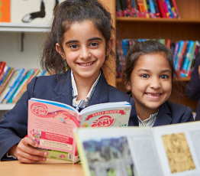

Yours sincerely

Chris Tolson
Headteacher

