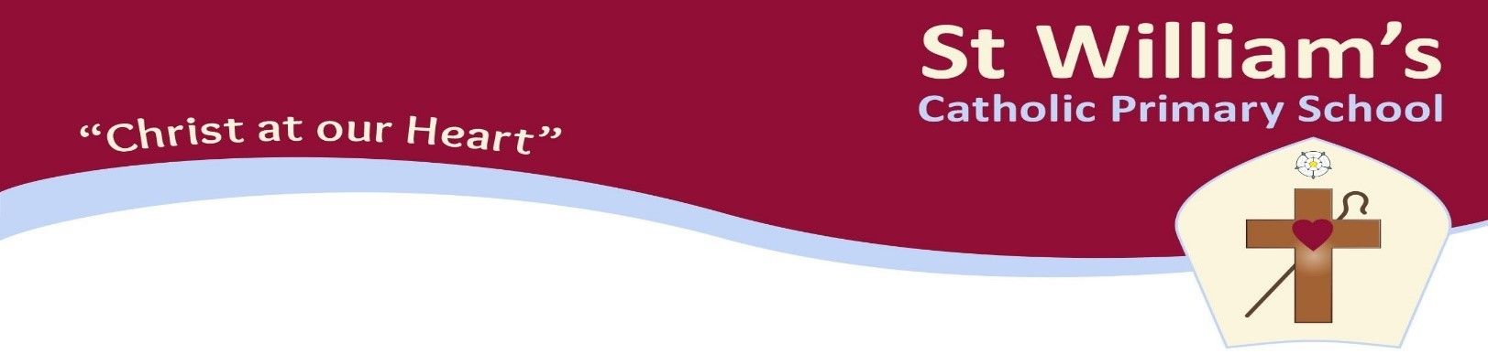

St William’s Catholic Primary School

Class Teacher
Recruitment Information for Applicants November 2019

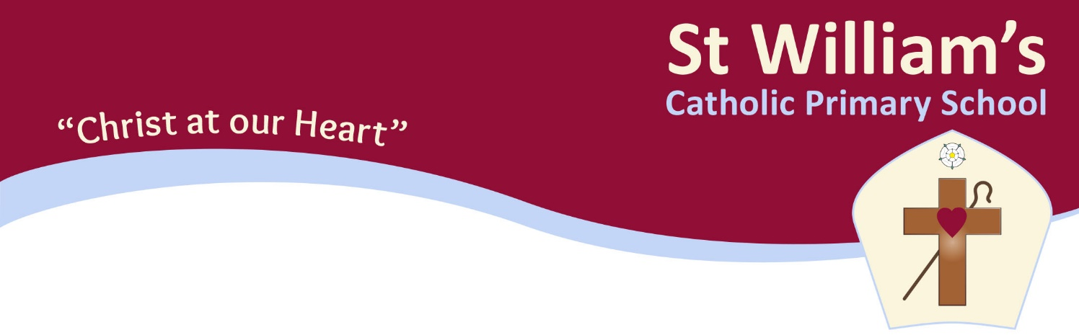

Consultant Head: Mrs Janet Keefe
Head of School: Miss Fiona Parker
Address: Young Street, Bradford, West Yorkshire, BD8 9RG
Tel/Fax: 01274 545743
Website: www.stwilliamsbradford.org.uk
E-mail: office@stwilliams.bradford.sch.uk

Class Teacher – full time permanent position
required for January 2020.

The Governors of St. William’s are looking to appoint an enthusiastic and committed teacher to join our inclusive and happy school.

Applications from experienced and Newly Qualified Teachers are welcome. Experience of Year 2 and 3 desirable but not essential.

We are looking for a teacher who:
- is committed to upholding the Catholic ethos of our school
- has high expectations of children’s attainment and behaviour
- is passionate about the education of all children
- is a highly effective classroom teacher who cares deeply about children’s learning

We can offer:
- high quality CPD to support your development
- enthusiastic, confident and well behaved children
- the opportunity to make a real difference
- a positive and caring school environment

If you are an effective and highly motivated teacher we would love to hear from you. We will provide you with a supportive environment where you will be valued and respected.

St. William’s is a one form entry school, with a friendly and welcoming environment.

If you think St William’s is the place for you, we would like to hear from you.

Visits to the school are welcomed and encouraged please contact the school office.

Application forms and further details are available from the school office – telephone 01274 545743 or e-mail office@stwilliams.bradford.sch.uk

Only applications submitted on Catholic Education Service forms will be accepted.

Closing date: 8am Friday 22 November 2019
Interviews to be held: Thursday 28 November 2019

The Governing Body is committed to safeguarding and promoting the welfare of children.
The post is subject to an Enhanced D.B.S. check and references.

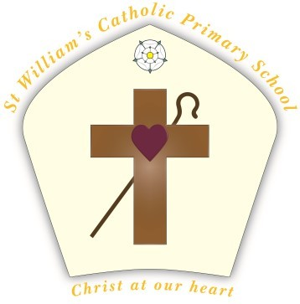
Our School

Our Mission Statement

The community of St William’s Catholic Primary School uses the Gospel values to provide a loving, caring and safe learning environment.

We celebrate and welcome our rich and diverse community, recognising we are all special in the eyes of God.

Working in partnership with parents and the wider community, we provide effective learning that is positive and challenging.

RE and Catholic Life
As a voluntary aided Catholic School the religious ethos is to be found across the whole curriculum and not just within the RE timetable.
The whole aim of the school is the Christian growth of the children, not simply their growth in Faith but their growing awareness of the world as a maturing Christian.
The school will foster in children respect for the value of their own culture and the culture of others and help them to live harmoniously in society.
Racism and racial prejudice will be challenged with positive attitudes.
As a Catholic school there is a consensus among parents about our basic values and therefore it is the norm that all children take part in Religious Education and collective worship.

Catholic Schools Partnership Teaching Schools Alliance
St William's are proud to be part of the Catholic Schools Partnership of Bradford & Keighley, a Teaching School Alliance since 2014 – a passionate partnership of 20 Catholic schools committed to sharing talent, faith, experience, leadership and excellent teaching to improve achievement in schools across Bradford, Keighley and beyond.

Our School: Words from our children…..

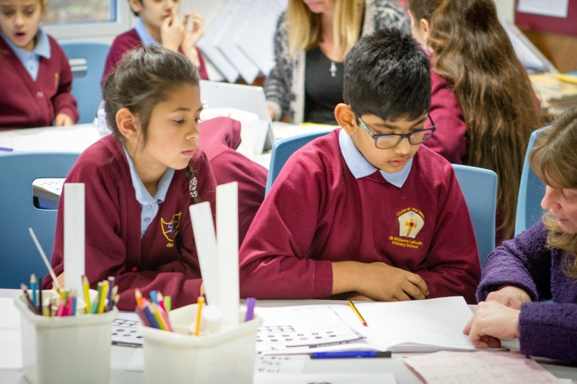  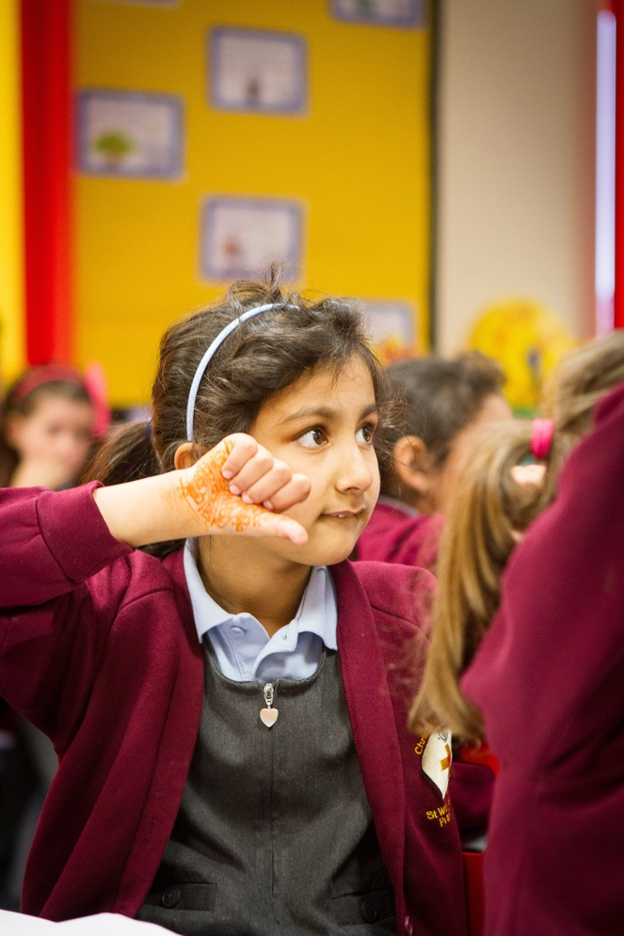 | Our active school council represents pupils who have been taught to see opportunities and develop their resilience. A good teacher for them is someone who is approachable, understanding and clever. Our school is also a happy place, so they would like our new teacher to embody that by putting trust in them and be friendly. They also want a teacher who makes sure they do the right things, keeps them safe and treats them equally.  Together with our families, we work closely to ensure our children feel safe, enthused in the classroom and are challenged in their learning. We believe our children are capable of achieving their full potential and will do our utmost to help them believe in their own abilities.

Our Catholic Ethos

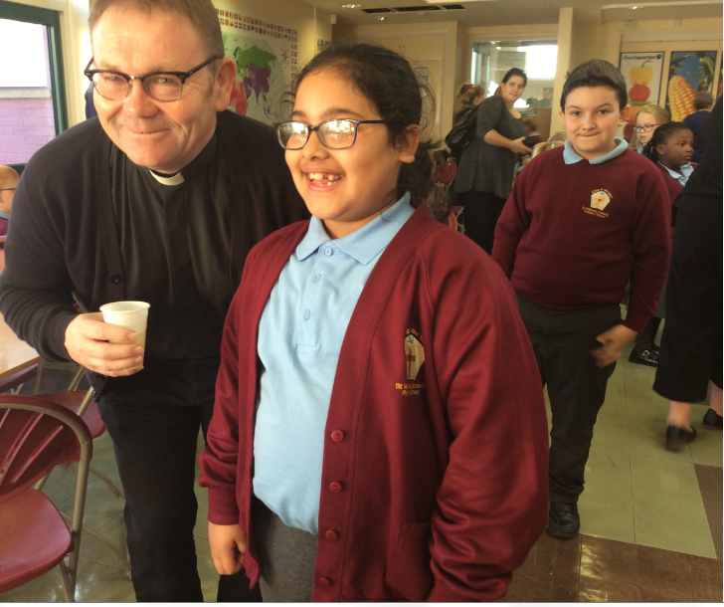  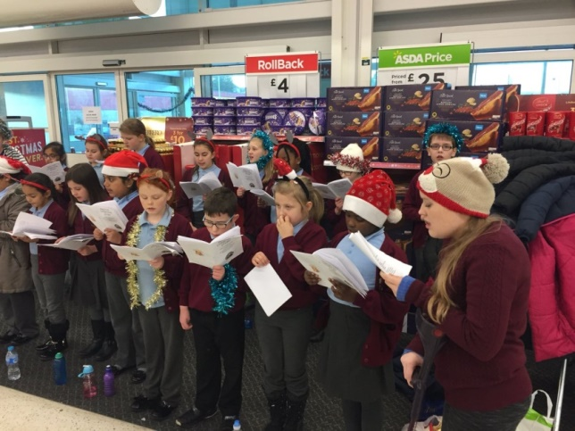 | We serve the families of the church of Our Lady of Lourdes and St William, within Bradford. Our school is part of the family of the Catholic Schools Partnership of Bradford and Keighley within the Diocese of Leeds and as such, prayer and worship play an important role in the life of the children and staff.  We work with Catholic Care to provide support for individuals and families.  Classes attend mass weekly in the church as well as a whole school at various times throughout the year.  Our Mini Vinnies group supports our prayer and liturgy in school.  Our school choir sings in local residential homes and in the community.

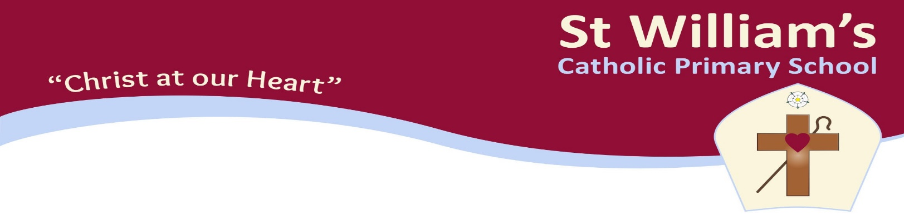

Headteacher: Miss Fiona Parker
Address: Young Street, Bradford, West Yorkshire, BD8 9RG
Tel/Fax: 01274 545743
Website: www.stwilliamsbradford.org.uk
E-mail: office@stwilliams.bradford.sch.uk

JOB DESCRIPTION

CLASS TEACHER – PAY SPINE POINT

PRINCIPAL RESPONSIBILITIES

1. To endeavour to maintain and develop the Catholic character of the school, in accordance with the directions
given by the Governors, subject to, the directions given by the Headteacher.

2. To carry out the professional duties of a teacher in accordance with directions given by the Governors, and
subject to, the directions given by the Headteacher. The professional duties are currently stipulated in the
Teachers Pay and Conditions Act. They are, of course, subject to such amendments as shall be made nationally
from time to time.

3. To exemplify the philosophy of the school, through good primary school practice in the classroom.

4. To teach children within the primary school age range, in the role of class teacher, as directed by the
Headteacher.

5. To work within all the policies of the school.

6. To establish and maintain a good educational ethos, including the control of storage, display and use of teaching
materials, books and resources relating to the class and curriculum responsibilities.

7. To carry out assessment and recording of pupil’s achievements and to plan work that is appropriate to the needs
of the pupil and enables them to make progress irrespective of their level of ability.

8. To work co-operatively with other colleagues as required including other schools.

9. To establish and maintain good relationships with parents and other agencies as required.

10. To supervise the work of any non-teaching staff allocated to work under your direction.

11. To prepare and deliver Key Stage and class assemblies/acts of worship/liturgies.

UPPER PAY SCALE

- To play a critical role in the life of the school.
- To provide a role model for teaching and learning.
- To make a distinctive contribution to the raising of pupil standards.
- To contribute effectively to the work of the wider team.
- To take advantage of appropriate opportunities for professional development and use the outcomes effectively to improve pupils’ learning.
- To continue to meet threshold standards.
- To continue to develop teaching expertise.

ST. WILLIAM’S CATHOLIC PRIMARY SCHOOL

PERSONNEL SPECIFICATION

POSITION TITLE - Class Teacher - Main Scale

SUMMARY OF JOB - To work as a part of a team of teachers
To be able to contribute to the development of the curriculum and ethos of the school

ATTRIBUTES | ESSENTIAL | DESIRABLE | HOW IDENTIFIED
QUALIFICATIONS | Teaching qualification  Degree | Any further professional qualification, which would indicate professional intentions.  Catholic Teaching Certificate | Application Form
EXPERIENCE | Teaching experience in a Primary School | Experience of working with other adults in the teaching situation. | Application Form  Interview  Referees
TRAINING | Teacher training course  National Curriculum requirements | Recent In-service work  ICT training | Application Form  Interview
SPECIAL KNOWLEDGE | To assess levels of learning and provide appropriate experiences.  To have an understanding of how children develop socially, emotionally, academically, expressively, physically.  How different parts of the curriculum contribute to the total development. | Expertise in one or more curriculum areas.  Knowledge of maths mastery approaches.  Curriculum planning for broad balanced curriculum.  Catholic Faith. | Interview  References
ATTRIBUTES | ESSENTIAL | DESIRABLE | HOW IDENTIFIED
PERSONAL  CIRCUMSTANCES | Allow for adequate preparation of work.  Allow availability for meetings out of teaching hours e.g. Staff, parents, special events re school.  Is in full sympathy of the Catholic Ethos and willing to take a full part in school life.  Able to contribute to the Catholic ethos of the school. | Practising Roman Catholic. | Interview  References
DISPOSITION  ADJUSTMENT  ATTITUDES | Relate well with children and adults.  Strongly self-motivating.  Adaptable and co-operative.  Work in the best interests of children.  Cheerful, positive, mature in outlook.  Sympathy with aims and ethos of a Catholic school, able to support them. Dependable. | Open-minded  Willing to be constructive part of the greater whole.  Sense of humour | Interview  References
PRACTICAL AND  INTELLECTUAL SKILLS | Ability to adapt to changing circumstances.  To portray and give confidence to children and adults.  To set high but attainable standards. | Ability to absorb new emphases in education and to select and implement appropriately.  Well organised  Able to use ICT for planning, teaching and administration | Interview  References
PHYSICAL | Good health physically and mentally.  General appearance acceptable to a wide range of persons including children, parents and colleagues.  Articulate. Good clear use of English.  Effective communication. Pleasant manner.  Genuinely interested in children. |  | Application Form  Interview

