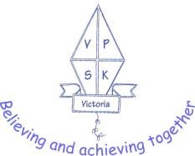
Victoria Primary School

Class Teacher

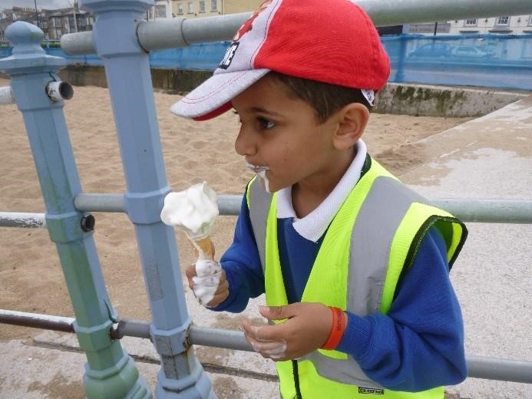 | 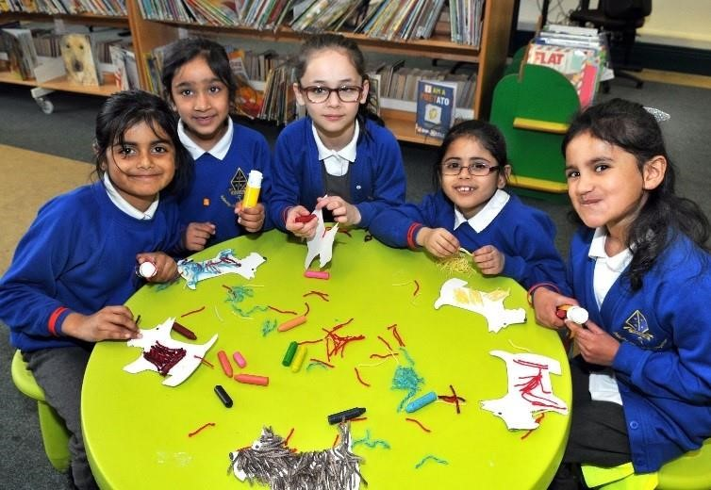 | 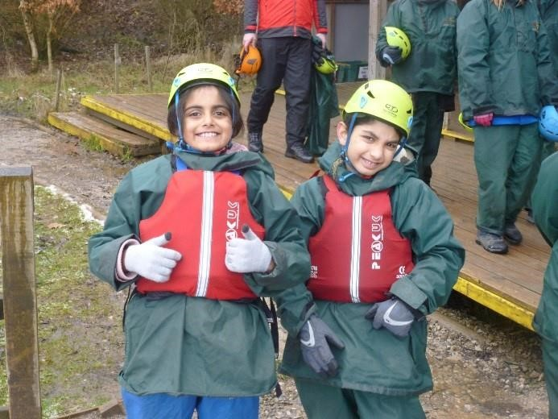
September 2019

Contents

Head Teacher’s Letter………….....………………………………………………………….….……………………………………………. Page 3

About Victoria Primary School ………………………………………………………………………………………………………………… Page 4

Person Specification …………………………………………………..…………………………………………………………………………… Page 6

Job Description.……………………………………….………………..…………………………………………………………………………… Page 8

How to Apply …………………………………………………………………………………………………………………………………………… Page 13

Enclosures

Application Form

Victoria Primary School

Dear Prospective Candidate,

On behalf of the Governing Body, staff and pupils of Victoria Primary, I would like to thank you for expressing an interest in the post.

Victoria Primary School is 1.5 form entry school. There are 296 pupils on roll full time and 40 part-time in our Nursery. We are proud of our school, particularly the good attendance and behaviour of our pupils as recognised by all. Our school effectively promotes celebration of diversity and actively seeks to develop strong partnerships with the wider community.

We are one of the founding schools of the Nurture Academies Trust which includes Victoria Primary, Denholme Primary, Parkwood Primary, Lapage Primary, Byron Primary and Fearnville Primary Schools. We converted to Academy Status on 1st January 2017.

We are a committed staff with a strong drive for school improvement. We are seeking a KS2 Class Teacher, who is an effective team player and can work using their own initiative.

Visits are warmly welcomed and are available by appointment. Please contact the school office on 01535 210110 to make an appointment.

We look forward to receiving your application.

Yours sincerely

J Dark

Mrs Jane Dark

Head teacher
About Victoria Primary School

Our Vision Statement

‘Believing and Achieving Together’
Victoria Primary School is a safe, caring and aspirational learning environment where everyone respects each other. We work in partnership to ensure each child achieves their full potential, has self-belief and is equipped for life.

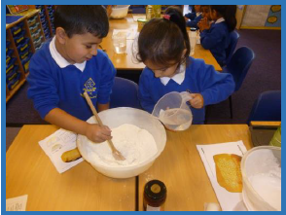  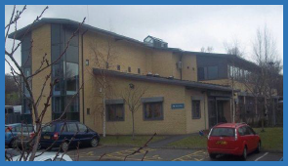 | Our Children  Our school serves a diverse community and includes children of Mirpuri Pakistani, Bangladeshi, African, White British and Eastern European heritage. For the majority of our pupils English is an additional language. Our children are well behaved and keen to learn.  Our Community  Victoria Primary is a popular school. There are good partnerships and high levels of engagement between parents and the community. We are committed to links with the local and wider communities of Keighley and beyond. We work closely with other local schools and with other schools in our Multi Academy Trust.  Our Building  We are a modern purpose built primary school with good indoor and outdoor facilities including a community room that can be used for a variety of purposes. In 2015/6 the school underwent a buildings programme to enlarge the capacity as we continue to increase to a 1.5 form entry school all through. Our Foundation Stage caters well for Nursery and Reception children.  Our Curriculum  Our school is committed to delivering a broad, balanced, creative and rich curriculum to provide quality education for all children. This is based on the National Curriculum and incorporates a wide range of visits and visitors to enhance learning. We have 2 minibuses that are well used and all classes go on at least one visit per half term.
Children learn most effectively through a well-planned, stimulating and challenging curriculum. The curriculum includes a variety of first hand experiences which bring areas of learning alive and really help the children to understand by touching, seeing and doing. Educational visits, visitors and well planned practical opportunities play a vital role in achieving this.  The majority of children’s learning focuses on a theme or topic for a block of time. Science, history or geography may be the main focus with links being made across other areas of the curriculum. English and mathematics are taught both separately and in a cross curricular way where appropriate.  Varied teaching strategies are used according to the learning situation and the needs of the children. The different ways children learn are taken into account when planning for learning. Children work individually, in pairs, in small and large groups and as a whole class.  Home learning tasks are set for children to support or prepare for the learning at school. Children have the opportunity to continue their learning on the school website at www.victoria.bradford.sch.uk  We have made significant changes to our provision in EYFS and have improved the outdoor learning environment for Reception and Nursery children. Access to outdoor learning is free-flow and children have a wide range of resources to enhance their learning. There is a strong team of staff in EYFS who are committed to improving experiences and outcomes for our children.  As the school continues to expand, we now have mixed age classes and are delivering the curriculum on a rolling programme from Y1 – Y6. This enables staff to plan collaboratively and support each other across the curriculum, helping to maintain a high quality of teaching and learning but minimise planning workload. |  | 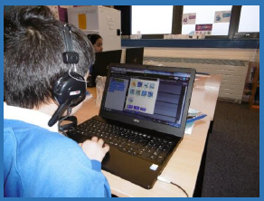  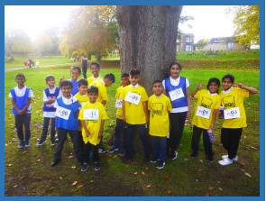  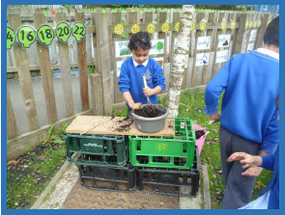

Person Specification – Class Teacher

Attributes | Essential | Desirable
Qualifications | - Qualified Teacher Status  - Degree  - Evidence of professional development/recent training  - ICT literate | - Any further professional qualification
Experience | - Recent experience in teaching in KS2 in a primary school  - Experience of effective curriculum planning and assessment  - Commitment to providing appropriate challenge and meeting the needs of all children including SEND and more able  - Experience of leading children on educational visits | - Relevant curriculum training  - Evidence of INSET  - Experience of varying classroom organisation  - Experience of leading a core subject in school  - Experience of working in KS1 and KS2
Knowledge and  Understanding | - Ability to provide an imaginative, interesting and stimulating learning  - environment  - Ability to use ICT effectively to enhance outcomes for children across the curriculum  - Knowledge of current national initiatives relating to the primary curriculum and assessment  - Knowledge of an appropriate range of teaching methods for the primary school  - Commitment to parental/community involvement  - Willingness to contribute fully to the life of the school, including support for extra-curricular activities | - Knowledge of how to make links in learning and develop a creative curriculum  - Knowledge of using online assessment tools
Practical/  Interpersonal/Intellectual  Skills | - An outstanding classroom practitioner – effectively fulfils all of the Teacher’s Standards  - Excellent communication skills at all levels  - Ability to foster good working relationships with parents, children and colleagues  - Ability to manage time and use initiative to solve problems  - Ability to work effectively as part of a team  - Positive behaviour management
Disposition/  Attitude | - Highly motivated and committed  - Ability to listen and value the opinion of others  - Good time management and able to work to deadlines  - Flexible, approachable and enthusiastic with a sense of humour  - Uses a variety of teaching and Learning strategies to engage the learner  - A commitment to raising standards  - Positive attitude towards continuous personal and professional development  - Commitment to a policy of Equal Opportunities and Inclusion
Personal  Circumstances | - Able to work in a flexible way which may involve out of school hours
Physical | - Be physically and mentally equipped to cope with the pressures and stresses of the post  - Present a professional image

Equal Rights
Our Trust / School is an equal rights employer. We require our governors and employees to follow our equality policies and to follow all statutory requirements concerning age, race, religious, sex, sexual orientation and disability discrimination. We respect and protect the rights of people with disabilities both in terms of equal opportunity for employment and access to the school's services.

Disabled Applicants
Disabled applicants are guaranteed an interview if they meet the essential requirements of the Personnel Specification. As an equal rights employer our school is committed to make any necessary reasonable adjustments to the selection process, the job role and the working environment that would enable access to employment opportunities for disabled people. Where a disabled applicant is being assessed the selection panel's decisions will be based on an assessment of that person's expected capabilities once reasonable adjustments have been made.

Job Description – Teacher

Victoria Primary School
General
To have responsibility as a Class Teacher and to lead on a subject (to be negotiated)
The job description should be read alongside the range of professional duties of teachers as set out in the relevant sections of the current Teachers’ Pay and Conditions Document. The post holder will be expected to undertake duties in line with the DfE Teacher’s Standards, at a level appropriate to their career stage, (refer to Victoria Primary School Career Stage expectations).
Principal responsibilities: Teaching and Learning
- To teach children within the Primary School age range in the role of class teacher as directed by the Headteacher
- To work within the curriculum policies of the school, with due regard to the requirements of the National Curriculum.
- To be responsible to the Headteacher through the school management structure.
- To maintain good classroom practice, including the control and use of teaching materials / resources / books relating to class and / or curriculum responsibilities.
- To create a purposeful and stimulating environment in which pupils feel independent, confident, secure and able to develop their potential.
- To be responsible, in the first instance, for the pastoral care, discipline and guidance of the pupils in your class working within relevant school policies and guidelines.
- To provide an inclusive environment which through effective planning, drawing on a range of teaching styles, supports and challenges all learners within the class.
- To assess pupil progress in line with the schools Assessment Policy and use this information to inform future planning.
- To set targets and record and monitor pupils’ progress on the school tracking system and use this information to set individual targets and maintain accurate records in accordance with the policies of the school.
- To identify children with Special Educational Needs and more able pupils and provide appropriate learning activities, with the support of the SEND Leader.
- Make appropriate contributions to the preparation, implementation, monitoring and review of progress and individual targets for pupils.
- To report to parents as required and to consult with parents regarding the educational/emotional needs and progress of their children.
- To plan and supervise the work of support staff and other adults as required and to supervise students as and when necessary.
- To participate in any Performance Management arrangements with regard to local and National guidelines / requirements.

Additional responsibilities
- To be involved in, and contribute to, curriculum development within the school.
- Responsibility for the learning environment other than their own class base, as designated by the Headteacher. This will include contributing to displays about agreed themes in other areas, for example, corridors.
- To attend staff meetings, planning sessions and INSET. To contribute to discussions as a member of the school team.
- Carry out any other duties as might reasonably be required by the Headteacher

Curriculum Responsibility
- To be responsible for co-ordinating a curriculum area throughout the school, or to be part of a curriculum team.
- To prepare and produce, in consultation with colleagues, resources required to support the development of the Creative Curriculum throughout the school and to evaluate and monitor the coverage of the National Curriculum skills progression
for the subject area.
- To monitor progress and evaluate standards, with colleagues, in the curriculum area.
- To develop and update subject policy within the cycle of policy reviews undertaken by Governors.
- To have an enthusiasm for the subject that motivates and supports other staff.

The information is furnished to help people considering joining this School / Nurture Academies Trust to understand and appreciate the work content of their post and the role they are to play in the organisation. However, the following points should be noted:
- Whilst every endeavour has been made to outline all the duties and responsibilities of the post, a document such as this does not permit every item to be specified in detail. Broad headings, therefore, may have been used below, in which case all the usual associated routines are naturally included in the job description.
- Officers should not refuse to undertake work, which is not specified on this form, but they should record any additional duties they are required to perform and these will be taken into account when the post is reviewed.
- This School / Trust is an Equal Opportunities Employer and requires its employees to comply with all current equality policies both in terms of equal opportunity for employment and access to the Council Services.

How to Apply

- If you wish to apply for this post, please complete the application form outlining how you meet the criteria on the job description and the attributes required in the person specification.

- You may supplement your application form with a supporting statement of no longer than two sides of A4. Your supporting statement should outline your reasons for applying for the post and give an indication of what you can offer the school.

- We would be grateful if you could provide details of any daytime and evening contact telephone numbers as well as your email address should you be called for interview.

- Completed applications should be sent to: admin@victoria.bradford.sch.uk

Contact details:
Victoria Primary School
Cartmel Road
Keighley
BD21 2RD
Please mark the envelope: Class Teacher
Key Dates
Closing Date: Friday 4th October 2019
Interviews: Week commencing Monday 7th October 2019
Visits: Visits to the schools are welcomed. Please contact the school on 01535 210110 to make an appointment.
Thank you for your interest in our post. We look forward to receiving your completed application. Business Manager

