

Recruitment Pack Administrator

Contents:
- Letter from the Headteacher
- Our school
- Job Advertisement
- Job Description
- Person Specification

Introduction from the Headteacher
Dear Candidate,
Thank you for your interest in the position of administrator at St. Stephen’s CE Primary School.
I am delighted that you have taken the opportunity to consider joining our hardworking and dedicated staff team.
St Stephen’s is a popular and thriving voluntary aided church school in the West Bowling area of Bradford where parents, staff and governors work closely together as a school family to make sure that all pupils have a positive experience and achieve their full potential.
Our ethos builds on the Church of England foundation of the school, promoting the belief that every individual has the right to be nurtured so that they can grow and flourish in their lives.
The dedicated staff team at St Stephen's provides a wide range of lessons and activities in order to enhance learning. We work hard to make sure that all our pupils, regardless of gender, class, additional support need, religion or ethnic heritage have equal access to a broad, balanced and differentiated curriculum, and are provided with opportunities to develop their sense of self-worth, increase their self-esteem and grow in confidence.
Keeping our pupils safe is one of the most important aspects of our work and we take Safeguarding very seriously.
Please take the opportunity to enjoy exploring our website to find out more about our school community https://www.ststephens.bradford.sch.uk/
Visits to the school are strongly recommended and we invite all prospective candidates to make an appointment to visit our school. Please contact Louise Hurley, School Business Manager, louise.hurley@ststephens.bradford.sch.uk to arrange a visit.

Please do not hesitate to get in touch if you have any questions about our school.

Mr Paul Urry
Headteacher

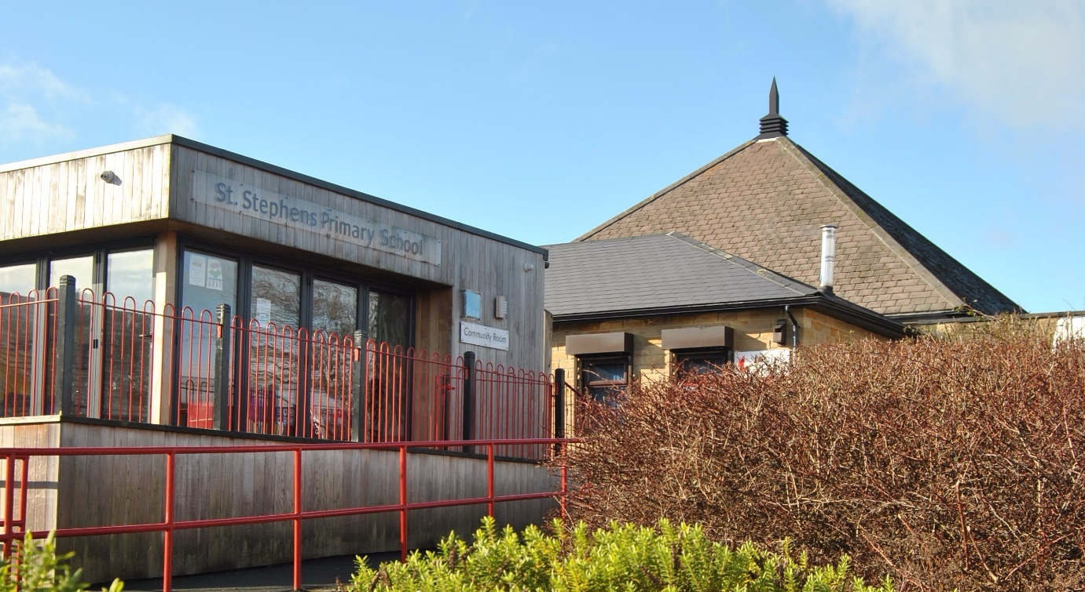

Our school
St. Stephen’s is a two-form entry primary school with a 60-place nursery based on a split site. We serve the community of West Bowling, which sits just outside the centre of Bradford.
We operate from five buildings – Nursery, Willow (EYFS & KS1), Sycamore (KS2), The Orchard (community space) and our very own standalone Digital Den.
We currently have 467 pupils on role and our pupils come from a wide variety of backgrounds with around 40% of our pupils being eligible for Pupil Premium.
St. Stephen’s is at the heart of the local community and partnership is our watchword.
Our school is well resourced with support staff who support learning. We are lucky to have our own woodlands team who support our most vulnerable children and those with additional needs.

To find out more about our school, please visit our school website, Facebook page and Twitter.

Job Advertisement

Administrator (Required to start Monday 8th June 2026)

Salary
Band 5
Temporary Maternity Cover, term time only
37 hours per week - hours of work to be negotiated.

Job Summary

The role of the administrator is a crucial role and is central to the successful running of our school. We are looking to recruit an experienced and skilled administrator to work in our busy school office.
The role will be challenging and varied therefore it is important that you have a good understanding of how a busy office operates.
If you are a highly motivated, committed and enthusiastic person, then we encourage you to apply for this job!

Job Information

St. Stephen’s Primary School is a vibrant, creative and aspirational school with a team of hard working and highly skilled staff and governors.
We are seeking to appoint a dedicated and organised individual who is a team player and will go the ‘extra mile’. The ideal applicant should be able to work effectively with all stakeholders to ensure the best outcomes for our pupils.
The successful applicant must be able to provide quality administrative support to the school and have a can-do attitude with a good sense of humour. Prior school administrative experience and an understanding of school information management systems such as Arbor or Access Finance is highly preferred for this role.
We can offer you an opportunity to further develop your skills, knowledge and practice in a caring, forward thinking and dynamic school. You will be supported by a visionary leadership team, talented teachers and support staff, an encouraging community and amazing children.
Key responsibilities of the post include:
- Providing administrative support to the school, including managing phone calls, emails, and visitors.
- Maintaining and updating school records
- Ensuring efficient communication links for parents/carers, staff and visitors
- Ensure a smooth operation of the school's front office and reception area.
We are looking for a candidate who:

- Has high expectations and a passion to raise standards
- Is creative and can contribute to the school’s overall vision and aims
- Is organised, has a keen eye for detail and is able to prioritise daily workloads
- Is able to demonstrate effective communication skills both verbal and written
- Has a flexible approach and the ability to use their initiative
- Can work effectively as part of a team developing strong working relationships with all stakeholders
- Is skilled in the use of computer systems including Word, Excel and Microsoft Outlook
- Has a good standard of English and Maths (GCSE Grade 5, Grades A- C or above or equivalent)
- Is willing and able to be part of a team of first aiders/fire wardens.

We can offer:
- A commitment to your on-going professional development, ensuring that you feel ready for the role.
- Children keen to learn with supportive families
- A hard-working and professional school environment
- A team of caring, hardworking and dedicated staff with a sense of humour who are committed to making the school the best it can be
- A supportive school that offers welfare as well as professional support to all employees.

If you are ready to take on this challenging and rewarding role as a School Administrator then please apply at https://prospectsonline.co.uk/

A visit to the school is strongly encouraged and individual times can be arranged by contacting Louise Hurley, School Business Manager on 01274 731698 or at louise.hurley@ststephens.bradford.sch.uk

Closing Date: 12 noon, Sunday 3rd May 2026. Shortlisted candidates will be notified by email.

St. Stephen's CE Primary School is committed to safeguarding and promoting the welfare of our pupils and we expect all prospective candidates to share this commitment. All candidates are subject to an Enhanced DBS Check and recruitment checks satisfactory to the school.
Please note: CVs are not accepted for this post.

JOB DESCRIPTION
Post Title: | Administrator
Payscale: | band 5

Generic Introduction:
The following information is furnished to assist staff joining the school to understand and appreciate the work content of their post and the role they are to play in the organisation. The following points should be noted:

- Whilst every endeavour has been made to outline the main duties and responsibilities of the post, a document such as this does not permit every item to be specified in detail. Broad headings, therefore, may have been used below, in which case all the usual associated routines are naturally included in the job profile.

- Employees should not refuse to undertake work, which is not specified on this form, but they should record any additional duties they are required to perform, and these will be taken into account when the post is reviewed.

- St. Stephen’s Primary School is an Equal Opportunities Employer and requires its employees to comply with all current equality policies both in terms of equal opportunity for employment and access to the Council Services.

- St. Stephen’s is committed, where possible, to making any necessary reasonable adjustments to the job role and the working environment that would enable access to employment opportunities for disabled job applicants or continued employment for any employee who develops a disabling condition.

Prime Objectives of the Post:

To assist in the provision of high quality professional, flexible, proficient and constructive clerical, administration, financial support and reception service to the school.

Responsible to the Business Manager and Headteacher from whom they will receive formal supervision and who will allocate work when necessary. However, much of the work is self-generating, and the post holder will be expected to work within established procedures and guidelines and to prioritise day-to-day work, referring only exceptional or complex queries to senior members of staff. In the absence of the Office Manager, the administrator would be expected to liaise with senior team members to ensure continuation of essential services.

To provide prompt and effective information, advice and access to services provided by the School to parents/carers, governors, community groups, members of the public and other agencies, dealing with requests for help and intervention, seeking guidance from and working in conjunction with senior/qualified professional staff on more complex requests. Undertaking and promoting the School to public and external agencies.

May from time to time be required to undertake other duties commensurate with the grade and level of responsibility defined in this job description.

Knowledge and Skills:

(See Personnel Specification)

Effort Demands:

- Will work under own initiative with minimum supervision, working to the priorities set by the Office/Business manager.

- Will contribute to the planning, development and organisation of systems/procedures/policies.

- Will make decisions regarding individual visitors/callers in terms of the advice and information provided, liaising with other staff within the school and assessing the level of urgency.

- Day to day decisions regarding the organisation of the working area/workload and school priorities.

- To participate in in-school training and other training programmes as required, and maintain personal and professional development in order to meet the changing demands of the post.

MAIN DUTIES AND Responsibilities:

ORGANISATION

- To give advice and guidance as appropriate, making decisions regarding individual visitors/callers in terms of the advice and information provided and using some judgement within established procedures and guidelines, liaising with other staff within the school and assessing the level of urgency

- Undertake reception duties, answering routine telephone and face-to-face enquiries and signing in visitors.

- Assisting with arrangements for visits by outside professionals such as the school nurse, photographer etc.

- Assist with pupil first aid/welfare duties, looking after sick pupils, liaising with parents/staff etc.

- Will contribute to the overall ethos/work/aims of the school and appreciate and support the role of other professionals

- Will ensure the highest standards of professional conduct and confidentiality at all times.

- Will present a positive personal image, contributing to a welcoming school environment, which supports equal opportunities for all, treating all users of the school with courtesy and consideration.

- Will cover the necessary duties of other admin team members in their absence.

ADMINISTRATION

- Provide routine clerical support e.g. record and circulate messages to other members of staff, photocopying, filing, scanning, faxing, emailing, complete routine forms, sort and distribute mail, ensuring supplies of internal forms are kept well stocked.

- Data inputting of computerised records/management information systems.

- Produce data/information/basic reports as required e.g. pupils’ data.

- Undertake typing, word-processing and other IT based tasks (letters, memos, minutes etc).

- Undertaking financial procedures including, but not limited to, raising purchase orders, checking delivery of orders, and banking.

- Undertake routine administration, e.g. registers, dinner registers

RESOURCES

- Responsible for the safe keeping of office equipment and secure storage of supplies.

- Operate office equipment e.g. photocopier, computer.

- Maintaining stock and supplies and prepare information to help in the processing of orders, checking delivery notes, cataloguing and distributing as required.

- Responsible in the collection and recording of school money and other routine financial administration.

OTHER

- Use good common sense and initiative in all matters relating to the conduct and behaviour of individuals, groups of pupils and whole classes; the correct use and care of materials by individual and small groups of pupils, the safety, mobility (if required) and hygiene and well being of the pupils.

- Assist with arrangements of school events/trips etc.

- Preparing refreshments and clearing away.

- Receiving and escorting visitors around the School.

- To be responsible for reporting building maintenance in accordance with health and safety requirements

environmental demands/Working Conditions:

- Available to work during school hours during term time and a willingness to be flexible as may be required to attend staff meetings/training sessions and INSET days outside of usual hours.

- Will have contact with members of the public/other professionals e.g. teaching staff, governors, parents/carers, community groups, local education authority, external providers etc.

- The post holder may occasionally be subjected to antisocial behaviour from members of the public/parents/site users.

Special Conditions of Service:

- No contra-indications in personal background or criminal record indicating unsuitability to work with children/young people/vulnerable clients/finance (An Enhanced DBS Check is required.)

Other considerations

- To be aware of and comply with policies and procedures relating to safeguarding; being vigilant for signs that children may be being abused and to report any such suspicions to the school’s nominated Designated Safeguarding Lead or Headteacher.
- To act in accordance with Data Protection Act principles and maintain confidentiality at all times.

- Be able to perform all duties and tasks with reasonable adjustment, where appropriate, in accordance with the Equality Act.

- Must be legally entitled to work in the UK.

Fluency Duty
In line with the Immigration Act 2016; the Government has created a duty to ensure that all Public Authority staff working in customer facing roles can speak fluent English to an appropriate standard.
For this role the post holder is required to meet the Intermediate Threshold Level
Intermediate Threshold Level
The post holder should demonstrate:
- They can express themselves fluently and spontaneously with minimal effort and,
- Only the requirement to explain difficult concepts may hinder a natural smooth flow of language.

PERSONNEL SPECIFICATION:

 | ESSENTIAL (E) /DESIRABLE (D)
Experience: | - Experience using Microsoft Office (E)  - Experience of working in an office environment (E)  - Experience of working in a team situation (E)  - Experience of School Information Management Systems (D)
Qualifications/  Training: | - GCSE English and Maths (A-C) or equivalent e.g. Adult Literacy/Numeracy at level 1 (E)  - Other relevant qualifications relating to the post (D)  - Evidence of further training/development and/or willingness to participate in further training and development opportunities (D)  - First Aid qualification or willingness to undertake training (D)
Knowledge/Skills | - Will possess knowledge of the School’s relevant procedures or practices. (E)  - Will have an outline understanding of relevant legislation. (E)  - Good communication skills both verbally and written including telephone skills. (E)  - Knowledge of and the ability to use office machinery e.g. photocopiers, scanners, shredding machine etc.(D)  - Working knowledge/use of databases and other software packages e.g. Microsoft Office (Word/Excel/Outlook etc.).(E)  - Knowledge of maintaining financial information systems and making payments.(D)  - Have a neat and organised approach to work.(E)  - Courteous and able to work both using your own initiative and in a team.(E)  - Detailed knowledge/experience of general office work (D)  - Will possess the ability to self-evaluate learning needs and actively seek learning opportunities. (E)  - Will possess the ability to relate well to children and adults. (E)  - Basic ICT skills. (E)  - An understanding of the needs of a multicultural society. (E)  - Ability to work constructively as part of a team. (E)  - Ability to remain calm under pressure. (E)  - Demonstrate good co-operative, interpersonal and effective listening skills. (E)  - Maintain confidentiality in matters relating to the school, its pupils, parents or carers. (E)  - Ability to perform all duties and tasks with reasonable adjustments where necessary. (E)  - Ability to cope with the requirements of the post. (E)  - In line with the Immigration Act 2016; you should be able to demonstrate fluency of the English Language at an Intermediate Threshold Level. (E)

