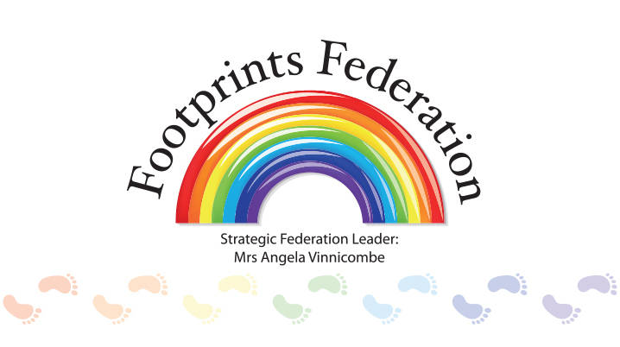
Ingrow, Long Lee and Glenaire Federation

Deputy Head Teacher - Glenaire
Lead as Assistant Head throughout the whole school, taking responsibility for Social Emotional and Mental Health needs of all children.
Leadership Scale – 7-11
Location –
The duties outlined in this document are in addition to those set out in the School Teachers’ Pay and Conditions Document. It may be modified by the Strategic Leader, with your agreement, to reflect or anticipate changes in the job, commensurate with the salary and the job title. In addition, you will be required to undertake any professional duties reasonably delegated to you by the Strategic Leader.
Key duties and responsibilities
- Take on the role of deputy headteacher at Glenaire as per teachers’ pay and conditions documents.
- In addition, lead across all schools in the spirit of the Footprints Federation core values, centred around teaching and Learning/ SEND/behaviour.
- Actively shape and contribute to the Inclusive ethos of our schools
- Ensure that the Federation’s vision and values are clearly articulated, shared, understood and acted upon by all
- Inspire and develop staff
- Be an outstanding role model for staff and children, promoting high expectations for all
- Participate, where appropriate, in the appointment of teaching and support staff
- Organise systems, timetables and routines
- Teach a class as required and demonstrate consistently excellent teaching
- Ensure the safety, welfare and well-being of children at all times
- Deputise for the Head Teacher at the substantive school and act in this capacity when required
Specific Responsibilities - Strategic direction and development of our schools
- Play an active role in leading the strategic development of Footprints Federation, including the implementation of an ambitious vision to develop us into outstanding schools
- Support the vision, ethos, and policies of our individual schools and promote high levels of achievement throughout schools for all groups
- Play a key role in the formation, implementation and evaluation of the School Improvement Plans at Glenaire.
- Assist the Headteachers in developing and implementing a programme of ongoing School Self-Evaluation
- Be committed to, and take an active role in promoting, membership of The Footprints Federation
- Identify emerging talents and aspiring leaders in a climate where excellence is the standard, leading to clear succession planning
- Take lead responsibility in achieving outstanding outcomes for all across the Federation.
- Support colleagues in the development and implementation of action plans and other policy developments and monitor their impact
- Contribute to the Federation’s programme for Continuing Professional Development, identifying appropriate opportunities and keeping accurate records of training and development undertaken by members of staff
- Review the performance of allocated members of staff
- Lead by example when implementing and managing initiatives
Leading Teaching and Learning
- Embed creative, responsive and reflective approaches to curriculum and teaching and learning
- In partnership with other members of the leadership team, monitor, evaluate and review the quality of teaching and learning and the wider curriculum
- Lead a continuous focus on pupils’ achievement using data and best practice research to monitor progress in every child’s learning
- Through effective feedback and support, including building on our culture of collaboration and action inquiry, develop our staff so that teaching and learning is consistently good and engaging for all children
- Ensure a continuous and consistent Federation-wide focus on children’s achievement using data, benchmarks and knowledge of the children to monitor progress
- Tackle under performance at all levels, offering targeted and focused support
- Through effective feedback and support, including building on our culture of collaboration and action inquiry, develop our staff so that leadership at all levels is effective
- Provide consistently exemplary teaching which demonstrates a reflective approach and inspires and motivates staff and children
- Maintain an awareness of curriculum developments, current research and maintain changes in government policy and how these affect primary education
- Encourage a culture and ethos of challenge and support, where all children and staff can achieve their best in a supportive environment
- Develop and maintain stimulating learning environments
Developing self and working with others
- Manage processes and systems for professional development of self and others
- Promote and maintain a culture of high expectations for self and others
- Regularly review own practice, set personal targets and take responsibility for own development
- Model a healthy approach to life work balance in all that you do
Safeguarding, Behaviour and Attendance
- Act as one of the Federation’s Designated Safeguarding Leads
- Demonstrate an active commitment to inclusion, positive relationships and behaviour management
- Promote high standards of achievement, behaviour, attendance and punctuality from all children, staff and families
- Monitor, evaluate and review current policy and practice
- Be a point of contact regarding serious behaviour issues and be committed to high standards of behaviour, using a range of strategies relevant to the individual child and family
- Work with colleagues to develop effective systems for monitoring pupil attendance and punctuality and implement initiatives to address these where necessary
- Organise and conduct meetings, where appropriate, with parents and carers to ensure positive outcomes for our children
Leadership and Management
- Work with the Headteacher on the ongoing development of an organisational structure which reflects the Federation’s values and enables effective and efficient daily operations
- Ensure evidence-based improvement plans and policies promote continuous school improvement and impact on raising standards
- Develop the Federation’s ethos of enabling everyone to work together collaboratively
- Work with the Governing Board so as to ensure that the Federation meets its statutory responsibilities
- Ensure every child has access to high quality teaching and learning
- Ensure the protection and welfare of all children and staff
- Assist, as a key member of the Senior Leadership Team, in the promotion of the Federation in its relationship with other schools, trusts and federations, supporting its future development in the process

