**Blakehill Primary School**

Recruitment Information Pack

**Administrative Assistant**

34 hours per week - Permanent - From October 2023

Band 5, SCP 4-6



**✶Together We Can✶**

**Timeline**

**Closing date for applications:** Friday 29th September 2023 – 9am

**Interviews taking place:** Week commencing 2nd October 2023

**Contents**

|  |  |
| --- | --- |
| Welcome letter | Page 3 |
| Blakehill’s Vision | Page 4 |
| Administrative Assistant Advert | Page 5 |
| Job Description | Page 6 |
| Personnel Specification | Page 10 |
| Safeguarding Statement | Page 11 |
| Selection Process Guidance | Page 12 |

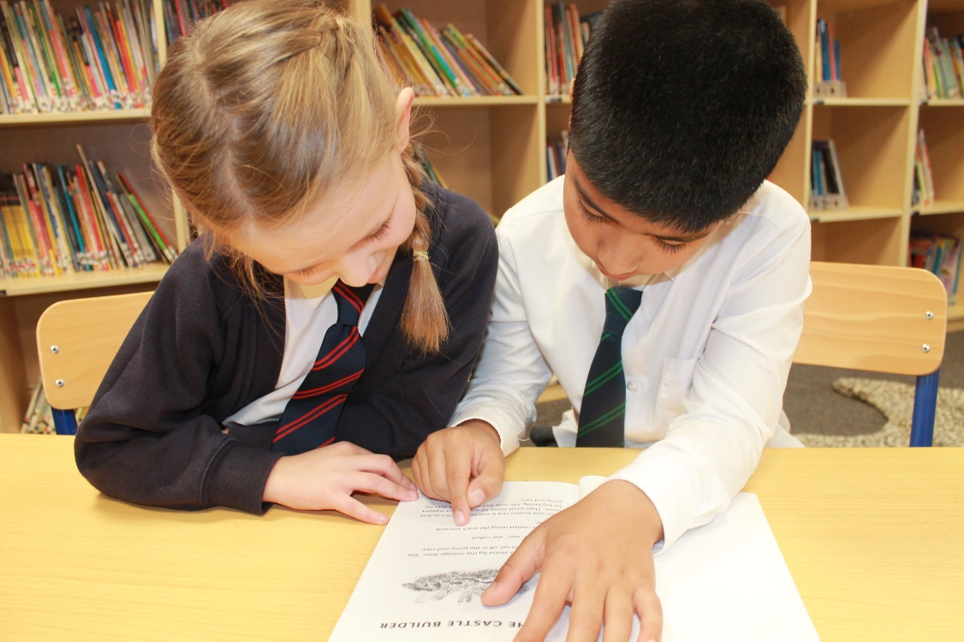

Dear candidate,

Thank you for your interest in the position of Administrative Assistant at our school. We are looking to recruit an outstanding administrative assistant to join us. This is a 34 hour, permanent post, to start October 2023.

Blakehill Primary School is a two form entry, successful school that provides and values positivity, achievement and teamwork. We create an exciting curriculum with an extensive range of learning opportunities, all of which makes Blakehill a fantastic place to work and learn.

The children are central to everything we think and do and the staff are uncompromising in their ambition to provide our pupils with the skills and knowledge they will need to lead successful and happy future lives.

Our school Mission Statement is **‘Together We Can.’**  This is paramount to the ethos of Blakehill Primary School where everyone shares the commitment of promoting the safeguarding, well-being and achievement of all our children.

In our latest **Ofsted Inspection (July 2022) we were graded GOOD with OUTSTANDING for pupil behaviour and welfare.**

‘Behaviour at Blakehill Primary is exceptional. Pupils are happy and safe. Relationships between staff and pupils are extremely positive. They feel valued by staff and pupils.’

‘Leaders have designed a highly effective curriculum for pupils’ personal, social and health education. Pupils are prepared well for life in Britain’

‘Staff are proud to work at Blakehill Primary School.’

We are fully committed to providing support, training and opportunities for career progression to all our staff and value the contribution that each and every one makes to the improvement and development of our school.

We are looking for an excellent administrative assistant who can be creative in their work and contribute to the continuing development of Blakehill Primary School. Passion, drive and commitment are key factors in the staff team at Blakehill.

We welcome you to visit us to gain a fuller insight into our school.

Please ring to arrange an appointment or to request further information.

We look forward to hearing from you.

Mrs Lisa Keighley

Headteacher

#### **WELCOME TO BLAKEHILL PRIMARY SCHOOL**



Staff, governors, pupils and their parents are very proud of our school. There is a strong culture of shared values and cooperation at Blakehill. We understand and embrace teamwork, create trust, maintain focus and, most importantly, understand the importance of people and relationships to our mission of success.

Because we put people first, everyone at school feels valued allowing us to focus on and provide a quality of education that enables pupils to thrive.

Our pupils and staff are central to all that we think and do at Blakehill and by listening to our school community, we are able to shape pupils’ learning journeys and provide experiences that capture their interests and needs.

**Vision and Ethos**

We are uncompromising in our vision for excellence and enjoyment for all pupils in all areas of the curriculum across school, to ensure that our children have the skills, knowledge, attitudes and values to lead successful lives both now and in the future.

This vision is under pinned by:

* Staff that have an unwavering commitment to the school and its pupils and are equipped to provide a high quality education.
* A curriculum that is shaped by listening to our pupils, their parents, staff and governors.
* An embedded culture and practice of our school ethos.
* School leaders that are relentless in their ambition to provide the best possible education for its pupils.
* A school community that is fully supportive and proud of the school.





**School Administrative Assistant**

**Permanent Contract: 34 hours per week, term time only**

**Band 5, SCP 4-6**

**Required to start Monday 30th October 2023**

We are seeking to appoint an enthusiastic, self-motivated and experienced Administrator to join our team here at Blakehill Primary School. We are keen to hear from individuals who will support our aims and ethos and who are willing to work as part of a friendly team.

The ideal candidate will be well organised with good communication and IT skills and have previous experience of working in a school office/customer service environment.

Previous experience of financial accounting and Information Management systems would be advantageous but not essential.

**The successful candidate should have experience of;**

* Day to day finance operations
* General administrative duties
* Accurate data management and reporting to Department of Educations
* Providing front-of-house service to pupils, parents, visitors and staff
* Using own initiative and working with limited supervision

**The successful candidate will need:**

* High standards of English and Maths (minimum GCSE ‘C’ grade or equivalent). Please note this is an essential part of the criteria and we are unable to consider your application if you do not fulfil this requirement
* Willingness to undertake first aid and other training if required

**We offer:**

* A dedicated and experienced staff team, supported by Governors and parents
* Enthusiastic, confident and well-behaved children
* An opportunity to make a significant contribution to our ongoing improvements
* An opportunity to further your professional development
* An opportunity to work in a school that is going places

**Closing date: Friday 29th September 2023 – 9am**

**Interviews to be held: Week commencing 2nd October 2023**

Interested candidates are requested to apply online for this post. To download the job details and apply, please visit [www.prospectsonline.co.uk](http://www.prospectsonline.co.uk) or contact the School Business Manager, Vicky Scott via the school office. Email: office@blakehill.bradford.sch.uk or telephone 01274 414355.

*Blakehill Primary School is committed to safeguarding and promoting the welfare of all our children. All posts are subject to an Enhanced DBS check and references. Proof of eligibility to work in the UK will be required*

Applicants will be subject to an online search if shortlisted.

Proof of eligibility to work in the UK will be required.

Please note: CVs are not accepted for this post.

**Job Description**

|  |  |
| --- | --- |
| Post Title | KS1 Class Teacher |
| School | Blakehill Primary School |
| Pay grade | Band 5, SCP 4-6 |

**Generic Introduction:**

The following information is furnished to assist staff joining the School to understand and appreciate the work content of their post and the role they are to play in the organisation. The following points should be noted:

1. Whilst every endeavour has been made to outline the main duties and responsibilities of the post, a document such as this does not permit every item to be specified in detail. Broad headings, therefore, may have been used below, in which case all the usual associated routines are naturally included in the job profile.
2. Employees should not refuse to undertake work, which is not specified on this form, but they should record any additional duties they are required to perform and these will be taken into account when the post is reviewed.
3. This school is an Equal Opportunities Employer and requires its employees to comply with all current equality policies in terms of equal opportunity for employment.
4. This school is committed, where possible, to making any necessary reasonable adjustments to the job role and the working environment that would enable access to employment opportunities for disabled job applicants or continued employment for any employee who develops a disabling condition.

**Prime Objectives of the Post:**

To assist in the provision of high quality professional, flexible, proficient and constructive clerical, administration, financial support and reception service to the school.

Responsible to the Office Manager/Headteacher from whom they will receive formal supervision and who will allocate work when necessary. However, much of the work is self-generating, and the post holder will be expected to work within established procedures and guidelines and to prioritise day-to-day work, referring only exceptional or complex queries to senior members of staff. In the absence of the Office Manager would be expected to liaise with senior team members to ensure continuation of essential services.

To provide prompt and effective information, advice and access to services provided by the School to parents/carers, governors, community groups, members of the public and other agencies, dealing with requests for help and intervention, seeking guidance from and working in conjunction with senior/qualified professional staff on more complex requests. Undertaking and promoting the School to public and external agencies.

May from time to time be required to undertake other duties commensurate with the grade and level of responsibility defined in this job description.

**Knowledge and Skills:**

*(See Personnel Specification)*

**Effort Demands:**

* Will work under supervision and on occasion under own initiative, working to the priorities set by the Office Manager/Headteacher.
* To contribute to the overall ethos/work/aims of the school.
* Will make decisions regarding individual visitors/callers in terms of the advice and information provided, liaising with other staff within the school and assessing the level of urgency.
* Day to day decisions regarding the organisation of the working area/workload and school priorities.
* To participate in in-school training and other training programmes as required, and maintain personal and professional development in order to meet the changing demands of the post.

**Responsibilities:**

ORGANISATION

* To give advice and guidance as appropriate, making decisions regarding individual visitors/callers in terms of the advice and information provided and using some judgement within established procedures and guidelines, liaising with other staff within the school and assessing the level of urgency.
* To support/assist in the supervision of students on work experience, trainees and voluntary helpers.
* Undertake reception duties, answering routine telephone and face to face enquiries and signing in visitors.
* Assist with pupil first aid/welfare duties, looking after sick pupils, liaising with parents/staff etc.
* Assisting with arrangements for visits by school nurse, photographer etc.

ADMINISTRATION

* Provide routine clerical support e.g. record and circulate messages to other members of staff, photocopying, filing, scanning, faxing, emailing, complete routine forms, sort and distribute mail, ensuring supplies of internal forms are kept well stocked.
* Maintain manual systems.
* Maintain and collate pupil reports.
* Data inputting of computerised records/management information systems.
* Produce data/information/basic reports as required e.g. pupils’ data.
* Undertake typing, word-processing and other IT based tasks (letters, memos, minutes etc).
* Undertake routine administration, e.g. registers/school meals/arranging and coordinating meetings on behalf of other school staff/room bookings/minute taking/retrieve and disseminate information as appropriate to the needs of the school/school lettings and other uses of school premises.

RESOURCES

* Responsible for the safe keeping of office equipment and secure storage of supplies.
* Operate office equipment e.g. photocopier, computer.
* Maintaining stock and supplies and prepare information to help in the processing of orders, checking delivery notes, cataloguing and distributing as required.
* Responsible in the collection and recording of school dinner money and other routine financial administration.
* Operate uniform/snack/’other’ shops within the school.

OTHER

* Use good common sense and initiative in all matters relating to the conduct and behaviour of individuals, groups of pupils and whole classes; the correct use and care of materials by individual and small groups of pupils, the safety, mobility (if required) and hygiene and well being of the pupils.
* Make travel arrangements.
* Assist with arrangements of school events/trips etc.
* Preparing refreshments and clearing away.
* Receiving and escorting visitors around the School.
* To be responsible for reporting building maintenance in accordance with health and safety requirements.

**environmental demands/Working Conditions:**

* Available to work during school hours during term time and a willingness to be flexible as may be required to attend staff meetings/training sessions outside of usual hours.
* Will have contact with members of the public/other professionals e.g. teaching staff, governors, parents/carers, community groups, local education authority, external providers etc.
* The post holder may occasionally be subjected to antisocial behaviour from members of the public/parents/site users.
* This post may include a degree of manual lifting and handling. You are expected to be aware of health and safety polices and procedures and frequently assess your ability to carry out the lifting tasks required of you.
* Report all concerns to an appropriate person.

**Fluency Duty**

In line with the Immigration Act 2016; the Government has created a duty to ensure that all Public Authority staff working in customer facing roles can speak fluent English to an appropriate standard.

For this role the post holder is required to meet the Intermediate Threshold Level

Intermediate Threshold Level

The post holder should demonstrate:

* They can express themselves fluently and spontaneously with minimal effort and,
* Only the requirement to explain difficult concepts may hinder a natural smooth flow of language.

**Special Conditions of Service:**

* No contra-indications in personal background or criminal record indicating unsuitability to work with children/young people/vulnerable clients/finance (An enhanced DBS check is required).

**Other considerations**

* To be aware of and comply with policies and procedures relating to child protection; being vigilant for signs that children may be being abused and to report any such suspicions to the school’s nominated Child Protection Co-ordinator or the Headteacher.
* To act in accordance with the Data Protection Act and maintain confidentiality at all times e.g. access to staff/student/parent and carers files.
* Accept and commit to the principles underlying the Schools Equal Rights policies and practices.
* Be able to perform all duties and tasks with reasonable adjustments, where appropriate, in accordance with the Equality Act.
* Must be legally entitled to work in the UK.

**PERSONNEL SPECIFICATION:**

|  |  |
| --- | --- |
|  | **ESSENTIAL (E)/ DESIRABLE (D)** |
| **Experience:** | * Experience using Microsoft Office. (E) * Experience of working in an office environment. (E) * Provide evidence of having previously spoken fluently to customers at an Intermediate Threshold Level (E) |
| **Qualifications/**  **Training:** | * Minimum of GCSE English and Mathematics at grade C or above (or equivalent). (E) * NVQ2 (or equivalent) in a relevant discipline. (D) |
| **Knowledge/Skills:** | * Knowledge/experience of general office work. (E) * Good literacy and numeracy skills. (E) * Good communication skills including telephone/reception skills. (E) * Knowledge of and the ability to use office machinery e.g. photocopiers, scanners, shredding machine etc. (E) * Working knowledge/use of databases and other software packages e.g. Microsoft Office (Word/Excel/Outlook etc.). (E) * Knowledge of maintaining financial information systems and making payments. (D * Have a neat and organised approach to work. (E) * Be willing, courteous and able to work both using your own initiative and in a team. (E) * Respect confidentiality. (E) * In line with the Immigration Act 2016; you should be able to demonstrate fluency of the English Language at an Intermediate Threshold Level (E) |



**Safeguarding Statement**

The school pays full regard to current DfE guidance Keeping Children Safe in Education. We ensure that all appropriate measures are applied in relation to everyone who works in the school who is likely to be perceived by the children as a safe and trustworthy adult including volunteers and contractors’ staff.

In line with statutory duties, the following will apply:

• We will maintain an up to date single central record detailing the range of checks carried out on our staff and volunteers

• We obtain a DBS Enhanced Disclosure for all new appointments to the school workforce

• We seek confirmation from applicable staff that they are not disqualified from childcare under the Childcare (Disqualification) Regulations 2009. This includes:

- Staff employed in our EYFS

- Staff running our breakfast club & after school provision

- Members of the SLT

• We obtain confirmation of appropriate checks and on–going training for supply staff from their agencies

• Where possible, contractors whose staff have DBS checks are used. Where this is not possible, appropriate measures are taken to supervise these workers. Similarly, occasional visitors to the school who do not have DBS certificates are supervised appropriately.

All staff are provided with a copy of Keeping Children Safe in Education and relevant updates; they are asked to sign that they have read and will follow the guidance given.

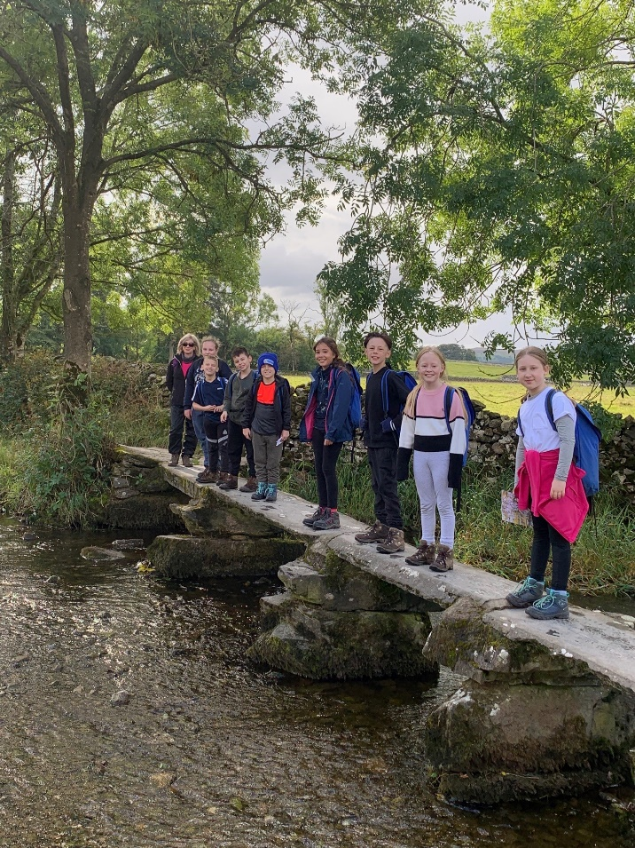

**Selection Process Guidance**

**Safeguarding**

We are committed to safeguarding our pupils and will assess the candidate’s suitability for working with children as part of the selection process. We will check the accuracy of all information and investigate any perceived anomalies. Firm offers of employment are never made without satisfactory references. All potential employees are subject to an enhanced disclosure from the Disclosure and Barring Service (DBS).

**Inclusion**

We welcome applications from candidates of all backgrounds, faith, ethnicities or with any protected characteristics. We are simply looking for the very best candidate for the job and will assess your application only on the information in your written application or your performance at interview should you be successfully shortlisted. We will ensure that the selection process is fair and without discrimination for or against any candidate based on age, ethnicity, gender, religious beliefs, marital status, or sexual orientation. The personnel specification sets out the criteria used to assess candidates through the selection process.

**Visits to the school**

Visits to the school are warmly welcomed by prior arrangement. Please contact Vicky Scott (School Business Manager), via email: Vicky.scott@blakehill.bradford.sch.uk to arrange a mutually convenient appointment.

**Applications**

Please ensure that all parts of the application are completed. We do not accept CVs as part of the selection process. Please ensure that you demonstrate how your experience and skills make you suitable for the position. Applications should be submitted via the Prospects website.

**Shortlisting**

We assess all applications against the specification criteria using the evidence you provide in your application. This is done by a panel of senior staff and governors. We carefully check all applications for anomalies. Applicants will be subject to an online search if shortlisted. Candidates who best meet the personnel specification will be invited to an interview. We will notify you by telephone with e-mail confirmation to follow. If you have not heard from us within 3 days of the closing date, you have not been successful at this stage.

**References**

We request references for all candidates who are invited to interview. Requests will be made at the same time that candidates are invited to interview. Your first referee should be your current or last employer.

**Interview Process**

The interview day will consist of a teaching task and a formal interview. This is designed to allow you to demonstrate your skills and abilities and share your experiences. You will be asked to bring proof of qualifications and identity on the day.

**Final Selection**

Following the task and formal interview, we will consider your responses to select the most suitable candidate for our school. We will then telephone each candidate to inform them of the outcome. We will offer brief feedback during this telephone conversation.

**Offer of Employment**

We will make a verbal offer of employment by telephone on the day of the interview and this will be confirmed in writing.

Any offer is made subject to:

• Receipt of references satisfactory to us

• Satisfactory DBS checks

• Provision of proof of identity and qualifications

