

Recruitment Information

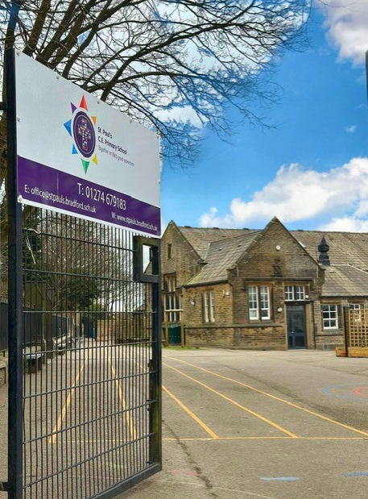

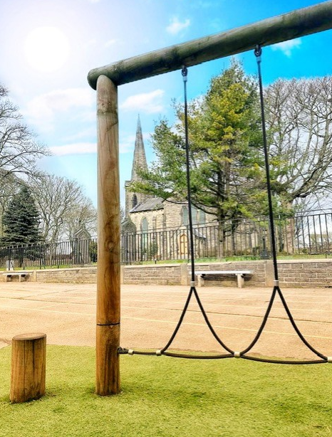 | Contents:  - Welcome letter from the Headteacher  - What we’re looking for  - Information about St Paul’s CE Primary school
Vision Statement
Through the love of God, we protect our school community. Together we trust, hope, persevere and flourish on life's great adventure.
Core Values
Our pupils have chosen our core values of love, courage, community, forgiveness, honesty, determination and respect. These are also the names of our school ‘families’ and each one is represented by a colour of the rainbow.

One of our values is chosen as the focus of our behaviours and worship each week or half term. This allows us to link the behaviours we would expect from the staff, children and community of St Paul’s with the values and behaviours God guides us to demonstrate.

We celebrate the children’s achievements each week through Celebration Worship where a Star of the Week is selected for demonstrating exceptional work or progress throughout the week. Our close links with St Paul’s church are extremely important to us as a church school and we regularly worship or gather in church for various celebrations.

Our vision drives what decisions we make as a school, our values support how we live out our vision. Our values underpin all our policies and behaviours within school.

Welcome letter from the Headteacher

Dear Applicant,

We are delighted that you have shown an interest in the role of Administrative Assistant at St Paul’s C. E. Primary School. St Paul’s is a popular primary school with a reputation for high standards of behaviour and achievement. We pride ourselves on our amazing children who are polite, enthusiastic and eager to learn and we strive to create a special place where all children, parents, carers, governors and staff feel valued and respected. It is our aim to nurture and promote achievement for all within a caring Christian environment. We want everyone in our school community to enjoy learning and coming to our school!

St Paul’s is brimming with potential and the pupils’ participation in school life provides good spiritual, moral, social and cultural development. In our most recent Ofsted inspection (March 2025) the inspector commented on the clear vision and values that the children and adults of St Paul’s ‘live and breathe’. This is something that we are extremely proud of because visitors to our school regularly comment on the positive and welcoming atmosphere that we have, solidified by our strong school values.
We are also very proud of our close links with the St Paul’s Church. The links with church are extremely important to us and we regularly worship and collectively gather in church for services and assemblies such as weekly worship, Mother’s Day and Easter services, nativities etc. We work with and support the local community in many ways including
The successful candidate will receive my full support, along with that of our dedicated staff team and committed Governing Body. They will have the opportunity to work closely with parents and carers who actively seek a strong and productive partnership with the school and fantastic children who are keen to learn.

Further information about our school can be found on the website: www.stpaulsceprimary.com


Thank you for your interest, I look forward to receiving your completed application and to meeting you in due course. Good luck!

Sean Helliwell-Kenny
Headteacher

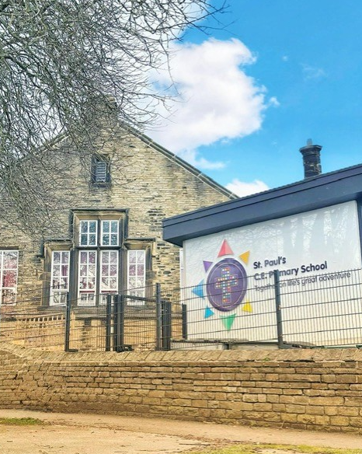
St Paul’s CE Primary School
School Values:
Love
Courage
Community
Forgiveness
Honesty
Determination
Respect

What We’re Looking For
We are looking for the perfect fit for our wonderful school! Someone who is hard working, dedicated and has a desire do their very best for the children of St Paul’s. Someone who is able to ‘live and breathe’ our school values in and outside of school and be a role model to all.
Please come and visit us for a full tour of the school so you can get a feel of us, the school and the amazing children and staff of St Paul’s CE Primary School.


St Paul’s CE Primary School
Outline Job Description

Post Title: | ADMINISTRATIVE assistant
Grade: | Band 6, SCP 7 - 11

Generic Introduction:

The following information is furnished to assist staff joining the school to understand and appreciate the work content of their post and the role they are to play in the organisation. The following points should be noted:

- Whilst every endeavour has been made to outline the main duties and responsibilities of the post, a document such as this does not permit every item to be specified in detail. Broad headings, therefore, may have been used below, in which case all the usual associated routines are naturally included in the job profile.

- Employees should not refuse to undertake work, which is not specified on this form, but they should record any additional duties they are required to perform and these will be taken into account when the post is reviewed.

- This school is an Equal Opportunities Employer and requires its employees to comply with all current equality policies in terms of equal opportunity for employment and access to the Council Services.

- This school is committed, where possible, to making any necessary reasonable adjustments to the job role and the working environment that would enable access to employment opportunities for disabled job applicants or continued employment for any employee who develops a disabling condition.

PRIME OBJECTIVES OF THE POST:

To assist in the provision of high-quality professional, flexible, proficient and constructive clerical, administration, financial support and reception service to the school.

Responsible to the Business Manager from whom they will receive formal supervision and who will allocate work when necessary. However, much of the work is self-generating, and the post holder will be expected to work within established procedures and guidelines and to prioritise day-to-day work, referring only exceptional or complex queries to senior members of staff. In the absence of the Business Manager would be expected to liaise with senior team members to ensure continuation of essential services.

To provide prompt and effective information, advice and access to services provided by the school to parents/carers, governors, community groups, members of the public and other agencies, dealing with requests for help and intervention, seeking guidance from and working in conjunction with senior/qualified professional staff on more complex requests. Undertaking and promoting the school to public and external agencies.

May from time to time be required to undertake other duties commensurate with the grade and level of responsibility defined in this job description.

KNOWLEDGE AND SKILLS:

(See Personnel Specification)

EFFORT DEMANDS:

- Will work under supervision and will frequently use own initiative, working to the priorities set by the Business Manager.

- To contribute to the overall ethos/work/aims of the school.

- Will make decisions regarding individual visitors/callers in terms of the advice and information provided, liaising with other staff within the school and assessing the level of urgency.

- Day to day decisions regarding the organisation of the working area/workload and school priorities; assisting with the planning and development of the support services.

- To participate in in-school training and other training programmes as required, and maintain personal and professional development in order to meet the changing demands of the post.

Responsibilities:

ORGANISATION

- To give advice and guidance as appropriate, making decisions regarding individual visitors/callers in terms of the advice and information provided and using some judgement within established procedures and guidelines, liaising with other staff within the school and assessing the level of urgency.

- Frequently dealing with routine and occasional less routine enquires. Given the changing needs of the school, workloads can vary to involve less routine tasks and the post holder will be expected to undertake these with minimum supervision as they arise, liaising with senior members of staff to verify/seek authorisation for action.

- To support/assist in the supervision of less experienced staff, students on work experience, trainees and voluntary helpers.

- Training new and existing members of staff.

- Undertake reception duties, answering routine telephone and face to face enquiries and signing in visitors.

- Assist with pupil first aid/welfare duties, looking after sick pupils, liaising with parents/staff etc.

- Assisting with arrangements for visits by school nurse, photographer etc.

ADMINISTRATION

- Provide a high level of clerical support e.g., record and circulate messages to other members of staff, diary management, photocopying, filing, scanning, faxing, emailing, complete routine forms, sort and distribute mail, ensuring supplies of internal forms are kept well stocked.

- Create and maintain manual/electronic filing and information systems, including those of outside agencies e.g., DfE.

- Maintain and collate pupil reports.

- Data inputting of computerised records/management information systems, including payroll systems.

- Produce, analyse and interpret data/information/detailed reports on a regular basis as appropriate to the school to facilitate performance management in line with the completion of internal/external performance requirements e.g., pupils’ data.

- Undertake typing, word-processing and other IT based tasks (audio and copy typing services, letters, memos, minutes etc).

- Undertake routine administration, e.g., responding to letters and emails/maintaining and updating distribution lists/registers/school meals/arranging and coordinating meetings on behalf of other school staff/room bookings/minute taking/retrieve and disseminate information as appropriate to the needs of the school/school lettings and other uses of school premises.

RESOURCES

- Responsible for the safe keeping of office equipment and secure storage of supplies.

- Operate office equipment e.g., photocopier, computer.

- Support the Business Manager on budget matters relating to the school including accounting/banking etc.

- Maintaining stock and supplies, preparing and assisting in the processing orders, checking delivery notes and invoices ensuring they are correctly recorded, cataloguing and distributing as required.

- Assist with procurement and sponsorship.

- Responsible in the collection and recording of school dinner money, school fund accounts and other routine financial administration with frequent handling of substantial amounts of cash.

- Operate uniform/snack/’other’ shops within the school.

OTHER

- Use good common sense and initiative in all matters relating to the conduct and behaviour of individuals, groups of pupils and whole classes; the correct use and care of materials by individual and small groups of pupils, the safety, mobility (if required) and hygiene and wellbeing of the pupils.

- Recognise own strengths and areas of expertise and use these to advise and support others.

- Make travel arrangements.

- Assist in the organisation and arrangements of school events/trips etc.

- Assist with marketing and promotion of the school.

- Preparing refreshments and clearing away.

- Receiving and escorting visitors around the school.

- To be responsible for reporting building maintenance in accordance with health and safety requirements.

environmental demands/Working Conditions:

- Available to work during school hours during term time and a willingness to be flexible as may be required to attend staff meetings/training sessions outside of usual hours.

- Will have contact with members of the public/other professionals e.g., teaching staff, governors, parents/carers, community groups, local education authority, external providers etc.

- The post holder may occasionally be subjected to antisocial behaviour from members of the public/parents/site users.

- This post may include a degree of manual lifting and handling. You are expected to be aware of health and safety policies and procedures and frequently assess your ability to carry out the lifting tasks required of you.

- Report all concerns to an appropriate person.

FLUENCY DUTY

In line with the Immigration Act 2016; the Government has created a duty to ensure that all Public Authority staff working in customer facing roles can speak fluent English to an appropriate standard.

For this role the post holder is required to meet the Intermediate Threshold Level

Intermediate Threshold Level

The post holder should demonstrate:

They can express themselves fluently and spontaneously with minimal effort and,
Only the requirement to explain difficult concepts may hinder a natural smooth flow of language.

SPECIAL CONDITIONS OF SERVICE:

No contra-indications in personal background or criminal record indicating unsuitability to work with children/young people/vulnerable clients/finance (An enhanced DBS check is required).

OTHER CONSIDERATIONS

To be aware of and comply with policies and procedures relating to child protection; being vigilant for signs that children may be being abused and to report any such suspicions to the school’s nominated Child Protection Co-ordinator or the Headteacher.

To act in accordance with the Data Protection Act and maintain confidentiality at all times e.g., access to staff/student/parent and carers files.

Accept and commit to the principles underlying the Schools Equal Rights policies and practices.

Be able to perform all duties and tasks with reasonable adjustments, where appropriate, in accordance with the Equality Act.

Must be legally entitled to work in the UK.

PERSONNEL SPECIFICATION:

 | ESSENTIAL (E) / DESIRABLE (D)
Experience: | - Experience using Microsoft Office with good IT skills. (E)  - Experience of working in an office environment (preferably within a school) to include development, management and operation of administrative systems. (E)  - Experience in dealing with financial matters. (D)  - Provide evidence of having previously spoken fluently to customers at an Intermediate Threshold Level (E)
Qualifications/  Training: | - Minimum of GCSE English and Mathematics at grade C or above (or equivalent). (E)  - NVQ3 (or equivalent) in a relevant discipline. (E)
Knowledge/Skills: | - Experience of general office work including reception, switchboard and typing/word processing. (E)  - Good literacy and numeracy skills. (E)  - Good communication skills including telephone/reception skills. (E)  - Knowledge of and the ability to use office machinery e.g., photocopiers, scanners, shredding machine etc. (E)  - Experience in the use of databases and other software packages with a high level of word processing/typing skills e.g., Microsoft Office (Word/Excel/Outlook etc.). (E)  - Experience of maintaining financial information systems and making payments. (D)  - Have a neat and organised approach to work. (E)  - Be willing, courteous and able to work both using your own initiative and in a team. (E)  - Respect confidentiality. (E)  - In line with the Immigration Act 2016; you should be able to demonstrate fluency of the English Language at an Intermediate Threshold Level. (E)

Safeguarding
St Paul's C.E. Primary School is committed to safeguarding and promoting the welfare of children and expects all staff to share this commitment. All shortlisted candidates will be subject to appropriate pre-employment checks, including:

- Enhanced DBS check with barred list information
- References from current and previous employers
- Verification of identity, qualifications and right to work in the UK
- Online searches of publicly available information

Safeguarding checks will be undertaken in accordance with Keeping Children Safe in Education statutory guidance."

Equal Rights
Our school is an equal rights employer. We require our governors and employees to follow our equality policies and to follow all statutory requirements concerning age, race, religion, sex, sexual orientation and disability discrimination. We respect and protect the rights of people with disabilities both in terms of equal opportunity for employment and access to school’s services.

Disabled Applicants
Disabled applicants are guaranteed an interview if they meet the essential requirements of the Personal Specification. As an equal opportunities employer our school is committed to make any necessary reasonable adjustments to the selection process, the job role and the working environment that would enable access to employment opportunities for disabled people. Where a disabled applicant is being
assessed the selection panel’s decisions will be based on an assessment of that person’s expected capabilities once reasonable adjustments have been made.

Key Dates Summary

Closing Date: Wednesday 4th February 2026 -12 noon
Interview Date: Tuesday 10th February 2026

We warmly welcome all applicants to visit our school before submitting an
application. To arrange a visit, please contact the school office on 01274 679183.

