Sandal Primary School & Nursery

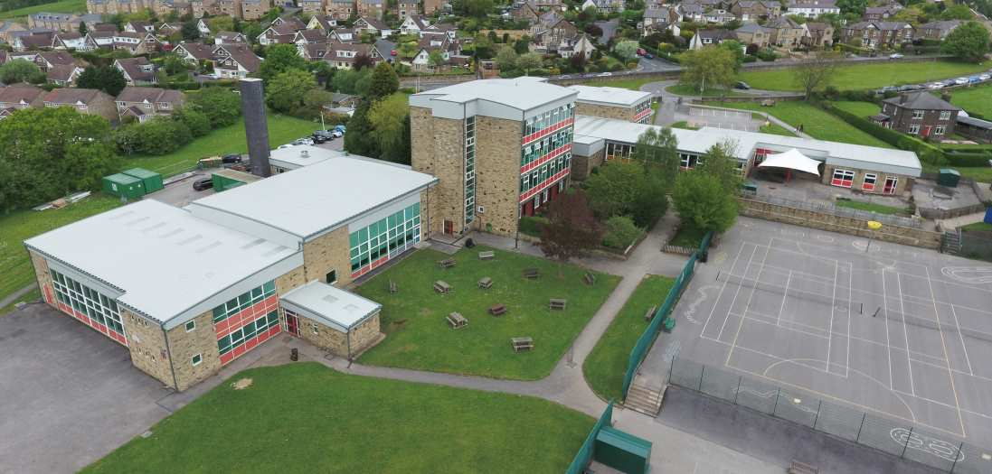

West Lane, Baildon, Shipley BD17 5DH
Tel: 01274 598115
Email: office@sandal.bradford.sch.uk
Headteacher: Mrs Louise Dale
Teaching Assistants x 2
Band 5, SCP 4-6 depending on experience
27.5 hours per week, TTO
Required September 2020

Sandal Primary School is seeking to appoint an ambitious, experienced and enthusiastic Teaching Assistant to join our highly-motivated and outstanding team in September 2020.

Vacancy Information
We are looking for:
- A successful Teaching Assistant who is able to raise and sustain high standards
- An innovative and creative practitioner with a drive and passion to ensure all students achieve
- Enthusiasm for working with a range of students with differing needs and abilities
- Initiative and a keenness to be involved in all aspects of school life;
- A Teaching Assistant who is able to enthuse and inspire students;
- A proven track record of good working relationships and professionalism;
- Confidence in working independently with small groups of students and with children 1 to 1.
- You will need to be creative, understand how early years children learn and be able to form excellent relationships with pupils, parents and colleagues

Closing Date: Friday 3rd July 2020/ 9.00am
Interviews: w/c 13th July 2020

Probationary terms are attached to permanent posts
We are committed to safeguarding children and all posts are subject to a DBS check

