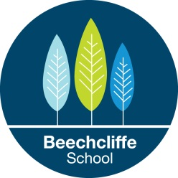
Additional Information for Applicants
Beechcliffe School is an ambitious secondary, generic special school rated Good, by Ofsted (April 2016)
We cater for pupils with a wide range of special educational needs including pupils with moderate, severe, or profound and multiple learning difficulties. Some of pupils have Autism, complex medical conditions and health needs, challenging behaviour or a sensory impairment.
We try to group our pupils into teaching groups of similar ability and need in order to deliver the curriculum, and meet individual needs appropriately.
The successful candidate must be enthusiastic, dedicated and willing to work with pupils of any age or ability within the school.
The successful candidate must have good communication and written English skills.
All staff must be willing to learn, and be flexible and adaptable in order to meet the ever changing needs of our pupils.
Please see the job description and person specification for more information about this post and please visit our website to find out more about Beechcliffe School.
www.beechcliffeschool.org/
Ofsted inspection April 2016 -please follow the attached link to read our latest Ofsted report.
http://reports.ofsted.gov.uk/inspection-reports/find-inspection-report/provider/ELS/135229
We are seeking to appoint staff who can help us make our school outstanding.
We are committed to Child Protection and all our practice and procedures reflect our commitment to Safeguarding.

