**Blakehill Primary School**

Recruitment Information Pack

**Teaching Assistant with the ability to cover supervise**

30 hours per week – Fixed term to start as soon as possible

Band 4-5, SCP 3-6 (based on experience)



**✶Together We Can✶**

**Timeline**

**Closing date for applications:** Friday 8th November 2024 – 9am

**Interviews taking place:** Week commencing 11th November 2024

**Contents**

|  |  |
| --- | --- |
| Welcome letter | Page 3 |
| Blakehill’s Vision | Page 4 |
| Teaching Assistant Advert | Page 5 |
| Job Description | Page 6 |
| Personnel Specification | Page 10 |
| Safeguarding Statement | Page 12 |
| Selection Process Guidance | Page 13 |

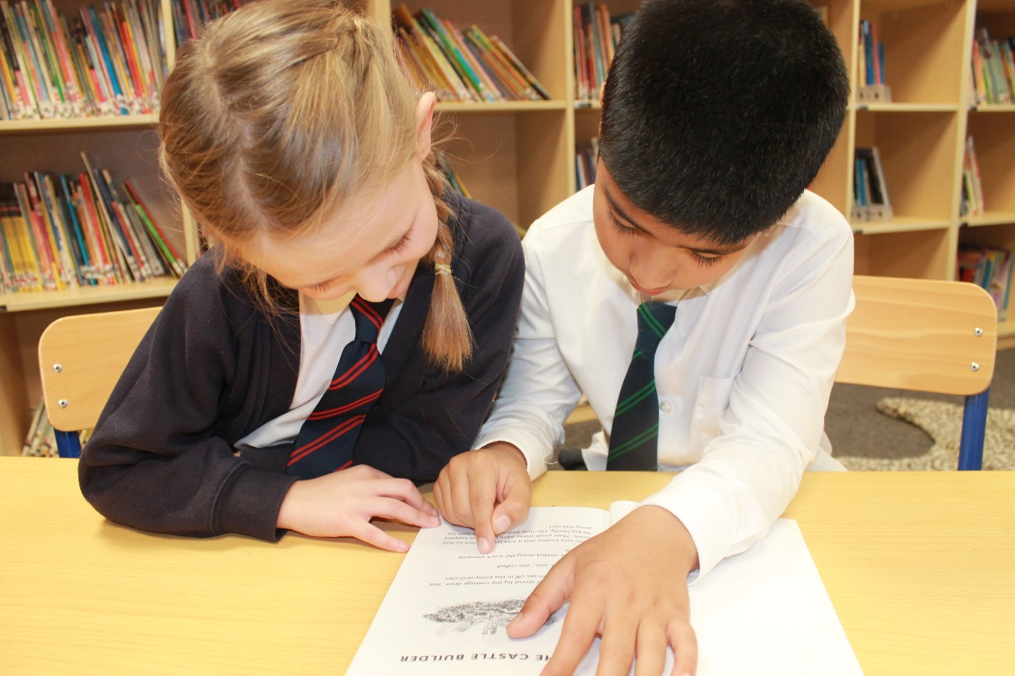

Dear candidate,

Thank you for your interest in the position of Teaching Assistant with the ability to cover supervise at our school. We are looking to recruit an experienced teaching assistant to join us. This is a 30 hour, fixed term post, to start as soon as possible.

Blakehill Primary School is a two form entry, successful school that provides and values positivity, achievement and teamwork. We create an exciting curriculum with an extensive range of learning opportunities, all of which makes Blakehill a fantastic place to work and learn.

The children are central to everything we think and do and the staff are uncompromising in their ambition to provide our pupils with the skills and knowledge they will need to lead successful and happy future lives.

Our school Mission Statement is **‘Together We Can.’**  This is paramount to the ethos of Blakehill Primary School where everyone shares the commitment of promoting the safeguarding, well-being and achievement of all our children.

In our latest **Ofsted Inspection (July 2022) we were graded GOOD with OUTSTANDING for pupil behaviour and welfare.**

‘Behaviour at Blakehill Primary is exceptional. Pupils are happy and safe. Relationships between staff and pupils are extremely positive. They feel valued by staff and pupils.’

‘Leaders have designed a highly effective curriculum for pupils’ personal, social and health education. Pupils are prepared well for life in Britain’

‘Staff are proud to work at Blakehill Primary School.’

We are fully committed to providing support, training and opportunities for career progression to all our staff and value the contribution that each and every one makes to the improvement and development of our school.

We are looking for an experienced teaching assistant who can be creative in their work and contribute to the continuing development of Blakehill Primary School. Passion, drive and commitment are key factors in the staff team at Blakehill.

We welcome you to visit us to gain a fuller insight into our school.

Please ring to arrange an appointment or to request further information.

We look forward to hearing from you.

Mrs Lisa Keighley

Headteacher

#### **WELCOME TO BLAKEHILL PRIMARY SCHOOL**



Staff, governors, pupils and their parents are very proud of our school. There is a strong culture of shared values and cooperation at Blakehill. We understand and embrace teamwork, create trust, maintain focus and, most importantly, understand the importance of people and relationships to our mission of success.

Because we put people first, everyone at school feels valued allowing us to focus on and provide a quality of education that enables pupils to thrive.

Our pupils and staff are central to all that we think and do at Blakehill and by listening to our school community, we are able to shape pupils’ learning journeys and provide experiences that capture their interests and needs.

**Vision and Ethos**

We are uncompromising in our vision for excellence and enjoyment for all pupils in all areas of the curriculum across school, to ensure that our children have the skills, knowledge, attitudes and values to lead successful lives both now and in the future.

This vision is under pinned by:

* Staff that have an unwavering commitment to the school and its pupils and are equipped to provide a high quality education.
* A curriculum that is shaped by listening to our pupils, their parents, staff and governors.
* An embedded culture and practice of our school ethos.
* School leaders that are relentless in their ambition to provide the best possible education for its pupils.
* A school community that is fully supportive and proud of the school.





**Experienced Teaching Assistant with the ability to cover supervise**

**required to start as soon as possible**

**30hrs per week, term time only**

**Fixed Term Contract (one year initially)**

**Level 2 – 3 - Band 4 - 5 SCP 3-6 (based on experience)**

We are seeking to appoint a dynamic, enthusiastic and committed individual to join our team of teaching assistants. The role will involve supporting learning in the classroom, leading interventions and supporting small group and 1:1 learning. The successful candidate would also be required to cover classes when necessary

**The successful applicant will need:**

* Experience of working in a primary classroom as an existing teaching assistant, HLTA/class teacher
* A calm and caring nature
* A flexible approach and the ability to use their initiative
* The ability to work successfully as part of a team
* Excellent communication skills

**We offer:**

* A school with a positive, caring ethos where teamwork is paramount
* Committed and enthusiastic staff who put children at the heart of everything they do
* A supportive governing body
* A happy and thriving school community
* An opportunity to further your professional development

**Closing Date:** Friday 8th November 2024 at 9:00am

**Interviews to be held:** Week commencing 11th November 2024

Interested candidates are requested to apply online for this post. To download the job details and apply, please visit [www.prospectsonline.co.uk](http://www.prospectsonline.co.uk) or contact the school office by email: office@blakehill.bradford.sch.uk or telephone 01274 414355.

*At Blakehill Primary School we are committed to safeguarding and promoting the welfare of children, and all posts are subject to an enhanced DBS check.*

Applicants will be subject to an online search if shortlisted.

Proof of eligibility to work in the UK will be required.

Please note: CVs are not accepted for this post.

**Job Description**

|  |  |
| --- | --- |
| Post Title | Teaching Assistant with the ability to cover supervise |
| School | Blakehill Primary School |
| Pay grade | Band 4-5, SCP 3-6 (based on experience) |

**Generic Introduction:**

The following information is furnished to assist staff joining the School to understand and appreciate the work content of their post and the role they are to play in the organisation. The following points should be noted:

1. Whilst every endeavour has been made to outline the main duties and responsibilities of the post, a document such as this does not permit every item to be specified in detail. Broad headings, therefore, may have been used below, in which case all the usual associated routines are naturally included in the job profile.
2. Employees should not refuse to undertake work, which is not specified on this form, but they should record any additional duties they are required to perform and these will be taken into account when the post is reviewed.
3. Blakehill Primary School is an Equal Opportunities Employer and requires its employees to comply with all current equality policies in terms of equal opportunity for employment.
4. Blakehill Primary School is committed, where possible, to making any necessary reasonable adjustments to the job role and the working environment that would enable access to employment opportunities for disabled job applicants or continued employment for any employee who develops a disabling condition.

**Prime Objectives of the Post:**

To complement, appreciate and support the role of teachers and other professionals by undertaking work/care/support programmes which enables access to learning in the community as part of a teacher planned approach.

To support the class teacher and other senior staff on a range of teaching and learning experiences which deliver an appropriately differentiated and suitably challenging creative curriculum for all pupils whilst meeting statutory requirements.

Work within school policies and procedures under the direction and guidance of senior staff and within an agreed system of supervision.

May from time to time be required to undertake other duties commensurate with the grade and level of responsibility defined in this job description.

**Knowledge and Skills:**

*(See Personnel Specification)*

**Effort Demands:**

* Will assist in maintaining the good discipline of pupils throughout school and be expected to use good common sense, as well as use initiative in all matters relating to the conduct and behaviour of individual pupils, groups of pupils and whole classes, the safety, mobility (if required), hygiene and well being of the pupils; making decisions within established working practices and procedures.
* Will recognise and challenge any incidents of racism, bullying, harassment, victimisation and any form of abuse of equal opportunities, ensuring compliance with the relevant school policy and procedures.
* Will deal with any issues, immediate problems or emergencies that arise in line with school policies and procedures liaising with colleagues where necessary e.g. dealing with a sick, injured or distressed child.
* Acting as a role model, will establish productive and constructive working relationships with pupils, setting high expectations, motivating and interacting with them, being aware of their individual needs, supporting difference and ensuring all pupils have equal access to opportunities to learn and develop whilst responding appropriately.
* Will have the ability to cope with the requirements of the post, which may include working with pupils who have emotional/behavioural/physical difficulties.
* Will contribute to the overall ethos/work/aims of the school.
* Will appreciate and support the role of other professionals.
* Be vigilant and sensitive to any child protection/safeguarding concerns that arise, reporting any concerns to the designated officer in line with school policy and procedure.

**Responsibilities:**

* Assist in the management of pupils in the learning environment.
* Undertake structured and agreed learning activities/teaching programmes appropriate to the pupil’s needs to ensure physical, social, emotional and intellectual development, taking into account diversity e.g. language, culture, ability, race and religion.
* Will supervise and support pupils consistently at all times; recognising and responding to their individual needs whilst ensuring their safety and education in the learning environment.
* For posts working with pupils who are physically less able, it may be necessary to be able to physically assist the pupil in line with school polices and good practice.
* Attend to the pupils’ personal needs, implementing and maintaining related personal care programmes with the correct use of care materials including the safety and well being of the pupils and first aid, paying attention to social, health, physical and welfare matters as well as high standards of cleanliness and hygiene e.g. washing, dressing, toileting, and, if applicable, mobility.
* Will occasionally be required to supervise the class for brief periods in a lesson where the classroom teacher is not available.
* Promote and reinforce the inclusion, acceptance and integration of all pupils, including those with specific and special needs and those from different cultures and/or with a different first language as appropriate.
* Set challenging and demanding expectations whilst promoting self-esteem and encouraging pupils to act independently as appropriate as well as interact and work co-operatively with others and engage in activities led by the teacher.
* Will prepare the classroom as directed to meet the lesson plans. Take responsibility for the care, preparation, maintenance and use of relevant equipment, assisting pupils in its use and clearing/storage afterwards.
* Will be aware of pupil progress, monitor/record pupil responses against pre-determined learning objectives as well as provide accurate, constructive and detailed feedback/reports to the teacher and pupils.
* Promote positive values, attitudes and good pupil behaviour and encourage pupils to take responsibility for their own actions whilst supporting the teacher in managing this. Deal promptly with conflict and incidents (including those involving restraint) and reporting challenging behaviour where appropriate in line with established policy.
* Will gather/report information from/to parents/carers as directed, taking into account parental/carer concerns, dealing with them sensitively under the direction of the teacher.
* Will provide clerical/administrative support as directed by the teacher.
* In respect of local and national learning strategies, will support pupils to achieve learning goals e.g. literacy, numeracy, KS3, early years as directed by the teacher.
* Will support pupils in the use of ICT in learning activities as directed by the teacher, and develop pupils competence and independence in its use.
* Will participate in own performance development, identify and address any training needs/other learning activities.
* Will assist with the supervision of pupils out of lesson times, including before and after school and at lunchtimes, accompanying teaching staff and pupils on visits, trips and out of school activities.
* Will assist in the supervision of students on work experience, trainees and voluntary helpers.

**environmental demands/Working Conditions:**

* Will have long periods of sitting or standing.
* Available to work during school hours during term time and a willingness to be flexible as may be required to attend staff meetings/training sessions outside of usual hours.
* Will have contact with members of the public/other professionals e.g. teaching staff, governors, parents/carers, community groups, local education authority, external providers etc.
* The post holder may occasionally be subjected to antisocial behaviour from members of the public/parents/site users.
* This post may include a degree of manual lifting and handling. You are expected to be aware of health and safety policies and procedures and frequently assess your ability to carry out the lifting tasks required of you.
* Report all concerns to an appropriate person.

**Fluency Duty**

In line with the Immigration Act 2016; the Government has created a duty to ensure that all Public Authority staff working in customer facing roles can speak fluent English to an appropriate standard.

For this role the post holder is required to meet the Intermediate Threshold Level

Intermediate Threshold Level

The post holder should demonstrate:

* They can express themselves fluently and spontaneously with minimal effort and,
* Only the requirement to explain difficult concepts may hinder a natural smooth flow of language.

**Special Conditions of Service:**

* No contra-indications in personal background or criminal record indicating unsuitability to work with children/young people/vulnerable clients/finance (An enhanced DBS check is required).

**Other considerations**

* To be aware of and comply with policies and procedures relating to child protection; being vigilant for signs that children may be being abused and to report any such suspicions to the school’s nominated Child Protection Co-ordinator or the Headteacher.
* To act in accordance with the Data Protection Act and maintain confidentiality at all times e.g. access to staff/student/parent and carers files.
* Accept and commit to the principles underlying the Schools Equal Rights policies and practices.
* Be able to perform all duties and tasks with reasonable adjustment, where appropriate, in accordance with the Equality Act.
* Must be legally entitled to work in the UK.

**PERSONNEL SPECIFICATION:**

|  |  |
| --- | --- |
|  | **ESSENTIAL (E)/DESIRABLE (D)** |
| **Experience:** | * Experience of working in a team situation. (D) * Experience of working with or caring for children of relevant age e.g. voluntary organisation or parental/caring responsibilities.(E) * Provide evidence of having previously spoken fluently to customers at an Intermediate Threshold Level. (E) |
| **Qualifications/**  **Training:** | * GCSE English and Maths or equivalent e.g. Adult Literacy/Numeracy at level 1. (E) * Qualifications relating to the post e.g. Health/Childcare, first aid qualification.(D) * Willingness to participate in development and training opportunities. (E) |
| **Knowledge/ Skills:** | * Will possess knowledge of the School’s relevant procedures or practices.(E) * Will have an outline understanding of relevant legislation. (E) * Will have some knowledge of some of the policies covering their service area. (E) * Problem solving skills. (E) * Good communication skills. (E) * Good numeracy/literacy skills. (E) * Basic ICT skills. (E) * An understanding of the needs of a multicultural society. (E) * An understanding of the issues relating to pupils who have additional learning needs, more able and special educational needs. (E) * Knowledge of childcare. (E) * Awareness of child development. (E) * Knowledge and commitment to schools Equality policy. (E) * Ability to relate well to pupils and adults. (E) * Ability to work constructively as part of a team. (E) * Ability to remain calm under pressure. (E) * Demonstrate a commitment to working with children of the relevant age. (E) * Demonstrate good co-operative, interpersonal and effective listening skills. (E) * Maintain confidentiality in matters relating to the school, its pupils, parents or carers. (E) * Ability to perform all duties and tasks with reasonable adjustments where necessary. (E) * Ability to cope with the requirements of the post, which will include working with pupils who have emotional/ behavioural/physical difficulties. (E) * In line with the Immigration Act 2016; you should be able to demonstrate fluency of the English Language at an Intermediate Threshold Level. (E) |



**Safeguarding Statement**

The school pays full regard to current DfE guidance Keeping Children Safe in Education. We ensure that all appropriate measures are applied in relation to everyone who works in the school who is likely to be perceived by the children as a safe and trustworthy adult including volunteers and contractors’ staff.

In line with statutory duties, the following will apply:

• We will maintain an up to date single central record detailing the range of checks carried out on our staff and volunteers

• We obtain a DBS Enhanced Disclosure for all new appointments to the school workforce

• We seek confirmation from applicable staff that they are not disqualified from childcare under the Childcare (Disqualification) Regulations 2009. This includes:

- Staff employed in our EYFS

- Staff running our breakfast club & after school provision

- Members of the SLT

• We obtain confirmation of appropriate checks and on–going training for supply staff from their agencies

• Where possible, contractors whose staff have DBS checks are used. Where this is not possible, appropriate measures are taken to supervise these workers. Similarly, occasional visitors to the school who do not have DBS certificates are supervised appropriately.

All staff are provided with a copy of Keeping Children Safe in Education and relevant updates; they are asked to sign that they have read and will follow the guidance given.

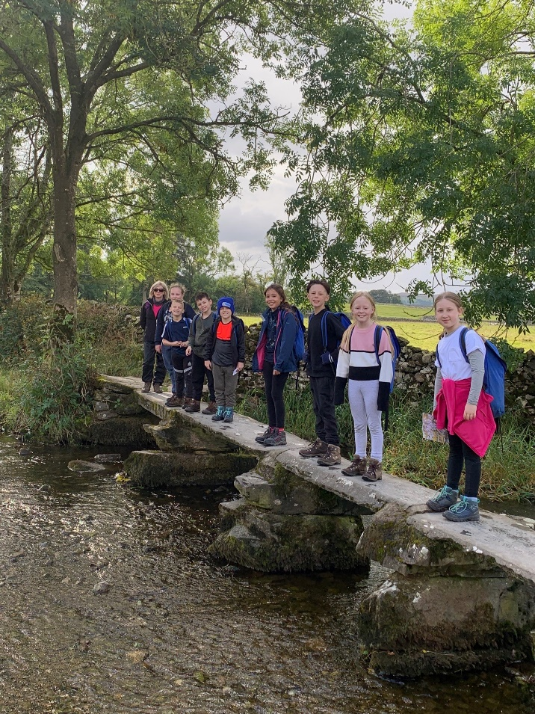

**Selection Process Guidance**

**Safeguarding**

We are committed to safeguarding our pupils and will assess the candidate’s suitability for working with children as part of the selection process. We will check the accuracy of all information and investigate any perceived anomalies. Firm offers of employment are never made without satisfactory references. All potential employees are subject to an enhanced disclosure from the Disclosure and Barring Service (DBS).

**Inclusion**

We welcome applications from candidates of all backgrounds, faith, ethnicities or with any protected characteristics. We are simply looking for the very best candidate for the job and will assess your application only on the information in your written application or your performance at interview should you be successfully shortlisted. We will ensure that the selection process is fair and without discrimination for or against any candidate based on age, ethnicity, gender, religious beliefs, marital status, or sexual orientation. The personnel specification sets out the criteria used to assess candidates through the selection process.

**Visits to the school**

Visits to the school are warmly welcomed by prior arrangement. Please contact Vicky Scott (School Business Manager), via email: Vicky.scott@blakehill.bradford.sch.uk to arrange a mutually convenient appointment.

**Applications**

Please ensure that all parts of the application are completed. We do not accept CVs as part of the selection process. Please ensure that you demonstrate how your experience and skills make you suitable for the position. Applications should be submitted via the Prospects website.

**Shortlisting**

We assess all applications against the specification criteria using the evidence you provide in your application. This is done by a panel of senior staff and governors. We carefully check all applications for anomalies. Applicants will be subject to an online search if shortlisted. Candidates who best meet the personnel specification will be invited to an interview. We will notify you by telephone with e-mail confirmation to follow. If you have not heard from us within 3 days of the closing date, you have not been successful at this stage.

**References**

We request references for all candidates who are invited to interview. Requests will be made at the same time that candidates are invited to interview. Your first referee should be your current or last employer.

**Interview Process**

The interview day will consist of a teaching task and a formal interview. This is designed to allow you to demonstrate your skills and abilities and share your experiences. You will be asked to bring proof of qualifications and identity on the day.

**Final Selection**

Following the task and formal interview, we will consider your responses to select the most suitable candidate for our school. We will then telephone each candidate to inform them of the outcome. We will offer brief feedback during this telephone conversation.

**Offer of Employment**

We will make a verbal offer of employment by telephone on the day of the interview and this will be confirmed in writing.

Any offer is made subject to:

• Receipt of references satisfactory to us

• Satisfactory DBS checks

• Provision of proof of identity and qualifications

