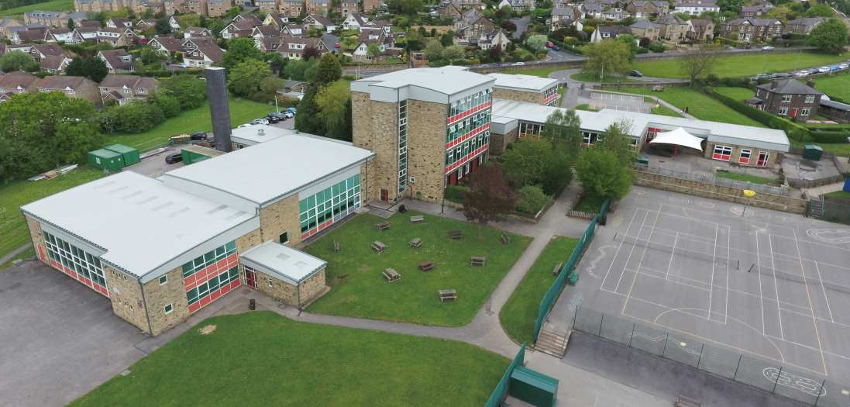


Learning Support Assistant
30hrs per week TTO
Band 5 SCP 4-6
Required January 2026
Sandal Primary School is looking to appoint an experienced Learning Support Assistant to support in class and possibly with specific children with Education Health and Care Plans and complex special educational needs, within the class.
You will provide educational and/or medical support to ensure the pupils successful engagement with and access to quality learning.
The role will involve one-to-one and class-based support.
Learning support assistants play an integral part, in partnership with teaching staff, to promote self-belief, social inclusion and high self-esteem amongst pupils. By supporting the classroom teacher, the Learning support assistant ensures that pupils flourish in a positive, nurturing, safe environment accessing the curriculum to achieve improved standards of learning and achievement in the school
Our team works together closely to create an amazing learning experience for our pupils which nurtures all children to be the best they can.
We want to hear from you if:
- Experience of working in a primary classroom as an existing learning support assistant, teaching assistant, HLTA/class teacher
- A calm and caring nature
- Excellent communication skills
- You can work independently but also have the interpersonal skills required to work effectively in a team
- Demonstrate the confidence and understanding of how to establish and maintain positive relationships with pupils and are able to support pupils learning in both the classroom, small groups and on an individual basis.
- Have experience working with vulnerable pupils, can empathise and move pupils forward in their learning
- Are committed to raising achievement through an exciting and stimulating curriculum

We will offer:

- A school with a positive, caring ethos where teamwork is paramount
- Committed and enthusiastic staff who put children at the heart of everything they do
- A supportive governing body
- A happy and thriving school community
- An opportunity to further your professional development
Closing Date: 9am Thursday 11th December 2025
Interviews will be held in person w/c 15th December 2025 and all shortlisted candidates with be notified by email.
All shortlisted candidates will have chance to view the school during the school day.

Interested candidates are requested to contact the school office for an application form.
Visits to the school are warmly welcomed and can be arranged by contacting the School Office.
Email: office@sandalprimaryschool.co.uk or telephone 01274 598115.

Sandal Primary School is committed to safeguarding and promoting the welfare of all our children. All posts are subject to an Enhanced DBS check and references.

Applicants will be subject to an online search if shortlisted.
Proof of eligibility to work in the UK will be required.
Please note: CVs are not accepted for this post.

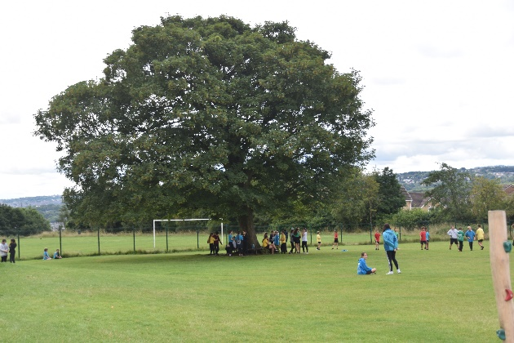

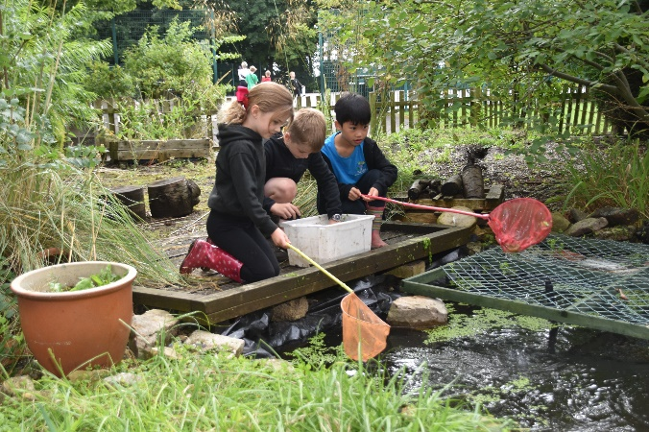

Job Description
Post Title | Learning Support Assistant
School | Sandal Primary School
Pay grade | Band 5 SCP 4-6 (depending on experience)

Generic Introduction:
The following information is furnished to assist staff joining the School to understand and appreciate the work content of their post and the role they are to play in the organisation. The following points should be noted:
- Whilst every endeavour has been made to outline the main duties and responsibilities of the post, a document such as this does not permit every item to be specified in detail. Broad headings, therefore, may have been used below, in which case all the usual associated routines are naturally included in the job profile.
- Employees should not refuse to undertake work, which is not specified on this form, but they should record any additional duties they are required to perform and these will be taken into account when the post is reviewed.
- This school is an Equal Opportunities Employer and requires its employees to comply with all current equality policies in terms of equal opportunity for employment.
- This school is committed, where possible, to making any necessary reasonable adjustments to the job role and the working environment that would enable access to employment opportunities for disabled job applicants or continued employment for any employee who develops a disabling condition.

PRIME OBJECTIVES OF THE POST:
To complement, appreciate and support the role of teachers and other professionals by undertaking work/care/support programmes which enables access to learning in the community as part of a teacher planned approach.

To support the class teacher in the management of pupils in the classroom, and other senior staff on a range of teaching and learning experiences which deliver an appropriately differentiated and suitably challenging creative curriculum for all pupils whilst meeting statutory requirements.

Work within school policies and procedures under the direction and guidance of senior staff and within an agreed system of supervision.

May from time to time be required to undertake other duties commensurate with the grade and level of responsibility defined in this job description.

KNOWLEDGE AND SKILLS:
(See Personnel Specification)

EFFORT DEMANDS:
- Will assist in maintaining the good discipline of pupils throughout school and be expected to use good common sense, as well as use initiative in all matters relating to the conduct and behaviour of individual pupils, groups of pupils and whole classes, the safety, mobility (if required), hygiene and wellbeing of the pupils; making decisions within established working practices and procedures.

- Will recognise and challenge any incidents of racism, bullying, harassment, victimisation and any form of abuse of equal opportunities, ensuring compliance with the relevant school policy and procedures.

- Will deal with any issues, immediate problems or emergencies that arise in line with school policies and procedures liaising with colleagues where necessary e.g. dealing with a sick, injured or distressed child.

- Acting as a role model, will establish productive and constructive working relationships with pupils, setting high expectations, motivating and interacting with them, being aware of their individual needs, supporting difference and ensuring all pupils have equal access to opportunities to learn and develop whilst responding appropriately.

- Will have the ability to cope with the requirements of the post, which may include working with pupils who have emotional/behavioural/physical/medical difficulties.

- Will contribute to the overall ethos/work/aims of the school.

- Will appreciate and support the role of other professionals.

- Be vigilant and sensitive to any child protection/safeguarding concerns that arise, reporting any concerns to the Designated Safeguarding Lead in line with school policy and procedure.

RESPONSIBILITIES:
- Assist in the management of pupils in the learning environment.

- Assist in the planning of learning activities.

- Undertake structured and agreed learning activities/teaching programmes appropriate to the pupil’s needs to ensure physical, social, emotional and intellectual development, taking into account diversity e.g. language, culture, ability, race and religion.

- Will supervise and support pupils consistently at all times; recognising, responding and meeting the individual and physical needs of each child whilst ensuring their safety and education in the learning environment.

- Assist with the development and implementation of Education Health and Care Plans (EHCP), Individual Education Plans, and Personal Care Programmes; attending to the pupils’ personal needs and maintaining related personal programmes with the correct use of care materials including the safety and wellbeing of the pupils, therapy and medical intervention needs of the pupil and first aid, paying attention to social, health, physical and welfare matters as well as high standards of cleanliness and hygiene e.g. washing, dressing, toileting (including intimate care if appropriate), and, if applicable, mobility.

- For posts working with pupils who are physically less able, it may be necessary to be able to physically assist the pupil in line with school polices and good practice.

- Will occasionally be required to supervise the class for brief periods during a morning or afternoon session where the classroom teacher is not available.

- Promote and reinforce the inclusion, acceptance and integration of all pupils, including those from different cultures and/or with a different first language as appropriate.

- Set challenging and demanding expectations whilst promoting self-esteem and encouraging pupils to act independently as appropriate as well as interact and work co-operatively with others and engage in activities led by the teacher.

- Will prepare, create and maintain a purposeful, orderly and supportive learning environment to meet the lesson plans. Take responsibility for the care, preparation, maintenance and use of relevant equipment, assisting pupils in its use and clearing/storage afterwards.

- Will be aware of pupil progress, monitor/record pupil responses against pre-determined learning objectives as well as provide accurate, constructive and detailed feedback/reports to the teacher and pupils.

- Promote positive values, attitudes and good pupil behaviour and encourage pupils to take responsibility for their own actions whilst supporting the teacher in managing this. Deal promptly with conflict and incidents (including those involving restraint) and reporting challenging behaviour where appropriate in line with established policy.

- Will gather/report information from/to parents/carers as directed, taking into account parental/carer concerns, dealing with them sensitively under the direction of the teacher.

- Will provide clerical/administrative support as directed by the teacher.

- Will support pupils in the use of ICT in learning activities as directed by the teacher, and develop pupil’s competence and independence in its use.

- Will participate in own performance development, identify and address any training needs/other learning activities.

- Will assist with the supervision of pupils out of lesson times, including before and after school and at lunchtimes, accompanying teaching staff and pupils on visits, trips and out of school activities; taking responsibility for a group under the supervision of the teacher.

- Will assist in the supervision of students on work experience, trainees and voluntary helpers.

ENVIRONMENTAL DEMANDS/WORKING CONDITIONS:
- Will have long periods of sitting or standing.

- Available to work during school hours during term time and a willingness to be flexible as may be required to attend staff meetings/training sessions outside of usual hours.

- Will have contact with members of the public/other professionals e.g. teaching staff, governors, parents/carers, community groups, local education authority, external providers etc.

- This post may include duties which require specific training such as First Aid or Positive Handling and will be provided by the school where necessary.

- The post holder may occasionally be subjected to antisocial behaviour from members of the public/parents/site users.

- This post may include a degree of manual lifting and handling. You are expected to be aware of health and safety policies and procedures and frequently assess your ability to carry out the lifting tasks required of you.

- Report all concerns to an appropriate person.

FLUENCY DUTY
In line with the Immigration Act 2016; the Government has created a duty to ensure that all Public Authority staff working in customer facing roles can speak fluent English to an appropriate standard.
For this role the post holder is required to meet the Intermediate Threshold Level
Intermediate Threshold Level
The post holder should demonstrate:
- They can express themselves fluently and spontaneously with minimal effort and,
- Only the requirement to explain difficult concepts may hinder a natural smooth flow of language.

SPECIAL CONDITIONS OF SERVICE:
- No contra-indications in personal background or criminal record indicating unsuitability to work with children/young people/vulnerable clients/finance (An enhanced DBS check is required).

OTHER CONSIDERATIONS
- To be aware of and comply with policies and procedures relating to child protection; being vigilant for signs that children may be being abused and to report any such suspicions to the school’s Designated safeguarding Lead or the Headteacher.

- To act in accordance with the Data Protection Act and maintain confidentiality at all times e.g. access to staff/student/parent and carers files.

- Accept and commit to the principles underlying the Schools Equal Rights policies and practices.

- Be able to perform all duties and tasks with reasonable adjustments, where appropriate, in accordance with the Equality Act.

- Must be legally entitled to work in the UK.

Application & Selection Guidance
Safeguarding
We are committed to safeguarding and promoting the welfare of young people and we expect all staff to share this commitment. All posts are subject to the safer recruitment process including an enhanced Disclosure and Barring Service Check.
Inclusion
We welcome applications from candidates of all backgrounds, faith, ethnicities or with any protected characteristics. We will ensure that the selection process is fair and without discrimination for or against any candidate based on age, ethnicity, gender, religious beliefs, marital status, or sexual orientation. The personnel specification sets out the criteria used to assess candidates through the selection process. We ask all applicants to complete the Equal Opportunities monitor section of the application form so that we can continue to monitor and improve our recruitment process.

How to Apply
Vacancies are advertised on our website and Prospects Online. Please complete the application form in full, ensuring you have provided full and accurate information including your education and employment history and any unpaid or voluntary work. Where there are gaps in your employment history, please explain why (e.g. gap year, career break). Use the job description and person specification as a guide and give specific examples to demonstrate how your experience and skills make you suitable for the position. Please ensure that all parts of the application are completed. We do not accept CVs as part of the selection process. Applications should be submitted via the Prospects website.
Shortlisting
We assess all applications against the specification criteria using the evidence you provide in your application. This is done by a panel of senior staff and governors. We carefully check all applications for anomalies. In line with Keeping Children Safe in Education (KCSIE) 2022 we will be carrying out online checks. Candidates who best meet the personnel specification will be invited to an interview. We will notify you by telephone with e-mail confirmation to follow. If you have not heard from us within 3 days of the closing date, you have not been successful at this stage.

References
We request references for all candidates who are invited to interview. Requests will be made at the same time that candidates are invited to interview. Your first referee should be your current or last employer.
Interview Process
The interview day will consist of a task and a formal interview. This is designed to allow you to demonstrate your skills and abilities and share your experiences. You will be asked to bring proof of qualifications and identity on the day.

Appointment and Pre-employment Checks
Successful candidates will receive a conditional offer of appointment and will be subject to satisfactory pre-employment checks.

Sandal Primary School

Learning Support Assistant

PERSONNEL SPECIFICATION
Summary of post as outlined in attached Job Specification

ATTRIBUTES | ESSENTIAL | DESIRABLE | HOW IDENTIFIED
QUALIFICATION | GCSE English and Maths or equivalent e.g. Adult Literacy/Numeracy at level 1 (E) | Other relevant qualifications relating to the post e.g. Level 2 NVQ in Health/Childcare, first aid qualification (D)  Evidence of further training/development and/or willingness to participate in further training and development opportunities e.g. Team Teach, Moving & Handling, Special Educational Needs (D) | Application form  References  Interview
EXPERIENCE | Experience of working in a team situation (E)  Experience of working with pupils who have special needs (E)  Experience of working with or caring for children of relevant age e.g. voluntary organisation or parental/caring responsibilities (E)  Provide evidence of having previously spoken fluently to customers at an Intermediate Threshold Level (E) | Experience of supporting children with behavioural difficulties or Social, Emotional & Mental Health needs, or Communication and Interaction needs including autism (D) | Application form  Interview  References  Letter of application
SKILLS & KNOWLEDGE | Will have an outline understanding of relevant legislation (E)  Will have knowledge of some of the policies covering their service area (E)  Problem solving skills (E)  Good communication skills (E)  Good numeracy/literacy skills (E)  Basic ICT skills (E)  An understanding of the needs of a multicultural society (E)  An understanding of the issues relating to pupils who have additional learning needs, more able and special educational needs (E)  Knowledge and commitment to schools Equality policy (E)  Ability to relate well to pupils and adults (E)  Ability to work constructively as part of a team (E)  Ability to remain calm under pressure (E)  Demonstrate a commitment to working with children of the relevant age (E)  Demonstrate good co-operative, interpersonal and effective listening skills (E)  Maintain confidentiality in matters relating to the school, its pupils, parents or carers (E)  Ability to perform all duties and tasks with reasonable adjustments where necessary (E)  Ability to cope with the requirements of the post, which will include working with pupils who have emotional/ behavioural/physical difficulties (E)  In line with the Immigration Act 2016; you should be able to demonstrate fluency of the English Language at an Intermediate Threshold Level (E) | Will possess knowledge of the School’s relevant procedures or practices (D)  Exercising advisory, guiding, negotiating and persuasive skills at a developed level (D)  Knowledge of childcare (D)  Awareness of child development (D) | Application form  Interview  References
PHYSICAL | Strength and mobility to operate in a primary school classroom |  | Application form  References  Interview
PERSONAL CIRCUMSTANCES | Flexibility of circumstances to meet the requirements of the job. | Willing to participate in local community activities  Commitment to taking part in out of school activities.  Commitment to contribute to the full life of the school | Application form  Interview

Bradford is an equal opportunities employer and requires its employees to carry out its policies concerning racial and sex equality and the right of people with disabilities both in terms of equal opportunity for employment and access to the Council’s services.

The School is committed to safeguarding and promoting the welfare of children.

Successful applicants will be required to undertake enhanced DBS checking.

