Home Farm Primary School

Teaching Assistant



**Contents**

1. Welcome letter from the Headteacher
2. Our School – Pupil views
3. Key Facts, Statistics and Location
4. Copy of the advert
5. Statement of the school’s values and ethos
6. Job Description and Personnel Specification
7. Equal Opportunities
8. Key Dates summary

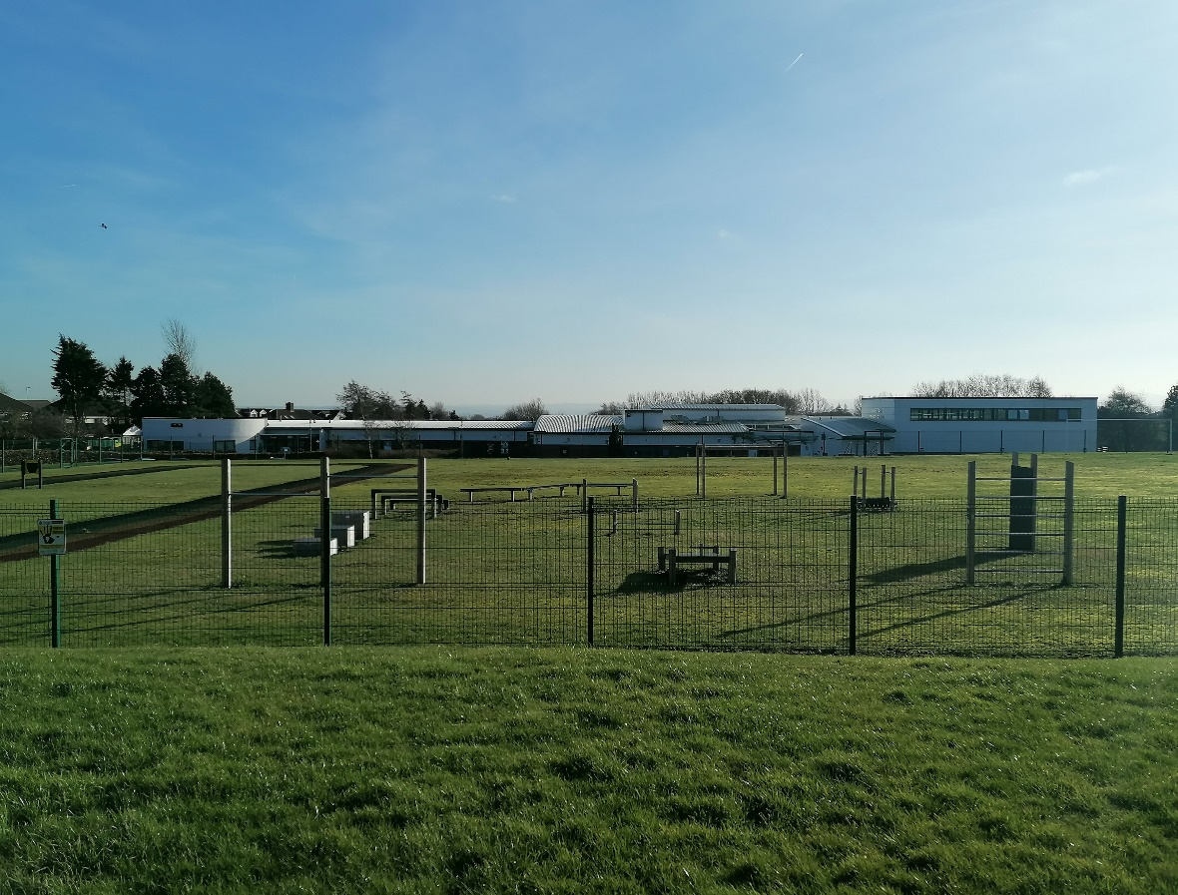

**Letter from the Headteacher**

Dear Applicant,

Thank you for your interest in the vacancy for the Teaching Assistant position at Home Farm. I hope you find this information pack useful and that it encourages you to apply for this exciting position within our school community.

We are a two form entry school with 470 pupils on roll. Our children come from a range of backgrounds and our school is rightly proud of the work we do and the support we provide to, the community that is in our catchment area. We use our Home Farm values to underpin the work we do for all who are part of our school.

Home Farm is a welcoming, happy school on the outskirts of Bradford, with wonderful children and a hardworking, committed staff who have helped shape the culture of the school into a nurturing and vibrant educational establishment. We collaborate well with other schools in the local area and additionally, have developed strong links with the high schools.

Therefore, we are looking for a positive, creative and hard-working individual who cares passionately about children’s education and wellbeing. The ideal applicant will share the schools vision and enthusiasm for learning to ensure the best outcomes for our children. Please have a look at our website ([https://www.homefarm.bradford.sch.uk/](https://www.homefarm.bradford.sch.uk/bradford/primary/homefarm)) where you can find more information and our latest reports.

I invite you to come and visit the school, to have a look around and judge for yourself, as I am certain visiting us would encourage you to apply. We look forward to your application and seeing what you can bring to our school.

Yours sincerely,

Joanne Poole

Headteacher

*“Coming to school makes me happy. I am proud of the Home Farm Way.” KS1 Pupil*

*“I have lots of kind friends. My teachers help me learn and they are very kind.” KS1 Pupil*

**H**onesty

**O**pportunities

**M**utual Respect

**E**njoyment

**F**riendship

**A**chievement

**R**esilience

**M**aturity

*“Everyone is kind and helpful, and say how nice the teachers are. The teachers help every pupil. Not all schools have Home Farm Values, that’s what makes us special.” KS2 Pupil*

*“I love everything about Home Farm.” KS2 Pupil*

**Key Facts and Statistics**

|  |  |
| --- | --- |
| Type of School | Community |
| Age Range | Nursery, 5-11 |
| Number of Children | 470 |
| % of children with SEN support | 19% |
| % EHCP | 4.4% |
| % of children with EAL | 17.6% |
| % eligible for free school meals | 32% |
| Pupil Premium (2023/24 budget) | 34% |

**School Location**

Home Farm Primary School  
Home Farm Close  
Bradford  
West Yorkshire  
BD6 3NR

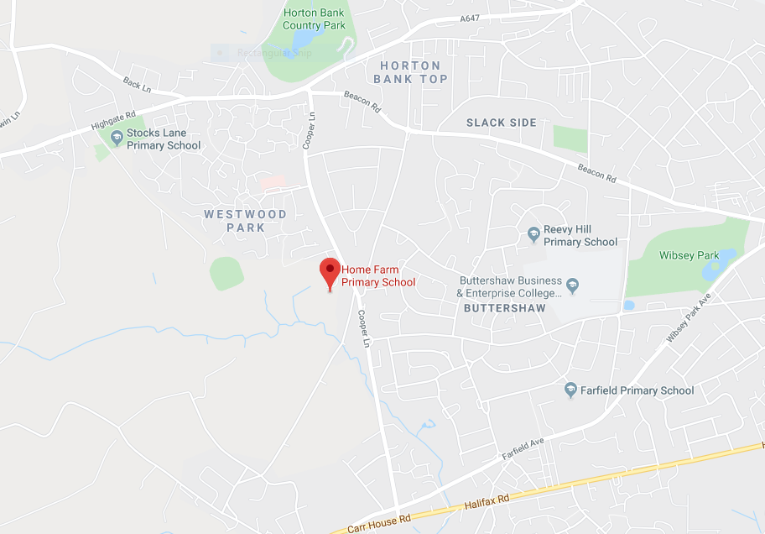

**Teaching Assistant**

**3 x Fixed Term to 31st August 2026**

**1 x Permanent**

**1 x Maternity Cover until Easter 2026 in the first instance to specialise in Early Years**

**27.5 hours per week, Term Time Only**

**Salary (Band 4) £15,200**

**Required from 2nd September 2025**

**Job Information**

Home Farm Primary School wishes to appoint 5 x inspirational and outstanding TA’s who have the ability to support children of all years to achieve high standards of learning.

Home Farm Primary School is a 2 form entry school with 470 pupils on roll.

We are looking for an outstanding individual who can support our school in an innovative, nurturing and creative manner. Our school is looking to appoint someone who can utilise our many strengths and also see what’s needed to move our school to the next level. The ideal applicant should be able to use our embedded ethos to work with parents. The role may be 1:1 SEN support, SEN Groups or class based.

**The successful candidate will:**

* Be passionate about working with children
* Be patient, caring and a good communicator
* Be inspirational and believes all children deserve the very best
* Have great teamwork skills, a good sense of humour and a willingness to ‘go the extra mile’ every day
* Are committed to and display the ‘Home Farm Way’ in everything they do

**Duties may include:**

* Taking groups and individuals for learning sessions across the primary age range
* Using your initiative
* Supporting class teachers within the classroom
* Preparing teaching resources
* Helping children with toileting and meals
* Supporting special needs children, some of whom have severe and complex difficulties

A good level of literacy and numeracy is essential and previous experience of working with early years children is desirable

**We can offer:**

* A friendly school with strong links with the community
* A supportive governing body and leadership team
* A genuine, welcoming, caring and professional school with pupils who are keen to learn in a very happy and engaging atmosphere
* Hardworking, supportive and enthusiastic colleagues
* A commitment to your continued professional development

**Please have a look at our website to find out more about our school.**

**Closing date: 22nd April 2025  
Interviews: 6th May 2025**

We are committed to safeguarding and promoting the welfare of children  
All posts are subject to an enhanced DBS check

Proof of eligibility to work in the UK will be required   
**Please note: CVs are not accepted for this post**

**Statement of school’s values and ethos**

Our School Values

**H**onesty

**O**pportunities

**M**utual Respect

**E**njoyment

**F**riendship

**A**chievement

**R**esilience

**M**aturity

British Values

At Home Farm Primary School we provide opportunities for pupils to explore their own culture and have a clear understanding and appreciation of a wide range of the cultural influences that have shaped modern Britain.

We are a school for *all.* We recognise the multi-cultural, multi-faith nature of our community and of Britain. We understand the crucial role our school plays in promoting British Values.

**JOB DESCRIPTION: TEACHING ASSISTANT**

The following information is furnished to help staff and those people considering joining the City of Bradford Metropolitan District Council to understand and appreciate the work content of their post and the role they are to play in the organisation. However, the following points should be noted:

1. Whilst every endeavour has been made to outline all the duties and responsibilities of the post, a document such as this does not permit every item to be specified in detail. Broad headings, therefore, may have been used below, in which case all the usual associated routines are naturally included in the job description.
2. Officers should not refuse to undertake work, which is not specified on this form, but they should record any additional duties they are required to perform and these will be taken into account when the post is reviewed.
3. Bradford is an Equal Opportunities Employer and requires its employees to comply with all current equality policies both in terms of equal opportunity for employment and access to the Council Services.
4. The Council is committed to making any necessary reasonable adjustments to the job role and the working environment that would enable access to employment opportunities for disabled job applicants or continued employment for any employee who develops a disabling condition.

**PRIME OBJECTIVES OF THE POST:**

To undertake work/care/support programmes in any class / age group determined by the headteacher. To enable access to learning for pupils and to assist the teacher in the management of pupils and the classroom. Work may be carried out in the classroom or outside the main teaching area.

**SUPERVISORY/MANAGERIAL RESPONSIBILITIES**

Assisting as a member of the classroom team in the supervision of students on work experience, trainees and voluntary helpers with whom the post holder is working.

**SUPERVISION AND GUIDANCE;**

To work under the instruction /guidance of teaching/senior staff.

**RANGE OF DECISION MAKING**

To make decisions using initiative within established working practices and procedures. The post holder will be expected to use good common sense and initiative in all matters relating to:

* the conduct and behaviour of individuals, groups of children and whole classes
* the correct use and care of materials by individual and small groups of children
* the safety, mobility (if required) hygiene and well-being of the children.

**RESPONSILITY FOR ASSETS, MATERIALS ETC:**

To maintain the confidential nature of information relating to the school, it’s children, parents and carers. The provision, use and storage of equipment and materials used by pupils with whom the post holder is working. General responsibility for the care of all equipment and materials within the classroom/designated area of the school.

**CONTACTS:**

Internal at all levels, Parents/Carers, Governors, Community Groups, Health, Social Services, Police, Local Education Authority, Education Bradford, Contractors, External Agencies.

**RANGE OF DUTIES:**

1. **SUPPORT FOR PUPILS**
   1. Supervise and provide particular support for children, including those with special needs, ensuring their safety and access to learning activities. Deal with children’s hygiene requirements as directed by the teacher.
   2. Establish constructive relationships with children and interact with them according to individual needs.
   3. Promote the inclusion and acceptance of all children.
   4. Encourage children to interact with others and engage in activities led by the teacher.
   5. Set challenging and demanding expectations and promote self-esteem and independence.
   6. Provide feedback to children in relation to progress and achievement under guidance of the teacher.
   7. Assist with the development and implementation of Individual Education/Behaviour Plans/My Support Plans and Personal Care programmes.
2. **SUPPORT FOR THE TEACHER**
   1. Create and maintain a purposeful, orderly and supportive environment, in accordance with lesson plans and assist with the display of children’s work.
   2. Provide detailed and regular feedback to teachers on childrens achievement, progress, problems etc.
   3. Monitor childrens responses to learning activities and accurately record achievement/progress as directed
   4. Promote good child behaviour, dealing promptly with conflict and incidents in line with established policy and encourage children to take responsibility for their own behaviour.
   5. Establish constructive relationships with parents/carers.
   6. Provide clerical/admin. support e.g. photocopying, typing, filing, money, administer coursework etc.
   7. Use strategies, in liaison with the teacher, to support pupils to achieve learning goals.
   8. Assist with the planning of learning activities.
   9. Administer routine tests and invigilate exams and undertake routine marking of children’s work
3. **SUPPORT FOR THE CURRICULUM**

3.1 Undertake structured and agreed learning activities/teaching programmes, adjusting

activities according to child responses.

3.2 Undertake programmes linked to local and national learning strategies e.g. literacy,

numeracy, early years recording achievement and progress as well as feeding back to the

teacher.

* 1. Support the use of ICT in learning activities and develop children’s competence and independence in its use.
  2. Prepare, maintain and use equipment/resources required to meet the lesson plans/relevant learning activity and assist children in their use.

1. **SUPPORT FOR THE SCHOOL**
   1. Be aware of and comply with policies and procedures relating to children’s safeguarding, health, safety and security, confidentiality and data protection, reporting all concerns to an appropriate person
   2. Be aware of and support difference and ensure all children have equal access to opportunities to learn and develop
   3. Contribute to the overall ethos/work/aims of the school
   4. Appreciate and support the role of other professionals
   5. Attend and participate in relevant meetings as required
   6. Participate in training and other learning activities and performance development as required
   7. Accompany teaching staff and pupils on visits, trips, and out of school activities as required and take responsibility for a group under the supervision of the teacher
   8. To support, uphold and contribute to the development of the Council’s Equal Rights policies and practices in respect of both employment issues and the delivery of services to the community
   9. To undertake additional duties as reasonably requested by senior staff

**Teaching Assistant**

**Person Specification**

**Essential Knowledge**

* A good standard of literacy and numeracy skills

**Desirable Knowledge**

* A basic knowledge of the National Curriculum requirements for the sector
* A basic knowledge of Health & Safety requirements in a school environment
* Basic knowledge of Information Technology e.g. use of mouse and keyboard, or a willingness to learn.
* NVQ Level 1 or equivalent and willingness to work towards NVQ2

**Essential Experience**

* Experience of establishing positive relationships with children

**Desirable Experience**

* Experience of working in a school
* Experience of preparing learning materials for children

**Essential Skills & Abilities**

* Ability to use language and other communication skills that children can understand and relate to
* Ability to demonstrate active listening skills
* Ability to empathise with the needs of children
* Ability to undertake observations of individual pupils and complete lesson records under the direction of the teacher
* Ability to work within and apply all school policies e.g. behaviour management, health & safety, equal opportunities
* Ability to work effectively with colleagues

**Desirable Skills and Abilities**

* Ability to speak and write a language spoken by our ethnic minority children

**Essential Personal Qualities**

* Be flexible and willing to undertake a range of duties
* Able to remain calm in stressful situations
* Willingness to participate in training and developmental opportunities offered by the school
* Willingness to deal with children’s personal hygiene where required
* Willingness to maintain confidentiality on all school matters

**Equal Rights and Key Dates**

**Equal Rights**

Our School is an equal rights employer. We require our governors and employees to follow our equality policies and to follow all statutory requirements concerning age, race, religious, sex, sexual orientation and disability discrimination. We respect and protect the rights of people with disabilities both in terms of equal opportunity for employment and access to the school's services.

**Disabled Applicants**

Disabled applicants are guaranteed an interview if they meet the essential requirements of the Personnel Specification. As an equal rights employer our school is committed to make any necessary reasonable adjustments to the selection process, the job role and the working environment that would enable access to employment opportunities for disabled people. Where a disabled applicant is being assessed the selection panel's decisions will be based on an assessment of that person's expected capabilities once reasonable adjustments have been made.

**Job Sharing**

Job share applicants are welcome to apply for all full-time posts unless otherwise stated in the advertisement.

**Key Dates**

|  |  |
| --- | --- |
| Closing Date | 22nd April 2025 |
| Visits round school | By Appointment |
| Shortlisting Date | 22nd April 2025 |
| Interview Date | 6th May 2025 |
| Start Date | 2nd September 2025 |