CITY OF BRADFORD METROPOLITAN DISTRICT COUNCIL JOB PROFILE
DEPARTMENT: Children’s Services | SERVICE GROUP: Specialist Teaching & Support Service
POST TITLE: Specialist Teacher | REPORTS TO: SCIL Service Manager
GRADE: MPS/UPS plus SEN Allowance | SAP POSITION NUMBER : 50139665
The following information is furnished to help Council staff and those people considering joining the City of Bradford Metropolitan District Council to understand and appreciate the general work content of their post and the role they are to play in the organisation. The duties and responsibilities highlighted in this Job Profile are indicative and may vary over time. Post holders are expected to undertake other duties and responsibilities relevant to the nature, level and scope of the post and the grade has been established on this basis. For posts where employees speak directly to members of the Public, the post holder is required to demonstrate their ability to speak fluently in English.
As a candidate you will be expected to demonstrate your ability to meet the special knowledge, experience and qualifications required for the role by providing evidence in the application form for the purpose of shortlisting. Applicants with disabilities are only required to meet the essential special knowledge requirements shown by a cross in the end column of this section.
The employee competencies are the minimum standard of behaviour expected by the Council of all its employees and the management competencies outlined are those relevant for a post operating at this level within our organisation.
Both sets of competencies will be used at interview stage and will not be used for short listing purposes.

Key Purpose of Post:
- To be an integral part of the Specialist Teaching & Support Service ensuring effective delivery of high quality specialist teaching services for children and young people with SEND to improve outcomes by delivering effective evidence based programmes, as well as support, advice, training for service users.
- To work with schools/providers with children and young people who have SEND so that they meet children and young people’s needs and enhance their own capacity to meet needs and improve their outcomes.
- To demonstrate experience and expertise in delivering support and intervention to children and young people in the following area of specialism: Social, Emotional and Mental Health Difficulties.

Main responsibilities of post:
- To work as part of the SCIL team providing high quality services to service users and offering an area of specialism and generic skills, knowledge, expertise and understanding.
- To contribute to the research, training, development and dissemination of best practice to the STASS wider team in the specialist area of expertise.
- To work with staff in settings/schools/provision to directly support, teach and advise young people with SEND including exemplifying good practice, modelling teaching and direct delivery of evidence based programmes.
- To ensure own knowledge, practice and understanding are current and regularly updated in order to give current and timely advice and support to the service users based on recent research and robust evidence.
- To assist staff in settings/schools/provisions in the development of effective and robust assessment and monitoring procedures, including statutory work for EHCPs i.e. providing advice and succinct reports.
- To plan and deliver, to the highest standards, the requirements specified in the agreements with schools/provision for children and young people with SEND.
- To communicate effectively with children and young people, their parents and carers, school staff and service users, professional colleagues within the STASS & SCIL team, the Prevention & Early Help Service, Children’s Services, VCS organisations and other external agencies and partners.
- To participate in Service meetings and professional development and training and contribute to service evaluation and improvements.
- To ensure that the safety and safeguarding of children and young people is paramount and to implement the policies, procedures in line with the Bradford Safeguarding Children Board, promoting the safety and welfare of children and young people and work with other council colleagues to identify any ‘missing’ children and young people, liaising and working closely with the DSL for the issue.
- To monitor and evaluate specific programmes/pieces of work for their impact on the range of outcomes for the children and young people with SEND.
- Contribute to any evaluative reports required by service users, the service, the Local Authority and other stakeholders on performance and the impact of the specialist teaching and resourced provisions on improving a range of outcomes for children and young people with SEND.
- To undertake all duties commensurate to the nature and level of the post at an initial place of work or any other provision within the district.

Structure
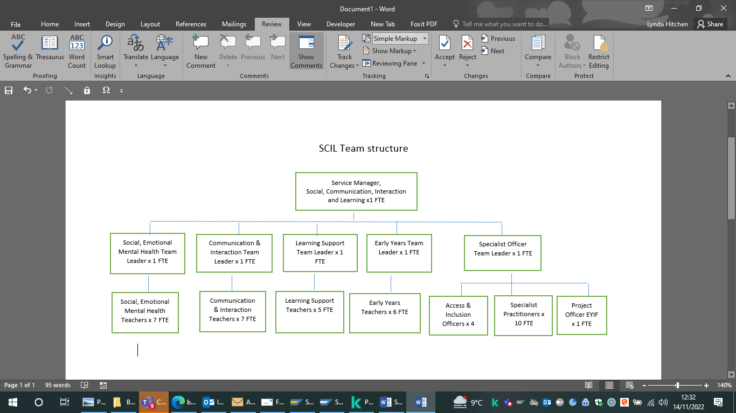

Special Knowledge Requirement: Essential for shortlisting
Applicants with disabilities are only required to meet the essential special knowledge requirements shown by a cross in the end column
 | Essential
Due to the Government’s fluency in English duty for posts where employees speak directly to members of the public, the post holder is required to meet the Advanced Threshold level which will be implemented where the post requires a greater level of sensitive interaction with the public.  Able to demonstrate during the interviews:  - Can express themselves fluently and spontaneously, almost effortlessly.  - Only the requirement to explain difficult concepts simply hinders a natural smooth flow of language. | X
Carries out the working practices, procedures and basic operations across a specialist area or number of specialist areas. Carries out a variety of specialist professional or general managerial responsibilities effectively, with a considerable depth of knowledge across a range of areas relevant to the SEND agenda. | X
Uses specialist knowledge of health, safety and safeguarding policies, procedures and regulations (Keeping Children Safe in Education), including risk in own area and/or across other areas of work.  Plans own work, and programmes work for others, taking into account any Health, Safety and Safeguarding policies, procedures and issues  - briefing others where relevant and carrying out checks as/when appropriate, including taking preventative and/or remedial action. Identifies and manages risk, in relation to operational objectives. | X
Uses a range of specialist ICT systems across own work area and or across other areas of work. Understands the requirements surrounding data protection and information security and the relevant transfer of data through internal and external mechanisms. | X
Assists in oversight of a budget, keeping costs within agreed levels for own area and contributes to Corporate savings. | X
Uses, interprets, analyses and communicates complex information from a variety of sources. | X
Detailed and current knowledge of Safeguarding and the Prevent agenda and the ability to advise and respond quickly and appropriately in line with local and national legislation and advice. | X

Relevant experience requirement: Essential for shortlisting
The applicant is required to provide evidence of having previously spoken fluently to members of the public in order to meet the advanced threshold standard outlined under Special Knowledge above.
A minimum of 3 years specialist teaching experience of working with children and young people with SEND in the area of need identified in the Code of Practice specifically Social, Emotional and Mental Health Difficulties.
Experience of delivering high quality professional development and training which has had an impact on improving outcomes for children and young people with SEND.
Recent experience of delivering impactful interventions to children and young people with SEND.
Recent experience of using SEND assessment tools, interpreting and using the results to improve outcomes for children and young people with SEND.
Recent experience of delivering support and intervention in the following area of specialism: Social, Emotional and Mental Health Difficulties.

Relevant professional qualifications requirement: Will be used in shortlisting
- Educated to a degree level
- Qualified teacher status (QTS)
- Evidence of further study/professional accreditation in the field of Special Needs and Disabilities

Core Employee competencies at manager level to be used at the interview stage
Carries Out Performance Management – covers the employee’s capacity to manage their workload and carry out a number of specific tasks accurately to a high standard.
Communicates Effectively – covers a range of spoken and written communication skills required as a regular feature of the job. It includes exchanging information/building relationships, giving advice and guidance, counselling, negotiating and persuading and handling private, confidential and sensitive information.
Carries Out Effective Decision Making – covers a range of thinking skills required for taking initiative and independent actions within the scope of the job. It includes planning and organising, self-effectiveness and any requirements to quality check work.
Undertakes Structured Problem Solving Activity - covers a range of analytical skills required for gathering, collating and analysing the facts needed to solve problems. It includes creative and critical thinking, developing practical solutions, applying problem solving strategies and managing interpersonal relationships.
Operates with Dignity and Respect - covers treating everyone with respect and dignity, maintains impartiality/fairness with all people, is aware of the barriers people face.
Management Competencies: to be used at the interview stage
Operates with Strategic Awareness Our managers work with corporate priorities and policies in a joined up way with others, internally and externally. Works democratically, transparently and accountably.
Practices Appropriate Leadership Our managers motivate their staff to exceed expectations through raising their awareness of goals and moving them beyond self-interest for the sake of the team or service. They consider serving the District in all that they do.
Delivering Successful Performance Our managers monitor performance of services, teams & individuals against targets & celebrate great performance. They promote the District’s vision & work to achieve Council’s values & agreed outcomes.
Applying Project and Programme Management Our managers work to ensure that outcomes and objectives are achieved within desired timescales, make best use of resources and take a positive approach to contingency planning.
Developing High Performing People and Teams Our managers coach individuals and teams to achieve their potential and take responsibility for continuous improvement. They champion the Council’s values and goals.

Working Conditions:
Must be able to perform all duties and tasks with reasonable adjustment, where appropriate, in accordance with the Equality Act 2010 in relation to Disability Provisions.
Special Conditions:
No contra-indications in personal background or criminal record indicating unsuitability to work with children/young people/vulnerable clients/finance Enhanced DBS check required.
The post holder is required to have a useable car available at all times or as advised by the line manager. The post is designated Casual Class 1 Car User status for the better performance of the duties for which the HMRC rate is payable.
Compiled and reviewed by:  Lynn Donohue  Date: 04.02.2021 | Grade Assessment Date: | Post Grade:  UPS/MPS + SEN allowance

