Home Farm Primary School

Attendance and Family Support Worker



**Contents**

1. Welcome letter from the Headteacher
2. Our School – Pupil views
3. Key Facts, Statistics and Location
4. Copy of the advert
5. Statement of the school’s values and ethos
6. Job Description and Personnel Specification
7. Equal Opportunities
8. Key Dates summary

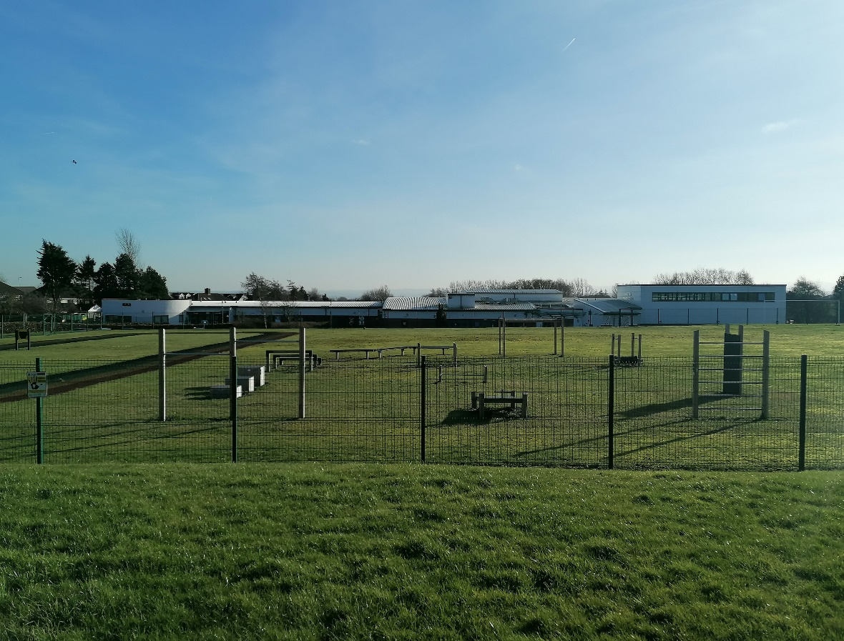

**Letter from the Headteacher**

Dear Applicant,

Thank you for your interest in the vacancy for our Attendance and Family Support Worker position at Home Farm. I hope you find this information pack useful and that it encourages you to apply for this exciting position within our school community.

We are a two form entry school with 466 pupils on roll. Our pupils come from a range of backgrounds and our school is rightly proud of the work we do with, and the support we provide to, the community that is in our catchment area. We use our Home Farm values to underpin the work we do for all who are part of our school.

Home Farm is a welcoming, happy school on the outskirts of Bradford, with wonderful pupils and a hardworking, committed staff who have helped shape the culture of the school into a nurturing and vibrant educational establishment. We collaborate well with other schools in the local area and additionally, are developing stronger links with the high schools.

Therefore, we are looking for an outstanding individual who can lead our school forward in an innovative, nurturing and creative manner. Our school is looking to appoint someone who can utilise our many strengths and also see what’s needed to move our school to the next level. The ideal applicant should be able to use our embedded ethos to work with parents, governors and the local community to ensure the best outcomes for our pupils. Please have a look at our website ([https://www.homefarm.bradford.sch.uk/](https://www.homefarm.bradford.sch.uk/bradford/primary/homefarm)) where you can find more information and our latest reports.

I invite you to come and visit the school, to have a look around and judge for yourself, as I am certain visiting would encourage you to apply. We look forward to your application and seeing what you can bring to our school.

Yours Sincerely,

Joanne Poole, Headteacher

*“Coming to school makes me happy. I am proud of the Home Farm Way.” KS1 Pupil*

*“I have lots of kind friends. My teachers help me learn and they are very kind.” KS1 Pupil*

**H**onesty

**O**pportunities

**M**utual Respect

**E**njoyment

**F**riendship

**A**chievement

**R**esilience

**M**aturity

*“Everyone is kind and helpful, and say how nice the teachers are. The teachers help every pupil. Not all schools have Home Farm Values, that’s what makes us special.” KS2 Pupil*

*“I love everything about Home Farm.” KS2 Pupil*

**Key Facts and Statistics**

|  |  |
| --- | --- |
| Type of School | Community |
| Age Range | Nursery, 5-11 |
| Number of Children | 466 |
| % of children with SEN support | 13.3% |
| % EHCP | 2.8% |
| % of children with EAL | 14.6% |
| % eligible for free school meals | 29.2% |
| Pupil Premium (2018/19 budget) | 30.7% |

**School Location**

Home Farm Primary School  
Home Farm Close  
Bradford  
West Yorkshire  
BD6 3NR

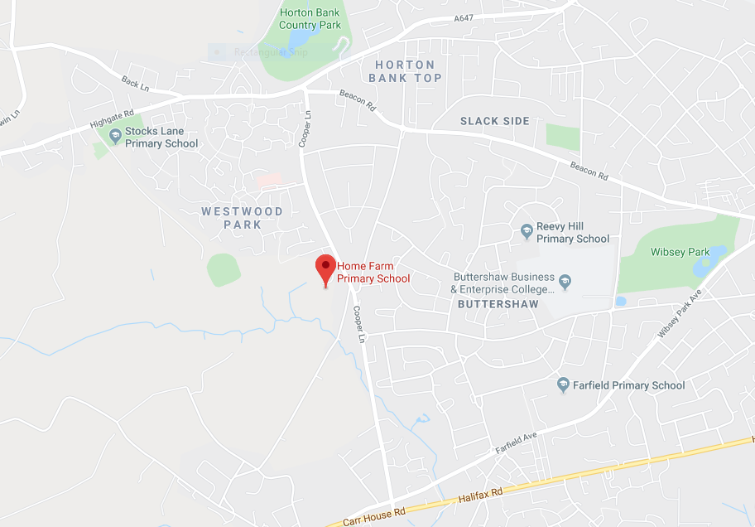

**Attendance and Family Support Worker**

**Salary Range Band 6/7 (Depending on experience)**

**Actual Salary £16,093 - £19,760**

**Start Date – As soon as possible**

Our school is looking for an ideal candidate to become the Attendance and Family Support Worker of our inclusive, pupil-centred, ambitious school which is looking forward to the next phase of its development.

We are looking to appoint an Attendance and Family Support Worker who will build on and develop the vision of our dedicated, hard-working team who have our ‘Home Farm Values’ as the centre point for their educational ethos.

We are looking for an Attendance and Family Support Worker who is:

* Able to build on our achievements and develop a clear vision for the successful future of the school.
* Able to develop parent/carer engagement to ensure excellent attendance for all pupils
* Passionate about raising standards and has a proven track record of doing so.
* Committed to supporting social, emotional development, health & wellbeing
* Proactive in developing community links
* Compassionate and supportive when working with the Safeguarding lead in their work with pupils and their families.
* Innovative and adaptable in finding solutions to challenges.

We can offer:

* The opportunity to work in a welcoming and hard working two form entry school, with pupils who are determined to do their best and enjoy coming to school.
* A committed and very hard-working team who are determined to help all children reach their potential.
* A senior leadership team who support, develop and give their all to the school.
* A Special Educational Needs provision that gives all our children with additional needs the tools and support they need to succeed in school.
* Our ‘Home Farm Values’, which are the corner stone of our learning journey.
* A network of schools that work closely to help improve and drive forward excellent educational practice (Great Heights Partnership)
* A supportive and highly engaged governing body.
* The opportunity to take our school on a journey of success.

We would be delighted to welcome you to our school to meet the team and our wonderful children.  Please make an appointment by contacting the school on 01274 777020

Further information about our school is available at: [https://homefarm.bradford.sch.uk/bradford/primary/homefarm](https://homefarm.bradford.sch.uk/bradford/primary/homefarm" \t "_blank)

Closing date: Midday, Tuesday 21st March 2023.

Shortlisting: 23rd March 2023.

Interviews: 28th March 2023

Please do not send a CV. For the purposes of Equal Opportunities, we can only accept Bradford Council application forms via the Prospects website: <https://prospectsonline.co.uk/>

Home Farm Primary School is committed to safeguarding and promoting the welfare of children and the successful applicant will be subject to an enhanced disclosure through the Disclosure and Barring Service.

**Statement of school’s values and ethos**

Our School Values

**H**onesty

**O**pportunities

**M**utual Respect

**E**njoyment

**F**riendship

**A**chievement

**R**esilience

**M**aturity

British Values

At Home Farm Primary school we provide opportunities for pupils to explore their own culture and have a clear understanding and appreciation of a wide range of the cultural influences that have shaped modern Britain.

We are a school for *all.* We recognise the multi-cultural, multi-faith nature of our community and of Britain. We understand the crucial role our school plays in promoting British Values.

**Job Description**

**Attendance and Family Support Worker**

**Band 6/7 (Depending on Experience)**

**Actual Salary £16,093 - £19,760**

Hours: 32.5 hours per week term time only– some flexibility in how times are allocated across the week.

**Line of Responsibility**

Attendance and Family Support Worker will be directly responsible to a member of the school leadership team.

**Range of Decision making**

To make decisions, using initiative where appropriate, within established working practices and procedures. The post-holder will be expected to use good common sense and initiative in all matters relating to the liaison with other stake holders, schools, parents/carers and pupils as well as other members of staff.

**Job Purpose**

The purpose of the Attendance and Family Support Worker’s role is to support staff in creating an atmosphere in school which is welcoming to parents, ensuring they feel comfortable in engaging with school. The post-holder will be expected to co-ordinate a range of services and activities to help to raise standards of achievement for all the school community.

Prime objectives will include:

* Ensuring excellent attendance from all pupils
* Developing parent/carer engagement with their child’s learning
* Creating opportunities to develop parents as learners
* Supporting social, emotional development, health and well-being
* Working with parents/carers and others so children achieve regular attendance
* Supporting and encouraging the school’s ethos and its objectives, policies and procedures
* Developing community links
* Working with the Safeguarding lead in their work with pupils and their families

**Duties & Responsibilities**

Main duties and responsibilities are indicated below. Other duties of an appropriate level and nature may also be required, as directed by the Headteacher.

**Conditions of Employment**

The post holders responsibilities are subject to the general duties and responsibilities contained in the written statement of condition of employment (the Contract of employment).

The post holder is required to support and encourage the school’s ethos and its objectives, policies and procedures as agreed by the governing body.

To uphold the school’s policy in respect of child protection matters.

S/he shall be subject to relevant statutory and institutional requirements.

The post holder may be required to perform any other reasonable tasks.

The job description allocates duties and responsibilities but does not direct the particular amount of time spent on carrying them out and no part of it may be so constructed.

This job description is not necessarily a comprehensive definition of the post. It will be reviewed at least once a year and it may be subject to modification at any time after consultation with the post holder.

All staff participate in the school’s appraisal scheme.

**Job Specification**

**Operational**

* To establish and maintain good relationships with all pupils, parents/carer, colleagues and other professionals.
* To link with the Parents Group to build positive relationships between them and the school
* To ensure parents/carers and families feel confident to engage with their child’s learning by facilitating and arranging learning opportunities linked to children’s needs and parents’ personal aspirations.
* To work with parents/carers and families to identify why their child/ren are not achieving full attendance and recommend practical strategies to resolve the situation, working closely with school staff, the child/ren and families.
* To monitor attendance and work with families, other school staff and education social workers to promote improved attendance and punctuality, identifying and implementing strategies as appropriate.
* Monitor student attendance, ensure checks are made on missing students and ensure school information management system is updated so that attendance is properly recorded and accurate data can be retrieved
* To carry out home visits where appropriate to support parents/carers and families in encouraging their child/ren to maintain full regular attendance.
* To provide advice and guidance to staff, students, parents/carers and others.
* Delivering parenting programmes and support groups for parents/carers to promote high quality parenting.
* To encourage good relations and effective dialogue between parents/carers, families and teachers about child/ren progress.
* To ensure parents/carers, families, children are consulted about the support they receive.
* To develop innovative ways to engaging with and developing services for families, especially those who are harder to reach.
* To assist parents with education bureaucracy e.g. free school meals, filling in forms
* To listen to parents and community groups and represent their view to school
* To provide information and explanations to parents about school policies and practices.
* To support community development activity and to work collaboratively with neighbourhood groups and partner organisations.
* To maintain strict professional confidentiality yet understanding the need to share information with other staff and agencies as appropriate in line with school policies and procedures.
* Be aware and support difference, accepting the principles underlying the school’s equal opportunities policy and complying with GDPR Principles.
* To participate in internal and multi-agency groups as appropriate for exchange of information and best practice.
* To build positive relationships with other schools in the locality and liaise with other Parent Support Advisors as appropriate across the cluster.
* To participate in school and local initiatives including with Police and other agencies.
* To report any welfare and/or child protection concerns as per school policies.
* To put up and maintain appropriate displays within the school.
* Attend parents evening and other out of school events (within contracted hours).
* To keep records and all documentation pertaining to meetings and contact with children, and their families.
* To undertake and ensure that all administrative duties, checks, documentation, reports and returns (internal and external) are completed accurately and submitted within required deadlines.
* To audit current provision for parents and identify needs.
* To monitor and evaluate work with parents, collate information, statistics and prepare reports as required by Line manager, Headteacher and the Governing Body.
* To undertake responsibility to ensure that all manual and computerised records and filing systems relating to all areas within post holder’s remit are maintained as required.
* To process, input, extract and analyse information from school’s database system/s.
* To ensure compliance within the school of data protection regulations.
* To take minutes/notes in meetings and circulate necessary information.
* To deal with correspondence promptly and as required.
* To liaise with SLT on student attendance matters and administer and support the SLT as required.

**General**

* To participate in the general life of the school e.g. assemblies, performances, open days, parents’ evenings and meetings with parents/carers and other professionals as required.
* To escort students on educational visits/trips as required.
* To ensure that financial procedures and activities are carried out as required as placing purchase orders and authorising invoices for payment.
* To attend relevant meetings and training sessions as required.
* To arrange and give training sessions to staff when required to ensure that they are aware of procedures and regulations.
* To keep abreast of developments, current initiatives and changes in post holder’s field and communication to staff.
* To comply with policies and procedures relating to child protection, health and well-being (including the administration of medicines), safety and security, confidentiality and data protection, reporting all concerns to an appropriate person.
* To assist in such duties and activities relating to any of the above areas appropriate to grade as the Headteacher and Governors shall from time to time reasonably require.
* Support the efficient running of the administrative function by providing occasional cover to reception as required.
* Take and convey messages from parents about absent children seeking to improve communication between school and parents/carers.
* Comply and assist with the development of policies and procedures relating to area of responsibility as required.

**PERSON SPECIFICATION**

**Attendance and Family Support Worker**

|  |  |  |  |
| --- | --- | --- | --- |
|  | **ESSENTIAL** | **DESIRABLE** | **How this will be identified** |
| **SKILLS AND EXPERIENCE** | * Recent experience of working with parents and children, assisting in their development * Experience of working as part of a team * Recent and appropriate experience of enabling families/carers to access support agencies * Methodical, organised approach to work * A high degree of accuracy and attention to detail * Use of ICT packages including Microsoft Office software * Excellent organisational and time management skills * Ability to fulfil all spoken aspects of the role with confidence. * Influencing skills | * Experience of working in a school * Experience of working with other professionals * Experience of organising activities and promoting events * Experience in attendance monitoring | Application / Interview / References |
| **QUALIFICATIONS** | * 5 GCSEs including English and Math’s | * Designated Safeguarding Lead training * NVQ Level 3 in a relevant discipline or equivalent qualification or experience * Qualifications relating to the post e.g. health, children, practical skills, first aid etc. | Interview / Documents |
| **TRAINING** | * Evidence of self-development * Willing to undertake training as required and assist in training colleagues | * Evidence of training in advanced ICT applications | Application / Interview / Documents |
| **KNOWLEDGE /SKILLS** | * An interest in education * Knowledge and understanding of Safeguarding and Child Protection practices * A good understanding of the principles of supporting parents and in particular, barriers to learning or participation in events * Knowledge and understanding of the needs of young children and their families * An excellent understanding of the range of support services/providers available for parents/children * Good oral and written communication skills * Understanding of child development and learning * Effective use of ICT packages and good keyboard/computer skills * Good literacy/numeracy skills | * Knowledge of relevant policies and procedures relating to working in a school specifically attendance regulations, safeguarding and child protection * Knowledge of Health and Safety requirements * Knowledge of the local area and facilities available to families * General understanding of national/foundation stage curriculum | Application / Interview / References |
| **PERSONAL CIRCUMSTANCES** | * Flexible in terms of working evenings on occasion in line with school calendar * Eligible to work in the U.K. * No contra-indications in personal background/criminal record indicating unsuitability to work with children/young people |  | Interview / References  Documents |
| **DISPOSITION/ATTITUDE** | * Ability to work under pressure and meet conflicting demands within deadlines * Ability to communicate effectively at all levels * Flexible and positive approach to change * Willing to work as part of a team * Professional, working with tact, sensitivity and diplomacy * Ability to maintain a high level of confidentiality and discretion at all times |  | Interview / References |
| **PRACTICAL/INTELLECTUAL SKILLS** | * Analysis and basic problem solving * Proactive | * Creative thinking * Able to contribute to the wider school community and activities | Application / Interview / References |
| **PHYSICAL/SENSORY** | * Must be able to perform all duties and responsibilities in work location with reasonable adjustments where appropriate |  | Interview |
| **EQUALITY & SAFEGUARDING** | Candidates should indicate an acceptance of, and a commitment to,   * the principles of the school’s equal opportunities policies and practices as they relate to employment issues and to the delivery of services to the community”. * safeguarding and promoting the welfare of children and young people | | Interview |

**Equal Rights and Key Dates**

**Equal Rights**

Our School is an equal rights employer. We require our governors and employees to follow our equality policies and to follow all statutory requirements concerning age, race, religious, sex, sexual orientation and disability discrimination. We respect and protect the rights of people with disabilities both in terms of equal opportunity for employment and access to the school's services.

**Disabled Applicants**

Disabled applicants are guaranteed an interview if they meet the essential requirements of the Personnel Specification. As an equal rights employer our school is committed to make any necessary reasonable adjustments to the selection process, the job role and the working environment that would enable access to employment opportunities for disabled people. Where a disabled applicant is being assessed the selection panel's decisions will be based on an assessment of that person's expected capabilities once reasonable adjustments have been made.

**Job Sharing**

Job share applicants are welcome to apply for all full-time posts unless otherwise stated in the advertisement.

**Key Dates**

|  |  |
| --- | --- |
| Closing Date | Midday, Tuesday 21st March 2023 |
| Visits round school | By Appointment |
| Shortlisting Date | 23rd March 2023 |
| Interview Date | 28th March 2023 |
| Start Date | As soon as possible |