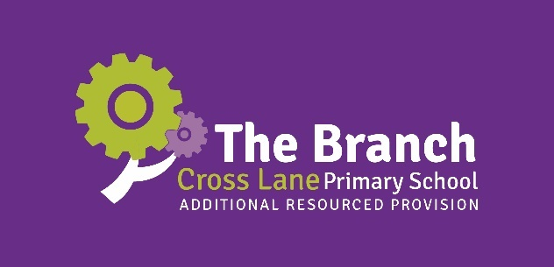

Cross Lane Primary School is graded GOOD in ALL areas (Ofsted, April 2023)

Do you want to work in a school where…

… there is a ‘strong sense of community’?

… there is a ‘significant focus on supporting pupils’ personal development’?

… ‘pupils enjoy and are enthusiastic about their learning across the curriculum’?

… everyone is ‘growing together’?

It is now YOUR once-in-a-lifetime opportunity to take the step you have always wanted to and join our FLAGSHIP SEMH Additional Resourced Provision (in partnership with Calderdale Council) for up to 10 pupils (Years 1-4) as our:

Specialist Teachers

MPS/UPS + SEN allowance

Full Time

x2 vacancies

*Required from April 2025 or at an agreed date thereafter (before September 2025)*

* Do you have the passion, energy and drive to improve the life chances of vulnerable children with social, emotional and mental health (SEMH) difficulties?
* Do you want to surround yourself with like-minded, inspirational colleagues who share the same belief and vision for inclusive education?
* Do you want to enhance your professional and personal learning with opportunities that no other primary school can offer you in this flagship provision?
* Do you want to work within a highly resourced and skilled team where opportunities to work collaboratively, creatively and innovatively are endless?
* Do you want to embark upon a new career path or enhance a current career in specialist education and shape the future success and scope of our provision?
* Do you want to part of a community that prioritises staff wellbeing and workload and promotes *‘work-life brilliance’*?

If so, we need your skills and expertise on our Specialist Team!

Visits to the school are warmly welcomed and encouraged: please contact the school office to make an appointment (01422 372614). You are also encouraged to explore our website and Facebook page to provide you with a greater insight into life at our school.

We are proud of our fully inclusive school. If you would like any assistance with completing the application form, please do not hesitate to ask for support.

An application form and Job Pack (including Job Description and Person Specification) can be downloaded from the school’s website at [www.crosslaneschool.co.uk](http://www.crosslaneschool.co.uk)

Application forms should be returned to the School Business Manager, Mrs Fiona Hodgson: [fhodgson@crosslane.calderdale.sch.uk](mailto:fhodgson@crosslane.calderdale.sch.uk)

Closing Date: Monday 17th March 2025, 3pm

Interviews: w/c Monday 24th March 2025

Safeguarding Statement

Cross Lane Primary School is committed to ensuring a culture of safer recruitment and as part of that implements recruitment procedures that deter, identify, prevent or reject unsuitable people from gaining access to pupils within the organisation. The school adopts a consistent and rigorous approach in the recruitment and selection processes, with the aim of ensuring that those recruited are suitable for such an important and responsible role.

The school is committed to safeguarding and promoting the welfare of children, young people and vulnerable adults and expects all staff to share this commitment. Applicants to posts that are exempted from the Rehabilitation of Offenders Act will require a DBS (formerly CRB) from the Disclosure and Barring Service before the appointment is confirmed, alongside suitable references.



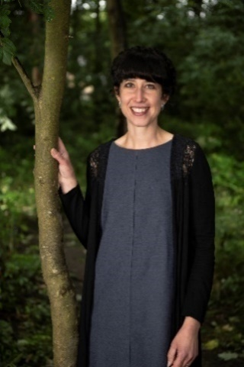

Mr Mark Sharp Mrs Nicola Dumbreck Mrs Emma Wyatt

Headteacher Deputy Headteacher The Branch Manager

Associate Deputy Headteacher

*Closely supported by Calderdale Council colleagues:*

Emma Ingham: SEND and Inclusion Service Manager

Dawn Kimmings: Specialist Inclusion Team

Amanda Rose: Specialist Inclusion Team

Background and Vision

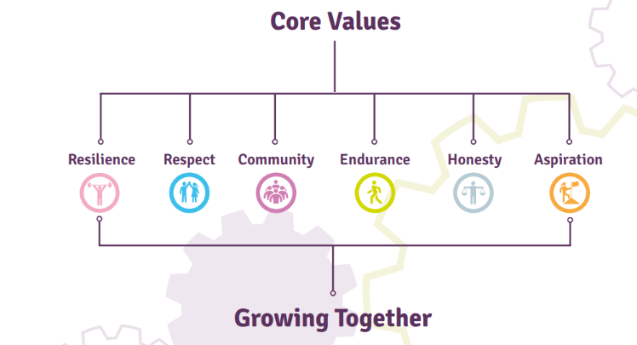

Cross Lane Primary School is a larger than average primary school with over 300 children, from diverse socio-economic and cultural backgrounds, from nursery to Year 6. In recent years, it has been on an incredible journey of transformation – a journey that was applauded in its most recent Ofsted inspection (April 2023), where the school was judged as securely ‘Good’ in all areas (a first in the school’s history).

The school has a strong vision for education and its carefully chosen values underpin the culture and ethos of the school. The school’s supportive Governing Body, staff, families and external partners are wholly committed to *‘Growing Together’* and champion continuous school development. The clarity of which is reflected in the school’s current 2020 Vision:

* ‘providing a rich and inspiring education for all’;
* ‘investing in high-quality CPD at all levels’;
* having a ‘productive, pedagogical-informed culture and climate of teaching and learning’;
* fostering ‘positive collaboration and partnerships’;
* where everyone ‘upholds high aspirations for all’.

The commitment to this vision, alongside the consistent hard work and dedication of all stakeholders, has allowed us to ultimately realise the ambition of becoming ‘the next flagship school: a beacon of excellence’ as we open Calderdale’s **first** primary SEMH Additional Resourced Provision in Summer 2025.

The aptly named SEMH Additional Resourced Provision, **‘The Branch’**, is the first of its kind in the authority and we are proud to work in funded partnership with Calderdale Council’s SEND and Inclusion Team to provide up to 10 places for pupils in Years 1, 2, 3 and 4, where SEMH is identified as a primary need on the pupils’ Education, Health and Care Plans (EHCPs).

The name of the provision stems from the school’s powerful branding, culture and legacy.

Cross Lane Primary School’s motto of *‘Growing Together’* is steeped in the school’s history. The school has an enviable reputation for its expansive outdoor space, its commitment to high-quality provision and its aspiration for continuous growth across all aspects of education. Its easily identifiable school logo and branding – with a tree and branches at its core – reflect what Cross Lane is all about… *new* opportunities, *new* journeys, *new* learning, *new* growth, *new* hope.

The Branch, as an integral part of the school, will provide you, the specialist and wider school teams and the pupils within the provision the ‘*new’* you all deserve. Expedite this job opportunity as a *new* branch in your career: a *new* lease of life for realising the true you.

At Cross Lane, there is a highly-skilled and experienced team of staff who are all committed to providing a safe environment and a high-quality education for all of its learners. Our expectations are high and we work relentlessly and at pace to realise them. Our belief is that all children, whatever their background and starting points, can achieve highly and will do in our care. We know that children only get one chance at their education and we have a duty to ensure that at the end of each stage, they are ready and prepared for moving on to the next.

Alongside the strong focus on progress and attainment within the provision, a thoughtfully-planned programme of enrichment, opportunity and curriculum enhancement is in place that not only tailors a curriculum to meet each learner’s individual needs, but one that also encourages them to develop their passions and interests, nurture their social and emotional growth and embrace the supportive community and stability around them, thus, allowing them to flourish across many areas of learning.

We aspire for our children to be truly involved and excited by their education and we listen carefully to their voice and understand the behaviours they demonstrate, believing that all good work is formed on strong, positive relationships. As a member of the team at Cross Lane, this is a fundamental non-negotiable within all remits of all roles.

One of the many benefits of the role of **Specialist Teacher** in The Branch is the accessibility to work in an environment that does not have some of the additional pressures of the mainstream classroom, where one can truly immerse themselves in research-informed pedagogy and creative thinking, planning and delivery. Furthermore, this important role will provide you with some of the best professional learning and experience and will rival any CPD packages offered by other mainstream primary settings.

Do you want to be a teacher who:

* has true autonomy in how they deliver the curriculum to meet learners’ needs?
* is supported to take measured risks by school leaders who provide you with the opportunity to do so?
* is surrounded by colleagues who are experts in their fields and enhance the provision?
* works closely with mainstream staff and external partners so that your professional learning is enhanced, rather than restricted or minimised, to create an enviable CV for future career progression?
* has ease of access to the necessary resources, including therapies, to provide high-quality and purposeful learning experiences inside and outside the classroom?
* utilises the great outdoors to promote the positive mental health and wellbeing of all?
* has dedicated time in the school day to reflect on practice with colleagues who inspire, motivate and challenge?
* plays an influential role in a forward-thinking school that proactively responds to the ever-changing world of education?
* is pivotal in the creation of the school’s new 2025-2030 vision that will be lived out in the school’s brand-new building and state-of-the-art facilities?

We are uncompromising in our drive for the very best for every single child and adult and their unique circumstances.

If you think you are the right person to join our ambitious team, please do apply and branch out into this *new*, exciting and rewarding world.

*‘Living with fear stops us taking risks, and if you don’t go out on the branch, you’re never going to get the best fruit.’*

*–* Sarah Parish









Just look at their faces… come and be part of something remarkable and realise your true potential.



**The Branch at Cross Lane Primary School**

**Specialist Teacher SEMH Additional Resourced Provision: Job Description**

**Post Title: Specialist SEMH Teacher**

**Responsible to: Headteacher**

**Salary: MPS/UPS + SEN allowance**

Cross Lane is committed to safeguarding and promoting the welfare of children and young people and expects all staff to share this commitment. The following information is provided to assist teaching staff to understand and appreciate the work content of their post and the role they are to play in our SEMH provision – The Branch.

The post holder is required to carry out the duties of a teacher as set out in the School Teachers’ Pay and Conditions Document and in accordance with the school’s aims and policies. You may also be required to work with mainstream schools, including Cross Lane, to assist with effective transition procedures and offer support and advice regarding pupils with Special Educational Needs.

This job description is not definitive of the post; duties may vary within this framework in line with its general character and level of responsibility entailed. This document does not permit every item to be specified in detail, nor does it direct the particular amount of time to be spent on carrying them out.

In addition, if the post holder is on a UPS Scale, they will be required to carry out additional duties and responsibilities to those listed, in relation to specifics within their role.

The duties of Main Professional Grade teachers include the following:

**Teaching:**

In each case having regard to the curriculum for the school, and with a view to promoting the development of the abilities and aptitudes of the pupils in any class or group assigned to him/her.

* Planning and preparing excellent lessons for his/her group/class
* Teaching, according to their educational needs, the pupils assigned to him/her, including the setting and marking of work to be carried out by the pupil in school and elsewhere
* Assessing, recording and reporting on the development, progress and attainment of pupils
* Contributing towards curriculum development and appropriate differentiation within the provision and mainstream school
* Sharing in maintaining good order and discipline
* Advocating for inclusive practice across all areas of school life
* Establishing and maintaining effective, high-quality relationships with all stakeholders
* Liaising positively with supporting agencies
* Organising and attending EHCP reviews alongside The Branch manager

**Other Activities:**

* Championing equality, diversity and inclusion
* Adhering to safe working practices
* Promoting the excellent progress and well-being of individual pupils and group/class
* Providing guidance and advice to pupils on educational and social matters and on their further education and future careers, including information about sources of more expert advice on specific questions
* Making records of and reporting on the personal, emotional and social needs of pupils
* Communicating and consulting with parents/carers of pupils
* Communicating and co-operating with persons or partner agencies outside the school
* Participating in meetings arranged for any of the purposes described above

**Pupil Progress:**

* Providing or contributing to oral and written assessments, reports and references relating to individual pupils and groups of pupils, including the analysis of data in order to provide reports to: the Senior Leadership Team, the Governing Body, the Local Authority and other agencies, as required
* Ensuring adherence to all statutory assessment and reporting arrangements by individuals within the team and advise the SLT accordingly
* Contributing to reviews of identified pupils and support with the achievement of the outcomes identified in the EHCP
* Monitoring and evaluating the effectiveness of the support provided to provision and mainstream colleagues
* Taking responsibility for named pupils within the Additional Resourced Provision
* Sharing progress with colleagues across school, parents/carers and agencies, through rigorous reporting, meetings and contributing with wider Pupil Progress cycles
* Setting and evaluating individual targets (academic and personal/social) including Individual Education Plans

**Appraisal:**

Participating in arrangements made in accordance with the 2011 Regulations for the appraisal or review of his/her performance.

**Review, Induction, Further Training & Development:**

* Reviewing regularly his/her methods of teaching and programmes of work in order to best meet the needs of pupils
* Participating in arrangements for his/her further training and professional development as a teacher, including undertaking training and professional development that aims to meet needs identified in statements of objectives or in appraisal statements, where teachers are subject to the 2011 Regulations, and school/provision development priorities

**Educational Methods:**

Advising and co-operating with the Headteacher and other teachers (or any one or more of them) on the preparation and development of courses of study, teaching materials, teaching programmes, methods of teaching and assessment and pastoral arrangements.

**Discipline, Health and Safety:**

Maintaining good order and discipline among the pupils and safeguarding their health and safety both when they are authorised to be on the school premises and when they are engaged in authorised school activities elsewhere.

**Staff Meetings:**

Participating in and delivering meetings at the school which relate to the curriculum for the provision/school or the administration or organisation of the provision/school, including pastoral arrangements.

**Cover:**

Subject to the paragraph below, supervising, and so far as practicable, teaching any pupils whose teacher is not available to teach them. Except in the case of a teacher employed wholly or mainly for the purpose of providing such cover, no teacher shall be required to provide such cover for more than 38 hours in any school year.

**Administration:**

* Participating in administrative and organisational tasks related to such duties as are described above, including the direction or supervision of persons providing support for the teachers in the school
* Attending and leading assemblies and CPD
* Registering the attendance of pupils and supervising pupils, whether these duties are to be performed before, during or after school

The post holder will be expected to carry out such other duties as reasonably correspond to the general character of the post and are commensurate with its level of responsibility.

*All these responsibilities will be undertaken within the context of:*

*a) The responsibilities of a school teacher as defined in the Conditions of Service*

*b) The expectation of standards for Threshold Teachers as defined by the DfE*

*c) The expectations of standards to Subject Leaders as defined by the DfE*

Cross Lane Primary School is committed to providing access, aids, adaptations and alternatives wherever possible and reasonable to enable disabled people to fulfil the criteria for, and undertake the duties of, its jobs.

**The Branch at Cross Lane Primary School**

**Specialist Teacher SEMH Additional Resourced Provision: Person Specification**

**Post Title: Specialist SEMH Teacher**

**Responsible to: Headteacher**

**Salary: MPS/UPS + SEN allowance**

|  |  |  |
| --- | --- | --- |
| Attributes | Essential | Desirable |
| Experience, Qualifications and Specialist Knowledge | * Qualified Teacher Status * Degree in appropriate area * Professional learning linked to Special Educational Needs and SEMH * Successful teaching experience within the primary sector * Expert knowledge of the EYFS / National Curriculum and the skills to develop a creative and confident approach to curriculum coordination for pupils with SEMH needs * Excellent classroom management and organisation to create an effective, calm and stimulating learning environment for all * Track record of delivering high quality teaching and learning experiences, based on best practice and evidence-informed research and knowledge * Ability to contribute to and work towards school improvement plans as part of a team * Secure understanding of inclusion within the curriculum * Experience of working with children from different backgrounds | * Successful teaching experience within a specialist setting/provision * Strong commitment and experience in the field of SEMH and inclusive practice * Specialist knowledge in therapeutic intervention and/or services, including: drama therapy; music therapy; art psychotherapy; dance/movement psychotherapy * Qualifications and/or interest in child psychology and/or clinical psychology * Experience of teaching in Early Years * Experience of teaching in Key Stage One and Two * Experience of working in social care / residential care * Knowledge of how to effectively plan and lead Continuous Provision * Knowledge and experience of positive relationship strategies * Knowledge and experience of trauma-informed approaches * Team Teach qualification |
|  | | |
| Practical and Intellectual Skills | * High quality and effective interpersonal skills * Ability to effectively plan, assess, monitor and record pupil progress * Ability to use a wide variety of innovative teaching strategies to support all learners * Demonstrate a commitment to safeguarding and health and safety * Ability to establish positive relationships with all stakeholders * Ability to lead, enthuse and inspire colleagues * Demonstrate awareness and understanding of key national issues which affect primary and specialist education * Capacity to contribute to the development of the curriculum | * Commitment to using the outdoors as a valuable learning space * Interests in wider curriculum opportunities, e.g. The Arts |
|  | | |
| Professionalism | * Excellent attendance and punctuality * Support and adhere to school policies and positively promote the school’s ethos, vision and values * Willingness to engage in professional learning * Willingness to undertake extra- curricular activities * Ability to identify and implement action points for improvement * Commitment to confidentiality |  |
|  | | |
| Disposition / Attitude | * Possess exceptional communication skills * Demonstrate enthusiasm, assertiveness and ambition * Possess a cheerful and equitable disposition * Demonstrate a readiness to accept and embrace change; to be adaptable and flexible * Ability to work as part of a team but also independently * Resilience to work under pressure and meet tight deadlines in a fast-paced climate * Be an effective motivator, both personally and with colleagues and pupils * Commitment to equal opportunities: embrace and champion diversity |  |

We look forward to receiving your application soon.

Please do not hesitate to contact the school if you require any further information.

Thank you,

Mr Mark Sharp

Headteacher