CITY OF BRADFORD METROPOLITAN DISTRICT COUNCIL
JOB PROFILE

DEPARTMENT: Children’s Services | SERVICE GROUP: Education, Employment and Skills  Specialist Teaching and Support Services (STASS),  Deaf and MSI Children and Young People Service
POST TITLE: Deaf Instructor | REPORTS TO: Resourced Provision Lead Teacher, Senior Deaf Instructor
GRADE: Band 7 (SCP 11-17) |  | SAP POSITION NUMBER : 501851685

The following information is furnished to help Council staff and those people considering joining the City of Bradford Metropolitan District Council to understand and appreciate the general work content of their post and the role they are to play in the organisation. The duties and responsibilities highlighted in this Job Profile are indicative and may vary over time. Post holders are expected to undertake other duties and responsibilities relevant to the nature, level and scope of the post and the grade has been established on this basis. For posts where employees speak directly to members of the Public the post holder is required to demonstrate their ability to speak fluently in English.

As a candidate you will be expected to demonstrate your ability to meet the special knowledge, experience and qualifications required for the role by providing evidence in the application form for the purpose of shortlisting. Applicants with disabilities are only required to meet the essential special knowledge requirements shown by a cross in the end column of this section.

The employee competencies are the minimum standard of behaviour expected by the Council of all its employees and the management competencies outlined are those relevant for a post operating at this level within our organisation.

Both sets of competencies will be used at interview stage and will not be used for short listing purposes.

Key Purpose of Post

To implement agreed work programmes with individuals and groups, in or out of the classroom. This could include those requiring detailed and specialist knowledge in particular areas and will involve assisting the teacher in the whole planning cycle and the management and preparation of resources.

To take delegated responsibility for the development of BSL (British Sign Language) within the school and associated settings, assist in the training of students on work experience, trainees, voluntary helpers and families with whom the post holder is working.

To support the social and emotional wellbeing of children and young people by adopting an attachment aware and trauma informed approach to all practice. Applying agreed strategies for managing wellbeing including classroom management that foster a nurturing and Emotion Coaching approach.

Main Responsibilities of Post
- Assess the needs of pupils and use detailed knowledge of Deafness and British Sign Language (BSL) skills to support pupils’ learning and assist with the development and implementation of IEPs.

- Provide support in classrooms to ensure effective learning and to follow up with
additional support to ensure learning is secure and pupils receive feedback in in relation to progress and achievement

- Assess and monitor the development of children British Sign Language and plan and deliver BSL lessons to pupils in the Resourced Provision to ensure progress of learning in this area

- Plan and deliver specialist training (such as BSL and Deaf Awareness) to a range of professionals and or parents / carers to support the understanding of Deaf children’s language, communication and learning.

- Plan and deliver specialist curricula or programmes to support the social and emotional development and wellbeing of deaf pupils.

- Promote the inclusion and acceptance of all pupils within the classroom and adopt an attachment aware and trauma informed approach in all interactions with pupils, promoting positive wellbeing and positive emotional regulation

- Monitor and evaluate pupils progress through assessment, observation and planned recording. Provide objective and accurate feedback and reports as required, to the teacher on pupil achievement, progress and other matters, ensuring the availability of appropriate evidence.

- Liaise sensitively and effectively with parents/carers as agreed with the teacher within your role/responsibility and participate in feedback sessions/meetings with parents with, or as directed

- Contribute to assessment and annual review of EHCPs, providing advice, reports and attending meetings when required.

- Work with the teacher in lesson planning, evaluating and adjusting lessons/work plans as appropriate and undertake marking of pupils’ work and accurately record achievement/progress, administer and assess routine tests and invigilate exams/tests.

- Implement agreed learning activities/teaching programmes, adjusting activities according to pupil responses and individual needs

- Attend and participate in regular meetings and participate in training and other learning activities as required.

- Contribute to the overall ethos, work and aims of the school and Children’s Sensory and Physical Needs Team, with a particular focus on the development of a deaf friendly and sign bilingual environment.

- Use ICT effectively to support planning, development of resources and delivery of learning activities.

- Undertake planned supervision of pupils’ out of school hours learning activities. Supervise pupils on visits, trips and out of school activities as required

- Any additional duties as directed by the senior leadership team of the Children’s
Sensory and Physical Needs Service.

Structure:
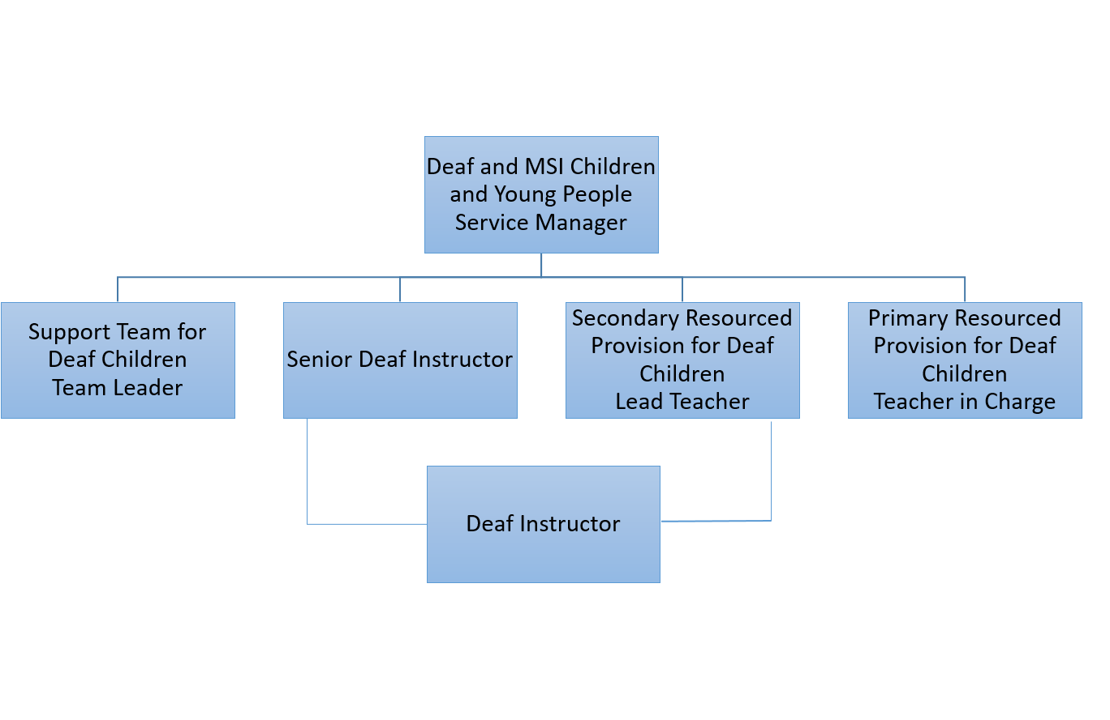

Special Knowledge Requirement: Essential for shortlisting
Applicants with disabilities are only required to meet the essential special knowledge requirements shown by a cross in the end column
 | Essential
Due to the Governments Fluency in English Duty for posts where employees speak directly to members of the public the post holder is required to meet the Advanced Threshold level which will be implemented where the post requires a greater level of sensitive interaction with the public, (e.g. in children’s centres) – where the person is able to demonstrate that they can during the interview:  a) Can express themselves fluently and spontaneously, almost effortlessly  b) Only the requirement to explain difficult concepts simply hinders a natural smooth flow of language | X
Uses knowledge, safety and environmental policies , procedures and regulations, including risk in own area and/or other areas of work (including relevant legislation) | X
Uses a range of specialist ICT systems across own work area and or across other areas of work. | X
Ability to adopt a process of continual improvement and suggest ways of working more efficient and effectively to improve service delivery | X
Knows and understands how to use, interpret, handle and communicate information | X
Knowledge of the implications of deafness on language acquisition and learning | X
Understands the degrees of deafness and respects the varying communication modes and audilogical support available | X
The nature of this post requires the post holder to be a native user of British Sign Language | X
Effective communication and engagement with children, young people and their families  - building trust and establishing relationships  - listening, building empathy and using clear language appropriate to age, ability, culture and personality  summarising, explaining options, consulting and involving children and young people and carers and colleagues in decisions and courses of action | x
Safeguarding and promoting the welfare of the child and young person- This requires understanding what harm or abuse is, recognising it and responding to it proportionately
- assessing risks and emotional resilience
- synthesising and analysing information
- reflecting and making informed judgements
- acting within local procedures, arrangements and resources
aware of own limits and boundaries and others roles

Integrated Working- Working with others in the children and young people’s workforce to put the child at the heart of decision making, offering help at the earliest point  - communicating well, sharing appropriate, succinct, objective information and analysis to aid joint decision making  - being proactive, persistent and prepared to challenge and be challenged  knowing your responsibilities and others roles and joint procedures | x

Relevant experience requirement: Essential for shortlisting
The applicant is required to provide evidence of having previously spoken fluently to members of the public in order to meet the Advanced threshold level outlined under Special Knowledge above.
Have worked with Deaf children and young people | X
Experience of teaching British Sign Language (accredited course)
Experience of working within an educational setting
Relevant professional qualifications requirement: Essential for shortlisting
BSL Level 3 | X
Level 3 Qualification or equivalent e.g. NVQ Level 3, A Levels, GNVQ
Advanced, BTEC National
Level 2 English equivalent | X
Level 2 maths or equivalent | X
Core Employee competencies to be used at the interview stage.
Carries Out Performance Management
Covers the employee’s capacity to manage their workload and carry out a number of specific tasks accurately and to a high standard.
Communicates Effectively
Covers a range of spoken and written communication skills required as a regular feature of the job. It includes exchanging information/building relationships; giving advice and guidance; counselling, negotiating and persuading and handling private, confidential and sensitive information.
Carries Out Effective Decision Making
Covers a range of thinking skills required for taking initiative and independent actions within the scope of the job. It includes planning and organising, self-effectiveness and any requirements to quality check work.
Undertakes Structured Problem Solving Activity
Covers a range of analytical skills required for gathering, collating and analysing the facts needed to solve problems. It includes creative and critical thinking; developing practical solutions; applying problem solving strategies and managing interpersonal relationships.
Operates with Dignity and Respect

Covers promoting equality, treating all people fairly and with dignity and respect, maintains impartiality/fairness with all people, is aware of the barriers people face.

Working Conditions:
Must be able to perform all duties and tasks with reasonable adjustment, where appropriate, in accordance with the Equality Act 2010 in relation to Disability Provisions.
May be required to work occasionally out of office hours as part of a family friendly
service
Special Conditions:
No contra-indications in personal background or criminal record indicating unsuitability to work with children/young people/vulnerable clients/finance
Enhanced DBS check required
Compiled by:  Kren Turner  Date: 13.06.2023 | Grade Assessment Date: | Post Grade:

