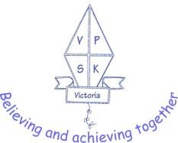
Victoria Primary School

SEND Teaching Assistant

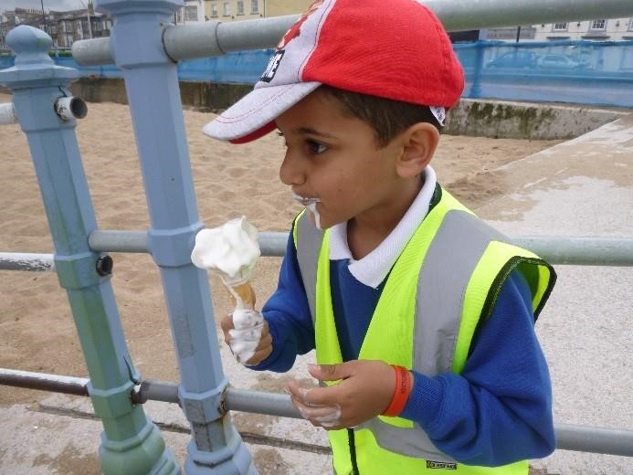 | 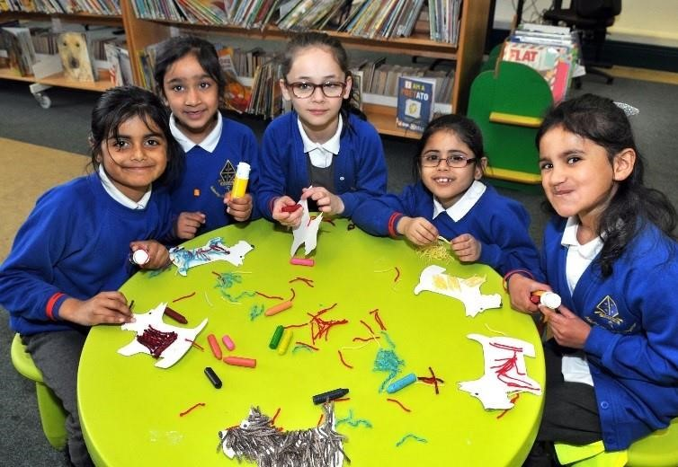 | 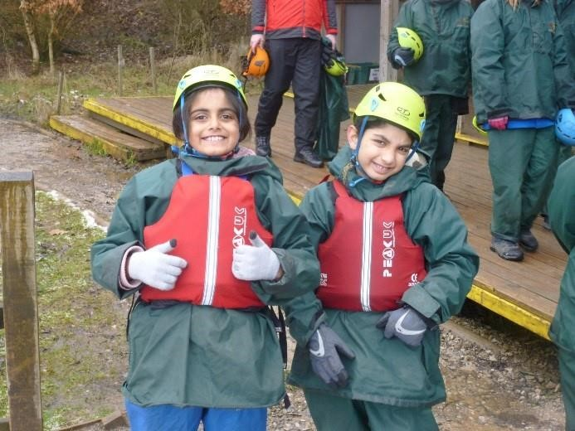
September 2019

Contents

Head Teacher’s Letter………….....………………………………………………………….….……………………………………………. Page 3

About Victoria Primary School ………………………………………………………………………………………………………………… Page 4

Person Specification …………………………………………………..…………………………………………………………………………… Page 6

Job Description.……………………………………….………………..…………………………………………………………………………… Page 8

How to Apply …………………………………………………………………………………………………………………………………………… Page 13

Enclosures

Application Form

Victoria Primary School

Dear Prospective Candidate,

On behalf of the Governing Body, staff and pupils of Victoria Primary, I would like to thank you for expressing an interest in the post.

Victoria Primary School is 1.5 form entry school. There are 296 pupils on roll full time and 40 part-time in our Nursery. We are proud of our school, particularly the good attendance and behaviour of our pupils as recognised by all. Our school effectively promotes celebration of diversity and actively seeks to develop strong partnerships with the wider community.

We are one of the founding schools of the Nurture Academies Trust which includes Victoria Primary, Denholme Primary, Parkwood Primary, Lapage Primary, Byron Primary and Fearnville Primary Schools. We converted to Academy Status on 1st January 2017.

We are a committed staff with a strong drive for school improvement. We are seeking an SEND Teaching Assistant to support the learning journey of an individual child in school, who is an effective team player and can work using their own initiative.

Visits are warmly welcomed and are available by appointment. Please contact the school office on 01535 210110 to make an appointment.

We look forward to receiving your application.

Yours sincerely

J Dark

Mrs Jane Dark

Head teacher
About Victoria Primary School

Our Vision Statement

‘Believing and Achieving Together’
Victoria Primary School is a safe, caring and aspirational learning environment where everyone respects each other. We work in partnership to ensure each child achieves their full potential, has self-belief and is equipped for life.

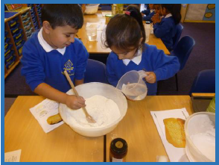  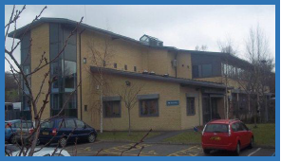 | Our Children  Our school serves a diverse community and includes children of Mirpuri Pakistani, Bangladeshi, African, White British and Eastern European heritage. For the majority of our pupils English is an additional language. Our children are well behaved and keen to learn.  Our Community  Victoria Primary is a popular school. There are good partnerships and high levels of engagement between parents and the community. We are committed to links with the local and wider communities of Keighley and beyond. We work closely with other local schools and with other schools in our Multi Academy Trust.  Our Building  We are a modern purpose built primary school with good indoor and outdoor facilities including a community room that can be used for a variety of purposes. In 2015/6 the school underwent a buildings programme to enlarge the capacity as we continue to increase to a 1.5 form entry school all through. Our Foundation Stage caters well for Nursery and Reception children.  Our Curriculum  Our school is committed to delivering a broad, balanced, creative and rich curriculum to provide quality education for all children. This is based on the National Curriculum and incorporates a wide range of visits and visitors to enhance learning. We have 2 minibuses that are well used and all classes go on at least one visit per half term.
Children learn most effectively through a well-planned, stimulating and challenging curriculum. The curriculum includes a variety of first hand experiences which bring areas of learning alive and really help the children to understand by touching, seeing and doing. Educational visits, visitors and well planned practical opportunities play a vital role in achieving this.  The majority of children’s learning focuses on a theme or topic for a block of time. Science, history or geography may be the main focus with links being made across other areas of the curriculum. English and mathematics are taught both separately and in a cross curricular way where appropriate.  Varied teaching strategies are used according to the learning situation and the needs of the children. The different ways children learn are taken into account when planning for learning. Children work individually, in pairs, in small and large groups and as a whole class.  Home learning tasks are set for children to support or prepare for the learning at school. Children have the opportunity to continue their learning on the school website at www.victoria.bradford.sch.uk  We have made significant changes to our provision in EYFS and have improved the outdoor learning environment for Reception and Nursery children. Access to outdoor learning is free-flow and children have a wide range of resources to enhance their learning. There is a strong team of staff in EYFS who are committed to improving experiences and outcomes for our children.  As the school continues to expand, we now have mixed age classes and are delivering the curriculum on a rolling programme from Y1 – Y6. This enables staff to plan collaboratively and support each other across the curriculum, helping to maintain a high quality of teaching and learning but minimise planning workload. |  | 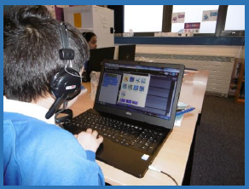  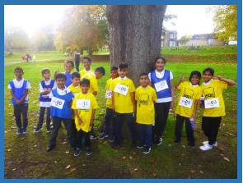  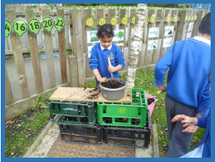

Person Specification – SEND Teaching Assistant

Attributes | Essential | Desirable
Experience | - Experience of working in a team situation.  - Experience of working with pupils who have special needs.  - Experience of working with or caring for children of relevant age e.g. voluntary organisation or parental/caring responsibilities. | - Provide evidence of having previously spoken fluently to customers at an Intermediate Threshold Level
Qualifications | - GCSE English and Maths or equivalent e.g. Adult Literacy/Numeracy at level 1.  - Other relevant qualifications relating to the post e.g. Level 2 NVQ in Health/Childcare, first aid qualification. | - Evidence of further training/development and/or willingness to participate in further training and development opportunities e.g. Team Teach, Moving & Handling, Special Educational Needs.
Knowledge / Skills / Attributes | - Will have knowledge of some of the policies covering their service area.  - Problem solving skills.  - Good communication skills.  - Exercising advisory, guiding, negotiating and persuasive skills at a developed level.  - Good numeracy/literacy skills.  - Basic ICT skills.  - An understanding of the needs of a multicultural society.  - An understanding of the issues relating to pupils who have additional learning needs, more able and special educational needs.  - Knowledge of childcare.  - Awareness of child development.  - Knowledge and commitment to schools Equality policy.  - Ability to relate well to pupils and adults.  - Ability to work constructively as part of a team.  - Ability to remain calm under pressure.  - Demonstrate a commitment to working with children of the relevant age.  - Demonstrate good co-operative, interpersonal and effective listening skills.  - Maintain confidentiality in matters relating to the school, its pupils, parents or carers.  - Ability to perform all duties and tasks with reasonable adjustments where necessary.  - Ability to cope with the requirements of the post, which will include working with pupils who have emotional/ behavioural/physical difficulties and be able to help pupils with self-care when necessary.  - In line with the Immigration Act 2016; you should be able to demonstrate fluency of the English Language at an Intermediate Threshold Level. | - Will possess knowledge of the School’s relevant procedures or practices.  - Will have an outline understanding of relevant legislation.
Equal Rights
Our Trust / School is an equal rights employer. We require our governors and employees to follow our equality policies and to follow all statutory requirements concerning age, race, religious, sex, sexual orientation and disability discrimination. We respect and protect the rights of people with disabilities both in terms of equal opportunity for employment and access to the school's services.

Disabled Applicants
Disabled applicants are guaranteed an interview if they meet the essential requirements of the Personnel Specification. As an equal rights employer our school is committed to make any necessary reasonable adjustments to the selection process, the job role and the working environment that would enable access to employment opportunities for disabled people. Where a disabled applicant is being assessed the selection panel's decisions will be based on an assessment of that person's expected capabilities once reasonable adjustments have been made.

Job Description – SEND Teaching Assistant

Victoria Primary School
Generic Introduction:
The following information is furnished to assist staff joining the School / Trust to understand and appreciate the work content of their post and the role they are to play in the organisation. The following points should be noted:
- Whilst every endeavour has been made to outline the main duties and responsibilities of the post, a document such as this does not permit every item to be specified in detail. Broad headings, therefore, may have been used below, in which case all the usual associated routines are naturally included in the job profile.

- Employees should not refuse to undertake work, which is not specified on this form, but they should record any additional duties they are required to perform and these will be taken into account when the post is reviewed.

- Nurture Academies Trust/This school is an Equal Opportunities Employer and requires its employees to comply with all current equality policies in terms of equal opportunity for employment.

- Nurture Academies Trust/This school is committed, where possible, to making any necessary reasonable adjustments to the job role and the working environment that would enable access to employment opportunities for disabled job applicants or continued employment for any employee who develops a disabling condition.

Prime Objectives of the Post:
To complement, appreciate and support the role of teachers and other professionals by undertaking work/care/support programmes which enables access to learning in the community as part of a teacher planned approach.
To support the class teacher in the management of pupils in the classroom, and other senior staff on a range of teaching and learning experiences which deliver an appropriately differentiated and suitably challenging creative curriculum for all pupils whilst meeting statutory requirements.

Work within school policies and procedures under the direction and guidance of senior staff and within an agreed system of supervision.
May from time to time be required to undertake other duties commensurate with the grade and level of responsibility defined in this job description.
SAFEGUARDING DUTIES AND RESPONSIBILITIES

The school is committed to safeguarding and promoting the welfare of pupils and expects all staff and volunteers to share this commitment. The following is expected of all staff:

- To uphold the school’s policies relating to safeguarding and child protection, behaviour, health and safety and all other relevant policies.
- To promote and safeguard the welfare of pupils for whom you are responsible and come into contact with.
- To ensure full compliance with all statutory regulations, in particular, Keeping Children Safe in Education (2019), communicating all concerns to the Designated Safeguarding Lead, other relevant staff or the Initial Contact Point as appropriate.

Effort Demands:
- Will assist in maintaining the good discipline of pupils throughout school and be expected to use good common sense, as well as use initiative in all matters relating to the conduct and behaviour of individual pupils, groups of pupils and whole classes, the safety, mobility (if required), hygiene and well-being of the pupils; making decisions within established working practices and procedures.

- Will recognise and challenge any incidents of racism, bullying, harassment, victimisation and any form of abuse of equal opportunities, ensuring compliance with the relevant school policy and procedures.

- Will deal with any issues, immediate problems or emergencies that arise in line with school policies and procedures liaising with colleagues where necessary e.g. dealing with a sick, injured or distressed child.

- Acting as a role model, will establish productive and constructive working relationships with pupils, setting high expectations, motivating and interacting with them, being aware of their individual needs, supporting difference and ensuring all pupils have equal access to opportunities to learn and develop whilst responding appropriately.

- Will have the ability to cope with the requirements of the post, which may include working with pupils who have emotional/behavioural/physical difficulties.

- Will contribute to the overall ethos/work/aims of the school.

- Will appreciate and support the role of other professionals.

- Be vigilant and sensitive to any child protection/safeguarding concerns that arise, reporting any concerns to the designated officer in line with school policy and procedure.

Responsibilities:
- Assist in the management of pupils in the learning environment.

- Assist in the planning of learning activities.

- Undertake structured and agreed learning activities/teaching programmes appropriate to the pupil’s needs to ensure physical, social, emotional and intellectual development, taking into account diversity e.g. language, culture, ability, race and religion.

- Will supervise and support pupils consistently at all times; recognising, responding and meeting the individual and physical needs of each child whilst ensuring their safety and education in the learning environment.

- Assist with the development and implementation of Individual Education Plans and Personal Care Programmes; attending to the pupils’ personal needs and maintaining related personal programmes with the correct use of care materials including the safety and well being of the pupils, therapy and medical intervention needs of the pupil and first aid, paying attention to social, health, physical and welfare matters as well as high standards of cleanliness and hygiene e.g. washing, dressing, toileting, and, if applicable, mobility.

- For posts working with pupils who are physically less able, it may be necessary to be able to physically assist the pupil in line with school polices and good practice.

- Will occasionally be required to supervise the class for brief periods during a morning or afternoon session where the classroom teacher is not available.

- Promote and reinforce the inclusion, acceptance and integration of all pupils, including those from different cultures and/or with a different first language as appropriate.

- Set challenging and demanding expectations whilst promoting self-esteem and encouraging pupils to act independently as appropriate as well as interact and work co-operatively with others and engage in activities led by the teacher.

- Will prepare, create and maintain a purposeful, orderly and supportive learning environment to meet the lesson plans. Take responsibility for the care, preparation, maintenance and use of relevant equipment, assisting pupils in its use and clearing/storage afterwards.

- Will be aware of pupil progress, monitor/record pupil responses against pre-determined learning objectives as well as provide accurate, constructive and detailed feedback/reports to the teacher and pupils.

- Promote positive values, attitudes and good pupil behaviour and encourage pupils to take responsibility for their own actions whilst supporting the teacher in managing this. Deal promptly with conflict and incidents (including those involving restraint) and reporting challenging behaviour where appropriate in line with established policy.

- Will gather/report information from/to parents/carers as directed, taking into account parental/carer concerns, dealing with them sensitively under the direction of the teacher.

- Will provide clerical/administrative support as directed by the teacher.

- Will support pupils in the use of ICT in learning activities as directed by the teacher, and develop pupils’ competence and independence in its use.

- Will participate in own performance development, identify and address any training needs/other learning activities.

- Will assist with the supervision of pupils out of lesson times, including before and after school and at lunchtimes, accompanying teaching staff and pupils on visits, trips and out of school activities; taking responsibility for a group under the supervision of the teacher.

- Will assist in the supervision of students on work experience, trainees and voluntary helpers.

environmental demands/Working Conditions:
- Will have long periods of sitting or standing.

- Available to work during school hours during term time and a willingness to be flexible as may be required to attend staff meetings/training sessions outside of usual hours.

- Will have contact with members of the public/other professionals e.g. teaching staff, governors, parents/carers, community groups, local education authority, external providers etc.

- The post holder may occasionally be subjected to antisocial behaviour from members of the public/parents/site users.

- This post may include a degree of manual lifting and handling. You are expected to be aware of health and safety policies and procedures and frequently assess your ability to carry out the lifting tasks required of you.

- Report all concerns to an appropriate person.

Fluency Duty
In line with the Immigration Act 2016; the Government has created a duty to ensure that all Public Authority staff working in customer facing roles can speak fluent English to an appropriate standard.
For this role the post holder is required to meet the Intermediate Threshold Level
Intermediate Threshold Level
The post holder should demonstrate:
- They can express themselves fluently and spontaneously with minimal effort and,
- Only the requirement to explain difficult concepts may hinder a natural smooth flow of language.

Special Conditions of Service:
- No contra-indications in personal background or criminal record indicating unsuitability to work with children/young people/vulnerable clients/finance (An enhanced DBS check is required).

Other considerations
- To be aware of and comply with policies and procedures relating to child protection; being vigilant for signs that children may be being abused and to report any such suspicions to the school’s nominated Child Protection Co-ordinator or the Headteacher.
- To act in accordance with the Data Protection Act and maintain confidentiality at all times e.g. access to staff/student/parent and carers files.

- Accept and commit to the principles underlying the Schools Equal Rights policies and practices.

- Be able to perform all duties and tasks with reasonable adjustments, where appropriate, in accordance with the Equality Act.

- Must be legally entitled to work in the UK.

How to Apply

- If you wish to apply for this post, please complete the application form outlining how you meet the criteria on the job description and the attributes required in the person specification.

- You may supplement your application form with a supporting statement of no longer than two sides of A4. Your supporting statement should outline your reasons for applying for the post and give an indication of what you can offer the school.

- We would be grateful if you could provide details of any daytime and evening contact telephone numbers as well as your email address should you be called for interview.

- Completed applications should be sent to: admin@victoria.bradford.sch.uk

Contact details:
Victoria Primary School
Cartmel Road
Keighley
BD21 2RD
Please mark the envelope: SEND Teaching Assistant
Key Dates
Closing Date: Friday 27th September 2019
Interviews: Week commencing Monday 30th September 2019
Visits: Visits to the schools are welcomed. Please contact the school on 01535 210110 to make an appointment.
Thank you for your interest in our post. We look forward to receiving your completed application. Business Manager

