ST CLARE’S CATHOLIC PRIMARY SCHOOL 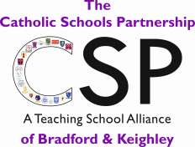
Diocese of Leeds

Fagley Road, Fagley, Bradford BD2 3JD
Headteacher: Mrs C A Utting
Fax/Phone: 01274 637841

Dear Applicant

Thank you for your interest in applying for a post at our school.

St. Clare’s is a strong and successful school with a very well-established and highly effective staff team and very happy, friendly children.

We will be delighted to welcome you to our school, to show you round and to answer any questions you may have prior to your application.

We look forward to meeting you and wish you success with your application.

Yours faithfully

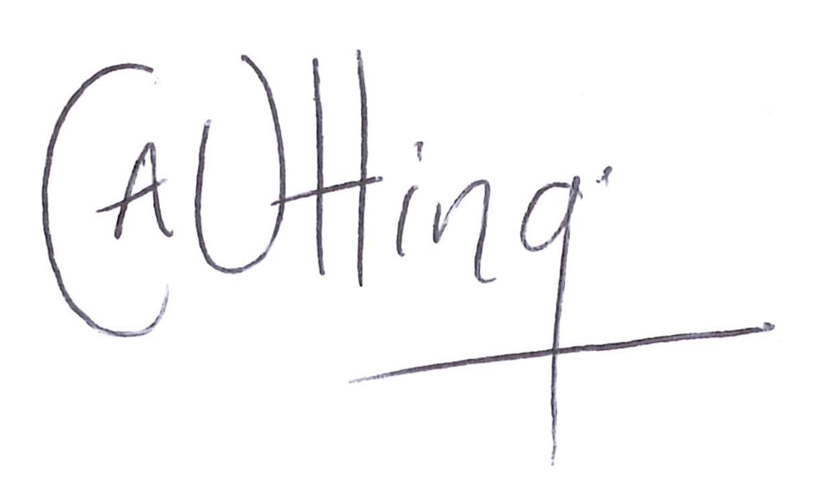
Mrs. C. A. Utting
Headteacher

