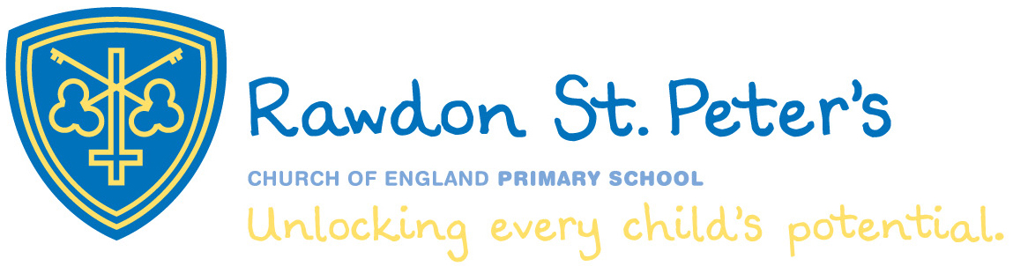

Rawdon St. Peter’s

C of E Primary School

2 x Learning Support Assistant Vacancies

Fixed term for one year in the first instance.

Vacancy 1 – Part Time. 3 days a week. Working pattern to be agreed

Vacancy 2 – Learning Support Assistant. Full Time


RSPCofEPrimary

Learn. Love. Grow

- Job Advert

- Information about our school

- Job Description

- Essentials and Desirables

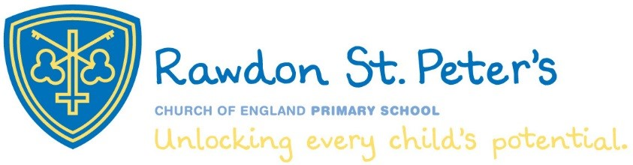

Learning Support Assistant

1 x Part Time (3 days) (Monday – Wednesday or Wednesday to Friday)
1 x Full Time.
Fixed Term

A1/B1

We are looking for an individual to join our team as a Learning Support Assistant. The ideal candidate will be motivated, flexible and able to work as part of a fast-paced team.

The successful candidate will:

- GCSE (Grade C or above) in maths and English or an equivalent Level 3 qualification
- An excellent level of spoken and written English
- A calm and caring nature and the ability to promote our School Vision and Christian ethos
- A flexible approach
- The ability to work successfully as part of a face paced forward thinking team
- Experience of working with children with some additional learning needs.

We can offer:

- A supportive and hardworking team
- Strong relationships with local schools and school community links
- Hard working, committed and enthusiastic colleagues
- An opportunity to make a difference
- Well behaved children who are keen to learn

For more information, please contact the Headteacher for an informal chat.

Discover what a great career move working with us would be!

Contact: v.huzzey@rawdonstpeters.co.uk
Website: www.rawdonstpeters.org.uk
Telephone: 0113 2504201
Town Street, Rawdon, Leeds, LS19 6PP
Closing date: 04th July 2024

Applications should be emailed to the School Business Manager on v.huzzey@rawdonstpeters.co.uk

Welcome and thank you for showing an interest in our Learning Support Assistant vacancy.

Rawdon St Peter’s C of E Primary School is a thriving primary school. Founded by Thomas Layton in 1710, the Old Town School' has evolved over three centuries to become Rawdon St Peter's Church of England Primary School. We are located amidst greenbelt land, in the heart of Rawdon village, nestled at the foot of 'The Billing'.

The school has 316 children on roll and beyond our single aged reception classes, mixed aged classes operate across the school. Most pupils who attend school live locally or in the neighbouring area. We work in partnership with Emma’s Angels who provide before and afterschool club provision alongside a number of extracurricular clubs and opportunities which are run by our Learning Support Staff and external providers.

The children and staff make our school an incredibly special place to be. All our staff work hard to ensure children learn in a safe, inclusive environment where they feel able to take risks and make mistakes. We pride ourselves on building strong relationships based on unconditional positive regard in an environment where children feel connected to their peers. The behaviour and conduct of our pupils, is a real strength of our school, with equal commitment from pupils, staff, parents/carers and governors.

Our curriculum is designed around experiences and supporting children to make memories and emotionally connect through the power of learning. Through our thematic approach, we bring in visitors to run curriculum workshops as well as going on school trips to give pupils an excellent curriculum experience. Our older children in school benefit from residential experiences. We are proud ‘The Hive’ our outdoor learning area, which all children experience each year.

Our mission is to inspire each child and each other to be the best they can be – in every lesson, every day. We have a wonderful Parent Teacher Association and have strong links with schools within the Aireborough Learning Teaching Partnership as well as working alongside local Universities and Teaching Schools to help develop the next generation of teachers. Rawdon St Peter’s is a great way to learn for both children and staff.
We have strong links with the Rawdon Parish Church and are proud of our reputation as an integral part of the local community. We recognise the importance of developing pupils’ spiritual and moral code within the context of the Christian community and faith. Our Key Christian Values decided on by the whole school community and are embraced by everyone. The strong Christian background of the school permeates every aspect of school life including the curriculum and its delivery, resulting in a supportive and caring ethos - in our SIAMS inspection of March 2020 we received the highest grade of excellence.

Being a member of the team is great fun and we cannot wait for the successful candidate to join us. We will provide you with a full induction and you will be surrounded by experienced colleagues who will guide you and show you the RSP way.
Should you have any questions, or wish to visit the school, you are welcome to contact me via the school office.
Kind regards,
Miss L Clapham
Headteacher

