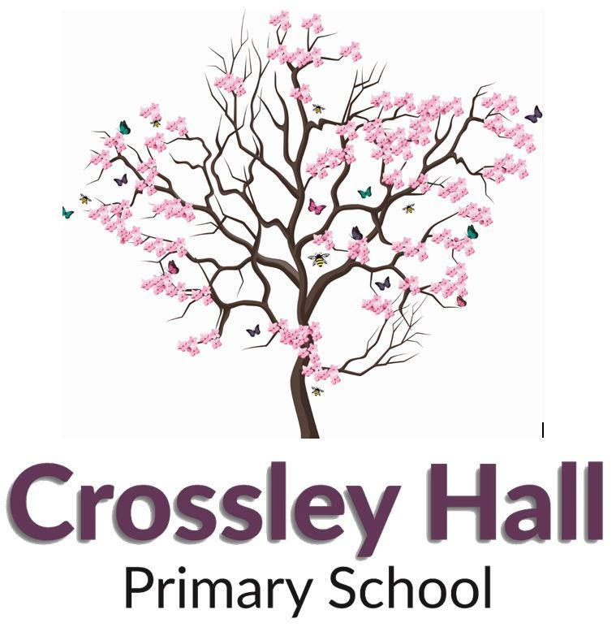

Recruitment Pack
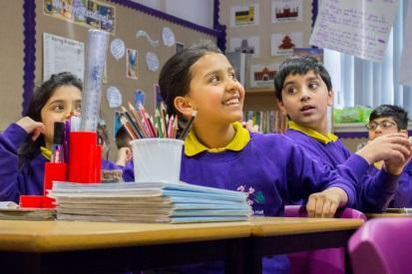
Class Teacher

Crossley Hall Primary School is a member of Pennine Academies Yorkshire
Registered address: Farnham Primary School, Stratford Road, Bradford, West Yorkshire, BD7 3HU
A charitable company limited by guarantee registered in England and Wales (Company number: 10975521)

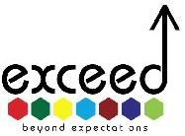
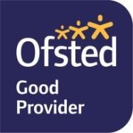
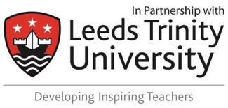
Contact Us!

Contents
- A letter from the Chair of Governors
- An introduction to the school, by the Executive Headteacher and Head of School
- Pennine Academies Yorkshire – Our Vision & Values
- Class Teacher Job Description
- Personnel Specification

Dear Applicant,

Thank you for expressing an interest in our Class Teacher vacancy.

We are seeking to appoint outstanding, inspirational practitioners to become part of our dedicated teaching team. You may be an experienced teacher looking for a new challenge, or a newly qualified teacher looking to make that first step in your career. If you are keen and motivated and want to be part of a creative and energetic team, then we want you!
As a teacher in our 3form entry school, you will work as a team alongside 2 other teachers to plan and deliver outstanding lessons and develop outstanding provision for our pupils. You will teach well-behaved, eager and highly motivated pupils who have a thirst for learning and a curiosity for the world around them. With access to our own minibuses you will be able to create a wide range of rich learning experiences, therefore raising standards and improving outcomes for our pupils.
At Crossley Hall, you are guaranteed a tailored programme of professional development. Our CPD has a proven track record of success with past senior leaders taking promotions as heads or deputies in Bradford schools. Over half of our current teachers joined us as Newly Qualified Teachers, some of which have now progressed to hold TLR posts. We also have strong links with Bradford College, Leeds Beckett and Leeds Trinity Universities, and we train teachers through the Exceed SCITT Programme.
Applications for this post can be submitted via post, email or online, using the approved application form. We would recommend that your supporting statement is presented on no more than 2 sides of A4 paper, stating your experience, strengths and evidence of the impact that your practice has had so far. Please take the time to look at our school website as it holds a wealth of information about our amazing school. We would also strongly encourage any candidate to visit us and discover what a great career move working with us would be. To arrange a visit, please contact Danielle Clifford on 01274 448703 or 07805 449496 or email her at
D.Clifford@chps.paymat.org
We wish you every success in your application and look forward to meeting you.

Yours sincerely,

Chair of Governors
Julie McGovern

Why Choose Crossley Hall Primary?
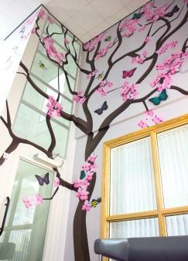
Let us tell you more about our amazing school! We are a thriving, energetic and vibrant three-form entry primary school, situated in the Fairweather Green area of Bradford. Our school stretches across three buildings, a mixture of traditional and modern, both with extensive facilities. We are fortunate to work in an executive leadership agreement with Grove House Primary across the city, sharing expertise and best practice to ensure that all our pupils receive the best education. Lynette Clapham, our Executive Head, leads both schools, with our Head of School (Eleanor Monnery) leading Crossley Hall on a day-to-day basis. Both have worked across Crossley Hall Primary School and Grove House Primary School for a number of years, and are incredibly passionate about our pupils and our wider community.
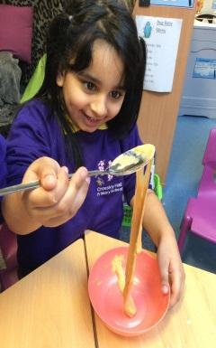
Here at Crossley Hall, our team of dedicated teachers bring our curriculum to life. Reading, writing and maths are taught using evidence-based principles such as ‘Talk for Writing’, ‘White Rose Maths’ and a five-day cycle of whole-class reading lessons. Our approach to teaching the wider curriculum uses elements of practice from the International Primary Curriculum - this is a thematic and creative approach to teaching and learning, and it provides teachers with high-quality resources and ideas as a basis for delivering exciting learning while maintaining a focus on the knowledge and skills from the National Curriculum. We believe that this will prepare our pupils for life as international citizens in modern society, as well as promoting independence.
We complement our classroom-based learning with lots of additional experiences to promote both academic achievement and wellbeing. Children in KS2 participate in a residential ‘adventure,’ and we visit a wide range of places such as the National Media Museum, Eureka and the York Chocolate Story to bring our curriculum to life. Our very own school allotment gets our pupils outdoors, looking after our school animals and growing plants and vegetables. We have an active School Council, a large pupil workforce and an ‘Anti-Bullying Patrol’ to promote kindness and empathy. Furthermore, school does not just end at 3 o’ clock, as we offer a range of after-school clubs that change termly and in the past have included football, reading, dance and drama!
The behaviour of our pupils is very good because we build positive relationships based on mutual respect- everyone is expected to be kind, polite and hard working. As a school, we actively promote diversity, tolerance and respect for people of all faiths and backgrounds, and there is a real sense of harmony and dedication from staff and pupils alike. Our pupils love coming to school! We reward their attendance by holding half-termly attendance celebrations to thank families for their commitment.
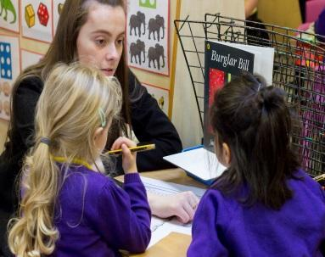
Mental Health and Wellbeing are central to what we do here at Crossley Hall Primary School. Members of our SLT are trained Youth Mental Health First Aiders. We also actively support the wellbeing of our staff; two members of our staff are trained as Mental Health First Aiders and can provide support/advice to our staff.
Not only do we have enthusiastic, well behaved pupils, we also have a talented team of motivated and dedicated professionals, who, along with the leadership team, are united in the strong sense of ambition for the school. Our team of Support Staff are confident and highly skilled. Our inclusive ethos resonates throughout the school, and we are proud to cater fully for our children with additional needs. Our Resourced Provision for children with Communication and Interaction Needs (including Autism) work closely and collaboratively with the rest of the school.
Finally, please rest assured that we take the Professional Development of our teachers seriously. We recognise talent when we see it, and we pride ourselves on nurturing future leaders. Our Head of School started here as our SENCO and Assistant Headteacher, a number of our Assistant Head Teachers started here as teachers, and staff who started as NQTs are now a key part of our Middle Leadership Team with Teaching and Learning Responsibilities across school.
We welcome you to come and visit and find out more!
Lynette Clapham Eleanor Monnery
Executive Head Head of School

