

CONTENTS Page:

Application letter 2

About our school 3

Mission Statement 4

Job Description and Person Specification 5 - 8

Copy of advert 9

How to find us 10

How to apply 11
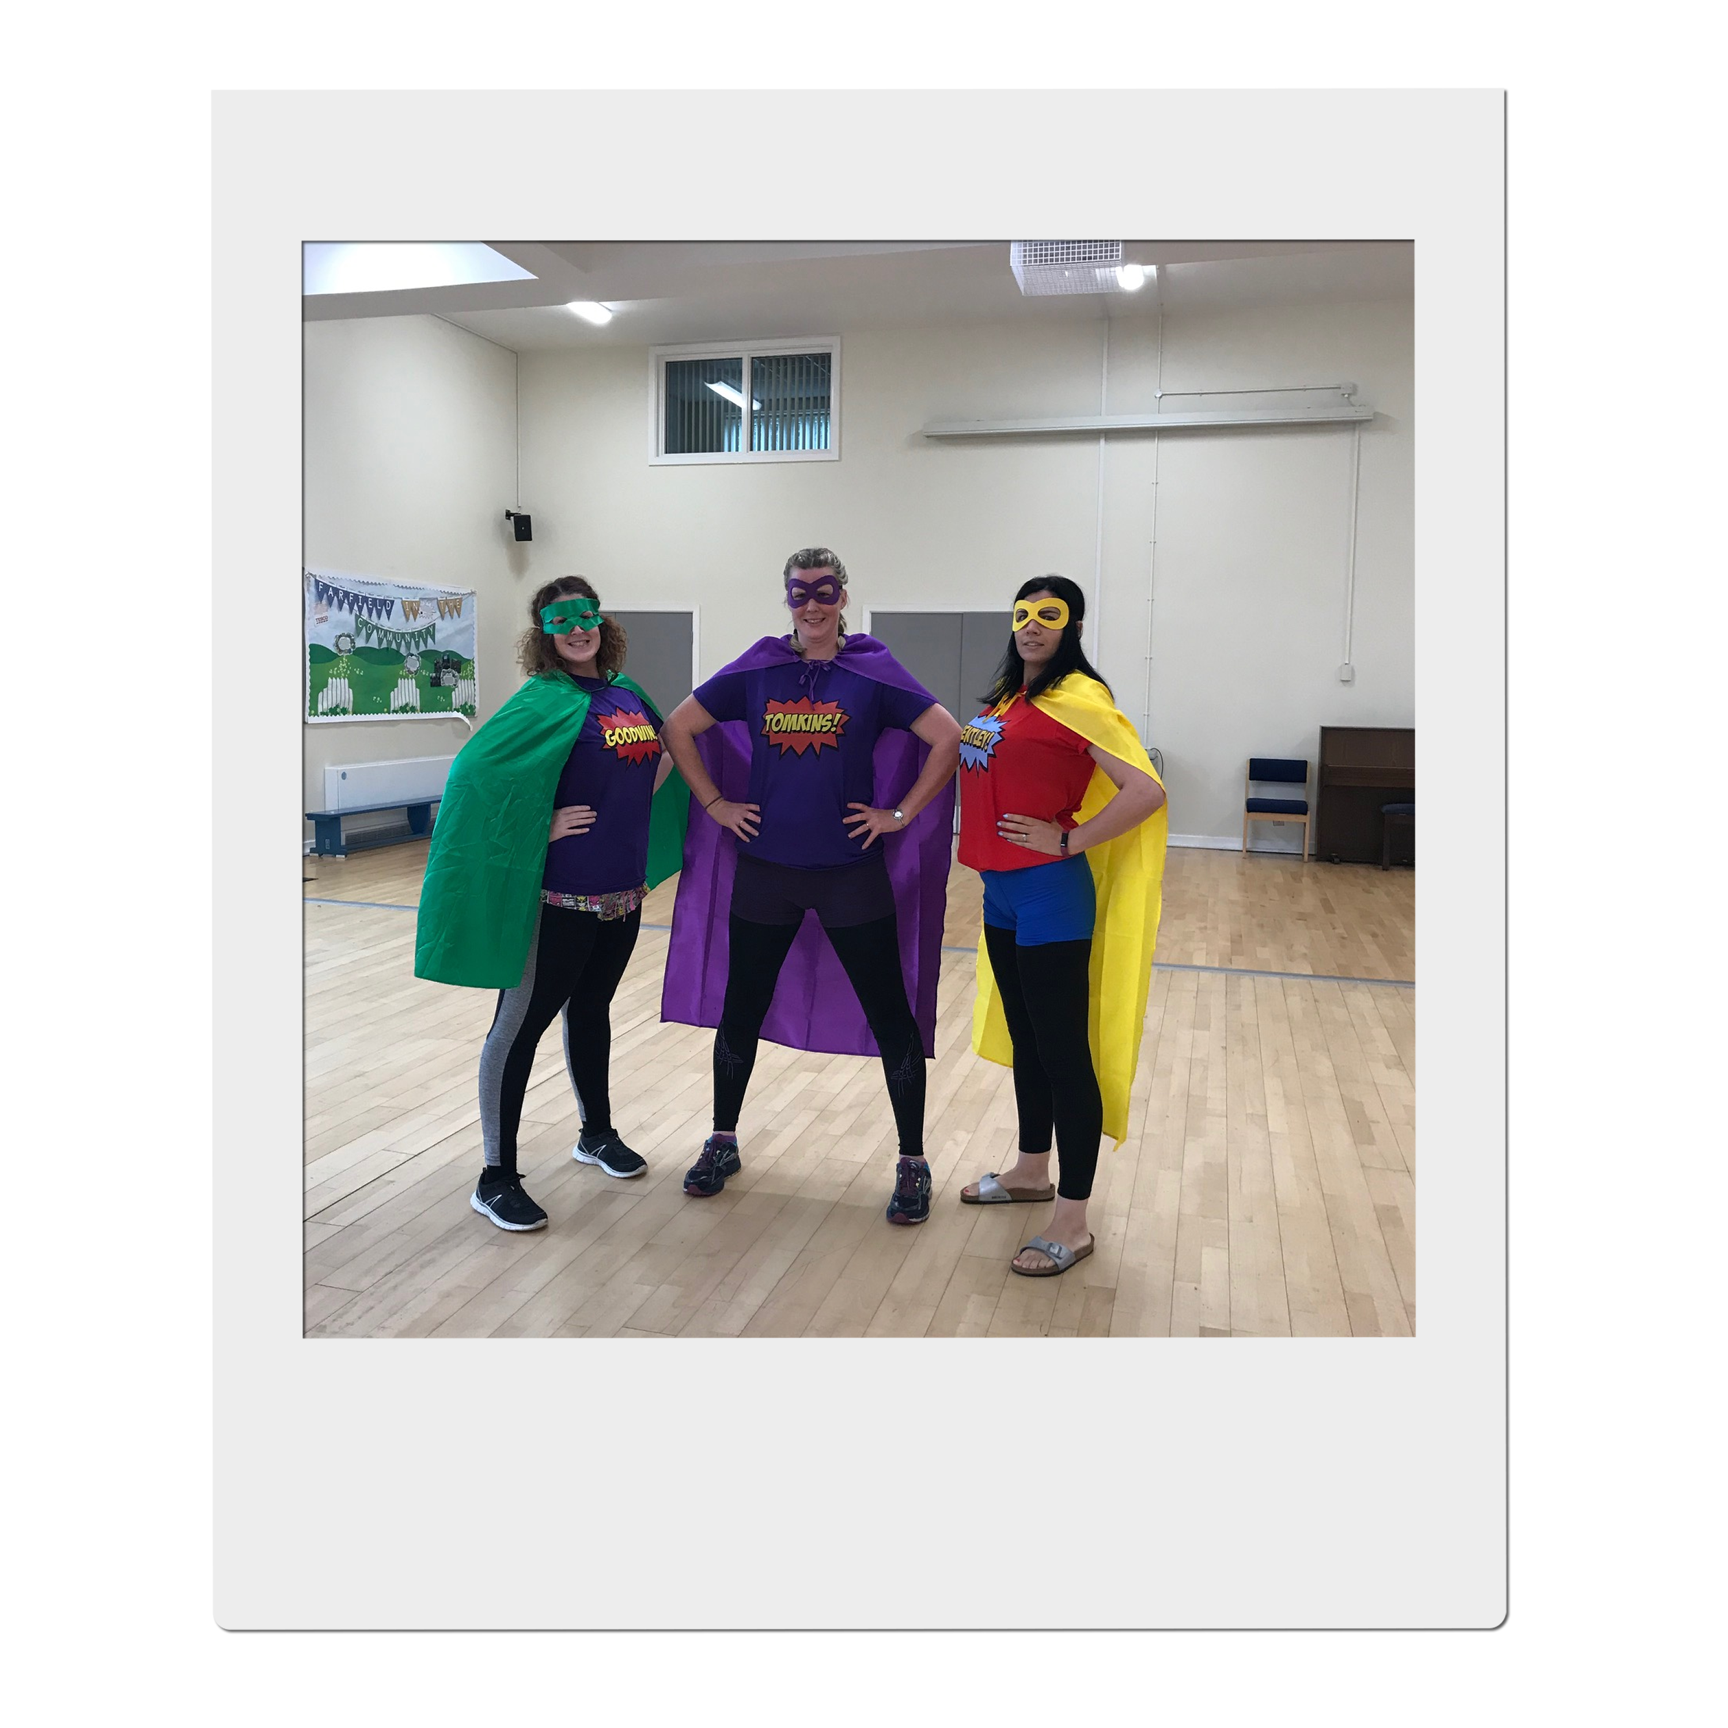
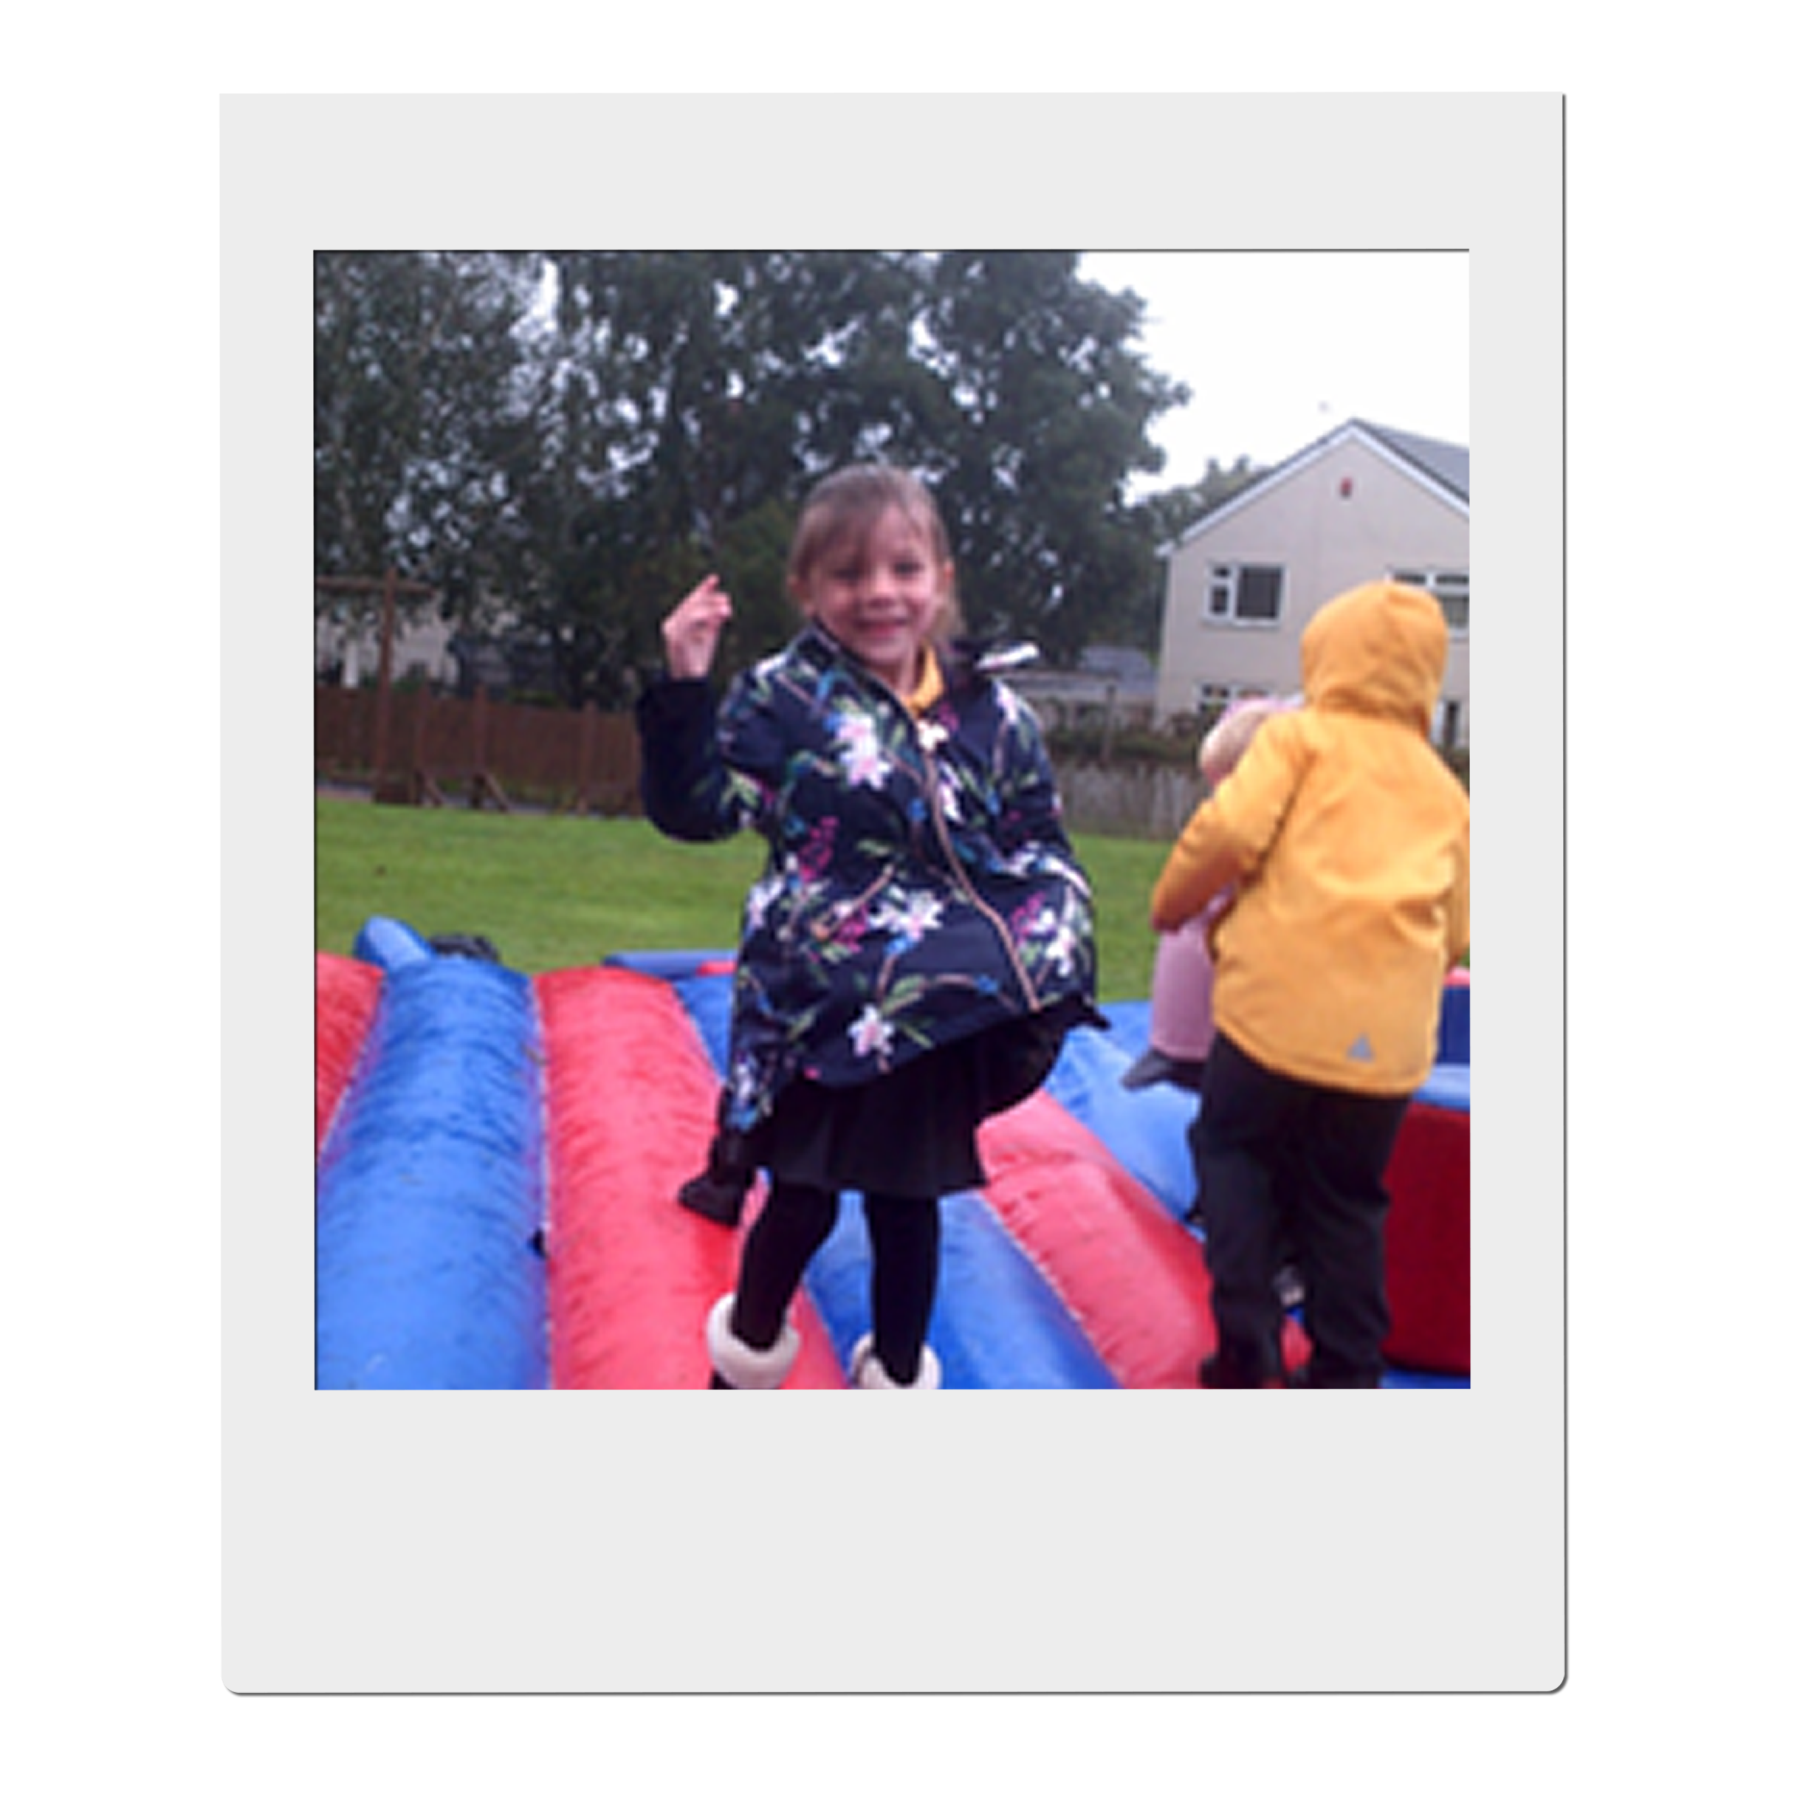



Congratulations
You have taken the first step on an exciting adventure to be part of our team, to inspire and enrich the education of all our children at Farfield Primary and Nursery School.
‘Farfield children can’
This is the belief of all staff and at the heart of everything we do. As Headteacher I want only the best teachers for our children, who are shining examples and strive every day to be ready, respectful, and safe. I expect them to attend school every day and I have the highest of expectations for their education. I want our children to,

“Walk with the dreamers, the believers, the courageous, the cheerful, the planners, the doers, the successful people with their heads in the clouds and their feet on the ground.” Wilfred Peterson
If you are enthusiastic, dynamic, up for a challenge, determined and want to have a positive impact on the education of our children - then fill out an application and tell me what you can bring to our community, what makes you unique and why you are the teacher I would entrust to educate Farfield children. Our priorities are to raise standards in phonics returning them to above 60% and increase combined in KS2 to 65%. All staff no matter what their role in school, know how important it is to ensure this goal is achieved and what they personally contribute to make it happen.
All our children have the potential to reach their goals, and this is a unique opportunity for you to join a supportive, hardworking, caring team and be part of their journey. You ‘MUST’ meet our amazing pupils and speak to our staff about what ‘Farfield’ means to them. Immerse yourself in our daily life and you will know immediately if you have what it takes to be part of our team. Every day is different, but every day is rewarding – we notice the positives and celebrate the differences. We inspire children to be scientists, deep sea divers, entrepreneurs, you name it! But most importantly we want our children to be unique, well-rounded citizens who will make a difference in our future communities.
We are a good school on a journey to outstanding. We will offer support whether you are at the start of your career or an experienced teacher within a community that will inspire and motivate you to be the best teacher you can be.
I look forward to meeting you, showing you around our school and introducing you to our Farfield Family.
Sarah Nichols
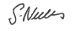
Head teacher
Farfield Primary and Nursery School
Job advert
HLTA's
Salary: £28,770 - £31.364 full time equivalent (this will be pro-rated 37 hours TTO plus 5 days)
Farfield Primary & Nursery School is looking for a skilled and caring adult who can support children in their learning. A key part of this role is to take responsibility for PPA cover of whole classes from EYFS - Year 6, this includes the planning of these lessons, as well as emergency cover as and when needed.
Are you ready to equip children with the knowledge and power to make a difference, to be different and embrace difference?
At Farfield Primary and Nursery School we will trust, support and challenge you to empower our future generations helping them to achieve their full potential and become unique well-rounded citizens.
Our priorities are to raise standards in phonics returning them to above 60% and increase combined attainment in KS2 to 65%. All staff, no matter what their role in school, have this as their focus.
Please click the link to find out more, and then read on : https://drive.google.com/file/d/11EgoPwye-1X6m7tAraPE6jQcDevYkINy/view?usp=sharing
We are looking for a highly motivated, inspirational practitioner who has the drive, vision and inter-personal skills to work with both staff, children, parents and other stakeholders.
We would like someone who cares about the children and is able to support them in lessons, allowing children to make good progress throughout their school career. This is a real opportunity to make a difference. If you are passionate about education and improving life chances, then we are keen to hear from you.
Grade C or above in GCSE English and Maths or equivalent is an essential requirement for this post. Please state all of your qualifications on your application.
We need a HLTA who is an:
- Outstanding classroom practitioner
- Committed to raising achievement through an exciting and stimulating curriculum
- Enthusiastic and forward thinking
- Well organised and creative
- Able to demonstrate excellent interpersonal skills and the ability to work with a range of staff to improve learning
- Able to work in partnership with parents/carers and the wider community

The successful candidate will be able to demonstrate:
- A good sense of humour, enthusiasm and a positive, proactive attitude to their role
- The ability to work well both independently and as part of a team
- Excellent interpersonal and communication skills
- Commitment to your own development
Farfield is a friendly, vibrant and lively school where our children are enthusiastic learners, well-motivated and encouraged to think for themselves. Visitors to our school always comment about the friendly, warm welcome from the staff and pupils.
Closing Date: Monday 8th January 2024, 12pm
Shortlisting: Monday 8th January 2024
Interview date: Wednesday 17th January 2024

Our mission statement

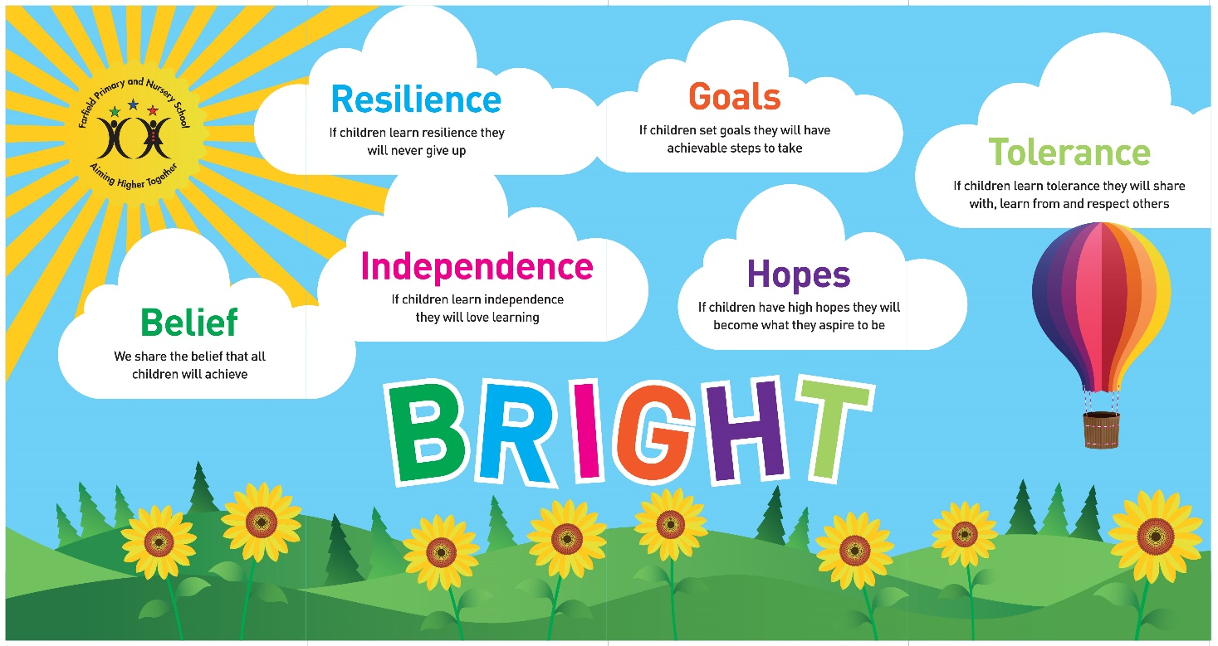

We share the Belief that all children will achieve,
If they learn Resilience they never give up,
If they learn Independence they will love learning,
If they set Goals they will have achievable steps to take,
If they have high Hopes they will become what they aspire to be,
If they learn Tolerance they will share with, learn from and respect others.

Outline Job Description for HLTAs

Post title: Higher Level Teaching Assistant
Payrange: Band 8 SCP 17- 22
Line manager: Headteacher
Supervisory responsibilities: None

Job Description

Core purpose

To complement the professional work of teachers by taking responsibility for undertaking work care/support programmes, under an agreed system of supervision. This will involve planning, preparing and delivering lessons for whole classes and monitoring students and assessing, recording and reporting on students’ achievement, progress and development.
Farfield Primary & Nursery School are fully committed to safeguarding children and promoting their welfare and expects all staff to share in this commitment. All posts are subject to an Enhanced DBS with Barred List check.
This Job Description is furnished to assist staff joining Farfield Primary & Nursery School to understand and appreciate the work content of their post and the role they are to play in the organisation.
Whilst every endeavour has been made to outline the main duties and responsibilities of the post, a document such as this does not permit every item to be specified in detail. This job description is not a definitive list of responsibilities but identifies the key components of the role. The post holder will, therefore, be required to undertake other reasonable duties commensurate with the purpose and salary level of this post.
Employees should not refuse to undertake work, which is not specified on this form, but they should record any additional duties they are required to perform, and these will be taken into account when the post is reviewed.
Farfield Primary & Nursery School is an Equal Opportunities Employer and requires its employees to comply with all current equality policies both in terms of equal opportunity for employment and access to the School’s Services.
Farfield Primary & Nursery School is committed, where possible, to making any necessary reasonable adjustments to the job role and the working environment that would enable access to employment opportunities for disabled job applicants or continued employment for any employee who develops a disabling condition.

Duties and Responsibilities

Support for Students
Assess the needs of students and use detailed knowledge and specialist skills to support students’ learning.
Establish productive working relationships with students, acting as a role model and setting high expectations.
Be aware of and support difference and ensure all students have equal access to opportunities to learn and develop.
Promote the inclusion and acceptance of all students within the classroom.
Encourage students to interact and work co-operatively with others and engage all students in activities.
Promote independence and employ strategies to recognise and reward achievement of self-reliance.
Provide feedback to students in relation to progress and achievement.
Develop and implement ILPs.
Support students consistently whilst recognising and responding to their individual needs.
Take the initiative as appropriate to develop appropriate multi-agency approaches to supporting students.

Support for the Teacher
Organise and manage appropriate learning environment and resources.
Provide objective and accurate feedback and reports as required on student achievement, progress and other matters, ensuring the availability of appropriate evidence.
Record progress and achievement in lessons/activities systematically and providing evidence of range and level of progress and attainment.
Work within an established behaviour and relationships policy to anticipate and manage behaviour constructively, promoting self-control and independence.
Supporting the role of parents in students’ learning and contribute to/lead meetings with parents to provide constructive feedback on student progress/achievement etc.
Production of lesson plans, worksheet, plans etc.
Monitor and evaluate student responses to learning activities through a range of assessment and monitoring strategies against pre-determined learning objectives.
Plan challenging teaching and learning objectives to evaluate and adjust lessons/work plans as appropriate.
Administer and assess/mark tests and invigilate exams/tests as required.

Support for Curriculum

Deliver learning activities to students within agreed system of supervision, adjusting activities according to student responses/needs.
Deliver local and national learning strategies and make effective use of opportunities provided by other learning activities to support the development of students’ skills.
Use ICT effectively to support learning activities and develop students’ competence and independence in its use.
Advise on appropriate deployment and use of specialist aid/resources/equipment.
Select and prepare resources necessary to lead learning activities, taking account of students’ interests and language and cultural backgrounds.
Recognise own strengths and areas of specialist expertise and use these to lead, advise and support others.

Resources
Operate relevant equipment/ICT packages (e.g. MS Office, Internet, School Information Management Systems (Arbor), CPOMS & Email).
Determine the need for, prepare and maintain, general and specialist equipment and resources.
Use administration and teaching supplies resourcefully.
Provide advice and guidance to staff, students, parents/carers and others.
Maintain tidy and organised work spaces and storage areas.
Keep up-to-date knowledge of the range of external agencies and opportunities that can be used to provide extra support for students.

Wider Responsibilities
Be aware of and comply with policies and procedures relating to child protection /safeguarding, equality and diversity, health and safety, ICT, security, confidentiality and data protection, reporting all concerns to an appropriate senior person.
Comply and assist with the development of policies and procedures relating to area of responsibility as required.
Develop effective professional relationships with others.
Be aware of and support difference and ensure equal opportunities for all stakeholders accepting the principles underlying the Farfield Primary & Nursery School equal opportunities policies and practice.
Maintain the confidential nature of information relating to the Farfield Primary & Nursery School its students, parents and carers acting in accordance with the principles of the Data Protection Act 2018 at all times.

Contribute to and support the overall life, work/aims and ethos of the Farfield Primary & Nursery School.
Attend and participate in relevant meetings as required.
Participate and engage in training and appraisal as required.
Undertake additional duties as reasonably requested by senior staff.

Person Specification
HLTA

 | ESSENTIAL | DESIRABLE | How this will be identified
SKILLS AND EXPERIENCE | - Experience of teaching whole classes or large groups of children aged 3 -11  - Able to motivate and inspire children and young people to achieve  - Ability to supervise children effectively  - Excellent organisational and time management skills  - Familiar with ICT packages including Microsoft Office software  - Ability to fulfil all spoken aspects of the role with confidence | - Experience of working with students with individual educational needs  - Ability to drive a minibus | Application / Interview / References
QUALIFICATIONS | - 5 GCSE’s or equivalent (A-C) including English and Maths  - Qualifications equivalent to NQF Level 3  - HLTA Status or equivalent which demonstrates/includes HLTA standards | - Health and safety qualification, e.g, First Aid | Interview / Documents
TRAINING | - Training in relevant learning strategies e.g. literacy.  - Evidence of self-development  - Willing to undertake training as required and assist in training colleagues | - Evidence of training of a particular learning difficulty | Application / Interview / Documents
SPECIAL KNOWLEDGE | - Knowledge of National Curriculum  - Knowledge of education and policies and procedures relating to working in a school  - Understanding of principals of child development and learning processes  - Knowledge of health and safety issues | - Multi-agency working | Application / Interview / References
PERSONAL CIRCUMSTANCES | - Flexible in terms of working evenings on occasion in line with school calendar  - Eligible to work in the U.K.  - No contra-indications in personal background/criminal record indicating unsuitability to work with children/young people | - UK valid driving license | Interview / References  Documents
DISPOSITION/ATTITUDE | - Understanding and commitment to Inclusion  - Ability to remain calm under pressure and meet deadlines  - Ability to use initiative in varying demands of the role  - Ability to communicate effectively at all levels  - Flexible and positive approach to change  - Willing to work as part of a team  - Professional and self-motivated  - Ability to maintain a high level of confidentiality and discretion at all times. |  | Interview / References
PRACTICAL/INTELLECTUAL SKILLS | - Ability to plan effective activities for students  - Creative | - Able to contribute to the wider school community and activities | Application / Interview / References
PHYSICAL/SENSORY | - Must be able to perform all duties and responsibilities in work location with reasonable adjustments where appropriate. |  | Interview
EQUALITY & SAFEGUARDING | Candidates should indicate an acceptance of, and a commitment to,  - the principles of the school’s equal opportunities policies and practices as they relate to employment issues and to the delivery of services to the community”.  - safeguarding and promoting the welfare of children and young people |  | Interview

HOW TO FIND US
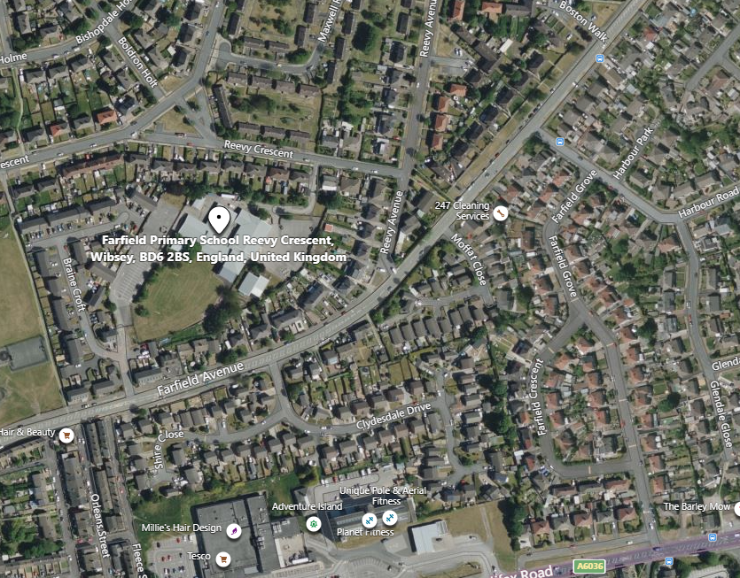

Farfield Primary School and Nursery
Reevy Crescent
Buttershaw
Bradford
BD6 2BS
(For carpark please use satnav postcode BD6 2JF)
Tel : 01274 678545
Fax: 01274 694022
E-mail: office@farfield.bradford.sch.uk

HOW TO APPLY

If you wish to apply for the post of full-time HLTA at Farfield Primary and Nursery School, please log onto the prospects online website at www.prospectsonline.co.uk.

If you wish to arrange a visit to look around Farfield Primary & Nursery School please contact Toni Wilson via email of telephone, farfieldadmin@farfield.bradford.sch.uk, Tel 01274 678545

Upload your completed application form onto the website outlining how you meet the criteria on the job description and attributes required. A continuation sheet may be used if necessary.

We would request that you provide details of daytime and evening contact numbers and email addresses for use should you be called for interview.

The closing date for applications is 12pm on Monday 8th January 2024, with short listing the same day.

You will be informed by email before 6pm on Tuesday 9th January 2024 if your application has been successful.

Interviews will take place on Wednesday 17th January 2024.

Please be available for observation/interview on this day if shortlisted.

Thank you for your interest in our post. We look forward to receiving your completed application.

