Westminster C of E Primary Academy
Information Pack

Start Date: January 2021 or sooner
Closing date: Monday 21st September 2020 at 9 am
Interview dates: Monday 28th & Tuesday 29th September 2020

Contents
- Letter from the CEO of BDAT and Chair of Governors
- About Bradford Diocese Academies Trust (BDAT)
- Our Mission, Vision and Values
- Advertisement
- How to find us
- Job Description and Person Specification
- The Selection Process

Additional documents:
- School Prospectus
- Latest Ofsted Report

Welcome to Bradford Diocesan Academies Trust
Dear Applicant

Post: Headteacher at Westminster C of E Primary School

On behalf of BDAT and the Governors of Westminster Primary school we would like to thank you for showing an interest in the Headteacher post at our school.

Westminster Primary is a member of the Bradford Diocesan Academies Trust (BDAT). The school converted to an academy in September 2016 which means that the Headteacher is employed by BDAT.

Westminster C of E Primary Academy is a three-form entry school located in the heart of Bradford and is central to its community, providing education of the highest quality. We are a caring and nurturing school with staff dedicated and committed to providing the best possible learning opportunities for our children.

By joining our team, you will have the opportunity to be at the forefront of securing good and outstanding outcomes for our children and working with our school to give the best opportunities for everyone within it.

We are looking for a dynamic leader with energy, drive and ambition who can build on our many strengths to give every one of our children every chance every day to be the very best they can be.

Visits to the school are warmly welcomed and actively encouraged. Please ring the Academy Trust Office on 01274 909120 and ask for Jilly Geering to make an appointment to see our school at work.

The application pack contains an application form, job description and personnel specification.

Closing date: Monday 21st September 2020 at 09.00
Shortlisting: Monday 21st September2020
Interview: Day 1 Monday 28th September 2020
Interview: Day 2 Tuesday 29th September 2020

Online applications will be accepted and should be emailed to recruitment@bdat-academies.org.

Thank you again for your interest in our school. We look forward to receiving your application.

Yours sincerely

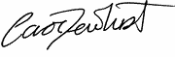
Carol Dewhurst Catherine Wilson, Chair of Governors
Chief Executive Officer, BDAT Westminster C of E Primary School
About BDAT

Westminster Primary School is an academy within Bradford Diocesan Academies Trust. If you are successful in being appointed, the Trust will be your employer.

General Information and Background
Bradford Diocesan Academies Trust (BDAT) is a Multi- Academy Trust (MAT) supporting a number of primary and secondary academies in Bradford. BDAT is the only Church of England MAT operating in Bradford, as part of the Diocese of Leeds.

BDAT is a charity, governed by a board of trustees who are responsible for, and oversee, the management of the company. The Memorandum and Articles are available on the Trust’s website at www.bdat-academies.org.

Our Mission Statement
“The Trust’s mission is to provide an education of the highest quality within the context of Christian belief and practice.” We believe every child only has one chance at a good education.

In practice, as a Trust, we seek to work with and alongside the academies in our Trust to provide a good quality of education to all children in our academies. The Trust does this through operating a light touch support role for academies at times of challenge and by establishing collaborative structures and processes to enable our academies to work together and share good practices. As our family of academies continues to grow, we are constantly looking at how we can continue to improve to establish effective and efficient ways of partnership working.

Our Growth
BDAT was established in 2012 to support both primary and secondary Church schools needing support within an academy model. As of January 2020, the BDAT family of schools consists of 17 schools: thirteen primaries and four secondaries. To view our latest plan and priorities for 2020-2021, or for more information on BDAT, visit www.bdat-academies.org or visit #wearebdat.

Our Christian Ethos
BDAT is a proudly Christian organisation committed to providing high-quality education for all within an ethos which encourages academic, vocational, mental, physical, and spiritual opportunities and development for each member of its academies. Whilst robust Christian principles underpin the work of the Academy, everyone is encouraged to explore their own spirituality and to recognise and understand that of others. It is for this reason that we choose to support and sponsor Non-Church of England Academies, as well as those within the faith.

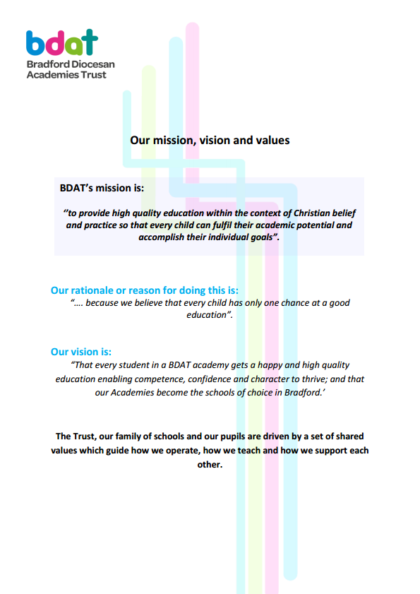
How to find us
Insert map

xxxxxxxxx School
Address of school
Website:

Westminster C of E Primary School
Westminster Road, Bradford, BD3 0HW
Headteacher
Full Time, Permanent, Required for January 2021
Salary L23 - L 29

The Governors at Westminster Primary School wish to appoint an inspirational Headteacher for this rewarding leadership role. The school is seeking a strong leader and team player who will build on existing strengths to ensure the school achieves its ambitions for excellence and success at every level.

Westminster Primary school is a welcoming Church of England Primary School where the appreciation of others is encouraged and attitudes of tolerance, care, concern and self-respect are developed in a happy, safe and secure environment.

We need from you
- strong strategic leadership and management
- a strong commitment to achieving success through partnership and teamwork
- a strong Christian commitment and personal demonstration of Christian values
- excellent interpersonal and communication skills
- drive, ambition and high expectations
- strong, innovative and creative leadership and management
- a commitment to learning and continuous improvement
- a passion for developing innovative approaches to the curriculum
- a passion for learning
- a proven ability to lead and develop staff
- a desire and passion to initiate, lead and manage effective strategies to support the development of the school

We can offer you
- engaged, happy, well-behaved and well-motivated children
- a dedicated, enthusiastic staff team committed to our school and our children
- high levels of Trust and Governor support
- a welcoming, friendly and vibrant school
- a school that is part of a forward thinking Academy Trust
- a strong village and church community

Visits to the school are welcomed and encouraged but are by appointment only. Please contact Jilly Geering (PA to the Director of Primary Education) via email: recruitment@bdat-academies.org

Closing date: Monday 21st September 2020 at 09.00
Shortlisting: Monday 21st September2020
Interview: Day 1 Monday 28th September 2020
Interview: Day 2 Tuesday 29th September 2020

We are committed to safeguarding and promoting the welfare of all our children and we require all our staff to share this commitment.
This post is subject to an enhanced criminal records check via the Disclosure and Barring Service (DBS). Please see our Safeguarding and Child Protection policy on the BDAT website www.bdat-academies.org/bdat-business/bdat-policies/
For the Full Job Description and Application Form please visit https://www.bdat-academies.org/vacancy/head-teacher/

How to Find Us
MAP

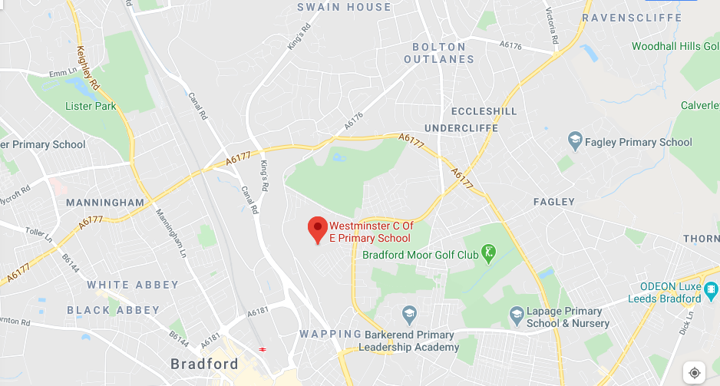

Westminster CE Primary School
Aspiring and achieving, united in God’s Love
Westminster Road, Bradford, BD3 0HW
www.westminsterschool.co.uk
www.bdat-academies.org

Our Vision

With God’s help, our school provides children with a safe, inspiring and nurturing learning environment. A place where children and community can thrive, achieve and develop life-long skills. Rich learning experiences will ignite desire to learn, achieving success. By raising aspirations and instilling self-belief, children are enabled to lead a fulfilled life, contributing to the community and beyond.

“For I know the plans I have for you,” declares the Lord, “plans to prosper you and not to harm you, plans to give you hope and a future. Jer 29:11

Trust in the Lord with all your heart, and do not lean on your own understanding. In all your ways acknowledge him, and he will make straight your paths. Prov 3:5-6

Our Values

Respect, Compassion, Thankfulness, Determination, Responsibility, Forgiveness

Headteacher Job Description

Purpose of the role
To provide professional leadership for the school in order to secure its success and improvement, ensure high quality education for all its pupils and improve standards of achievement.

Description of the role
Working with the Governing Body to:
- Lead by example to foster an open and transparent culture.
- Develop a collaborative Trust vision which embraces excellence, high standards and ensures inclusion, diversity and access for all.
- Translate the vision into an improvement plan and implement it successfully.
- Hold all staﬀ to account for their professional conduct and practice.
- To be responsible for the internal organisation, management and control of the school.
- Manage finance and resources astutely to maximise their use and value.
- Develop and sustain eﬀective relationships with the Trust to arrive at a shared vision for developing the school and to ensure eﬀective governance.
- Build, develop and maintain eﬀective relationships with parents and all members of the school and wider community to enhance the education of all pupils.
- Create an outward‐facing school to work with other schools within the Trust to champion best practice.

Key Responsibilities of the Post

Qualities and knowledge
- Hold and articulate clear values and moral purpose, focused on providing a world‐class education for the pupils they serve.
- Lead by example with integrity, creativity, resilience, and clarity ‐ drawing on their own scholarship, expertise and skills, and that of those around them.
- Communicate compellingly the school’s vision and drive the strategic leadership, empowering all pupils and staﬀ to excel.

Pupils and staﬀ
- Demand ambitious standards for all pupils, overcoming disadvantage and advancing equality, instilling a strong sense of accountability in staﬀ for the impact of their work on pupils’ outcomes.

- Create an ethos within which all staﬀ are motivated and supported to develop their own skills and subject knowledge, and to support each other.
- Hold all staﬀ to account for their professional conduct and practice.
- Work with the staff to develop, organise and implement an appropriate curriculum for the school taking into account the needs, experience, interests, aptitudes and stage of development of the pupils and the resources available to the school.
- Monitor and evaluate the standards of teaching and learning in the school and ensure that proper standards of professional performance are established and maintained.
- Develop a culture of coaching and peer support to enable teachers and staff to develop professionally and enable our children and community to succeed.
- Ensure that the progress of the pupils at the school is monitored, evaluated and effectively recorded. Analyse and use available school based and comparative data to assist in raising standards.

Systems and processes
- Provide a safe, calm and well‐ordered environment for all pupils and staﬀ, focused on safeguarding pupils and developing their exemplary behaviour in school and in the wider society.
- Establish rigorous, fair and transparent systems and measures for managing the performance of all staﬀ, addressing any under‐performance, supporting staﬀ to improve and valuing excellent practice.
- Welcome strong governance and actively support the governing board to understand its role and deliver its functions eﬀectively – in particular its functions to set school strategy and hold the Headteacher to account for pupil, staﬀ and financial performance.
- Exercise strategic, curriculum‐led financial planning to ensure the equitable deployment of budgets and resources, in the best interests of pupils’ achievements and the school’s sustainability.

Self‐improving school system
- Challenge educational orthodoxies in the best interests of achieving excellence, harnessing the findings of well evidenced research to frame self‐regulating and self‐improving schools.
- Model entrepreneurial and innovative approaches to school improvement, leadership and governance, confident of the vital contribution of internal and external accountability.
- Inspire and influence others within and beyond schools to believe in the fundamental importance of education in young people’s lives and to promote the value of education.

Developing Self and Others
- To use processes and put processes in place to generate a learning environment.
- To focus on the strengths and requirements of all individuals and enable them to further their skills and knowledge.
- To actively pursue their own development.
- To be self‐aware and to role model continuous self‐development.

Personnel Specification

PLEASE NOTE: When completing your application please demonstrate evidence of impact for each of the attributes below
Key: A = assessed at application I = assessed at interview T = assessed through selection test

 | ATTRIBUTES REQUIRED
QUALIFICATIONS AND EXPERIENCE | Essential  - Qualified Teacher Status (A)  - Further relevant professional/academic study and evidence of continuous  professional development (A)  - At least three years of proven, strong, successful senior leadership and management experience in a primary school (A,I,T)
SHAPING THE FUTURE  Critical to the role of Headteacher is working with the Governing Body and others to further develop a shared strategic vision and plan, which inspires and motivates learners, staff and all other members of the Academy and local community, and leads to the raising of achievement. | Essential:  - The ability to think strategically and take the leading role to develop, build on and communicate a shared vision and strategic plan which inspires and motivates the whole school community (A, I, T)  - Evidence of successfully implementing, managing and evaluating change in a collaborative and sensitive way (A, I, T)  - The ability to build on current strengths and initiatives and ensure a smooth transition that delivers continuous improvement (A, I, T)  - A clear understanding of and enthusiasm for current issues in education and evidence of embracing, implementing and embedding new approaches/technologies which are relevant to teaching and learning (A, I, T)
PUPILS AND STAFF  To work with and through others, including our learners, staff, governors, parents and other members of the community to build a professional learning environment which enables others to achieve. | Essential:  - Evidence of raising standards that have impacted positively on pupil attainment and teaching and learning (A, I, T)  - Significant experience in evaluating and using data to plan and improve pupil performance (I, A)  - A clear understanding of what makes good and outstanding teaching and the ability to develop a culture where striving for outstanding teaching and learning is central to the school’s work (I, A)  - A commitment to valuing, supporting and encouraging the professional development of all staﬀ members (I, T)
SYSTEMS AND PROCESSES | Essential:  - An understanding of how to create whole community accountability systems and implement them with the support of the leadership team to combine data from a range of sources in order to maximise the achievement of children (I,A)  - Strong financial planning and management skills, with experience of making eﬀective use of resources including the Pupil Premium (I, A)  - A clear understanding of and commitment to promoting and safeguarding the welfare of children (A, I, T)
STRENGTHENING COMMUNITY | Essential:  - Evidence of building and nurturing a strong, positive and collaborative team culture that enables all staﬀ to carry out their respective roles to the highest standard and for all staﬀ to work eﬀectively together to deliver school improvement (A, I , T)  - A commitment to building and maintaining eﬀective and positive relationships with parents, carers, governors, the wider community and other schools (I, T)
PERSONAL QUALITIES | Essential:  - Can inspire and influence others, within and beyond the school, to believe in the fundamental importance and value of education in young people’s lives (I, T)  - Excellent communication skills and proven ability to listen to, understand and work eﬀectively with all children, staﬀ, governors and parents (A, I, T)  - The ability to foster an open, transparent and equitable culture and deal eﬀectively with diﬃcult conversations and conflict at every level (A, I, T)
SECURING ACCOUNTABILITY  Ensure the Academy’s accountability to a wide range of groups, particularly parents, carers, governors and the LA; ensuring that learners enjoy and benefit from a high quality education; for promoting collective responsibility within the whole Academy community | Essential:  - Accepts accountability for the Academy’s performance. (I)  - Understands the need to take direction from the Governing Body and trust. (I)  - Is prepared to work with the Governing Body to enable it to meet its responsibilities. (I)  - Understands the need to maintain a safe and healthy environment for all users of the Academy. (I)  - Understands a Headteacher’s responsibilities for safeguarding and equality (I)  - Has high expectations of all teaching and support staff and is prepared to deal with any underperformance in a firm and fair way. (A, I)  - Has experience of supporting or coaching underperforming staff. (A, I)  Desirable :  - Proven track record of securing accountability evidenced through Ofsted judgements  - Successful experience of working with a Governing Body. (A,I)
SECURING, MAINTAINING AND PROMOTING A SMSC THROUGH DELIVERY  To secure an ethos which is explicit throughout the school vision and delivery in promoting Christian values and teaching, and in which each individual can explore their own faith and spiritual matters. | Essential:  1. Has a commitment to promoting mission, vision and values of the Academy. (A, I, T)  2. Knowledge of recent initiatives for developing SMSC (A,I)  3. Ability to develop the distinctiveness of the Academy’s Christian ethos and secure its contribution to children’s learning experience and to be accountable in its inspection from external sources. (A,I)
APPLICATION FORM AND SUPPORTING LETTER | Essential:  - Application form should be fully completed, accurate and legible (A)  - The supporting letter should be no longer than two sides of A4 (minimum font size 11) (A)

Selection Process Guidance

Our aim is to ensure that we recruit the right person for the job. We will ensure that the selection process is fair and without discrimination for or against any candidate based on age, ethnicity, sex, marital status, or sexual orientation. The person specification sets out the criteria used to assess candidates through the selection process.

We are committed to safeguarding our pupils and will assess the candidate’s suitability for working with children as part of the selection process. We will check the accuracy of all information and investigate any perceived anomalies. We take up references prior to interview and use these to verify the information you have given us. Firm offers of employment are never made without satisfactory references. All potential employees are subject to an enhanced disclosure from the Disclosure and Barring Service.

Visits to the school
Visits to the school are warmly welcomed by prior arrangement, you will not be disadvantaged if you are unable to visit. Please contact Jilly Geering (PA to the Director of Primary Education), via email: recruitment@bdat-academies.org to arrange a mutual appointment. The visit will give you an opportunity to ask questions about the role and the school to assess if this is somewhere you would like to work.

Applications
Please ensure that all parts of the application are completed. We do not accept CVs as part of the selection process. Please ensure that you demonstrate how your experience and skills make you suitable for the position. Applications can be submitted online, via email or via paper copy.

Shortlisting
We assess all applications against the person specification criteria using the evidence you provide in your application. This is done by a panel of senior staff and governors. We carefully check all applications for anomalies.

Candidates who best meet the person specification will be invited to an interview. We will notify you by telephone with e-mail confirmation to follow. If you have not heard from us within 3 days of the shortlisting date, you have not been successful at this stage.

References
We request references for all candidates who are invited to interview. Requests will be made at the same time that candidates are invited to interview. Your first referee should be your current or last, employer.

Interview Process
The interviews will be held over two days; day 1 will be held at the school and day 2 will be held at the BDAT Trust office. The interview will consist of several tasks and activities including a formal interview. These are designed to allow you to demonstrate your skills and abilities. You will be asked to bring proof of qualifications and identity on the first day.

Final Selection
Following the tasks and formal interview, we will use the person specification as a guide to select the most suitable candidate for our school. We will then telephone each candidate to inform them of the outcome. We will give brief feedback during this telephone conversation.

Offer of Employment
We will make a verbal offer of employment by telephone on the day of the interview and this will be confirmed in writing. Any offer is made subject to:
- References satisfactory to us
- A satisfactory DBS check
- Provision of proof of identity and qualifications

Timeline

Closing date: Monday 21st September 2020 at 09.00
Shortlisting: Monday 21st September2020
Interview: Day 1 Monday 28th September 2020
Interview: Day 2 Tuesday 29th September 2020

