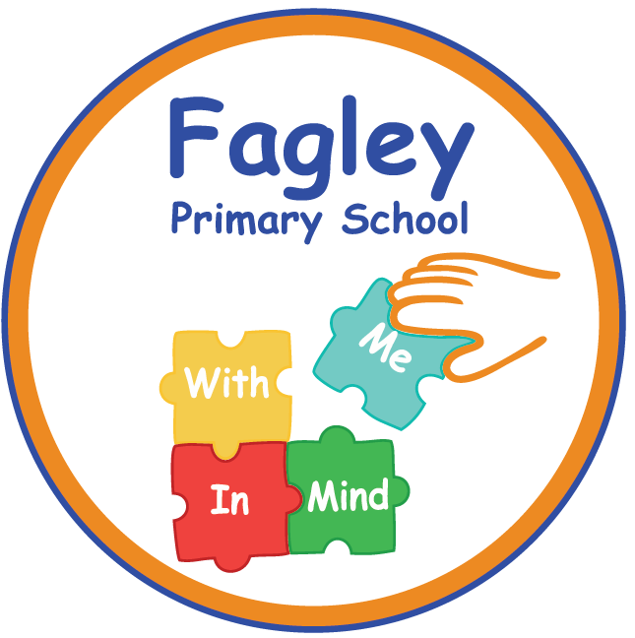
Site Manager
Contract: Permanent
37 hours per week all year round
Pay scale: Band 7 Scale 11-17
Closing date: Monday 6th October 2025
Interview dates: Week beginning WC 13th October 2025
Start : ASAP

Are you passionate about improving educational and life outcomes for the children in Bradford? Do you have the drive, determination and commitment to support young people in a disadvantaged community? If so, joining Fagley Primary School might just be the best career move you can make.
This is your opportunity to join a dedicated team of staff who are committed to providing the best possible education for our pupils. We are an outstanding, vibrant and inclusive one-form entry community school situated in Bradford.
The governors of Fagley Primary School are looking to appoint an enthusiastic and highly skilled Site Manager to continue to improve and maintain our school site.
The successful candidate will:
- Be a dynamic and creative team player, with excellent interpersonal skills
- Take pride in making your work environment look its best ready for children to learn
- Be calm with a positive and confident manner
- Take responsibility for managing the site and cleaning team on a day to day basis
- Have a strong understanding of health and safety / fire safety legislation linked to premises and people
- Keep good records including risk assessments and all compliance paperwork
- Undertake general maintenance of the school buildings and grounds

In return we can offer the successful candidate:
- A positive, safe and caring environment with a learning culture for all
- A commitment to your professional development
- A committed and dedicated staff team who are working together to develop excellence and enjoyment and a curriculum where every child matters
- A positive school ethos that celebrates success and is committed to inclusion

Visits to the school are encouraged and welcomed and should be made by contacting Catherine Boddy, School Business Manager, in the office on 01274 771124
Closing Date: 6th October 2025
Shortlisting: 7th October 2025
Interviews: Week commencing 13th October 2025
At Fagley Primary School we are committed to the safeguarding and welfare of
our children and therefore this post is subject to an enhanced DBS, references and online checks.

