CITY OF BRADFORD METROPOLITAN DISTRICT COUNCIL
JOB PROFILE

DEPARTMENT: Children’s Services | SERVICE GROUP: Specialist Teaching and Support Services  Low Incidence Team
POST TITLE: Specialist Support Worker Deaf Children and Young People | REPORTS TO Senior Specialist Support Worker / Resourced Provision Lead Teacher
GRADE: Band 5-6 (SCP 13-21) |  | SAP POSITION NUMBER :

The following information is furnished to help Council staff and those people considering joining the City of Bradford Metropolitan District Council to understand and appreciate the general work content of their post and the role they are to play in the organisation. The duties and responsibilities highlighted in this Job Profile are indicative and may vary over time. Post holders are expected to undertake other duties and responsibilities relevant to the nature, level and scope of the post and the grade has been established on this basis.
For posts where employees speak directly to members of the Public the post holder is required to demonstrate their ability to speak fluently in English.

As a candidate you will be expected to demonstrate your ability to meet the special knowledge, experience and qualifications required for the role by providing evidence in the application form for the purpose of shortlisting. Applicants with disabilities are only required to meet the essential special knowledge requirements shown by a cross in the end column of this section.

The employee competencies are the minimum standard of behaviour expected by the Council of all its employees and the management competencies outlined are those relevant for a post operating at this level within our organisation.

Both sets of competencies will be used at interview stage and will not be used for short listing purposes.

Key Purpose of Post
- To undertake and implement work/care/support programmes with individuals / groups to enable access to learning for pupils and to assist the teacher in the management of pupils and the classroom. Work may be carried out in the classroom or outside the main teaching area.

To facilitate access to the curriculum and whole school environment for Deaf children / young people and to support the social and emotional wellbeing of children and young people by adopting an attachment aware and trauma informed approach to all practice . Applying agreed strategies for managing wellbeing including classroom management that foster a nurturing and Emotion Coaching approach.

- Provide detailed and regular feedback to teachers on pupils’ achievement, progress
and problems

Main Responsibilities of Post
1. SUPPORT FOR PUPILS

1.1 Supervise and provide particular support for deaf pupils, ensuring their safety and access to learning activities.

1.2 Provide feedback to pupils in relation to progress and achievement under guidance of the teacher.

1.3 Assist with the development and implementation of Individual Education Plans, Social, Emotional and Wellbeing Plans and Personal Care programmes..

2. SUPPORT FOR THE TEACHER

2.1 Accurately record and provide detailed and regular feedback to teachers on pupils achievement, progress, problems and other relevant issues.
.
2.2 Promote good pupil behaviour, dealing promptly with conflict and incidents in line with established policy and encourage pupils to take responsibility for their own behaviour
.
2.3 Provide clerical and admin support e.g. photocopying, typing, filing, other relevant tasks.

2.4 Assist with the planning of learning activities.

A Band 6 SSW will also:
- Be responsible for maintaining records, information and data, producing analysis and reports as required
- Assist in the development of lessons, worksheets, programmes for implementation
- Implement lessons, worksheets and programmes under the guidance of a teacher
- Attend planning meetings and carry out related tasks as directed by a teacher

3. SUPPORT FOR THE CURRICULUM
3.1 Undertake structured and agreed learning activities/teaching programmes, adjusting activities according to pupil responses.
.
3.2 Prepare, maintain and use equipment/resources required to meet the lesson plans/relevant learning activity and assist pupils in their use.
3.3 Understand and maintain specialist equipment such as audiology equipment. Check quality and safety, undertake specialist repairs when possible and refer to appropriate people for check / repair if necessary
A Band 6 SSW will also:
- Implement agreed work programmes / lessons under the guidance of a teacher
- Fulfil the role of a CSW for adults who work within the service and the mainstream school (staff who hold BSL level 3), when an Qualified BSL / English interpreter is not available / necessary
4. SUPPORT FOR THE SCHOOL
4.1 Be aware of and comply with policies and procedures relating to child protection, health, safety and security, confidentiality and data protection, reporting all concerns to an appropriate person.
.
4.2 Attend and participate in relevant meetings as required and participate in training
and other learning activities and performance development as required.

4.3 Assist with the supervision of pupils out of lesson times, including before and after school and at lunchtime.

4.4 Accompany teaching staff and pupils on visits, trips and out of school activities and take responsibility for a group under the supervision of the teacher.

In order to facilitate 4.3 and 4.4, additional hours will be paid at the hourly rate, in negotiation with the Lead Teacher in advance of the event taking place.

A Band 6 SSW will also:
- Liaise with and take responsibility for multi agency working with relevant professionals under the guidance of a teacher
- Implement planned activities and supervise students in out of lesson clubs / activities

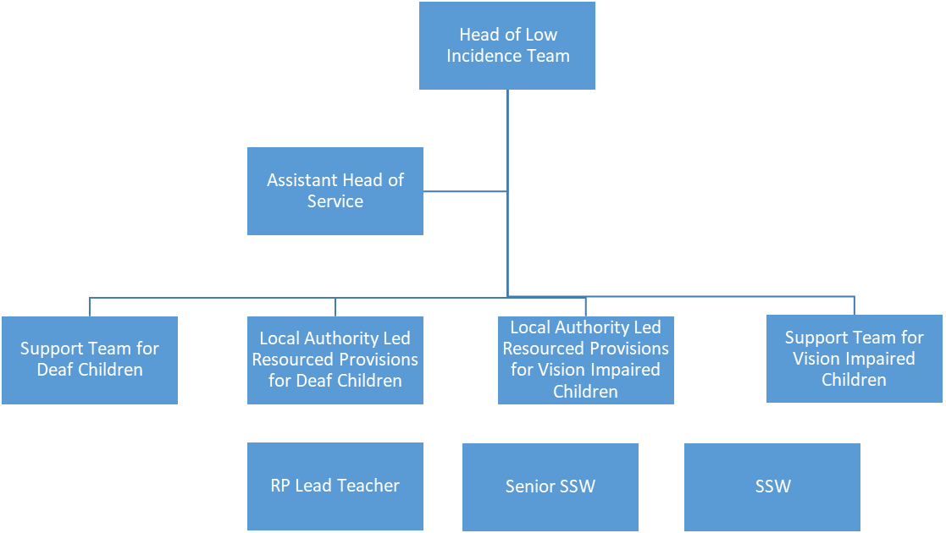
5 Any other duties as directed by the senior leadership team of the Sensory Service
Structure:

Special Knowledge Requirement. Will be used for shortlisting
 | Essential
Applicants with disabilities are only required to meet the essential special knowledge requirements shown by a cross in the end column.
Due to the Governments Fluency in English Duty for posts where employees speak directly to members of the public the post holder is required to meet the Advanced Threshold level which will be implemented where the post requires a greater level of sensitive interaction with the public,( e.g. in children’s centres) – where the person is able to demonstrate that they can during the interview:  a) Can express themselves fluently and spontaneously , almost effortlessly  b) Only the requirement to explain difficult concepts simply hinders a natural smooth flow of language | X
Uses knowledge of Health, Safety and Environmental policies, procedures and regulations including risks in own area of
work
Uses a range of complex IT packages relating to area of work
Ability to adopt a process of continual improvement and suggest ways of
working more efficient and effectively to improve service delivery.
Knows and understands how to use, interpret, handle and communicate
Information
Basic Deaf Awareness | X
Knowledge of British Sign Language to minimum Level 2 or equivalent functioning | X
An understanding of how deafness impacts upon language acquisition and learning | X

Relevant experience requirement: Will be used for shortlisting
The applicant is required to provide evidence of having previously spoken fluently to members of the public in order to meet either the Lower threshold or Advanced threshold level outlined under Special Knowledge above.
Experience of facilitating communication and access between deaf / hearing impaired and hearing people
Relevant professional qualifications requirement: Will be used for shortlisting
English and Mathematics GCSE/O level A* - C or equivalent
British Sign Language qualification at Level 2 OR demonstration of equivalent
Functioning
A Band 6 SSW will hold:
- Appropriate Level 3 qualification or equivalent e.g. NVQ Level 3, GCSE/O Levels at Grade A*-C Grade, GNVQ intermediate, BTEC General.
- English and mathematics GCSE/O level qualifications at Grade A*- C or equivalent
- British Sign Language qualification at Level 3 OR demonstration of equivalent
Functioning
Core Employee competencies to be used at the interview stage
Carries Out Performance Management
Covers the employee’s capacity to manage their workload and carry out a number of specific tasks accurately and to a high standard.
Communicates Effectively
Covers a range of spoken and written communication skills required as a regular feature of the job. It includes exchanging information/building relationships; giving advice and guidance; counselling, negotiating and persuading and handling private, confidential and sensitive information.
Carries Out Effective Decision Making
Covers a range of thinking skills required for taking initiative and independent actions within the scope of the job. It includes planning and organising, self effectiveness and any requirements to quality check work.
Undertakes Structured Problem Solving Activity
Covers a range of analytical skills required for gathering, collating and analysing the facts needed to solve problems. It includes creative and critical thinking; developing practical solutions; applying problem solving strategies and managing interpersonal relationships.
Operates with Dignity and Respect

Covers promoting equality, treating all people fairly and with dignity and respect, maintains impartiality/fairness with all people, is aware of the barriers people face.
Working Conditions:
Must be able to perform all duties and tasks with reasonable adjustment, where appropriate, in accordance with the Equality Act 2010 in relation to Disability Provisions.
May be required to work occasionally out of office hours as part of a family friendly service.
Special Conditions:
No contra-indications in personal background or criminal record indicating unsuitability to work with children/young people/vulnerable clients/finance
Enhanced DBS check required
Compiled by:  Date: | Grade Assessment Date: | Post Grade:

