Home Farm Primary School
Nursery Support Assistant



Contents
- Welcome letter from the Headteacher
- Our School – Pupil views
- Key Facts, Statistics and Location
- Copy of the advert
- Statement of the school’s values and ethos
- Job Description and Personnel Specification
- Equal Opportunities
- Key Dates summary

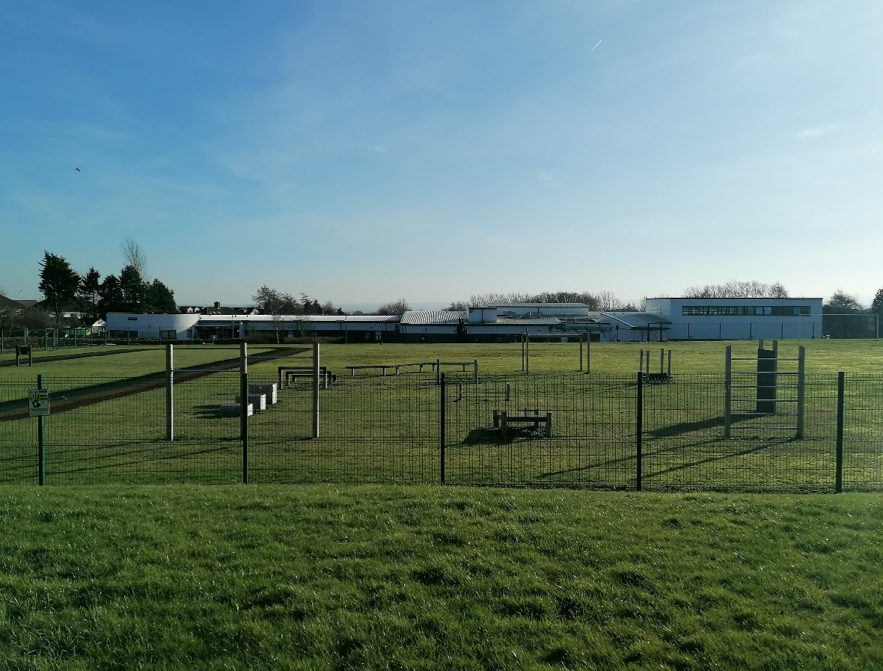
Letter from the Headteacher
Dear Applicant,
Thank you for your interest in the vacancy for the Nursery Support Assistant position at Home Farm Primary School. I hope you find this information pack useful and that it encourages you to apply for this exciting position within our school community.
We are a two form entry school with 451 pupils on roll. Our pupils come from a wide range of backgrounds and our school is rightly proud of the work we do, and the support we provide to the community. We use our Home Farm Values to underpin the work we do for all who are part of our school.
Home Farm is a welcoming, happy school on the outskirts of Bradford, with wonderful pupils and a hardworking, committed staff who have helped shape the culture of the school into a nurturing and vibrant educational establishment. We collaborate well with other schools in the local area and additionally develop strong links with neighbouring schools.
We are looking for an outstanding individual who has the drive, passion and commitment to deliver outstanding teaching and learning to young people through an innovative, nurturing and creative approach. The ideal applicant should be able to use our embedded ethos to work with parents, governors and the local community to ensure the best outcomes for our pupils. Please have a look at our website (https://www.homefarm.bradford.sch.uk/) where you can find more information and our latest Ofsted report.
I invite you to come and visit the school, to have a look around and judge for yourself, as I am certain visiting us would encourage you to apply. We look forward to your application and seeing what you can bring to our school.
Yours sincerely,
Joanne Poole
Headteacher

“Coming to school makes me happy. I am proud of the Home Farm Way.” KS1 Pupil

“I have lots of kind friends. My teachers help me learn and they are very kind.” KS1 Pupil

Honesty
Opportunities
Mutual Respect
Enjoyment

Friendship
Achievement
Resilience
Maturity

“Everyone is kind and helpful, and say how nice the teachers are. The teachers help every pupil. Not all schools have Home Farm Values, that’s what makes us special.” KS2 Pupil

“I love everything about Home Farm.” KS2 Pupil

Key Facts and Statistics
Type of School | Community
Age Range | Nursery, 5-11
Number of Children | 451
% of children with SEN support | 18.1%
% EHCP | 4.3%
% of children with EAL | 14.3%
% eligible for free school meals | 26.2%
Pupil Premium (2024/25 budget) | 27%

School Location
Home Farm Primary School
Home Farm Close
Bradford
West Yorkshire
BD6 3NR
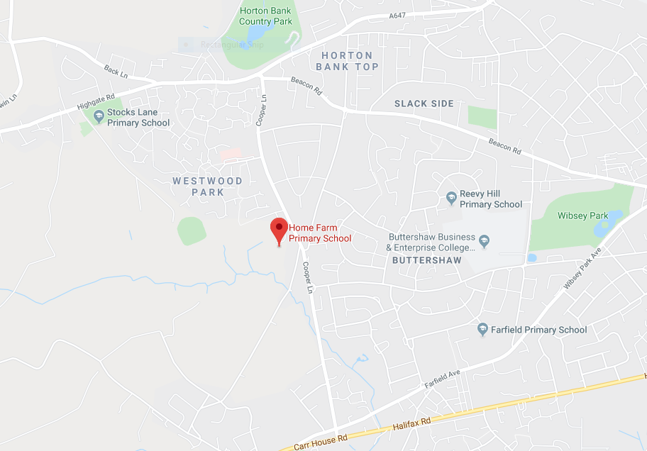

Vacancy Summary
Home Farm Primary School require the following:
FIXED TERM NURSERY SUPPORT ASSISTANT
Fixed Term till 31/08/27
13.75 hours per week, 08.50am – 11.35am Monday – Friday, Term Time Only
Salary (Band 5, Point 6) £8,238

Job Information
Home Farm Primary School wishes to appoint an enthusiastic and committed support assistant to work with and provide practical assistance to a group of children in nursery with additional needs.
We are looking for an outstanding individual who can support our school in an innovative, nurturing and creative manner.
The successful candidate will:
- Have some knowledge and experience of working with pupils with additional needs
- Have experience of working with pupils in primary schools
- Establish a warm, caring and supportive relationship with the pupils
- Promote the pupils cognitive, social, emotional, behavioural, physical development and spiritual well-being
- Liaise with other staff to ensure the pupil can access the learning and stay happy in school
- Be able to communicate effectively with the pupil they are providing support to
- Enjoy working with children and have a good understanding of their needs
- Be enthusiastic and willing to work as part of a team
- Have high expectations

Duties may include:
- To provide personal care and assistance for a pupil. This includes changing and supporting the pupils during break times.
- To prepare, and assist in the preparation, of the classroom resources, display, equipment, learning activities and computers for use by pupils.
- To work with individuals and small groups on specific activities under the guidance of the teacher and/or other lead person
- Accompanying and supporting pupil(s) on outings from school as necessary
- To pass on information about pupils personal and educational needs to the class teacher and other staff as appropriate. To contribute to team meetings and review meetings
- To support the pupils in physical activities (PE, Drama, Swimming etc.) as required
- To undertake training and attend INSET days in accordance to contractual requirements. To contribute to whole school policies
- Will participate in own performance development, identify and address any training needs and undertake any other training required in accordance to contractual requirements (Safeguarding, Manual Handling etc.)
- Undertake structured and agreed learning activities/teaching programmes appropriate to the pupils needs to ensure physical, social, emotional and intellectual development, taking into account diversity e.g. language, culture, ability, race and religion.
- Will supervise and support pupils consistently at all times; recognising, responding and meeting the individual and physical needs of the child.
- Assist with the development and implementation of My Support Plans and Personal Care Programmes.
- Will gather/report information from/to parents/carers as directed, taking into account parental/carer concerns, dealing with them sensitively under the direction of the teacher.
- A good level of literacy and numeracy is essential and previous experience of working with children is desirable.

We can offer:
- A friendly school with strong links with the community
- A supportive governing body and leadership team
- A genuine, welcoming, caring and professional school with pupils who are keen to learn in a very happy and engaging atmosphere
- Hardworking, supportive and enthusiastic colleagues
- A commitment to your continued professional development

The role will be perfect for someone who will be patient, understanding and empathetic to the pupil and their needs. The role will be extremely rewarding and provide strong job satisfaction.

Please have a look at our website to find out more about our school.

Closing date: 9am - 2nd November 2026
Interviews to take place: tbc

We are committed to safeguarding and promoting the welfare of children
All posts are subject to an enhanced DBS check
Proof of eligibility to work in the UK will be required
Please note: CVs are not accepted for this post

Statement of school’s values and ethos

Our School Values
Honesty
Opportunities
Mutual Respect
Enjoyment

Friendship
Achievement
Resilience
Maturity

British Values

At Home Farm Primary school we provide opportunities for pupils to explore their own culture and have a clear understanding and appreciation of a wide range of the cultural influences that have shaped modern Britain.
We are a school for all. We recognise the multi-cultural, multi-faith nature of our community and of Britain. We understand the crucial role our school plays in promoting British Values.

HOME FARM PRIMARY SCHOOL

Job Description

Post Title: | Nursery sUPPORT assistant
Post Ref: | HOME FARM PRIMARY SCHOOL
Grade: | Band 5 SCP 6

Generic Introduction:

The following information is furnished to assist staff joining the School to understand and appreciate the work content of their post and the role they are to play in the organisation. The following points should be noted:

- Whilst every endeavour has been made to outline the main duties and responsibilities of the post, a document such as this does not permit every item to be specified in detail. Broad headings, therefore, may have been used below, in which case all the usual associated routines are naturally included in the job profile.

- Employees should not refuse to undertake work, which is not specified on this form, but they should record any additional duties they are required to perform and these will be taken into account when the post is reviewed.

- This school is an Equal Opportunities Employer and requires its employees to comply with all current equality policies in terms of equal opportunity for employment and access to the Council Services.

- This school is committed, where possible, to making any necessary reasonable adjustments to the job role and the working environment that would enable access to employment opportunities for disabled job applicants or continued employment for any employee who develops a disabling condition.

Prime Objectives of the Post:

To complement, appreciate and support the role of teachers and other professionals by undertaking work/care/support programmes which enables access to learning in the community as part of a teacher planned approach.

To support the class teacher in the management of pupils in the classroom, and other senior staff on a range of teaching and learning experiences which deliver an appropriately differentiated and suitably challenging creative curriculum for all pupils whilst meeting statutory requirements.

Work within school policies and procedures under the direction and guidance of senior staff and within an agreed system of supervision.

May from time to time be required to undertake other duties commensurate with the grade and level of responsibility defined in this job description.

Knowledge and Skills:
(See Personnel Specification)

Effort Demands:

- Will assist in maintaining the good discipline of pupils throughout school and be expected to use good common sense, as well as use initiative in all matters relating to the conduct and behaviour of individual pupils, groups of pupils and whole classes, the safety, mobility (if required), hygiene and wellbeing of the pupils; making decisions within established working practices and procedures.

- Will recognise and challenge any incidents of racism, bullying, harassment, victimisation and any form of abuse of equal opportunities, ensuring compliance with the relevant school policy and procedures.

- Will deal with any issues, immediate problems or emergencies that arise in line with school policies and procedures liaising with colleagues where necessary e.g. dealing with a sick, injured or distressed child.

- Acting as a role model, will establish productive and constructive working relationships with pupils, setting high expectations, motivating and interacting with them, being aware of their individual needs, supporting difference and ensuring all pupils have equal access to opportunities to learn and develop whilst responding appropriately.

- Will have the ability to cope with the requirements of the post, which may include working with pupils who have emotional/behavioural/physical difficulties.

- Will contribute to the overall ethos/work/aims of the school.

- Will appreciate and support the role of other professionals.

- Be vigilant and sensitive to any child protection/safeguarding concerns that arise, reporting any concerns to the designated officer in line with school policy and procedure.

Responsibilities:

- Assist in the management of pupils in the learning environment.

- Assist in the planning of learning activities.

- Undertake structured and agreed learning activities/teaching programmes appropriate to the pupil’s needs to ensure physical, social, emotional and intellectual development, taking into account diversity e.g. language, culture, ability, race and religion.

- Will supervise and support pupils consistently at all times; recognising, responding and meeting the individual and physical needs of each child whilst ensuring their safety and education in the learning environment.

- Assist with the development and implementation of Individual Education Plans and Personal Care Programmes; attending to the pupils’ personal needs and maintaining related personal programmes with the correct use of care materials including the safety and wellbeing of the pupils, therapy and medical intervention needs of the pupil and first aid, paying attention to social, health, physical and welfare matters as well as high standards of cleanliness and hygiene e.g. washing, dressing, toileting, and, if applicable, mobility.

- For posts working with pupils who are physically less able, it may be necessary to be able to physically assist the pupil in line with school polices and good practice.

- Will occasionally be required to supervise the class for brief periods during a morning or afternoon session where the classroom teacher is not available.

- Promote and reinforce the inclusion, acceptance and integration of all pupils, including those from different cultures and/or with a different first language as appropriate.

- Set challenging and demanding expectations whilst promoting self-esteem and encouraging pupils to act independently as appropriate as well as interact and work co-operatively with others and engage in activities led by the teacher.

- Will prepare, create and maintain a purposeful, orderly and supportive learning environment to meet the lesson plans. Take responsibility for the care, preparation, maintenance and use of relevant equipment, assisting pupils in its use and clearing/storage afterwards.

- Will be aware of pupil progress, monitor/record pupil responses against pre-determined learning objectives as well as provide accurate, constructive and detailed feedback/reports to the teacher and pupils.

- Promote positive values, attitudes and good pupil behaviour and encourage pupils to take responsibility for their own actions whilst supporting the teacher in managing this. Deal promptly with conflict and incidents (including those involving restraint) and reporting challenging behaviour where appropriate in line with established policy.

- Will gather/report information from/to parents/carers as directed, taking into account parental/carer concerns, dealing with them sensitively under the direction of the teacher.

- Will provide clerical/administrative support as directed by the teacher.

- Will support pupils in the use of ICT in learning activities as directed by the teacher, and develop pupils’ competence and independence in its use.

- Will participate in own performance development, identify and address any training needs/other learning activities.

- Will assist with the supervision of pupils out of lesson times, including before and after school and at lunchtimes, accompanying teaching staff and pupils on visits, trips and out of school activities; taking responsibility for a group under the supervision of the teacher.

- Will assist in the supervision of students on work experience, trainees and voluntary helpers.

environmental demands/Working Conditions:

- Will have long periods of sitting or standing.

- Available to work during school hours during term time and a willingness to be flexible as may be required to attend staff meetings/training sessions outside of usual hours.

- Will have contact with members of the public/other professionals e.g. teaching staff, governors, parents/carers, community groups, local education authority, external providers etc.

- The post holder may occasionally be subjected to antisocial behaviour from members of the public/parents/site users.

- This post may include a degree of manual lifting and handling. You are expected to be aware of health and safety policies and procedures and frequently assess your ability to carry out the lifting tasks required of you.

- Report all concerns to an appropriate person.

Fluency Duty
In line with the Immigration Act 2016; the Government has created a duty to ensure that all Public Authority staff working in customer facing roles can speak fluent English to an appropriate standard.
For this role the post holder is required to meet the Intermediate Threshold Level
Intermediate Threshold Level

The post holder should demonstrate:

- They can express themselves fluently and spontaneously with minimal effort and,
- Only the requirement to explain difficult concepts may hinder a natural smooth flow of language.

Special Conditions of Service:
- No contra-indications in personal background or criminal record indicating unsuitability to work with children/young people/vulnerable clients/finance (An enhanced DBS check is required).

Other considerations

- To be aware of and comply with policies and procedures relating to child protection; being vigilant for signs that children may be being abused and to report any such suspicions to the school’s nominated Child Protection Co-ordinator or the Headteacher.

- To act in accordance with the Data Protection Act and maintain confidentiality at all times e.g. access to staff/student/parent and carers files.

- Accept and commit to the principles underlying the Schools Equal Rights policies and practices.

- Be able to perform all duties and tasks with reasonable adjustments, where appropriate, in accordance with the Equality Act.

- Must be legally entitled to work in the UK.

PERSONNEL SPECIFICATION:

 | ESSENTIAL (E)/DESIRABLE (D)
Experience: | - Experience of working in a team situation. E  - Experience of working with pupils who have special needs. D  - Experience of working with or caring for children of relevant age e.g. voluntary organisation or parental/caring responsibilities. E  - Provide evidence of having previously spoken fluently to customers at an Intermediate Threshold Level E
Qualifications/  Training: | - GCSE English and Maths or equivalent e.g. Adult Literacy/Numeracy at level 1. E  - Other relevant qualifications relating to the post e.g. Level 2 NVQ in Health/Childcare, first aid qualification. D  - Evidence of further training/development and/or willingness to participate in further training and development opportunities e.g. Team Teach, Moving & Handling, Special Educational Needs. E
Knowledge/ Skills: | - Will possess knowledge of the School’s relevant procedures or practices.  - Will have an outline understanding of relevant legislation.  - Will have knowledge of some of the policies covering their service area.  - Problem solving skills.  - Good communication skills.  - Exercising advisory, guiding, negotiating and persuasive skills at a developed level.  - Good numeracy/literacy skills.  - Basic ICT skills.  - An understanding of the needs of a multicultural society.  - An understanding of the issues relating to pupils who have additional learning needs, more able and special educational needs.  - Knowledge of childcare.  - Awareness of child development.  - Knowledge and commitment to schools Equality policy.  - Ability to relate well to pupils and adults.  - Ability to work constructively as part of a team.  - Ability to remain calm under pressure.  - Demonstrate a commitment to working with children of the relevant age.  - Demonstrate good co-operative, interpersonal and effective listening skills.  - Maintain confidentiality in matters relating to the school, its pupils, parents or carers.  - Ability to perform all duties and tasks with reasonable adjustments where necessary.  - Ability to cope with the requirements of the post, which will include working with pupils who have emotional/ behavioural/physical difficulties.  - In line with the Immigration Act 2016; you should be able to demonstrate fluency of the English Language at an Intermediate Threshold Level.

Equal Rights and Key Dates

Equal Rights
Our School is an equal rights employer. We require our governors and employees to follow our equality policies and to follow all statutory requirements concerning age, race, religious, sex, sexual orientation and disability discrimination. We respect and protect the rights of people with disabilities both in terms of equal opportunity for employment and access to the school's services.

Disabled Applicants
Disabled applicants are guaranteed an interview if they meet the essential requirements of the Personnel Specification. As an equal rights employer our school is committed to make any necessary reasonable adjustments to the selection process, the job role and the working environment that would enable access to employment opportunities for disabled people. Where a disabled applicant is being assessed the selection panel's decisions will be based on an assessment of that person's expected capabilities once reasonable adjustments have been made.

Job Sharing
Job share applicants are welcome to apply for all full-time posts unless otherwise stated in the advertisement.

Key Dates
Closing Date | 9am 2nd November 2026
Visits round school | By appointment through the school office
Shortlisting Date | 2nd November 2026
Interview Date | TBC
Start Date | ASAP

