St Matthew’s CE Primary School and Nursery
Learning Support Assistant
Band 5
Information pack

CONTENT
- Welcome to St Matthew’s - Letter from our Headteacher
- About St Matthew’s
- Teaching at St Matthew’s
WELCOME TO ST MATTHEW’S
Dear Candidate
Thank you for considering a post at St Matthew’s CE Primary School. St Matthew’s is a community school located in the BD5 area. We cater for children aged 3 - 11 years. To find out more about us please visit our website www.stmatthewsprimary.org.uk.
The governors’ vision for the school is that it will provide an outstanding learning environment for all, not just the children, it is committed to training for parents and staff, and provides excellent learning opportunities for children. We have high expectations of everyone to work hard and to achieve their best. To do this we provide a safe, happy school and take our safeguarding responsibilities very seriously.
Please complete the application form ensuring you follow all instructions.
Thank you again for your interest in the posts at the school and I wish you every success in your application and look forward to meeting you soon.
Yours faithfully,
KRemmer

Kay Remmer
Head Teacher

ABOUT ST MATTHEW’S
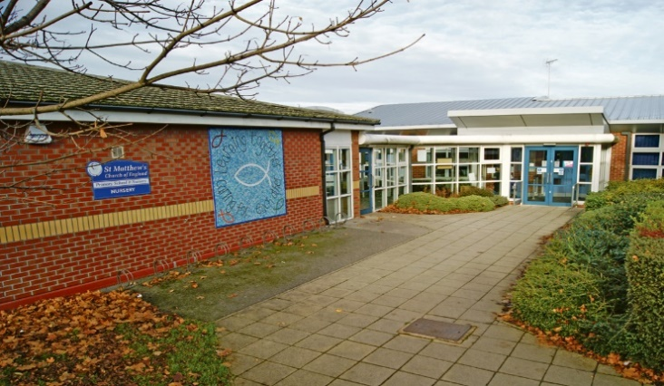
St Matthew’s is a two form entry multi-cultural primary school with a 52 place nursery, catering for children aged 3 - 11 years old. The school is in West Bowling at the top of the M606, giving you easy access to the M62.
On behalf of the children, parents, staff and governors we would like to thank you for your interest in St Matthew’s.
Our motto “We strive to achieve the best” is evident in every aspect of school life.
Staff, governors and parents all share high expectations of our pupils and, together, we pride ourselves in the warm, caring ethos that exists in our school. We aim to provide our children with exciting opportunities to gain academic success in English and Maths, as well as developing skills that will support life-long learning and develop the whole child. As such, we celebrate achievement, nurture individual talent and allow every pupil to shine.
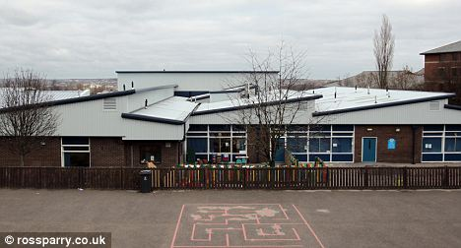
Key to the children’s success are our positive partnerships within our community and we work hard to involve families in all aspects of school life.
Please explore our website to find out what St Matthew’s has to offer, or visit us to learn more about our school.

TEACHING ASSISANT AT ST MATTHEW’S
Every school is unique in its own way. So why should you choose to work with us? Here are a few reasons why St Matthew’s is the place for you.
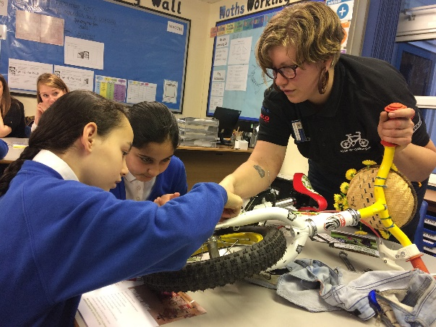
The children.
Our children are polite, inquisitive, resilient and determined. School is a place of open possibilities for every child and they grasp each opportunity with wide smiles and an eagerness to succeed. We have children who love to be creative, thought art, DT, dance, music and ICT as well as focusing on the more academic areas. Our children have a love of reading (and aspire to be librarians!) and are keen to show off their writing and maths skills.

Our ethos.
We know that children learn best through experiences and so bring the curriculum to life with a wealth of learning opportunities both inside and outside school. In the past year, this has included visitors into school to challenge the children to create adverts to promote fruit kebabs (including pitching these ideas to a board of professionals); a stardome in the hall to inspire the children and clarify scientific learning; Victorian toy workshops, enabling the children to experience and explore artefacts; and visiting artists to work with the children and develop their creative skills.

You.
Your career and its development is important to us. At St Matthew’s we work closely with the schools in the local BD5 partnership, providing wider opportunities for professional development. In addition, we actively encourage professional opportunities, such as the leadership of awards in school, for example, the anti-bullying award or the PSQM award, or professional qualifications, such as NPQML.

Post Title: | Teaching assistant
Grade: | Band 5

Generic Introduction:

The following information is furnished to assist staff joining the School to understand and appreciate the work content of their post and the role they are to play in the organisation. The following points should be noted:

Whilst every endeavour has been made to outline the main duties and responsibilities of the post, a document such as this does not permit every item to be specified in detail. Broad headings, therefore, may have been used below, in which case all the usual associated routines are naturally included in the job profile.

Employees should not refuse to undertake work, which is not specified on this form, but they should record any additional duties they are required to perform and these will be taken into account when the post is reviewed.

St Matthew’s school is an Equal Opportunities Employer and requires its employees to comply with all current equality policies in terms of equal opportunity for employment and access to the Council Services.

St Matthew’s is committed, where possible, to making any necessary reasonable adjustments to the job role and the working environment that would enable access to employment opportunities for disabled job applicants or continued employment for any employee who develops a disabling condition.

Prime Objectives of the Post:

To support an autism child on a 1:1 basis within a reception class.

To support the class teacher in the management of pupils in the classroom, and other senior staff on a range of teaching and learning experiences which deliver an appropriately differentiated and suitably challenging creative curriculum for all pupils whilst meeting statutory requirements.

To work within other classes across the school, as directed.

Work within school policies and procedures under the direction and guidance of senior staff and within an agreed system of supervision.
May from time to time be required to undertake other duties commensurate with the grade and level of responsibility defined in this job description.

Knowledge and Skills:
(See Personnel Specification)

EFfort Demands:

Will assist in maintaining the good discipline of pupils throughout school and be expected to use good common sense, as well as use initiative in all matters relating to the conduct and behaviour of individual pupils, groups of pupils and whole classes, the safety, mobility (if required), hygiene and well being of the pupils; making decisions within established working practices and procedures.

Will recognise and challenge any incidents of racism, bullying, harassment, victimisation and any form of abuse of equal opportunities, ensuring compliance with the relevant school policy and procedures.

Will deal with any issues, immediate problems or emergencies that arise in line with school policies and procedures liaising with colleagues where necessary e.g. dealing with a sick, injured or distressed child.

Acting as a role model, will establish productive and constructive working relationships with pupils, setting high expectations, motivating and interacting with them, being aware of their individual needs, supporting difference and ensuring all pupils have equal access to opportunities to learn and develop whilst responding appropriately.

Will have the ability to cope with the requirements of the post, which may include working with pupils who have emotional/behavioural/physical difficulties.

Will contribute to the overall ethos/work/aims of the school.

Will appreciate and support the role of other professionals.

Be vigilant and sensitive to any child protection/safeguarding concerns that arise, reporting any concerns to the designated officer in line with school policy and procedure.

Responsibilities:

Support an individual child on a 1:1 basis, working closely with class teacher and SENDCo.

Assist in the management of pupils in the learning environment.

Assist in the planning of learning activities.

Will administer routine tests, invigilate exams and undertake routine marking of pupils’ work.

Undertake structured and agreed learning activities/teaching programmes appropriate to the pupil’s needs to ensure physical, social, emotional and intellectual development, taking into account diversity e.g. language, culture, ability, race and religion.

Will supervise and support pupils consistently at all times including those with special needs; recognising and responding to their individual needs whilst ensuring their safety and education in the learning environment.

Assist with the development and implementation of Individual Education Plans and Personal Care Programmes; attending to the pupils’ personal needs and maintaining related personal programmes with the correct use of care materials including the safety and well being of the pupils, therapy and medical intervention needs of the pupil and first aid, paying attention to social, health, physical and welfare matters as well as high standards of cleanliness and hygiene e.g. washing, dressing, toileting, and, if applicable, mobility.

For posts working with pupils who are physically less able, it may be necessary to be able to physically assist the pupil in line with school polices and good practice.

Will occasionally be required to supervise the class for brief periods during a morning or afternoon session where the classroom teacher is not available.

Promote and reinforce the inclusion, acceptance and integration of all pupils, including those with specific and special needs and those from different cultures and/or with a different first language as appropriate.

Set challenging and demanding expectations whilst promoting self-esteem and encouraging pupils to act independently as appropriate as well as interact and work co-operatively with others and engage in activities led by the teacher.

Will prepare, create and maintain a purposeful, orderly and supportive learning environment to meet the lesson plans. Take responsibility for the care, preparation, maintenance and use of relevant equipment, assisting pupils in its use and clearing/storage afterwards.

Will be aware of pupil progress, monitor/record pupil responses against pre-determined learning objectives as well as provide accurate, constructive and detailed feedback/reports to the teacher and pupils.

Promote positive values, attitudes and good pupil behaviour and encourage pupils to take responsibility for their own actions whilst supporting the teacher in managing this. Deal promptly with conflict and incidents (including those involving restraint) and reporting challenging behaviour where appropriate in line with established policy.
Will gather/report information from/to parents/carers as directed, taking into account parental/carer concerns, dealing with them sensitively under the direction of the teacher.

Will provide clerical/administrative support as directed by the teacher.

In respect of local and national learning strategies, will support pupils to achieve learning goals e.g. literacy, numeracy, early years as directed by the teacher.

Will support pupils in the use of ICT in learning activities as directed by the teacher, and develop pupils competence and independence in its use.

Will participate in own performance development, identify and address any training needs/other learning activities.

Will assist with the supervision of pupils out of lesson times, including before and after school and at lunchtimes, accompanying teaching staff and pupils on visits, trips and out of school activities; taking responsibility for a group under the supervision of the teacher.

Will assist in the supervision of students on work experience, trainees and voluntary helpers.

environmental demands/Working Conditions:

Will have long periods of sitting or standing.

Available to work during school hours during term time and a willingness to be flexible as may be required to attend staff meetings/training sessions outside of usual hours.

Will have contact with members of the public/other professionals e.g. teaching staff, governors, parents/carers, community groups, local education authority, external providers etc.

The post holder may occasionally be subjected to antisocial behaviour from members of the public/parents/site users.

This post may include a degree of manual lifting and handling. You are expected to be aware of health and safety policies and procedures and frequently assess your ability to carry out the lifting tasks required of you.

Report all concerns to an appropriate person.

Fluency Duty

In line with the Immigration Act 2016; the Government has created a duty to ensure that all Public Authority staff working in customer facing roles can speak fluent English to an appropriate standard.
For this role the post holder is required to meet the Intermediate Threshold Level

Intermediate Threshold Level

The post holder should demonstrate:

They can express themselves fluently and spontaneously with minimal effort and,
Only the requirement to explain difficult concepts may hinder a natural smooth flow of language.

Special Conditions of Service:

No contra-indications in personal background or criminal record indicating unsuitability to work with children/young people/vulnerable clients/finance (An enhanced DBS check is required).

Other considerations

To be aware of and comply with policies and procedures relating to child protection; being vigilant for signs that children may be being abused and to report any such suspicions to the school’s nominated Child Protection Co-ordinator or the Headteacher.

To act in accordance with the Data Protection Act and maintain confidentiality at all times e.g. access to staff/student/parent and carers files.

Accept and commit to the principles underlying the Schools Equal Rights policies and practices.

Be able to perform all duties and tasks with reasonable adjustment, where appropriate, in accordance with the Equality Act.

Must be legally entitled to work in the UK.

PERSONNEL SPECIFICATION:

 | ESSENTIAL (E)/DESIRABLE (D)
Experience: | Experience of working with a child with Autism. (E)  Experience of working in a team situation. (E)  Experience of working with or caring for children of relevant age e.g. voluntary organisation or parental/caring responsibilities.(E)  Provide evidence of having previously spoken fluently to customers at an Intermediate Threshold Level.(E)

Qualifications/Training: | GCSE English and Maths or equivalent e.g. Adult Literacy/Numeracy at level 1.(E)  Other relevant qualifications relating to the post e.g. Level 2 NVQ in Health/Childcare, first aid qualification.(E)  Evidence of further training/development and/or willingness to participate in further training and development opportunities.(D)
Knowledge/ Skills: | Will possess knowledge of the School’s relevant procedures or practices.(E)  Knowledge of SEND - in particular, Autism.  Will have an outline understanding of relevant legislation. (D)  Will have knowledge of some of the policies covering their service area. (D)  Problem solving skills. (E)  Good communication skills.(E)  Exercising advisory, guiding, negotiating and persuasive skills at a developed level. (E)  Good numeracy/literacy skills. (E)  Basic ICT skills.(E)  An understanding of the needs of a multicultural society.(E)  An understanding of the issues relating to pupils who have additional learning needs, more able and special educational needs. (D)  Knowledge of childcare.(E)  Awareness of child development.(E)  Knowledge and commitment to schools Equality policy. (E)  Ability to relate well to pupils and adults. (E)  Ability to work constructively as part of a team.  (E)  Ability to remain calm under pressure. (E)  Demonstrate a commitment to working with children of the relevant age. (E)  Demonstrate good co-operative, interpersonal and effective listening skills. (E)  Maintain confidentiality in matters relating to the school, its pupils, parents or carers. (E)  Ability to perform all duties and tasks with reasonable adjustments where necessary. (E)  Ability to cope with the requirements of the post, which will include working with pupils who have emotional/ behavioural/physical difficulties. (E)  In line with the Immigration Act 2016; you should be able to demonstrate fluency of the English Language at an Intermediate Threshold Level. (E)
OFFICE USE ONLY:

Compiled by: | C.Dyer
Date of Issue: | May 2019

HOW TO FIND US

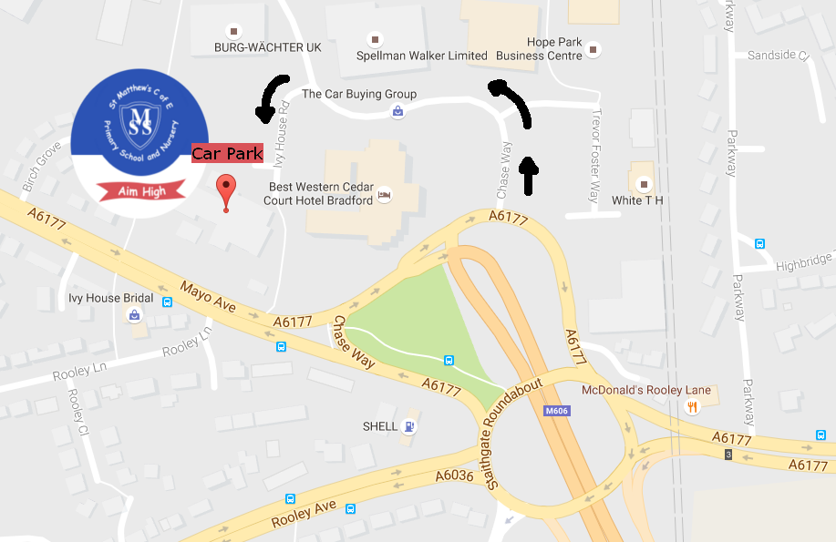

Driving instructions
Please note there is no access, by car, to the school from Mayo Avenue. If you are visiting the school by car, please approach the school using Chase Way and Ivy House Road.
Click on the following link for a map http://goo.gl/maps/3Lg3U

St Matthew's C of E Primary School & Nursery
Ivy House Road
West Bowling
Bradford
BD5 8FG
email: office@stmatthewsce.bradford.sch.uk
Telephone: 01274 731693

HOW TO APPLY
If you would like to visit our school please contact Cara Dyer, our School Business Manager on 01274 731693 to arrange an appointment. We will be delighted to show you around our school and answer any questions that you may have.
References will be sought for shortlisted candidates prior to the interview date. Successful candidates are subject to an enhance disclosure check from the Disclosure and Barring Service.
KEY DATES
Closing date: 15th January 2020
Interviews: Week commencing 20th January 2020

