Home Farm Primary School
HLTA



Contents
- Welcome letter from the Headteacher
- Our School – Pupil views
- Key Facts, Statistics and Location
- Copy of the advert
- Statement of the school’s values and ethos
- Job Description and Personnel Specification
- Equal Opportunities
- Key Dates summary

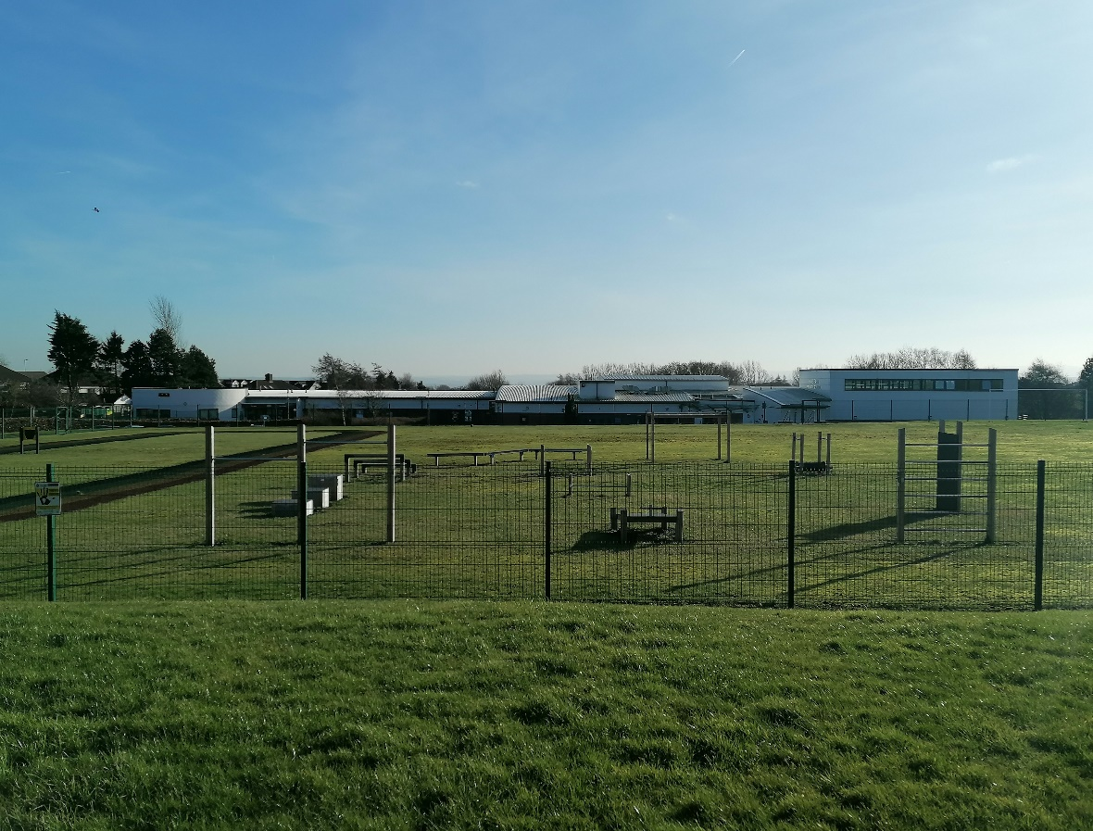
Letter from the Headteacher
Dear Applicant,
Thank you for your interest in the vacancy for the HLTA position at Home Farm. I hope you find this information pack useful and that it encourages you to apply for this exciting position within our school community.
We are a two form entry school with 458 pupils on roll. Our children come from a range of backgrounds and our school is rightly proud of the work we do and the support we provide to, the community that is in our catchment area. We use our Home Farm values to underpin the work we do for all who are part of our school.
Home Farm is a welcoming, happy school on the outskirts of Bradford, with wonderful children and a hardworking, committed staff who have helped shape the culture of the school into a nurturing and vibrant educational establishment. We collaborate well with other schools in the local area and additionally, have developed strong links with the high schools.
Therefore, we are looking for a positive, creative and hard-working individual who cares passionately about children’s education and wellbeing. The ideal applicant will share the schools vision and enthusiasm for learning to ensure the best outcomes for our children. Please have a look at our website (https://www.homefarm.bradford.sch.uk/) where you can find more information and our latest reports.
We look forward to your application and seeing what you can bring to our school.
Yours sincerely,
Joanne Poole
Headteacher


“Coming to school makes me happy. I am proud of the Home Farm Way.” KS1 Pupil

“I have lots of kind friends. My teachers help me learn and they are very kind.” KS1 Pupil

Honesty
Opportunities
Mutual Respect
Enjoyment

Friendship
Achievement
Resilience
Maturity

“Everyone is kind and helpful, and say how nice the teachers are. The teachers help every pupil. Not all schools have Home Farm Values, that’s what makes us special.” KS2 Pupil

“I love everything about Home Farm.” KS2 Pupil

Key Facts and Statistics
Type of School | Community
Age Range | Nursery, 5-11
Number of Children | 458
% of children with SEN support | 22%
% EHCP | 5%
% of children with EAL | 17.4%
% eligible for free school meals | 32.09%
Pupil Premium (2025/26 budget) | 33.4%

School Location
Home Farm Primary School
Home Farm Close
Bradford
West Yorkshire
BD6 3NR
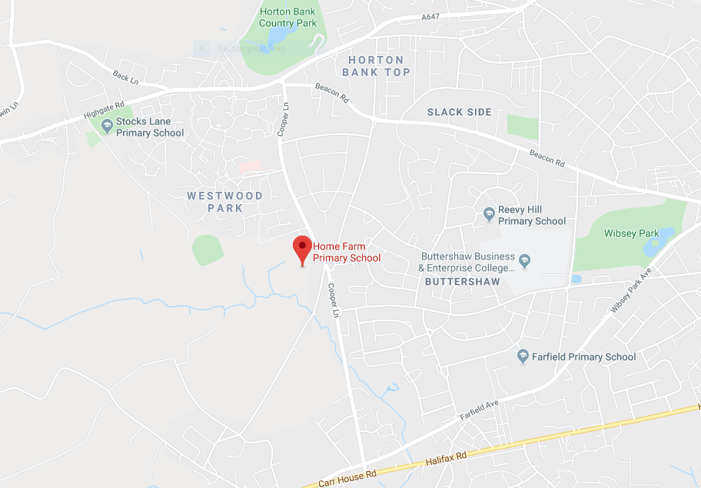

HLTA
Permanent

27.5 hours per week, Term Time Only
Salary (Band 8, SCP 17-22) £19,321 - £20,989
Required 1st September 2026
Job Information
Home Farm Primary School wishes to appoint an inspirational and outstanding HLTA who has the ability to support children of all years to achieve high standards of learning.
Home Farm Primary School is a 2 form entry school with 458 pupils on roll.
We are looking for an outstanding individual who can support our school in an innovative, nurturing and creative manner. Our school is looking to appoint someone who can utilise our many strengths and also see what’s needed to move our school to the next level. The ideal applicant should be able to use our embedded ethos to work with parents.
The successful candidate will:
- Be passionate about working with children
- Be patient, caring and a good communicator
- Be inspirational and believes all children deserve the very best
- Have great teamwork skills, a good sense of humour and a willingness to ‘go the extra mile’ every day
- Are committed to and display the ‘Home Farm Way’ in everything they do

Duties will include:
- To provide planned and emergency classroom cover for pupils from Nursery to Year 6 in the absence of a teaching member of staff.
- To provide PPA cover lessons
- Organise and manage appropriate learning environment and resources.
- Production of lesson plans, worksheet, plans etc.
- To create an orderly, purposeful classroom environment.
- To liaise with appropriate teacher on work to set for classes.
- To liaise with the member of staff on the return from absence where necessary
- To assist in classroom support if not needed for cover.
- To liaise with the School Business Manager for cover needed.
- To assist in assessment and SATs administration when required.
- To follow the school’s behaviour systems and promote the ‘Home Farm Way’.

We can offer:
- A friendly school with strong links with the community
- A supportive governing body and leadership team
- A genuine, welcoming, caring and professional school with pupils who are keen to learn in a very happy and engaging atmosphere
- Hardworking, supportive and enthusiastic colleagues
- A commitment to your continued professional development

Closing date: 20th April 2026
Interviews: 1st May 2026
We are committed to safeguarding and promoting the welfare of children
All posts are subject to an enhanced DBS check
Proof of eligibility to work in the UK will be required
Please note: CVs are not accepted for this post
Statement of school’s values and ethos

Our School Values
Honesty
Opportunities
Mutual Respect
Enjoyment

Friendship
Achievement
Resilience
Maturity

British Values

At Home Farm Primary School we provide opportunities for pupils to explore their own culture and have a clear understanding and appreciation of a wide range of the cultural influences that have shaped modern Britain.
We are a school for all. We recognise the multi-cultural, multi-faith nature of our community and of Britain. We understand the crucial role our school plays in promoting British Values.

Higher Level Teaching Assistant Job Description and Person Specification

Post title: Higher Level Teaching Assistant
School: Home Farm Primary School
Pay range:
Line manager: Headteacher

Job Description

Core purpose

To complement the professional work of teachers by taking responsibility for agreed learning activities under an agreed system of supervision. This may involve planning, preparing and delivering learning activities for individuals/groups or short term for whole classes and monitoring students and assessing, recording and reporting on students’ achievement, progress and development.
The School is fully committed to safeguarding children and promoting their welfare and expects all staff to share in this commitment. All posts are subject to an Enhanced DBS with Barred List check.

This Job Description is furnished to assist staff joining School to understand and appreciate the work content of their post and the role they are to play in the organisation.
Whilst every endeavour has been made to outline the main duties and responsibilities of the post, a document such as this does not permit every item to be specified in detail. This job description is not a definitive list of responsibilities but identifies the key components of the role. The post holder will, therefore, be required to undertake other reasonable duties commensurate with the purpose and salary level of this post.
Employees should not refuse to undertake work, which is not specified on this form, but they should record any additional duties they are required to perform, and these will be taken into account when the post is reviewed.
School is an Equal Opportunities Employer and requires its employees to comply with all current equality policies both in terms of equal opportunity for employment and access to the School’s Services.
School is committed, where possible, to making any necessary reasonable adjustments to the job role and the working environment that would enable access to employment opportunities for disabled job applicants or continued employment for any employee who develops a disabling condition.

Duties and Responsibilities

Support for Students

Assess the needs of students and use detailed knowledge and specialist skills to support students’ learning.
Establish productive working relationships with students, acting as a role model and setting high expectations.
Be aware of and support difference and ensure all students have equal access to opportunities to learn and develop.
Promote the inclusion and acceptance of all students within the classroom.
Encourage students to interact and work co-operatively with others and engage all students in activities.
Promote independence and employ strategies to recognise and reward achievement of self-reliance.
Provide feedback to students in relation to progress and achievement.
Develop and implement MSPs.
Support students consistently whilst recognising and responding to their individual needs.
Take the initiative as appropriate to develop appropriate multi-agency approaches to supporting students.

Support for the Teacher

Organise and manage appropriate learning environment and resources.
Provide objective and accurate feedback and reports as required on student achievement, progress and other matters, ensuring the availability of appropriate evidence.
Record progress and achievement in lessons/activities systematically and providing evidence of range and level of progress and attainment.
Work within an established discipline policy to anticipate and manage behaviour constructively, promoting self-control and independence.
Supporting the role of parents in students’ learning and contribute to/lead meetings with parents to provide constructive feedback on student progress/achievement etc.
Production of lesson plans, worksheet, plans etc.
Monitor and evaluate student responses to learning activities through a range of assessment and monitoring strategies against pre-determined learning objectives.
Within an agreed system of supervision, plan challenging teaching and learning objectives to evaluate and adjust lessons/work plans as appropriate.
Administer and assess/mark tests and invigilate exams/tests as required.

Support for Curriculum

Deliver learning activities and lessons to students within agreed system of supervision, adjusting activities according to student responses/needs.
Deliver interventions and make effective use of opportunities provided by other learning activities to support the development of students’ skills.
Use ICT effectively to support learning activities and develop students’ competence and independence in its use.
Advise on appropriate deployment and use of specialist aid/resources/equipment.
Select and prepare resources necessary to lead learning activities, taking account of students’ interests and language and cultural backgrounds.
Recognise own strengths and areas of specialist expertise and use these to lead, advise and support others.
Resources
Operate relevant equipment/ICT packages (e.g. MS Office, Internet, CPOMs, School Information Management Systems (Arbor, Email).
Determine the need for, prepare and maintain, general and specialist equipment and resources.
Use administration and teaching supplies resourcefully.
Provide advice and guidance to staff, students, parents/carers and others.
Maintain tidy and organised work spaces and storage areas.
Control and manage directed budgets.
Keep up-to-date knowledge of the range of external agencies and opportunities that can be used to provide extra support for students.
Wider Responsibilities
Be aware of and comply with policies and procedures relating to child protection /safeguarding, equality and diversity, health and safety, ICT, security, confidentiality and data protection, reporting all concerns to an appropriate senior person.
Comply and assist with the development of policies and procedures relating to area of responsibility as required.
Develop effective professional relationships with others.
Be aware of and support difference and ensure equal opportunities for all stakeholders accepting the principles underlying the School equal opportunities policies and practice.

Maintain the confidential nature of information relating to the School, its students, parents and carers acting in accordance with the principles of the Data Protection Act 2018 at all times.
Contribute to and support the overall life, work/aims and ethos of the School.
Attend and participate in relevant meetings as required.
Participate and engage in training and appraisal as required.
Undertake additional duties as reasonably requested by senior staff.
Comply with all aspects of the Staff Code of Conduct

This job description is not your contract of employment, or any part of it. It has been prepared only for the purpose of School organisation and may change either as your contract changes or as the organisation of the School is changed. Nothing will be changed without consultation. This document must not be altered once it has been signed but it will be reviewed annually as part of the performance management process or as appropriate.
Signature of post holder __________________________ Date / /

Signature of School ___________________________ Date / /

Person Specification
HLTA

 | ESSENTIAL | DESIRABLE | How this will be identified
SKILLS AND EXPERIENCE | - Experience of teaching whole classes or large groups of children aged 3-11  - Able to motivate and inspire children and young people to achieve  - Ability to supervise children effectively  - Excellent organisational and time management skills  - Familiar with ICT packages including Microsoft Office software  - Ability to fulfil all spoken aspects of the role with confidence | - Experience of working with students with individual educational needs | Application / Interview / References
QUALIFICATIONS | - 5 GCSEs or equivalent (A-C) including English and Maths  - Qualifications equivalent to NQF Level 3  - HLTA Status or equivalent which demonstrates/includes HLTA standards | - Health and safety qualification, e.g. First Aid | Interview / Documents
TRAINING | - Training in relevant learning strategies e.g. literacy.  - Evidence of self-development  - Willing to undertake training as required and assist in training colleagues | - Evidence of training of a particular learning difficulty | Application / Interview / Documents
SPECIAL KNOWLEDGE | - Knowledge of National Curriculum and EYFS  - Knowledge of education and policies and procedures relating to working in a school  - Understanding of principals of child development and learning processes  - Knowledge of health and safety issues | - Multi-agency working | Application / Interview / References
PERSONAL CIRCUMSTANCES | - Flexible in terms of working evenings on occasion in line with school calendar  - Eligible to work in the U.K  - No contra-indications in personal background/criminal record indicating unsuitability to work with children/young people | - UK valid driving licence | Interview / References  Documents
DISPOSITION/ATTITUDE | - Understanding and commitment to Inclusion  - Ability to remain calm under pressure and meet deadlines  - Ability to use initiative in varying demands of the role  - Ability to communicate effectively at all levels  - Flexible and positive approach to change  - Willing to work as part of a team  - Professional and self-motivated  - Ability to maintain a high level of confidentiality and discretion at all times |  | Interview / References
PRACTICAL/INTELLECTUAL SKILLS | - Ability to plan effective activities for students  - Creative | - Able to contribute to the wider school community and activities | Application / Interview / References
PHYSICAL/SENSORY | - Must be able to perform all duties and responsibilities in work location with reasonable adjustments where appropriate |  | Interview
EQUALITY & SAFEGUARDING | Candidates should indicate an acceptance of, and a commitment to,  - The principles of the school’s equal opportunities policies and practices as they relate to employment issues and to the delivery of services to the community”.  - Safeguarding and promoting the welfare of children and young people |  | Interview

Equal Rights and Key Dates

Equal Rights
Our School is an equal rights employer. We require our governors and employees to follow our equality policies and to follow all statutory requirements concerning age, race, religious, sex, sexual orientation and disability discrimination. We respect and protect the rights of people with disabilities both in terms of equal opportunity for employment and access to the school's services.

Disabled Applicants
Disabled applicants are guaranteed an interview if they meet the essential requirements of the Personnel Specification. As an equal rights employer our school is committed to make any necessary reasonable adjustments to the selection process, the job role and the working environment that would enable access to employment opportunities for disabled people. Where a disabled applicant is being assessed the selection panel's decisions will be based on an assessment of that person's expected capabilities once reasonable adjustments have been made.

Job Sharing
Job share applicants are welcome to apply for all full-time posts unless otherwise stated in the advertisement.

Key Dates
Closing Date | 20/04/26
Shortlisting Date | 20/04/26
Interview Date | 01/05/26
Start Date | 01/09/26

