Home Farm Primary School
KS2 Class Teacher



Contents
- Welcome letter from the Headteacher
- Our School – Pupil views
- Key Facts, Statistics and Location
- Copy of the advert
- Statement of the school’s values and ethos
- Job Description and Personnel Specification
- Equal Opportunities
- Key Dates summary

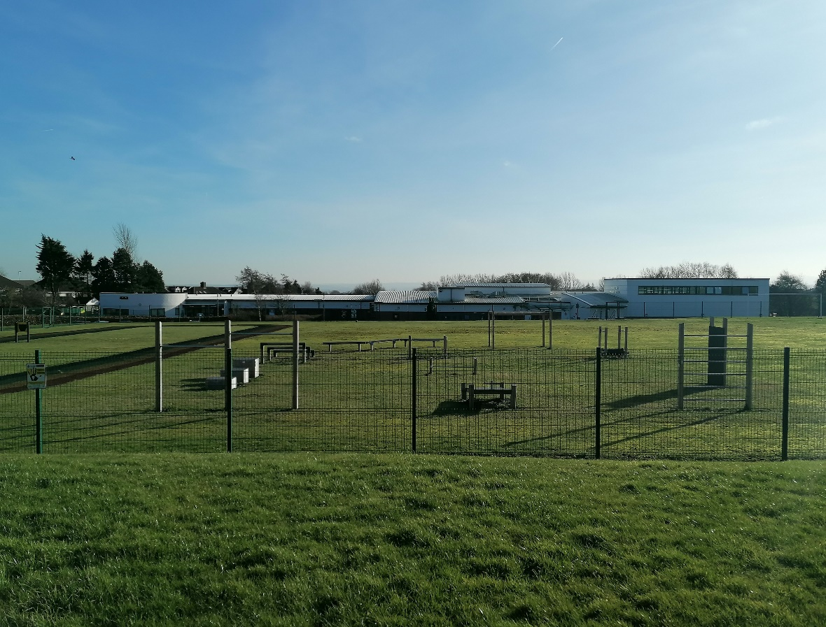
Letter from the Headteacher
Dear Applicant,
Thank you for your interest in the vacancy for the KS2 Class Teacher position at Home Farm Primary School. I hope you find this information pack useful and that it encourages you to apply for this exciting position within our school community.
We are a two form entry school with 458 pupils on roll. Our pupils come from a wide range of backgrounds and our school is rightly proud of the work we do, and the support we provide to the community. We use our Home Farm Values to underpin the work we do for all who are part of our school.
Home Farm is a welcoming, happy school on the outskirts of Bradford, with wonderful pupils and a hardworking, committed staff who have helped shape the culture of the school into a nurturing and vibrant educational establishment. We collaborate well with other schools in the local area and additionally develop strong links with neighbouring schools.
We are looking for an outstanding individual who has the drive, passion and commitment to deliver outstanding teaching and learning to our youngest pupils through an innovative, nurturing and creative approach. The ideal applicant should be able to use our embedded ethos to work with parents, governors and the local community to ensure the best outcomes for our pupils. Please have a look at our website (https://www.homefarm.bradford.sch.uk/) where you can find more information and our latest Ofsted report.
I invite you to come and visit the school, to have a look around and judge for yourself, as I am certain visiting us would encourage you to apply. We look forward to your application and seeing what you can bring to our school.
Yours sincerely,
Joanne Poole
Headteacher

“Coming to school makes me happy. I am proud of the Home Farm Way.” KS1 Pupil

“I have lots of kind friends. My teachers help me learn and they are very kind.” KS1 Pupil

Honesty
Opportunities
Mutual Respect
Enjoyment

Friendship
Achievement
Resilience
Maturity

“Everyone is kind and helpful, and say how nice the teachers are. The teachers help every pupil. Not all schools have Home Farm Values, that’s what makes us special.” KS2 Pupil

“I love everything about Home Farm.” KS2 Pupil

Key Facts and Statistics
Type of School | Community
Age Range | Nursery, 5-11
Number of Children | 458
% of children with SEN support | 22%
% EHCP | 5%
% of children with EAL | 17.4%
% eligible for free school meals | 32.09%
Pupil Premium (2024/25 budget) | 33.4%

School Location
Home Farm Primary School
Home Farm Close
Bradford
West Yorkshire
BD6 3NR
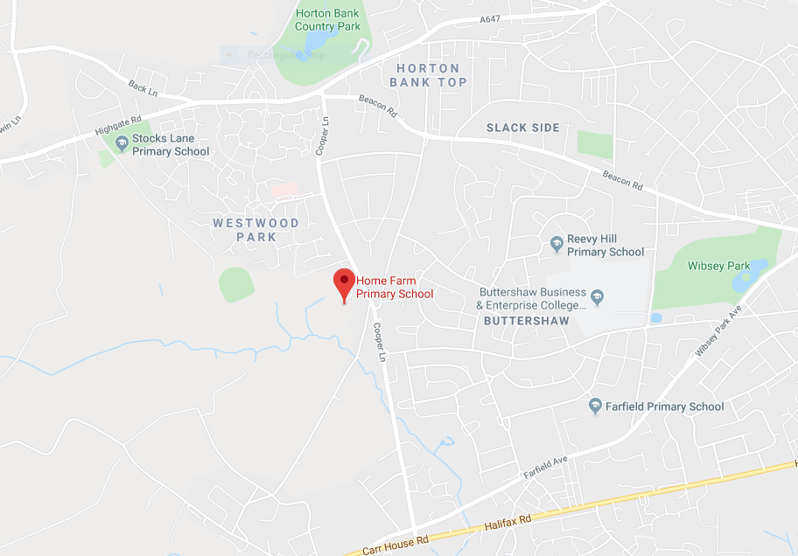

KS2 Class Teacher
1 x Permanent Full time
Required from September 2026
Home Farm Primary School wishes to appoint an inspirational and outstanding teacher who has the ability to achieve high standards of teaching and learning.
Although the post is initially to work in KS2, the postholder must be flexible to work in all key stages dependant on the needs of the school.
The successful candidate will:
- Be passionate about raising achievement and providing the best possible education for our children
- Are committed to promoting high standards of behaviour
- Have high expectations and excellent teaching skills, are enthusiastic, inspiring and motivating to colleagues and children
- Have a good understanding of pedagogy and how children learn
- Have great teamwork skills, a good sense of humour and a willingness to ‘go the extra mile’ every day
- Are committed to and display the ‘Home Farm Way’ in everything they do
We can offer:
- A friendly school with strong links with the community
- A supportive governing body and leadership team
- A genuine, welcoming, caring and professional school with pupils who are keen to learn in a very happy and engaging atmosphere
- Hardworking, supportive and enthusiastic colleagues
- A commitment to your continued professional development
Please have a look at our website to find out more about our school.
ECTs are welcome to apply. Visits to the school are warmly welcomed, please ring the school office on 01274 777020 to make an appointment, with our Headteacher Mrs Poole.
Interested candidates are requested to complete an application form for this post, available on Prospects Online. Please ensure you read the Job Description and check you meet the criteria before completing an application form.
Closing date for the above post will be: 20th April 2026
Interviews to take place on: 30th April 2026
We are committed to safeguarding children and all posts are subject to an enhanced DBS check.
Please do not send a CV. For the purposes of Equal Opportunities, we can only accept Bradford Council application forms.

Home Farm Primary School is committed to safeguarding and promoting the welfare of children and the successful applicant will be subject to an enhanced disclosure through the Disclosure and Barring Service.

Statement of school’s values and ethos

Our School Values
Honesty
Opportunities
Mutual Respect
Enjoyment

Friendship
Achievement
Resilience
Maturity

British Values

At Home Farm Primary school we provide opportunities for pupils to explore their own culture and have a clear understanding and appreciation of a wide range of the cultural influences that have shaped modern Britain.
We are a school for all. We recognise the multi-cultural, multi-faith nature of our community and of Britain. We understand the crucial role our school plays in promoting British Values.

Teacher Job Description and Person Specification

Post title: Class Teacher
School: Home Farm Primary School
Pay range: MPS/UPS Salary Range
Line manager: The headteacher, members of the senior leadership team (SIT) and the governing body
Supervisory responsibilities: The post holder may be responsible for the deployment and supervision of the work of teaching assistants relevant to their responsibility

Job Description

Core purpose

To provide and be accountable for high quality teaching and learning, contributing to the development of outstanding progress across the school in line with the stated aims and objectives of the school.
All teachers are expected to demonstrate high standards of personal and professional conduct and as a minimum, act within the statutory frameworks which set out professional duties and standards inside and outside the school.
The school is fully committed to safeguarding children and promoting their welfare and expects all staff to share in this commitment. All posts are subject to an Enhanced DBS with Barred List check.

This Job Description is furnished to assist staff joining school to understand and appreciate the work content of their post and the role they are to play in the organisation.
Whilst every endeavour has been made to outline the main duties and responsibilities of the post, a document such as this does not permit every item to be specified in detail. This job description is not a definitive list of responsibilities but identifies the key components of the role. The post holder will, therefore, be required to undertake other reasonable duties commensurate with the purpose and salary level of this post.
Although the post is initially to work in KS2, the postholder must be flexible to work in all key stages dependant on the needs of the school.
Employees should not refuse to undertake work, which is not specified on this form, but they should record any additional duties they are required to perform, and these will be taken into account when the post is reviewed.
School is an Equal Opportunities Employer and requires its employees to comply with all current equality policies both in terms of equal opportunity for employment and access to the school’s services.
School is committed, where possible, to making any necessary reasonable adjustments to the job role and the working environment that would enable access to employment opportunities for disabled job applicants or continued employment for any employee who develops a disabling condition.
Duties and Responsibilities

Teaching
In accordance with schemes of work, plan, deliver and review high quality lessons which are appropriate to the age and ability of the children so as to facilitate progression in all children’s learning.
Provide regular homework and out of class activities to consolidate and extend learning.
Provide regular constructive feedback and marking, promoting high standards of presentation in line with school’s guidelines.
Assess, record and report on the development, progress and attainment of the children within the school’s guidelines and assessment cycles.
Manage children’s behaviour and movement inside and outside the classroom ensuring that high standards are maintained in line with school’s policy and the safety and welfare for all.
Create a stimulating and positive learning environment which makes effective use of a range of different learning resources.
Communicate effectively with parents/carers with regard to children’s progress, achievement and
well-being in line with school’s process and calendar.
Provide and facilitate the general progress and well-being of any child providing appropriate guidance and advice.
Implement the school’s policy with regard to registration, and absence.
Management
Work with learning support staff and maximise their effectiveness in the classroom.
Participate in full staff and departmental meetings and contribute to school’s decision making and consultation procedures.
Develop effective professional relationships with others.
Resources
Operate relevant equipment/ICT packages (e.g. MS Office, internet, intranet, school information management systems (Arbor, CPoms, E-mail).
Keep abreast of curriculum developments in relevant area.
Keep up-to-date knowledge of the range of external agencies and opportunities that can be used to provide extra support for children.

Administration
Research, design and produce teaching materials and resources which are appropriate to age and ability and are in accordance with the School Development Plan.
Use relevant data to plan, set targets and monitor progress of children.
Wider Responsibilities
UPS 3 teachers provide a role model for teaching and learning, making a distinctive contribution to the raising of standards and contributing effectively to the work of a wider network of colleagues. Take advantage of appropriate opportunities for professional development and use the outcomes effectively to improve learning.
Engage in the school’s Appraisal process, and professional development activities so as to enhance personal performance, fulfil personal potential and be able to participate effectively in the implementation of the school’s goals and Development Plan.
Contribute to extra-curricular provision within the school carry out a share of supervisory duties in accordance with published rotas.
Be aware of and comply with policies and procedures relating to child protection /safeguarding, equality and diversity, health and safety, ICT, security, confidentiality and data protection, reporting all concerns to an appropriate senior person.
Comply and assist with the development of policies and procedures relating to area of responsibility as required.
Be aware of and support difference and ensure equal opportunities for all stakeholders accepting the principles underlying the school equal opportunities policies and practice.
Maintain the confidential nature of information relating to the school, its children, parents and carers acting in accordance with General Data Protection Regulation (GDPR) at all times.
Contribute to and support the overall life, work/aims and ethos of the school.
Participate and engage in training and appraisal as required.

PERSON SPECIFICATION
Teacher

 | ESSENTIAL | DESIRABLE | How this will be identified
SKILLS AND EXPERIENCE | - Relevant and successful teaching experience of improving student outcomes using a range of strategies  - Ability to motivate and inspire children of different abilities to achieve in well a positive environment  - Strong organisational and time management skills  - Effective use of ICT and data for planning and teaching  - Ability to fulfil all spoken aspects of the role with confidence through the medium of English at an advanced threshold level | - Experience of teaching across age ranges | Application / Interview / References
QUALIFICATIONS | - Honours degree or equivalent in relevant subject  - Qualified Teacher Status | - Health and safety qualification, e.g, First Aid | Interview / Documents
TRAINING | - Evidence of and commitment to further professional development | - Willing to assist in training colleagues | Application / Interview / Documents
SPECIAL KNOWLEDGE | - Strong and secure knowledge in relevant subject up to GCSE  - Understanding of the National Curriculum and Ofsted Framework  - Knowledge and understanding of theory and practise of effective teaching and learning | - Strong and secure knowledge in relevant subject up to A Level  - Knowledge of health and safety issues | Application / Interview / References
PERSONAL CIRCUMSTANCES | - Eligible to work in the U.K  - No contra-indications in personal background/criminal record indicating unsuitability to work with children/young people | - UK valid driving license | Interview / References  Documents
DISPOSITION/ATTITUDE | - Enthusiasm for subject and to making a positive difference  - Reflective  - Resilient with the ability to work under pressure and meet deadlines  - Ability to use initiative in varying demands of the role  - Ability to communicate effectively with students and parents  - Flexible and positive approach to change  - Willing to work as part of a team  - Professional and self-motivated  - Ability to maintain a high level of confidentiality and discretion at all times. |  | Interview / References
PRACTICAL/INTELLECTUAL SKILLS | - Problem solving  - Creative | - Willing and able to contribute to the wider school community and activities | Application / Interview / References
PHYSICAL/SENSORY | - Must be able to perform all duties and responsibilities in work location with reasonable adjustments where appropriate |  | Interview
EQUALITY & SAFEGUARDING | Candidates should indicate an acceptance of, and a commitment to,  - The principles of the school’s equal opportunities policies and practices as they relate to employment issues and to the delivery of services to the community”  - Safeguarding and promoting the welfare of children and young people |  | Interview

Equal Rights and Key Dates

Equal Rights
Our School is an equal rights employer. We require our governors and employees to follow our equality policies and to follow all statutory requirements concerning age, race, religious, sex, sexual orientation and disability discrimination. We respect and protect the rights of people with disabilities both in terms of equal opportunity for employment and access to the school's services.

Disabled Applicants
Disabled applicants are guaranteed an interview if they meet the essential requirements of the Personnel Specification. As an equal rights employer our school is committed to make any necessary reasonable adjustments to the selection process, the job role and the working environment that would enable access to employment opportunities for disabled people. Where a disabled applicant is being assessed the selection panel's decisions will be based on an assessment of that person's expected capabilities once reasonable adjustments have been made.

Job Sharing
Job share applicants are welcome to apply for all full-time posts unless otherwise stated in the advertisement.

Key Dates
Closing Date | 20/04/26
Visits round school | W/C 13/04/26
Shortlisting Date | 22/04/26
Interview Date | 30/04/26
Start Date | 01/09/2026

