

**Make a difference!**

**Are you ready for the challenge? A supportive, nurturing ethos underpins all that we do for our school communities. Whether you are new to teaching or more experienced, we are interested in hearing from you. We offer excellent career and training opportunities both within and across the three sites, an excellent learning environment with happy, enthusiastic children, supportive parents, committed staff and Governors.**

**The Footprints Federation**

**Comprising of 2 very different schools, the Federation was formed in 2010.**

**The Federation accommodates over 700 Keighley children. There is also a 16 place Resourced Provision for children with Social, Emotional, Mental Health (SEMH), which is based at Long Lee.**

**What is a Federation?**

Federations can take many forms. Ours is a hard Federation, which means that we are legally bound, having one Governing body which holds Ingrow and Long Lee to account. Staff are employed as Federation staff but are linked to one school. Some members of staff have responsibilities across both schools. We have some training days and staff meetings as a Federation and work in year group teams from time to time for things such as planning and moderation.

Staff can move to the other site for new challenges or experience, this arrangement is purely through choice and with your consent. As we are a large organisation we are able to offer a wealth of career opportunities.

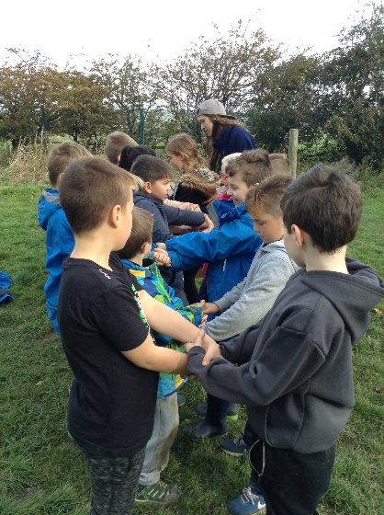

**Teamwork**

This is the key to our success. Everyone is valued as a member of our team, no-one is more important than anyone else as we all have incredibly important roles to play in order to ensure continued improvement.

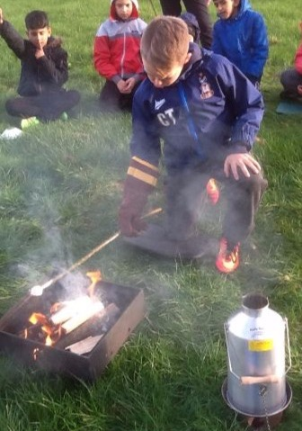

**Areas of Strength**

A large cross Federation leadership team

Access to quality training both in house and externally

Behaviour management

Partnership work at all levels

Supportive teams including Governors

**What are we really like?**

We are a large, friendly, hardworking, committed but very supportive team. We care about our staff and children and want the best for them. With that in mind, we want the best teachers to guide our children’s learning. We aim to develop you as a teacher and support you on your chosen career path, whether you are an ECT or an experienced teacher. This means working with you to identify appropriate training both linked to school improvement as well as to your personal pathway. As we are a large establishment we are increasingly able to promote within: being able to offer very contrasting roles and opportunities across the two sites.

**Governors**

We have an incredibly committed group of Governors who are very supportive of school leaders. They are involved in school life and act as a critical friend to the leadership team. The Governors and staff have a joint vision for our future.

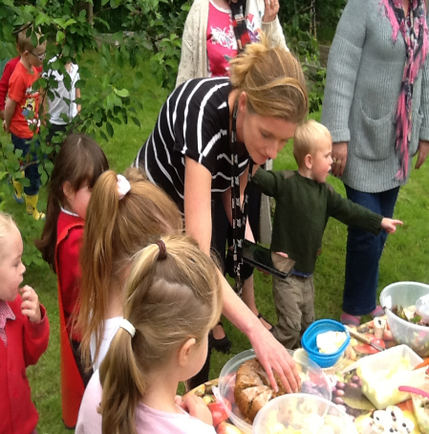



**Extra-curricular fun and games**

Our very talented team offer a wide range of out of school activities. We supplement these with the services of outside providers in order to ensure a breadth of experiences can be offered. We run many cross Federation residentials to Nell Bank, Kingswood and Ingleborough, which add to the many day trips and visitors we have to enrich the curriculum.

**What sort of people do we want to join us?**

We recognise that it takes all sorts to make the world go around, therefore we don’t have a ‘type’ in mind. We actually want to get to know you and evaluate how you might complement our team. What we really need are good teachers: willing to work hard, able to look on the sunny side of life and give things a go, sometimes taking a risk or two in order to provide the very best for our children.

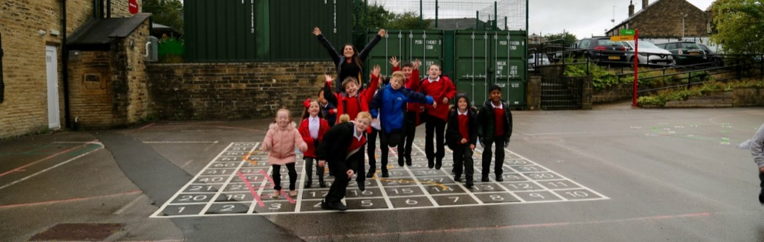

**What can we offer you?**

An induction package lead by our senior leadership team. If you are an Early Career Teacher, you will be supported by an experienced mentor. All our staff teams are very supportive and are more than willing and able to offer advice, guidance or just an ear to listen.

**Our vision for the future?**

We aim to enable children to develop the knowledge and skills required to flourish in an ever-changing world. We will be an outstanding, values-based school, striving for excellence, enabling all children to achieve to their highest potential in all areas of the curriculum. We encourage everyone in our community ‘to be the best that they can be’. We strive to create an environment where this can happen, a curriculum that supports learning for life, ensuring that everyone is nurtured within conditions that promote success.

We wish you the best of luck in your future career in education be it with us or elsewhere.

|  |  |
| --- | --- |
| Footprints Federation | Role profile  January 2025 |
| **Job Title – Permanent and full time**  **Deputy Headteacher - Long Lee with some cross federation responsibility** | |
| **Salary Scale-Leadership scale 9 – 13** | |
| **This post is based primarily at Long Lee Primary but may involve some working across the federation.**  **It will involve out of hours working from time to time** | |
| The following information is furnished to assist staff joining the School to understand and appreciate the work content of their post and the role they are to play in the organisation. The following points should be noted:  • Whilst every endeavour has been made to outline the main duties and responsibilities of the post, a document such as this does not permit every item to be specified in detail. Broad headings, therefore, may have been used below, in which case all the usual associated routines are naturally included in the job profile.  • Employees should not refuse to undertake work, which is not specified on this form, but they should record any additional duties they are required to perform and these will be reviewed annually.  • Bradford is an Equal Opportunities Employer and requires its employees to comply with all current equality policies both in terms of equal opportunity for employment and access to the Council Services.  • The federation is committed, where possible, to making any necessary reasonable adjustments to the job role and the working environment that would enable access to employment opportunities for disabled job applicants or continued employment for any employee who develops a disabling condition. | |
| **Prime Objectives:** | |
| The deputy headteacher, under the direction of the headteacher, will take a major role in:  • Formulating the aims and objectives of the school  • Establishing policies for achieving these aims and objectives  • Managing staff and resources to that end  • Monitoring progress towards the achievement of the school’s aims and objectives  • Take a lead on the continuing development of the curriculum  • Act as the lead DSL where the Head is absent  If the headteacher is absent, the deputy headteacher will deputise, as directed by the governing board and in line with STPCD. The deputy headteacher will also be expected to fulfil the professional responsibilities of a headteacher, as set out in the School Teachers’ Pay and Conditions Document (STPCD). | |
| **Supervision and Guidance** | |
| • Work under the instruction of the Headteacher and Governing Body.  • Line management and performance management rests with the Headteacher. | |
| **Qualities** | |
| The deputy headteacher will:  • Uphold public trust in school leadership and maintain high standards of ethics, behaviour and professional conduct • Build positive and respectful relationships across the school community and across the federation • Serve in the best interests of the school’s pupils and those of the federation  • To act in accordance with the priorities, policies and guidelines of the federation  • Be responsible for the management of their own time on tasks associated with the job.  • Be expected to use good common sense and initiative in all matters  • Know when to seek support | |
| **CONTACTS: Working Conditions** | |
| The post holder will require some out of hours working, | |
| **Duties and Responsibilities** | |
| **School culture and behaviour**  Under the direction of the headteacher, the deputy headteacher will:  • Create a culture where pupils experience a positive and enriching school life  • Uphold educational standards in order to prepare pupils from all backgrounds for their next phase of education and life • Ensure a culture of staff professionalism  • Encourage high standards of behaviour from pupils, built on rules and routines that are understood by staff and pupils and clearly demonstrated by all adults in school  • Use consistent and fair approaches to managing behaviour, in line with the school’s behaviour policy  • Be aware of and drive the federation strategy around Social emotional mental health and well-being for all within Long Lee  **Teaching, Curriculum and assessment**  Under the direction of the headteacher, the deputy headteacher will:  • Establish and sustain high-quality teaching across all subjects and phases, based on evidence  • Ensure teaching is underpinned by subject expertise  • Effectively use formative assessment to inform strategy and decisions  • Ensure the teaching of a broad, structured and coherent curriculum  • Establish curriculum leadership, including subject leaders with relevant expertise and access to professional networks and communities  • Use valid, reliable and proportionate approaches to assessing pupils’ knowledge and understanding of the curriculum    • Ensure the use of evidence-informed approaches to reading so that all pupils are taught to read  • Prepare and present succinct and understandable data for external users  • Take a lead on a significant core subject area within school  **Additional and special educational needs (SEN) and disabilities**  Under the direction of the headteacher, the deputy headteacher will:  • Promote a culture and practices that enables all pupils to access the curriculum  • Have ambitious expectations for all pupils with SEN and disabilities  • Make sure the school works effectively with parents, carers and professionals to identify additional needs and provide support and adaptation where appropriate  • Make sure the school fulfills statutory duties regarding the SEND Code of Practice.  • Have an understanding of the work and purpose of the Silver Birch Resourced Provision  **Organisational management and school improvement**  Under the direction of the headteacher, the deputy headteacher will:  • Establish and sustain the school’s ethos and strategic direction together with the governing board and through consultation with the school community  • Establish and oversee systems, processes and policies so the school can operate effectively  • Ensure staff and pupils’ safety and welfare through effective approaches to safeguarding, as part of duty of care • Manage staff well with due attention to workload  • Ensure rigorous approaches to identifying, managing and mitigating risk  • Allocate financial resources appropriately, efficiently and effectively  • Identify problems and barriers to school effectiveness, and develop strategies for school improvement that are realistic, timely and suited to the school’s context  • Make sure these school improvement strategies are effectively implemented  **Professional development**  Under the direction of the headteacher, the deputy headteacher will:  • Ensure staff have access to appropriate, high standard professional development opportunities  • Keep up to date with developments in education  • Seek training and continuing professional development to meet needs  • Focus and foster your own professional development  **Governance, accountability and working in partnership**  Under the direction of the headteacher, the deputy headteacher will:  • Understand and welcome the role of effective governance, including accepting responsibility  • Ensure that staff understand their professional responsibilities and are held to account  • Ensure the school effectively and efficiently operates within the required regulatory frameworks and meets all statutory duties  • Work successfully with other schools and organisations  • Maintain working relationships with fellow professionals and colleagues to improve educational outcomes for all pupils  **Please note that this is illustrative of the general nature and level of responsibility of the role. It is not a comprehensive list of all tasks that the Deputy Headteacher will carry out. The post holder may be required to do other duties appropriate to the level of the role.** | |
| **Personal qualities** | |
| • A commitment to getting the best outcomes for all pupils and promoting the ethos and values of the school  • Ability to work under pressure and prioritise effectively  • Commitment to maintaining confidentiality at all times  • Commitment to safeguarding and equality, ensuring that personal beliefs are not expressed in ways that exploit the position.  • Commitment to partnership working across the Federation and the wider locality. | |
| **Skills and knowledge** | |
| • Data analysis skills, and the ability to use data to set targets and identify lines of enquiry  • Understanding of high-quality teaching, and the ability to model this for others and support others to improve  • Understanding of school finances and financial management  • Effective communication and interpersonal skills  • Ability to communicate a vision and inspire others  • Ability to build effective working relationships | |
| **Special Conditions of Service:** | |
| No contra-indications in personal background or criminal record indicating unsuitability to work with children/young people/ vulnerable clients/finance (An enhanced DBS check is required) | |
| **Other Considerations:** | |
| • To be aware of and comply with policies and procedures relating to child protection; being vigilant for signs that children may be being abused and to report any such suspicions to the school’s nominated DSL.  • To act in accordance with Data Protection Act principles and maintain confidentiality at all times e.g. access to staff/ student/parent and carers files.  • Accept and commit to the principles underlying the Schools Equal Rights policies and practices.  • Be able to perform all duties and tasks with reasonable adjustment, where appropriate, in accordance with the Equality Act. • Must be legally entitled to work in the UK. | |
| Signed by:­­­­­­­­­­­_______________________________ Postholder Date:____________  Signed by:_______________________________ School Representative Date:____________  To be reviewed on:________________________ | |

**Person Specification: Deputy Headteacher – Long Lee Primary School. Sept 22**

|  |  |
| --- | --- |
| CRITERIA | QUALITIES |
| **Qualifications**  **and training** | • Qualified teacher status [note: this is a requirement under the STPCD]  • Degree  • Professional development in preparation for a leadership role |
| **Experience** | • Successful leadership and management experience in a school for a minimum of 3 years • Played an active role in Senior Leadership Team  • Teaching experience across the Primary age range for at least 5 years  • Involvement in school self-evaluation and development planning  • Demonstrable experience of successful line management and staff development  • Ability to demonstrate successful leadership of a key curriculum area at whole school level and leadership impact  • Involvement in school self-evaluation and school improvement  • Worked proactively across the federation to strengthen links |
| **Skills and**  **knowledge** | • Data analysis skills, and the ability to use data to set targets and identify weaknesses  • Understanding of high-quality teaching, and the ability to model this for others and support others to improve  • Understanding of school finances and financial management (des)  • Effective communication and interpersonal skills  • Ability to communicate a vision and inspire others  • Ability to build effective working relationships  • Ability to support and challenge colleagues in difficult situations  • Understanding of the key aspects of safeguarding and the referral process • Understanding of the current national curriculum and the OFSTED framework • Ability to deputise when the head is absent  • Ability to remain calm in a crisis |
| **Personal**  **qualities** | • A commitment to getting the best outcomes for all pupils and staff and promoting the ethos and values of the school  • Ability to work under pressure and prioritise effectively  • Commitment to maintaining confidentiality at all times  • Commitment to safeguarding and equality  • Commitment to a healthy work life balance for all members of the community, including self |