

CONTENTS Page:

Application letter 3

Mission Statement 4

Job Description 5 - 9

Copy of advert 10-11

How to find us 12

How to apply 13
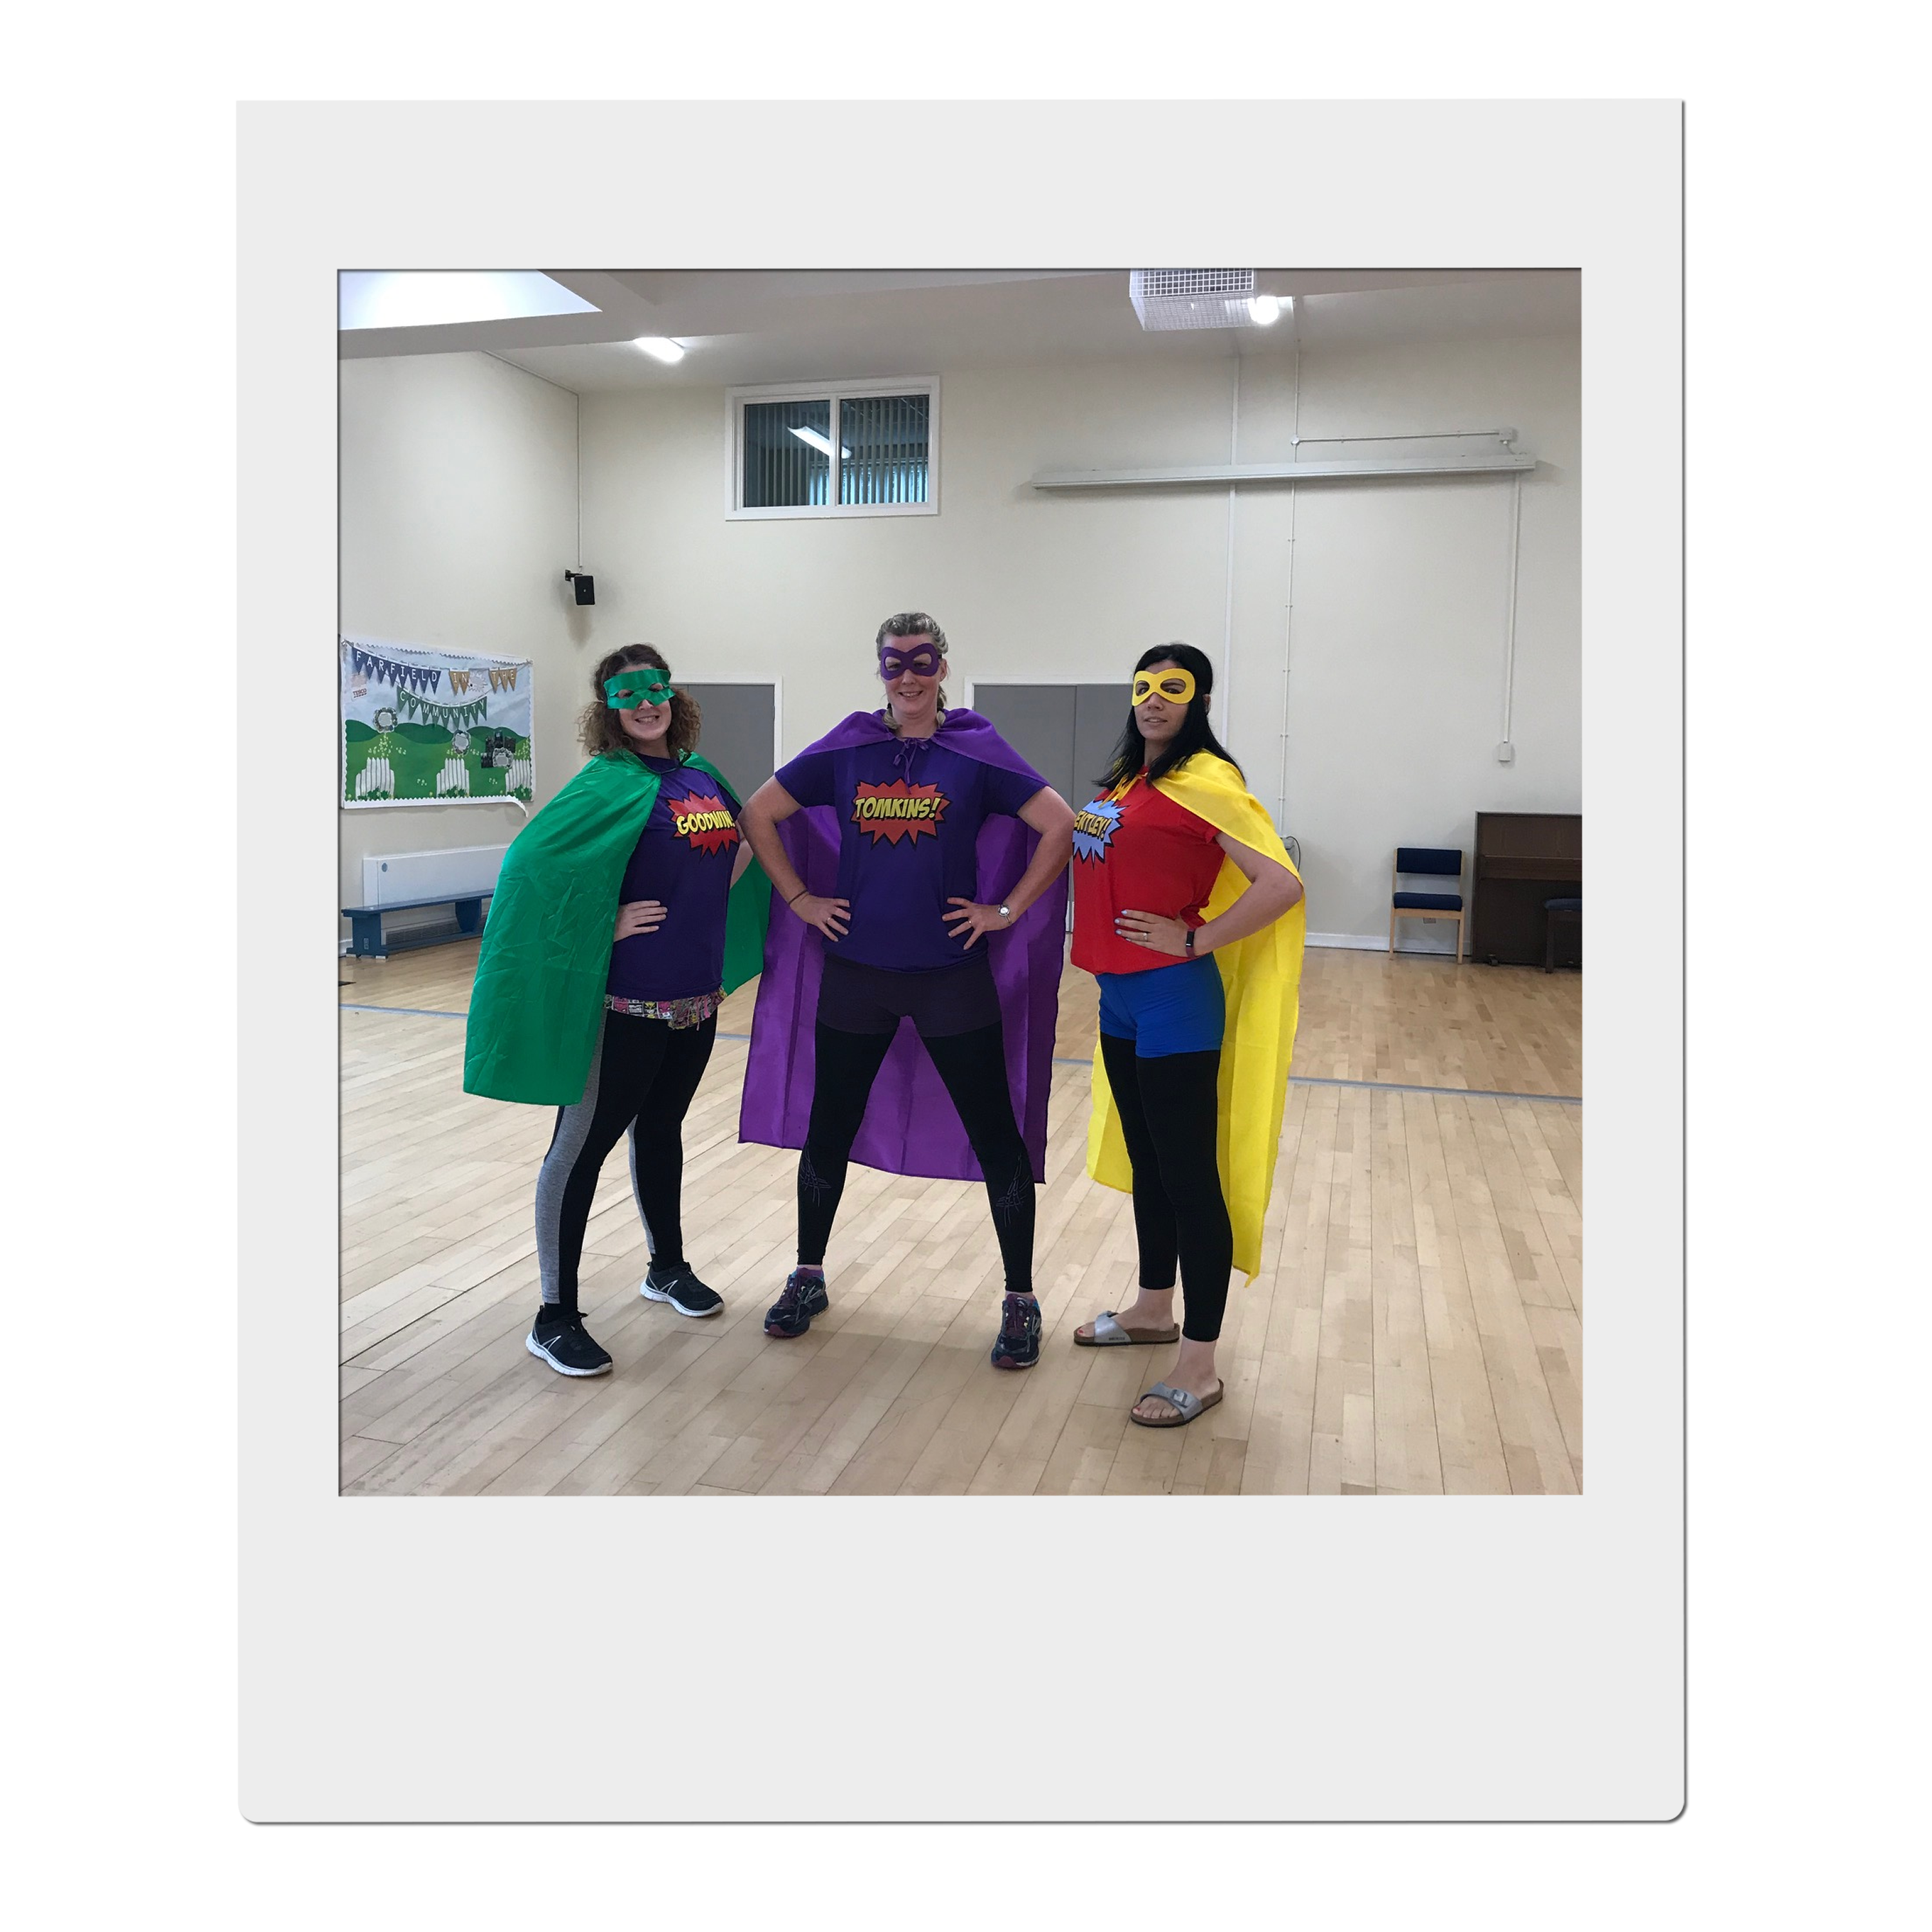
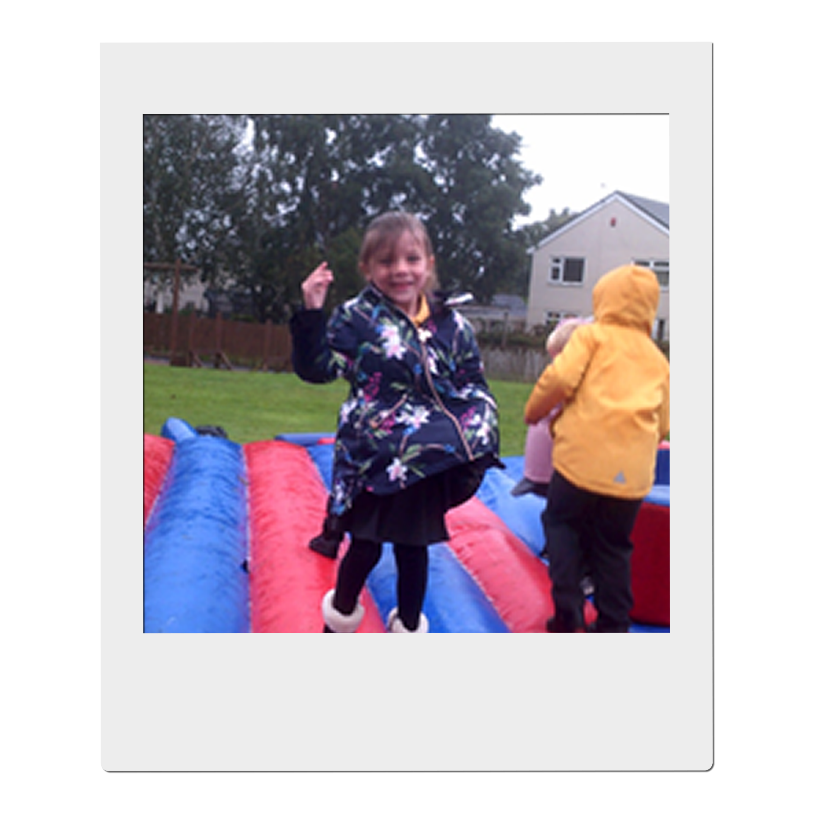



Congratulations
You have taken the first step on an exciting adventure to be part of our team, to inspire and enrich the education of all our children at Farfield Primary and Nursery School.
‘Farfield children can’
This is the belief of all staff and at the heart of everything we do. As Headteacher I want only the best teachers for our children, who are shining examples and strive every day to be ready, respectful, and safe. I expect them to attend school every day and I have the highest of expectations for their education. I want our children to,

“Walk with the dreamers, the believers, the courageous, the cheerful, the planners, the doers, the successful people with their heads in the clouds and their feet on the ground.” Wilfred Peterson
If you are enthusiastic, dynamic, up for a challenge, determined and want to have a positive impact on the education of our children - then fill out an application and tell me what you can bring to our community, what makes you unique and why you are the teacher I would entrust to educate Farfield children. Our priorities are to raise standards in phonics returning them to above 60% and increase combined in KS2 to 65%. All staff no matter what their role in school, know how important it is to ensure this goal is achieved and what they personally contribute to make it happen.
All our children have the potential to reach their goals, and this is a unique opportunity for you to join a supportive, hardworking, caring team and be part of their journey. You ‘MUST’ meet our amazing pupils and speak to our staff about what ‘Farfield’ means to them. Immerse yourself in our daily life and you will know immediately if you have what it takes to be part of our team. Every day is different, but every day is rewarding – we notice the positives and celebrate the differences. We inspire children to be scientists, deep sea divers, entrepreneurs, you name it! But most importantly we want our children to be unique, well-rounded citizens who will make a difference in our future communities.
We are a good school on a journey to outstanding. We will offer support whether you are at the start of your career or an experienced teacher within a community that will inspire and motivate you to be the best teacher you can be.
I look forward to meeting you, showing you around our school and introducing you to our Farfield Family.
Sarah Nichols
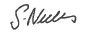
Head teacher
Farfield Primary and Nursery School

Our mission statement

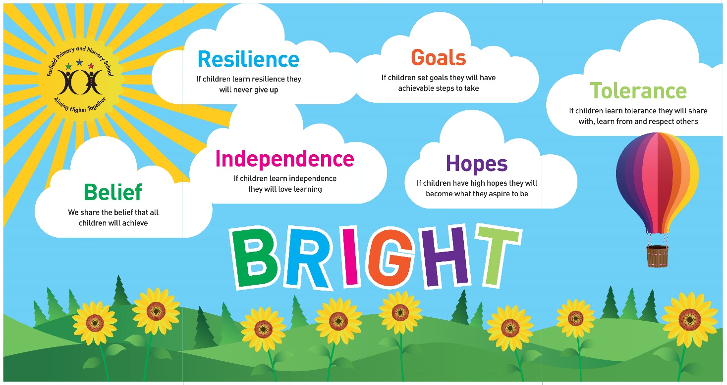

We share the Belief that all children will achieve,
If they learn Resilience they never give up,
If they learn Independence they will love learning,
If they set Goals they will have achievable steps to take,
If they have high Hopes they will become what they aspire to be,
If they learn Tolerance they will share with, learn from and respect others.

JOB DESCRIPTION: TEACHING ASSISTANT LEVEL 1

SEND 1-to-1 TEACHING ASSISTANT – GENERAL (LEVEL 1)

PRIME OBJECTIVES OF THE POST:

- To support access to learning for specific child and to provide general support to the Teacher in the management of pupils and the classroom

- To complement, appreciate and support the role of teachers and other professionals by undertaking work/care/support programmes which enables access to learning in the community as part of a teacher planned approach.

- To support the class teacher and other senior staff on a range of teaching and learning experiences which deliver an appropriately differentiated and suitably challenging creative curriculum for all pupils whilst meeting statutory requirements.

- Work within school policies and procedures under the direction and guidance of senior staff and within an agreed system of supervision.

- May from time to time be required to undertake other duties commensurate with the grade and level of responsibility defined in this job description.

SUPERVISORY/MANAGERIAL RESPONSIBILITIES:

Assisting as a member of the classroom team in the supervision of students on work experience, trainees and voluntary helpers with whom the post holder is working

SUPERVISION AND GUIDANCE:

To work under the instruction/direction of teaching/senior staff.

RANGE OF DECISION MAKING:

To make decisions within established working practices and procedures.
The post holder will be expected to use good common sense and initiative in all matters relating to:
- the conduct and behaviour of individuals, groups of pupils and whole classes
- the correct use and care of materials by individual and small groups of pupils
- the safety, mobility (if required) and hygiene and well-being of the pupils.

Knowledge and Skills:
(See Personnel Specification)

- Effort Demands:
- Will assist in maintaining the good discipline of pupils throughout school and be expected to use good common sense, as well as use initiative in all matters relating to the conduct and behaviour of individual pupils, groups of pupils and whole classes, the safety, mobility (if required), hygiene and well being of the pupils; making decisions within established working practices and procedures.

- Will recognise and challenge any incidents of racism, bullying, harassment, victimisation and any form of abuse of equal opportunities, ensuring compliance with the relevant school policy and procedures.

- Will deal with any issues, immediate problems or emergencies that arise in line with school policies and procedures liaising with colleagues where necessary e.g. dealing with a sick, injured or distressed child.

- Acting as a role model, will establish productive and constructive working relationships with pupils, setting high expectations, motivating and interacting with them, being aware of their individual needs, supporting difference and ensuring all pupils have equal access to opportunities to learn and develop whilst responding appropriately.

- Will have the ability to cope with the requirements of the post, which may include working with pupils who have emotional/behavioural/physical difficulties.

- Will contribute to the overall ethos/work/aims of the school.

- Will appreciate and support the role of other professionals.

- Be vigilant and sensitive to any child protection/safeguarding concerns that arise, reporting any concerns to the designated officer in line with school policy and procedure.

2 Responsibilities:

  - Assist in the management of pupils in the learning environment.

- Undertake structured and agreed learning activities/teaching programmes appropriate to the pupil’s needs to ensure physical, social, emotional and intellectual development, taking into account diversity e.g. language, culture, ability, race and religion.

- Will supervise and support pupils consistently at all times; recognising and responding to their individual needs whilst ensuring their safety and education in the learning environment.

- For posts working with pupils who are physically less able, it may be necessary to be able to physically assist the pupil in line with school polices and good practice.

- Attend to the pupils’ personal needs, implementing and maintaining related personal care programmes with the correct use of care materials including the safety and well being of the pupils and first aid, paying attention to social, health, physical and welfare matters as well as high standards of cleanliness and hygiene e.g. washing, dressing, toileting, and, if applicable, mobility.

- Will occasionally be required to supervise the class for brief periods in a lesson where the classroom teacher is not available.

- Promote and reinforce the inclusion, acceptance and integration of all pupils, including those with specific and special needs and those from different cultures and/or with a different first language as appropriate.

- Set challenging and demanding expectations whilst promoting self-esteem and encouraging pupils to act independently as appropriate as well as interact and work co-operatively with others and engage in activities led by the teacher.

- Will prepare the classroom as directed to meet the lesson plans. Take responsibility for the care, preparation, maintenance and use of relevant equipment, assisting pupils in its use and clearing/storage afterwards.

- Will be aware of pupil progress, monitor/record pupil responses against pre-determined learning objectives as well as provide accurate, constructive and detailed feedback/reports to the teacher and pupils.

- Promote positive values, attitudes and good pupil behaviour and encourage pupils to take responsibility for their own actions whilst supporting the teacher in managing this. Deal promptly with conflict and incidents (including those involving restraint) and reporting challenging behaviour where appropriate in line with established policy.

- Will gather/report information from/to parents/carers as directed, taking into account parental/carer concerns, dealing with them sensitively under the direction of the teacher.

- Will provide clerical/administrative support as directed by the teacher.

- In respect of local and national learning strategies, will support pupils to achieve learning goals e.g. literacy, numeracy, KS1, early years as directed by the teacher.

- Will support pupils in the use of ICT in learning activities as directed by the teacher, and develop pupils competence and independence in its use.

- Will participate in own performance development, identify and address any training needs/other learning activities.

- Will assist with the supervision of pupils out of lesson times, including before and after school and at lunchtimes, accompanying teaching staff and pupils on visits, trips and out of school activities.

- Will assist in the supervision of students on work experience, trainees and voluntary helpers.

3 environmental demands/Working Conditions:

- Will have long periods of sitting or standing.

- Available to work during school hours during term time and a willingness to be flexible as may be required to attend staff meetings/training sessions outside of usual hours.

- Will have contact with members of the public/other professionals e.g. teaching staff, governors, parents/carers, community groups, local education authority, external providers etc.

- The post holder may occasionally be subjected to antisocial behaviour from members of the public/parents/site users.

- This post may include a degree of manual lifting and handling. You are expected to be aware of health and safety policies and procedures and frequently assess your ability to carry out the lifting tasks required of you.

- Report all concerns to an appropriate person.

4 Special Conditions of Service:

- No contra-indications in personal background or criminal record indicating unsuitability to work with children/young people/vulnerable clients/finance (An enhanced DBS check is required).

5 Other considerations

- To be aware of and comply with policies and procedures relating to child protection; being vigilant for signs that children may be being abused and to report any such suspicions to the school’s nominated Child Protection Co-ordinator or the Headteacher.

- To act in accordance with the Data Protection Act and maintain confidentiality at all times e.g. access to staff/student/parent and carers files.

- Accept and commit to the principles underlying the Schools Equal Rights policies and practices.

- Be able to perform all duties and tasks with reasonable adjustment, where appropriate, in accordance with the Equality Act.

- Must be legally entitled to work in the UK.

6 RESPONSIBILITY FOR ASSETS, MATERIALS ETC:

- To maintain the confidential nature of information relating to the school, it’s pupils, parents and carers.

- The provision, use and storage of equipment and materials used by pupils with whom the post holder is working.

- General responsibility for the care of all equipment and materials within the classroom/designated area of the school.

CONTACTS:

Internal at all levels, Parents / Carers, Governors, Community Groups, Health, Social Services, Police, Local Authority, Education Bradford, Contractors, External Agencies.

Job advert
SEN 1 to 1
Salary: £22,737 - £23,114 full time equivalent (this will be pro-rated 31.15 hours, term time only)
Farfield Primary & Nursery School is looking for a skilled and caring adult who can support individual children in their learning. A key part of this role is to take responsibility for supporting learning in the classroom.
Are you ready to equip children with the knowledge and power to make a difference, to be different and embrace difference?
At Farfield Primary and Nursery School we will trust, support and challenge you to empower our future generations helping them to achieve their full potential and become unique well-rounded citizens.
Our priorities are to raise standards in phonics returning them to above 60% and increase combined attainment in KS2 to 65%. All staff, no matter what their role in school, have this as their focus.
Please click the link to find out more, and then read on : : https://drive.google.com/file/d/1knTFm9UuABiElbYuC2IfZPRq3K5tGeA2/view?usp=drive_link
We are looking for a highly motivated, inspirational practitioner who has the drive, vision and inter-personal skills to work with both staff, children, parents and other stakeholders.
We would like someone who cares about the children and is able to support children in lessons, allowing children to make good progress throughout their school career. This is a real opportunity to make a difference. If you are passionate about education and improving life chances, then we are keen to hear from you.
Grade C or above in GCSE English and Maths or equivalent is an essential requirement for this post. Please state all of your qualifications on your application.
We need a SEN 1 to 1 who is an:
- Outstanding classroom practitioner
- Committed to raising achievement through an exciting and stimulating curriculum
- Enthusiastic and forward thinking
- Well organised and creative
- Able to demonstrate excellent interpersonal skills and the ability to work with a range of staff to improve learning
- Able to work in partnership with parents/carers and the wider community

The successful candidate will be able to demonstrate:
- A good sense of humour, enthusiasm and a positive, proactive attitude to their role
- The ability to work well both independently and as part of a team
- Excellent interpersonal and communication skills
- Commitment to your own development
Farfield is a friendly, vibrant and lively school where our children are enthusiastic learners, well-motivated and encouraged to think for themselves. Visitors to our school always comment about the friendly, warm welcome from the staff and pupils.
Closing Date: Monday 8th April 2024, 10am
Shortlisting: Monday 8th April 2024
Interview date: Monday 15th April 2024
HOW TO FIND US
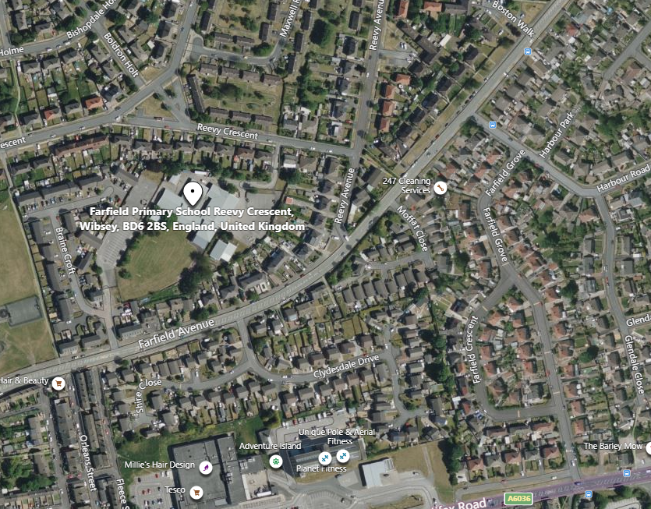

Farfield Primary School and Nursery
Reevy Crescent
Buttershaw
Bradford
BD6 2BS
(For carpark please use satnav postcode BD6 2JF)
Tel : 01274 678545
Fax: 01274 694022
E-mail: office@farfield.bradford.sch.uk

HOW TO APPLY

If you wish to apply for the post of full-time of SEN 1 to 1 at Farfield Primary and Nursery School, please log onto the Prospects Online website at www.prospectsonline.co.uk.

If you wish to arrange a visit to look around Farfield Primary & Nursery School please contact Toni Wilson via email of telephone, farfieldadmin@farfield.bradford.sch.uk, Tel 01274 678545

Upload your completed application form onto the website outlining how you meet the criteria on the job description and attributes required. A continuation sheet may be used if necessary.

We would request that you provide details of daytime and evening contact numbers and email addresses for use should you be called for interview.

The closing date for applications is 10am on Monday 8th April 2024, with short listing on the same day.

You will be informed by email before 6pm on Tuesday 9th January 2024 if your application has been successful.

Interviews will take place on Monday 15th April 2024.

Please be available for observation/interview on this day if shortlisted.

Thank you for your interest in our post. We look forward to receiving your completed application.

