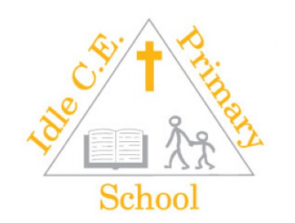

**Required for September 2025**

**Full-time, permanent LKS2 Teacher (MPS-UPS)**

Our vision: ‘For all to discover and develop their God-given gifts and talents, and flourish in the fullness of life Jesus came to give.’ (Based on John 10:10)

Are you an inspiring and enthusiastic teacher looking to make a real impact? Do you want to be part of a vibrant school that is on an exciting journey of growth and development? Idle CE(A) Primary School is looking for a dynamic KS1 Teacher to join our team in Lower Key Stage 2.

This is a fantastic opportunity to shape the learning experiences of our wonderful pupils. Successful candidates will have strong subject knowledge and experience of successful impact on the curriculum through leading a subject area.

We are seeking to appoint a LKS2 class teacher for September 2025. Our new teacher will work as part of our committed school team to ensure that students are provided with an excellent education delivered in the context of our positive Christian ethos and with consideration for all individual needs.

**Why join us?**

At Idle CE(A) Primary School, no two days are the same! We are a thriving, high-energy school that believes learning should be exciting, engaging, and full of discovery. Our welcoming and supportive team is dedicated to nurturing every child’s unique talents—whether in the classroom, on the stage, or out on the sports field. The personal development opportunities and strong behaviour and attitudes are particular strengths of our school.

**We are:**

* a caring and friendly school with high aspirations.
* a motivated, professional and lively team of staff.
* a school with a curriculum enriched with numerous visits and visitors.
* proud of our pupils who are cheerful, confident and enthusiastic learners.
* supported by enthusiastic governors with a strong vision for the school.

**You are:**

* an inspirational and motivated teacher
* an excellent classroom practitioner with a passion for teaching and learning.
* actively supportive of the values of a Church of England primary school.
* a team player with vision and creativity who is able to motivate both pupils and support staff.
* a person who strives for excellence, has high expectations and enjoys school life.

Interested candidates should apply via Prospects. Visits to the school are welcomed – please contact Mohammed Hussain, School Business Manager, to arrange a convenient time.

Closing date: Monday 5th May 2025 9am

Interviews: Thursday 8th May 2025