

CONTENTS Page:

Application letter 3

Mission Statement 4

Copy of advert 5

Job Description 6 - 12

How to find us 13

How to apply 14
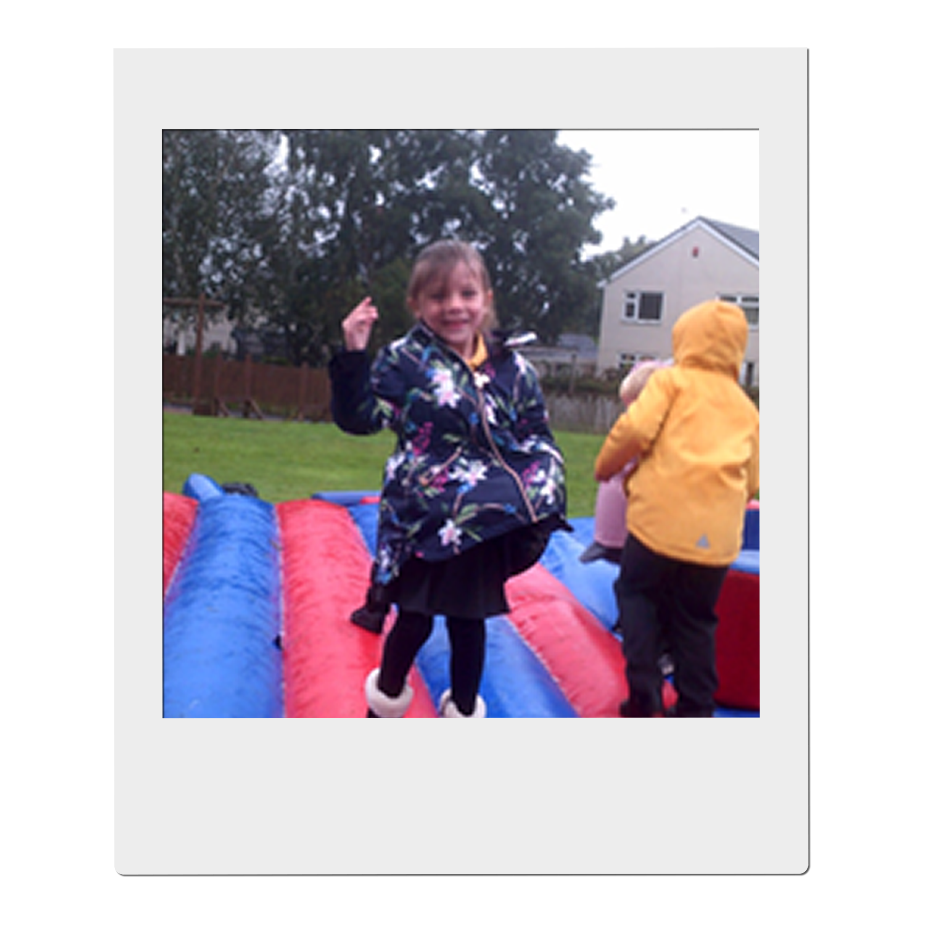



Congratulations
You have taken the first step on an exciting adventure to be part of our team, to inspire and enrich the education of all our children at Farfield Primary and Nursery School.
‘Farfield children can’
This is the belief of all staff and at the heart of everything we do. As Headteacher I want only the best teachers for our children, who are shining examples and strive every day to be ready, respectful, and safe. I expect them to attend school every day and I have the highest of expectations for their education. I want our children to,

“Walk with the dreamers, the believers, the courageous, the cheerful, the planners, the doers, the successful people with their heads in the clouds and their feet on the ground.” Wilfred Peterson
If you are enthusiastic, dynamic, up for a challenge, determined and want to have a positive impact on the education of our children - then fill out an application and tell me what you can bring to our community, what makes you unique and why you are the teacher I would entrust to educate Farfield children. Our priorities are to raise standards in phonics returning them to above 60% and increase combined in KS2 to 65%. All staff no matter what their role in school, know how important it is to ensure this goal is achieved and what they personally contribute to make it happen.
All our children have the potential to reach their goals, and this is a unique opportunity for you to join a supportive, hardworking, caring team and be part of their journey. You ‘MUST’ meet our amazing pupils and speak to our staff about what ‘Farfield’ means to them. Immerse yourself in our daily life and you will know immediately if you have what it takes to be part of our team. Every day is different, but every day is rewarding – we notice the positives and celebrate the differences. We inspire children to be scientists, deep sea divers, entrepreneurs, you name it! But most importantly we want our children to be unique, well-rounded citizens who will make a difference in our future communities.
We are a good school on a journey to outstanding. We will offer support whether you are at the start of your career or an experienced teacher within a community that will inspire and motivate you to be the best teacher you can be.
I look forward to meeting you, showing you around our school and introducing you to our Farfield Family.
Sarah Nichols
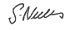
Head teacher
Farfield Primary and Nursery School

Our mission statement

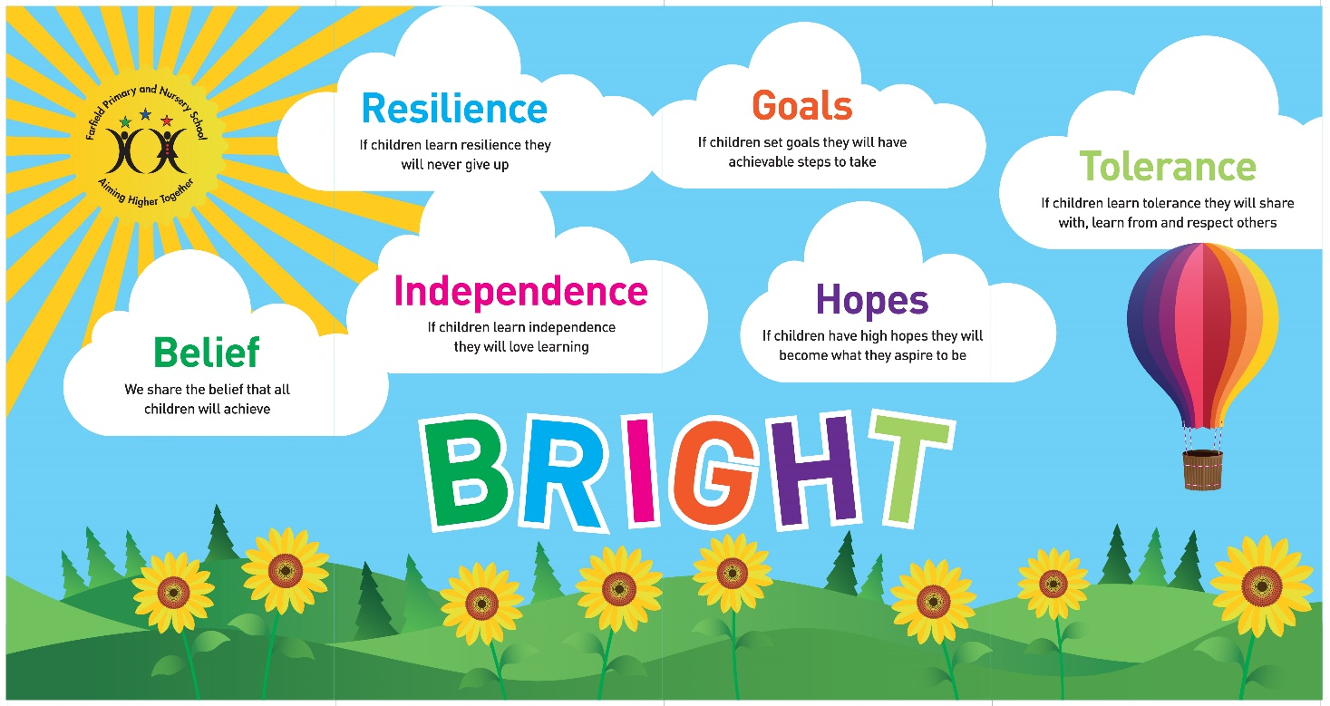

We share the Belief that all children will achieve,
If they learn Resilience they never give up,
If they learn Independence they will love learning,
If they set Goals they will have achievable steps to take,
If they have high Hopes they will become what they aspire to be,
If they learn Tolerance they will share with, learn from and respect others.

Job advert
Required to start September 2025
Please click the link and then read on : https://drive.google.com/file/d/1wLnPo96Nxo4S_hqGUmYhw2Re9oAuOxpr/view?usp=share_link
Are you ready to equip children with the knowledge and power to make a difference, to be different and embrace difference?
At Farfield Primary and Nursery School we will trust, support and challenge you to empower our future generations helping them to achieve their full potential and become unique well-rounded citizens.
Our priorities are to raise standards in phonics returning them to above 60% and increase combined in KS2 to 65%. All staff no matter what their role in school have this as their focus.

Vacancy Information – MPS-UPS
We need a full-time class teacher who is an:
- Outstanding classroom practitioner
- Committed to raising achievement through an exciting and stimulating curriculum
- Enthusiastic and forward thinking
- Well organised and creative
- Able to demonstrate excellent interpersonal skills and the ability to work with a range of staff to improve learning
- Able to work in partnership with parents/carers and the wider community

The successful candidate will be able to demonstrate:
- A good sense of humour, enthusiasm and a positive, proactive attitude to their role
- The ability to work well both independently and as part of a team
- Excellent interpersonal and communication skills
- Commitment to your own development

For further information or to book your visit please email farfieldadmin@farfield.bradford.sch.uk

Visit times: 1.30pm -Tuesday 3rd & Wednesday 4th June 2025
10am – Thursday 5th & Friday 6th June 2025

ECT's are welcome to apply.
Closing date: 9am Monday 9th June 2025
Shortlisting: Monday 9th June 2025
Observations & interviews: w/c 16th June 2025

Outline Job Description for Teachers

Post Title: Class teacher
Pay Spine: MPS or UPS

Core Purpose of Class Teacher:

The following information is furnished to assist staff joining the School to understand and appreciate the work content of their post and the role they are to play in the organisation. The following points should be noted:

- Whilst every endeavour has been made to outline the main duties and responsibilities of the post, a document such as this does not permit every item to be specified in detail. Broad headings, therefore, may have been used below, in which case all the usual associated routines are naturally included in the job profile.

- Employees should not refuse to undertake work, which is not specified on this form, but they should record any additional duties they are required to perform and these will be taken into account when the post is reviewed.

- The Council and therefore Farfield Primary and Nursery School is an Equal Opportunities Employer and requires its employees to comply with all current equality policies in terms of equal opportunity for employment and access to the Council Services.

- The Council and therefore Farfield Primary and Nursery School is committed, where possible, to making any necessary reasonable adjustments to the job role and the working environment that would enable access to employment opportunities for disabled job applicants or continued employment for any employee who develops a disabling condition.

Prime Objectives of the Post:

As a Primary school teacher, you will be an outstanding classroom practitioner who consistently demonstrates the highest standards of delivery. You should be fully committed to raising attainment across the whole school and across all subjects that you are required to teach. You will be acutely aware of the strategies required to achieve the highest standards across the curriculum.

You may from time to time be required to undertake other duties commensurate with the grade and level of responsibility defined in this job description.

As a classroom teacher you will, at all times, be mindful of, and adhere to, the Professional Standards for Teachers and the Career Stage expectations negotiated and adopted by the school at any time.

In addition, for Teachers paid on the Upper Pay Range (UPR), your achievements and contribution to an educational setting should be substantial and sustained.

Effort Demands:
- Will contribute to the overall ethos/work/aims of the school.

- Will appreciate and support the role of other professionals.

- Be vigilant and sensitive to any child protection/safeguarding concerns that arise, reporting any concerns to the designated officer in line with school policy and procedure.

- Will deal with any issues, immediate problems or emergencies that arise in line with school policies and procedures liaising with colleagues where necessary e.g. dealing with a sick, injured or distressed child.
Responsibilities:
Teaching:
- To teach students according to their individual educational needs, including the appropriate setting and marking of work to be carried out by the students.

- Identifying effective intervention and mentoring strategies for students.

- To mark and grade students work in a way which enables you to give written/verbal and diagnostic feedback and maintain records of pupils' progress and development.

- To use a variety of delivery methods, which will stimulate learning appropriate to student needs and demands of the syllabus, for example, podcasts, interactive whiteboards etc.

- Prepare pupils for internal and external assessments and examinations.

- To undertake pastoral duties, such as taking on the role of form tutor, and supporting pupils on an individual basis through academic or personal difficulties.

Health, Safety and Discipline:
- To ensure a safe, secure and healthy environment for students
- To manage pupil behaviour in the classroom and on school premises, and apply appropriate and effective measures in cases of misbehaviour

- To actively encourage good practice with regard to punctuality, behaviour, standards of work and independent learning.

Whole school organisation and strategy:
- To participate in and organise extracurricular activities, such as outings, social activities and sporting events; including participation in occasional overnight visits.

- To contribute to the development, implementation and evaluation of school’s policies, practices and procedures in such a way as to support the school’s values and vision.

- Work with others on curriculum and/or pupil development to secure co-ordinated outcomes.

- Subject to the guidance relating to Cover, supervise and teach any pupils where the person timetabled to take the class is not available to do so.

Management of staff and Resources:
- To prepare and regularly update subject materials including researching new topic areas and writing new curriculum materials.

- To supervise and support the work of classroom support, teaching assistants, trainee teachers and newly qualified teachers (NQTs).

- To efficiently deploy such resources as are allocated/delegated to you.

- Contribute to the recruitment, selection appointment and professional development of other teachers and support staff.

Professional Development:
- To under-go regular observations and participate in regular in-service training (INSET) as part of continuing professional development (CPD).

- Where appropriate, to participate in arrangements for the appraisal and review of other teachers and support staff.

- Participate in arrangements for your own further training and professional development and, where appropriate, that of other teachers and support staff.

Communication:
- To communicate with parents and carers over pupils' progress and participate in departmental meetings, parents' evenings and whole school training events.
Working with colleagues and other relevant professionals:
- To liaise with other professionals, such as learning mentors, careers advisers, educational psychologists, education welfare officers etc.

environmental demands/Working Conditions:
- Will have long periods of sitting or standing.

- Available to work during school hours during term time and a willingness to be flexible as may be required to attend staff meetings/training sessions outside of usual hours.

- Will have contact with members of the public/other professionals e.g. teaching staff, governors, parents/carers, community groups, local education authority, external providers etc.

- The post holder may occasionally be subjected to antisocial behaviour from members of the public/parents/site users.

- This post may include a degree of manual lifting and handling. You are expected to be aware of health and safety policies and procedures and frequently assess your ability to carry out the lifting tasks required of you.

- Report all concerns to an appropriate person.
Fluency Duty

- In line with the Immigration Act 2016; the Government has created a duty to ensure that all Public Authority staff working in customer facing roles can speak fluent English to an appropriate standard.

- For this role the post holder is required to meet the Threshold Level

Special Conditions of Service:

- No contra-indications in personal background or criminal record indicating unsuitability to work with children/young people/vulnerable clients/finance (An enhanced DBS check is required).

Other considerations
- To be aware of and comply with policies and procedures relating to child protection; being vigilant for signs that children may be being abused and to report any such suspicions to the school’s nominated Child Protection Co-ordinator or the Headteacher.

- To act in accordance with the Data Protection Act and maintain confidentiality at all times e.g. access to staff/student/parent and carers files.

- Accept and commit to the principles underlying the Schools Equal Rights policies and practices.

- Be able to perform all duties and tasks with reasonable adjustment, where appropriate, in accordance with the Equality Act.

- Must be legally entitled to work in the UK.

Person Specification: Classroom Teacher
Personnel Specification
Attributes | Essential | Desirable | How identified
Qualifications | Qualified Teacher Status | Evidence of additional study | Application form  Letter of application  References  Interview
Experience | Have a proven record of raising standards.  Experience of effective use of assessment information  Experience of teaching within the 7 – 11 age range. | Experience of leading or being involved in curriculum development and leading a subject across the whole school  At least one years teaching experience | Application form  Letter of application  References  Interview
Training | Willingness to be involved in training for personal and professional development. | Evidence of training in Curriculum development and classroom organisation  Courses relating to Primary Practice. | Application form  Letter of application  References  Interview
Special Knowledge | Knowledge and understanding of the role of a Primary School in preparing children for adult life and transition to secondary school.  Knowledge and understanding of how to incorporate ICT into learning.  An informed awareness of current developments within National Curriculum.  Flexible to adapt the curriculum to meet the needs of a range of pupils | Knowledge of one or more areas of the Primary School Curriculum.  Creative and inspirational  An additional area of interest that would support or extend the Primary Curriculum. | Application form  Letter of application  References  Interview
Circumstances - Personal | To be in a position to fulfil the requirements of the post. | To be able to devote time out of school to extra curricular activities. | Application form  Letter of application  References  Interview
Disposition/  Adjustment/Attitude | An identification and an understanding of the nature of the school and the children its serves.  A willingness to work throughout the Primary School age range.  An ability to work as a member of a team and promote positivity.  Positive attitude to parents and children.  Enthusiastic and a sense of humour.  Hard working and conscientious.  Good communication skills.  No contra-indicators in personal or criminal record to indicate unsuitability for the post applied for.  To be in a position to fulfil the requirements of the post.  To be able to sometimes work outside of school hours. |  | Application form  Letter of application  References  Interview  Disclosure and barring service check and self declaration form.
Practical and Intellectual skills | Good classroom teacher.  Willingness to make a significant contribution to the school and its journey to being outstanding  A practical grasp of the National Curriculum and the cohesive nature in which it can be used in a creative curriculum  An ability to motivate and engage children. | An interest that can be brought to school for the children's benefit.  A keenness to continue learning about learning | Application form  Letter of application  References  Interview

HOW TO FIND US
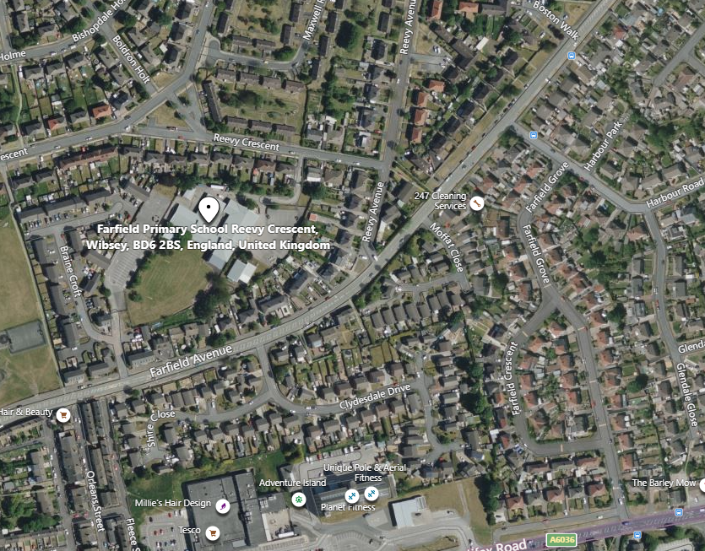

Farfield Primary School and Nursery
Reevy Crescent
Buttershaw
Bradford
BD6 2BS
Tel : 01274 678545
Fax: 01274 694022
E-mail: office@farfield.bradford.sch.uk

HOW TO APPLY

If you wish to apply for the post of full-time KS2 Class Teacher at Farfield Primary and Nursery School, please log onto the Prospects Online website at www.prospectsonline.co.uk.

Upload your completed application form onto the website outlining how you meet the criteria on the job description and attributes required. A continuation sheet may be used if necessary.

We would request that you provide details of daytime and evening contact numbers and email addresses for use should you be called for interview.

The closing date for applications is 9am on Monday 9th June 2025.

Shortlisting will take place on Monday 9th June 2025.

Observations & interviews will take place w/c 16th June 2025.

Please be available for observation/interview w/c16th June 2025 if shortlisted.

Thank you for your interest in our post. We look forward to receiving your completed application.

