JOB DESCRIPTION

Post Title: | Behaviour and Learning Practitioner (28.5 hrs / week)  With Lunchtime Supervision (2.5 hrs / week)
Reports To: | Head Teacher, Bradford AP Academy Central
Salary Details: | BLP Band 6 SCP 6 – 11 TTO+5 days  Salary range £20,092 - £21,748 pro-rata  with  LS Band 4 SCP 3 – 4 TTO+5 days pro-rata  Salary range £18,562 – £18,933 pro-rata  Combined roles: TTO + 5 days Actual salary range :  Under 5 years exp. £14,321.28 - £15,434.61  Over 5 years exp. £14,588.96 - £15,723.11

The following information is furnished to help those people considering joining the Bradford AP Academy to understand and appreciate the general work content of their post and the role they are to play in the organisation. The following points should be noted:

- Whilst every endeavour has been made to outline the main duties and responsibilities of the post, a document such as this does not permit every item to be specified in detail. Broad headings, therefore, may have been used below, in which case all the usual associated routines are naturally included in the job profile.

- Employees should not refuse to undertake work, which is not specified on this form, but they should record any additional duties they are required to perform and these will be taken into account when the post is reviewed.

- Bradford AP Academy is an Equal Opportunities Employer and requires its employees to comply with all current equality policies both in terms of equal opportunity for employment and access to the Exceed Academies Trust services.

- Bradford AP Academy is committed, where possible, to making any necessary reasonable adjustments to the job role and the working environment that would enable access to employment opportunities for disabled job applicants or continued employment for any employee who develops a disabling condition.

Key Purpose of Post:
To support the Head Teacher in making excellent provision for referred students with challenging behaviour. This will include a curriculum that meets their identified needs and the requirements of legislation and local policy.

Main Responsibilities of Post:
Responsible for individual pupils and groups of pupils both within and outside the BAPA, within the scope of the duties of the Behaviour and Learning Practitioner post.

SUPERVISION AND GUIDANCE

To work under the guidance of teaching/senior staff. This would be on a BAPA site that is designated by the Head Teacher.

RANGE OF DECISION MAKING

To make decisions using initiative where appropriate within established working practices and procedures. The post holder will be expected to use good common sense and initiative in all matters relating to:
- The conduct and behaviour of individual and small groups of pupils
- The correct use and care of materials by individual and small groups of pupils
- The safety, mobility (if required) and hygiene and will being of the pupils.
- SUPPORT FOR PUPILS

1.1 Be aware of and follow up on safeguarding procedures that arise
1.2 Provide pastoral support to pupils
1.3 Receive and supervise pupils excluded from, or otherwise not working to, a normal timetable
1.4 Attend to pupils’ personal needs and provide advice to assist in their social, health & hygiene development
1.5 Participate in comprehensive assessment of pupils to determine those in need of particular help
1.6 Assist the teacher with the development and implementation of Individual Education/Behaviour/Support/Mentoring plans
1.7 Support provision for pupils with special needs
1.8 Establish productive working relationships with pupils, acting as a role model
1.9 Develop 1:1 mentoring arrangements with pupils and provide support for distressed pupils
1.10 Promote the speedy/effective transfer of pupils across phases/integration of those who have been absent
1.11 Provide information and advice to enable pupils to make choices about their own learning/behaviour/attendance
1.12 Challenge and motivate pupils, promote and reinforce self-esteem
1.13 Provide feedback to pupils in relation to progress, achievement, behaviour, attendance etc.
1.14 Use a 'Team Teach' methodology to support positive behaviour management of pupils.

2. SUPPORT FOR TEACHERS

2.1 Liaise with feeder schools and other relevant bodies to gather pupil information
2.2 Support pupils’ access to learning using appropriate strategies, resources etc.
2.3 Work with other staff in planning, evaluating and adjusting learning activities as appropriate
2.4 Monitor and evaluate pupils’ responses and progress against action plans through observation and planned recording
2.5 Provide objective and accurate feedback and reports as required, to other staff on pupils achievement, progress and other matters, ensuring the availability of appropriate evidence
2.6 Be responsible for keeping and updating records as agreed with other staff, contributing to reviews of systems/records as requested
2.7 Assist in the development and implementation of appropriate behaviour management strategies
2.8 Establish constructive relationships with parents/carers, exchanging information, facilitating their support for their child’s attendance, access and learning and supporting home to school and community links
2.9 Assist in the development, implementation and monitoring of systems relating to attendance and integration
2.10 Clerical/admin support e.g. dealing with correspondence, compilation/ analysis/reporting on attendance, exclusions etc., making phone calls etc.

3. SUPPORT FOR CURRICULUM

3.1 Implement agreed learning activities/teaching programmes, adjusting activities according to pupil responses/needs
3.2 Be aware of and appreciate a range of activities, courses, organisations and individuals to provide support for pupils to broaden and enrich their learning
3.3 Determine the need for, prepare and use specialist equipment, plans and resources to support pupils.

4. SUPPORT FOR THE SCHOOL
4.1 Be aware of and comply with policies and procedures relating to child protection, health, safety and security, confidentiality and data protection, reporting all concerns to an appropriate person.
4.2 Be aware of and support difference and ensure all pupils have equal access to opportunities to learn and develop
4.3 Contribute to the overall ethos/work/aims of the school
4.4 Establish constructive relationships and communicate with other agencies/professionals, in liaison with the teacher, to support achievement and progress of pupils
4.5 Attend and participate in regular meetings
4.6 Participate in training and other learning activities as required
4.7 Recognise own strengths and areas of expertise and use these to advise and support others
4.8 Supervise pupils on visits, trips and out of school activities as required.
4.9 To support, uphold and contribute to the development of the Council’s Equal Rights policies and practices in respect of both employment issues and the delivery of services to the community.
4.10 Assist in the supervision, training and development of staff
4.11 Implement planned supervision of pupils out of school hours
4.12 Contribute to the school's self-evaluation process.

Job Dimensions:

Bradford AP Academy provides an educational provision for secondary aged pupils who are either permanently excluded from mainstream school or who are nearing permanent exclusion. You will work under the guidance of teaching/senior staff on a BAPA site that is designated by the Head Teacher. As representatives of Bradford AP Academy, Behaviour and Learning Practitioners must model the highest professional standards at all times.

If this post has decision making responsibility outline its extent:

To work under the guidance of teaching/senior staff.

Professional Qualifications:
- English and mathematics to GCSE Grade C or equivalent
- Evidence of attendance at related training in Child Protection and related CPD
- Ability to demonstrate high level of experience of working with children with social, emotional and behavioural difficulties.
- Willingness to continue and review own professional development.

Routine Communications:
- Parents/Carers and pupils
- Senior Leadership Team
- Bradford AP Academy staff
- Colleagues within education
- Professionals within Children’s Services, Health Services, Police

To maintain the confidential nature of information relating to the centre, its pupils, parents and carers.

Staffing Structure

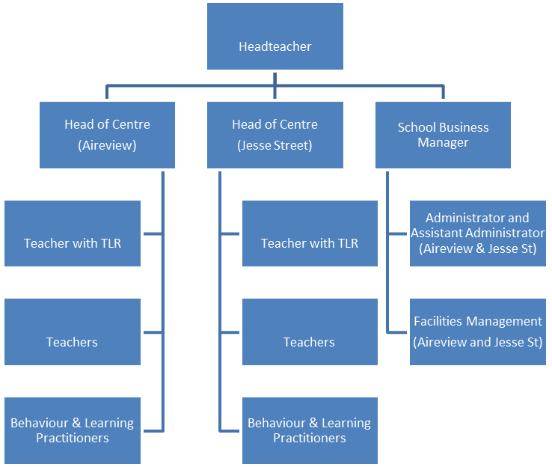

Working Conditions:
- Term Time only + 5 Training days
- 5hrs 30mins hours a week plus 1 hour staff team meeting (Tuesday) : total per week 28.5 hrs
- 30 mins per day Lunchtime Supervisor Post : total per week 2.5 hrs
- Casual, additional hours may be available, depending on the need of Bradford AP Academy
Special Conditions: Management require that the following checks be carried out as
part of the recruitment process
- Enhanced Barring and Disclosure Service check.
- Suitable references.

